CS351: Sentiment-Driven Book Recommendation System with AI- Powered Interaction
Introduction
In today's world the discovery of books is limited by recommendation systems that prioritize user behaviour and content similarity over emotional context, which leaves a significant gap in delivering actual personalized reading experiences. This project aims to address these limitations by focusing on the emotional experiences readers are looking for, making book discovery more engaging and expressive. Interactive AI features and utilizing natural language processing (NLP) techniques, the system will be able to recommend books that suit to emotions users seek or the feelings they want to experience.
The project’s primary idea is the concept of emotional tagging, where books are categorized based on predefined emotional tags and this categorization will enable more enhanced recommendations. The recommendation engine will also combine emotional tagging with thematic matching, a hybrid system that give better recommendation than simple emotional matching system. Machine learning components will play a crucial role in analysing user inputs, to identify emotional and thematic meanings, hence in the core of recommendation engine. This project can be considered prominent undertaking, as it requires the utilization of advanced NLP models, data preprocessing, and a full-stack web application which makes it a remarkable challenge as a third-year project. This report outlines the progress made so far and provides a detailed plan for the upcoming term.

Background Research

Problem Statement
A lot of modern digital platforms incorporate recommendation systems, which use cutting-edge technologies to increase user satisfaction and engagement. [ref]. While these approaches are effective in predicting general preferences of public, they fail to address the dynamic private emotional needs of users, which is critical in influencing reading choices [ref]. This discrepancy frequently leads to suggestions that are thematically appropriate but do not emotionally connect with the user, which lowers engagement [ref]. Another limitation of these approaches is that they need user engagement to some extent in order to identify their preferences.
As mentioned in specification, existing book recommendation platforms, such as Goodreads, LibraryThing , Amazon and other popular sites, primarily utilize collaborative filtering (CF) and content-based filtering (CBF) techniques to give suggestions to users [ref]. These approaches can be effective in general, but they also have significant limitations, such as dynamic personalized recommendations. As books can influence a reader's state of mind and evoke particular emotions, sentimental relevance would be essential for suggestions [ref].
Amazon's recommendation system is a well-known example of collaborative filtering. It analyses user behaviour, such as purchase history, browsing patterns, and items in basket, to identify patterns and similarities among users. Thus, Amazon recommends books by comparing one user's behaviour with others who exhibit similar patterns [ref].
Similarly, Goodreads utilizes a content-based approach that analyses user interactions, such as book ratings, preferred genres, and custom shelves, to give recommendations. This method exploits the user’s historical data to identify books that match their established preferences. Although Goodreads offers a enhanced experience for users who actively engage with the platform, it also lacks the capability to adapt to the reader's emotional state or mood [ref].
Other platforms, such as Netflix, have started experimenting with mood-based recommendations for movies and TV shows, recognizing the importance of aligning suggestions with a user’s emotional preferences [ref]. However, such approaches are not yet prevalent in book recommendation systems, leaving a significant gap in the industry.
Recent progress in sentiment analysis and emotion-driven AI indicates that emotional understanding in the recommendation systems becomes more to be significant [ref]. Indeed, a number of studies have already shown that recommendations towards the user's current emotional state increase engagement and satisfaction significantly [ref]. Techniques such as zero-shot classification and embeddings can foster deeper levels of textual content understanding by allowing systems to label books with emotional and thematic labels [ref]. These tools make it possible to construct dynamic systems that responds to users' needs and offer a more customized experience.

Dataset Collection
The first primary task was to find and select appropriate datasets. Our main was to find datasets with multiple reviews per book. That was going to facilitate analysis of diverse user reviews and extraction of emotional and thematic tags effectively. Initially, I explored several sources, including publicly available APIs like Google’s Books APIs and datasets from platforms like Kaggle. While there are different book datasets, they had their own issues that I had to consider.
First suitable dataset found was the Goodreads Complete Book Reviews dataset that has over 15 million reviews for approximately 2 million books, which is a comprehensive source for sentiment analysis [ref]. However, the enormous size of the dataset brought about significant preprocessing difficulties, such as filtering out invalid reviews. That itself would not be issue as I could use proportion of the dataset for system’s purposes, but most important challenge was that the dataset does not contain books names but contains book ids. Thus, there was second file with book titles metadata, and orderings of books on those two files were different. Namely, I had to create a new dataset by taking necessary columns from two dataset. This merging process was going to add complexity considering disorganized structure of datasets.

Considering the requirements, I found a dataset that was not only manageable in size but also has comprehensive metadata. This dataset contains 3 million user reviews for 212,404 unique books and comes with two files: one containing user reviews and another providing detailed book metadata [ref]. The metadata includes essential fields like book titles, authors, descriptions, categories, and ratings, which eliminates the need for merging multiple datasets. Furthermore, it also includes additional information such as publisher information, publication dates, and links to access books images, making it ideal for building not just an robust recommendation system but also better User Interface (UI).

This new dataset was better choice because it has:
1. Complete Metadata: This dataset includes all necessary fields, such as book titles, descriptions, and genres.
2. Manageable Size: 212,404 books in diverse genres the is practical for computationally expensive tasks, allowing tagging books with emotional and thematic labels efficiently.
3. Balanced Reviews: The dataset provides enough reviews per book for richer sentiment analysis unlike the deficiency seen in other datasets.
In summary, after evaluating several datasets, I decided the Amazon book reviews and metadata dataset would be the final choice for the project as this dataset aligns with requirements of the project

Technical Content

Development Methodology
For this project, the Waterfall model is a suitable choice due to the reasons below:
- Distinct Phases: The project progresses through distinct phases (specification, design, implementation, testing, and deployment).
- Well-Defined Requirements: Since the system's requirements (login/registration system, recommendation microservice with emotional tagging, thematic matching) are clear, Waterfall allows for detailed upfront planning
- Minimized Changes: Waterfall reduces the risk of significant changes during development considering that we have clear requirements and decided the toolstack.

Requirements

Functional Requirements
Functional requirements describe the core features and functionality of the system. Those below are functional requirements of the project with MoSCoW prioritization:
- Users can register, log in, and manage their profiles (Must-Have)
- Save previous recommendations for future reference (Should-Have)
- The system should be able to extract emotional tags from user input (e.g., “funny” → “joy”) (Must-Have)
- Match books based on emotional and thematic tags (Must Have)
- Store metadata such as book overviews, emotional tags, and themes (Must-Have)
- Provide ranked recommendations (Must-Have)
- Allow users to input preferences and view recommendations on both desktop and mobile devices (Should-Have)
- Advanced search functionality (e.g., filter by author or genre) (Could-Have)
- Allowing users to provide feedback on recommendations for future refinement (Could-Have)
- Saving user recommendation history for future access (Should-Have)
- There will be an AI-powered chatbot that will interact with users, simulating book discussions or answering questions about the emotional or thematic content of books (Could-Have)

Non-Functional Requirements
Non-functional requirements define the system's performance and quality attributes. Those below are non-functional requirements of system with MoSCoW prioritization:
- The system should return recommendations within 10 seconds of user input (Must-Have)
- Secure user data with encryption and implement safe authentication mechanisms (Must-Have)
- A mobile-responsive web application interface (Could-Have)
- The web application should feature an intuitive interface with clear input fields and instructions (Should-Have)
- All communications between the frontend and backend must use HTTPS to prevent data interception (Should-Have)
- Use a version control system (e.g., Git) to track changes and ensure collaboration efficiency (Must-Have)

User Interaction and System Flow
The system is designed to provide an engaging experience for users. Users begin with accessing the web interface, where they can easily input their preferences, such as the emotions they want to experience (e.g., "funny," "dramatic," "uplifting") and specific themes they are interested in (e.g., "mystery," "adventure," "romance"). The interface is intuitive, making it easy for users to specify their interests in either a conversational or categorical format. Once users enter their preferences, the frontend captures this input and sends it to the backend for further processing.

The backend checks the user inputs, validates the input, and handles the interaction with the Recommendation Engine. The backend performs initial data checks to ensure proper formatting and filters out any irrelevant information before passing the data to the Recommendation Engine. The Engine then performs core analysis, using NLP techniques to generate a list of books that best match the user's emotional and thematic preferences.

After generating an initial list of recommended books, the backend further processes and refines the results. The books are ranked based on their relevance, considering both the emotional context and thematic alignment with the user's input. This ranking ensures that users are presented with the most suitable books first. Once the recommendations are ready, the backend sends the final ranked list to the frontend, which displays it to the user in an easy-to-navigate format. Users can explore the recommendations, read book summaries, and save suggestions for future reference. This entire flow—from user input to recommendation delivery—is designed to be seamless and efficient, ensuring that users receive high-quality, personalized recommendations in a timely manner.

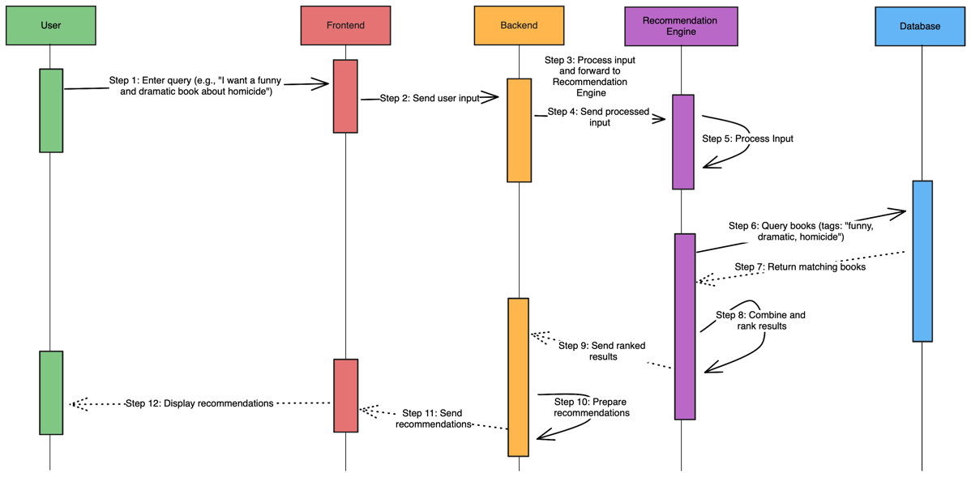
Figure 1: Sequence Diagram that illustrates the user’s interaction with system

Technical System Details

Our system is made of several core components, each has a specific role in processing user input, generating recommendations, and showing results. The Frontend will be employ React to provide a dynamic, user-friendly interface. It will collect user preferences as input, for example, emotional and thematic interests, and sends this data to the backend for processing. The frontend is also responsible for presenting the book recommendations in a visually appealing and organized way, that will improve user engagement.

The Backend will be implemented with Django, a powerful web framework that manages the main logic [ref]. It will be responsible for processing user queries, extracting semantic and thematic meanings from it , matching those semantic meanings with defined emotional tags in our system, and directing it to the recommendation engine. The backend serves as the link between the frontend and the recommendation logic that provides smooth and adequate communication. Its other purpose is handling user authentication, profile management, and user preferences for future, to enhance the personalization of recommendations. Frontend and backend will communicate through RESTful APIs for secure and reliable data exchange.

The Recommendation Engine is designed as a microservice, enabling it to operate independently and handle the computational workload of generating recommendations. The engine uses a hybrid approach, combining emotional tagging and thematic extraction to provide relevant suggestions. The emotional tagging process involves analysing book metadata, such as overviews and reviews, to determine the emotions conveyed by each book. This is achieved using NLP models like GoEmotions or Zero-shot Classification, which categorize books into emotions such as "joy," "suspense," or "sadness."

In addition to emotional tagging, the thematic extraction component categorizes books based on themes like "adventure," "romance," or "science fiction." By combining both emotional and thematic information, the Recommendation Engine ensures that the recommendations are contextually and emotionally relevant to the user. Once the input is processed, the engine generates a list of potential book matches, which are then ranked by relevance. The ranking is performed using Sentence-BERT (SBERT), which calculates similarity scores between user input and book descriptions to identify the best matches. The ranked list is sent back to the backend, which formats it for display and sends it to the frontend.

The Database is implemented using PostgreSQL, a relational database system that stores all book data, including metadata, emotional tags, and thematic classifications. It also stores user profiles, preferences, and recommendation history, which are used to personalize future interactions. The database is optimized for efficient querying to ensure that recommendations can be generated quickly, even as the system scales with more books and users. This modular architecture, with distinct roles for the frontend, backend, recommendation engine, and database, ensures that the system is scalable, maintainable, and reliable.
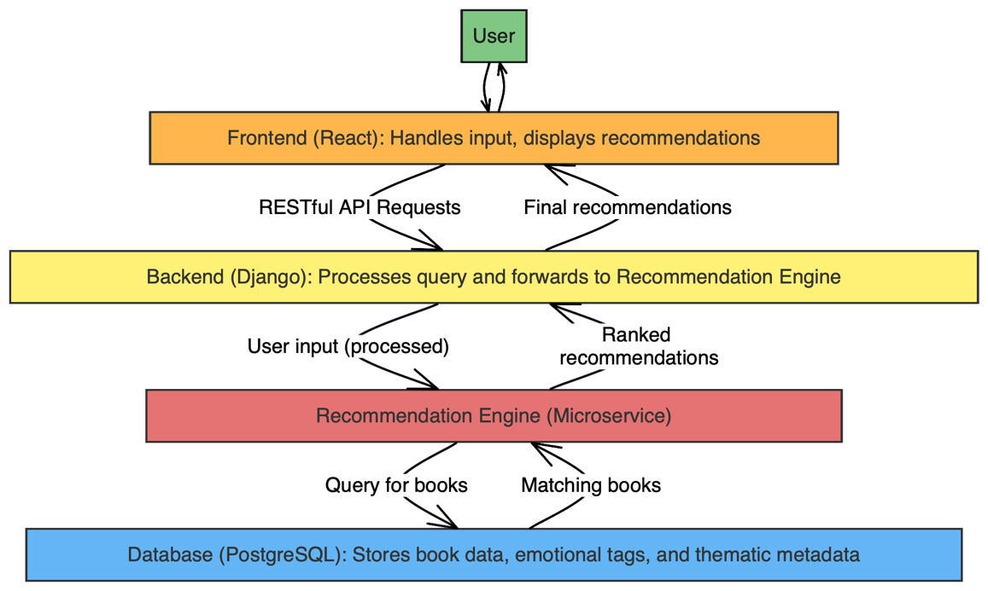

Recommendation Engine Design
The Recommendation Engine is the core of our system for generating personalized book recommendations based on user input. It is designed as a modular and multi-layered system, ensuring that every step in the recommendation process contributes to accurate, meaningful, and personalized results. By incorporating emotional and thematic tagging, alongside semantic analysis, the engine aligns its recommendations with users' emotional states and thematic preferences.

Preprocessing Layer
The first layer processes raw book data, including reviews, overviews, and metadata. This involves cleaning, deduplication, and transformation to ensure high-quality input for downstream components. By filtering inconsistencies and irrelevant information, the system lays a strong foundation for accurate tagging and recommendation generation.

Emotion and Thematic Tagging System
At the heart of the engine is the Tagging System, responsible for extracting emotional and thematic tags from book data. This system is powered by advanced natural language processing (NLP) techniques and machine learning models.

Emotion Extraction Module:
- This module identifies emotional tags (e.g., *joy*, *sadness*, *excitement*) for books based on user reviews.
- Using a pre-trained **Support Vector Machine (SVM)** model, reviews are classified into predefined emotional categories.
- The system aggregates review-level tags to generate book-level emotional scores. For example:

- The tagging process uses insights from the **CARER dataset** for initial testing, but it is designed to adapt to book-specific data for domain relevance.

2. **Thematic Extraction Module**:
- Alongside emotions, books are tagged with thematic categories such as *mystery*, *romance*, *self-help*, and *adventure*.
- This module employs classification models to assign themes based on book overviews and metadata.
- The combined emotional and thematic tags allow the system to cater to complex user inputs, such as "I want a funny and dramatic mystery."

#### **Ranking and Matching**
Once books are tagged, the **Ranking Module** processes user input to provide personalized recommendations:
1. **User Input Parsing**:
- The system extracts emotional and thematic preferences from user queries (e.g., "I feel sad and want something uplifting").
- Emotional tags (e.g., *uplifting → joy*) and thematic interests (e.g., *self-help*) are identified.

2. **Semantic Matching with SBERT**:
- Using **Sentence-BERT (SBERT)**, the module generates embeddings for the user query and book descriptions.
- Similarity scores are calculated between the user input and candidate books, ensuring that the highest-ranked books are the best matches for the user's preferences.

3. **Result Aggregation**:
- The engine combines emotional, thematic, and semantic scores to rank books. Books that closely align with both emotional and thematic criteria are prioritized, ensuring recommendations are contextually and emotionally relevant.

#### **Output and Delivery**
The **Output Layer** formats the ranked list of books for presentation. The recommendations are sent to the backend, where additional processing, such as sorting and formatting, occurs. Finally, the backend delivers the recommendations to the frontend, presenting users with an interactive interface to explore book summaries, save suggestions, and refine their preferences.

---

### **Development of the Tagging System**

The Tagging System plays a critical role in the recommendation engine. Its development was guided by systematic testing and refinement:

1. **Model Evaluation**:
- Multiple machine learning models were tested on the **CARER dataset**, including **Naive Bayes**, **Logistic Regression**, **SVM**, and an **Ensemble Model**.
- **SVM** was selected for its superior accuracy (~89%) and balanced performance across precision, recall, and F1-score.

2. **Challenges and Refinements**:
- **Class Imbalance**: Addressed using class weighting and oversampling techniques.
- **Domain Relevance**: While the CARER dataset provided a solid starting point, the system is being adapted to book-specific data to improve performance in the recommendation domain.

3. **Integration with the Recommendation Engine**:
- Tags generated by the system are stored as part of the book metadata. When a user query is received, the engine matches the query's emotional and thematic elements with these tags to provide personalized recommendations.

---

### **System Features**
The Recommendation Engine's multi-layered design ensures:
1. **Personalization**:
- The system dynamically adapts to users’ emotional states and thematic preferences, deliverin
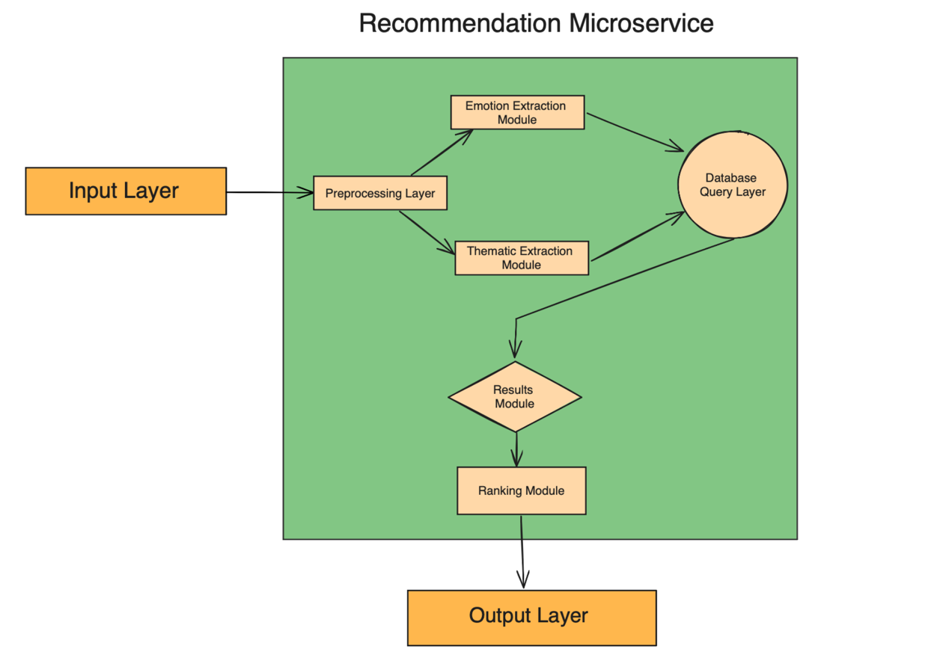
Figure 3:

