TASK 1: Python File Handling & Automation

Student Details
Name: Shaik Sadik
Course: B.Tech – Computer Science and Engineering
Mail id : postboxnum21@gmail.com
Tools Used: Visual Studio Code (VS Code), Python

Aim
To perform Python file handling and automation operations such as reading, writing, renaming, moving, and deleting files with exception handling.

Procedure
- Created a Python automation file.
- Read data from a text file.
- Wrote processed content into another file.
- Renamed the processed file.
- Moved the file into a folder.
- Deleted temporary files.
- Handled exceptions using try-except.

Program
import os
import shutil
def automate_files():
input_file = "data.txt"
output_file = "processed_data.txt"
renamed_file = "final_report.txt"
target_folder = "archive_folder"
temp_file = "temp_to_delete.txt"
try:
print("Starting file operations...")
if not os.path.exists(input_file):
with open(input_file, "w") as f:
f.write("User ID, Name, Status\n101, Shaik Sadik, Active")
with open(input_file, "r") as f:
content = f.read()
print(f"Read successful. Content: {content}")
with open(output_file, "w") as f:
f.write(f"PROCESSED DATA:\n{content.upper()}")
print(f"Write successful. Created '{output_file}'.")
if os.path.exists(renamed_file):
os.remove(renamed_file)
os.rename(output_file, renamed_file)
print(f"Rename successful: '{output_file}' -> '{renamed_file}'.")
if not os.path.exists(target_folder):
os.makedirs(target_folder)
shutil.move(renamed_file, os.path.join(target_folder, renamed_file))
print(f"Move successful: '{renamed_file}' moved to '{target_folder}'.")
with open(temp_file, "w") as f:
f.write("This file will be deleted.")
if os.path.exists(temp_file):
os.remove(temp_file)
print(f"Delete successful: '{temp_file}' has been removed.")
print("\nAll automation tasks completed successfully!")
except FileNotFoundError:
print("Error: The specified file was not found.")
except PermissionError:
print("Error: You do not have permission to modify these files.")
except Exception as e:
print(f"An unexpected error occurred: {e}")
if __name__ == "__main__":
automate_files()

Screenshots:

1. Folder Structure
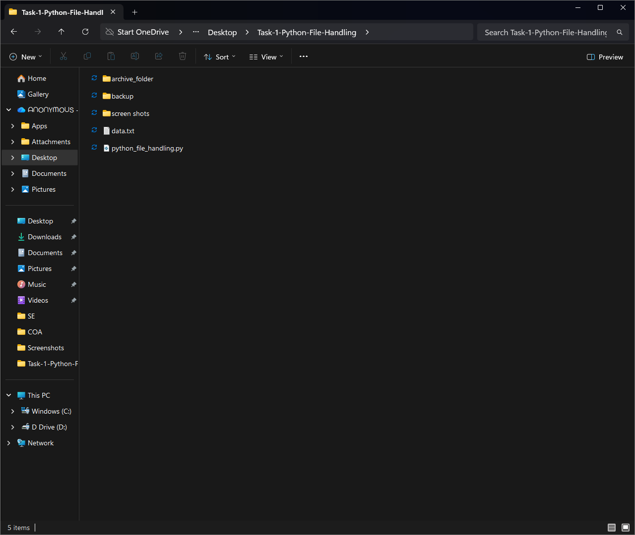

2. Code
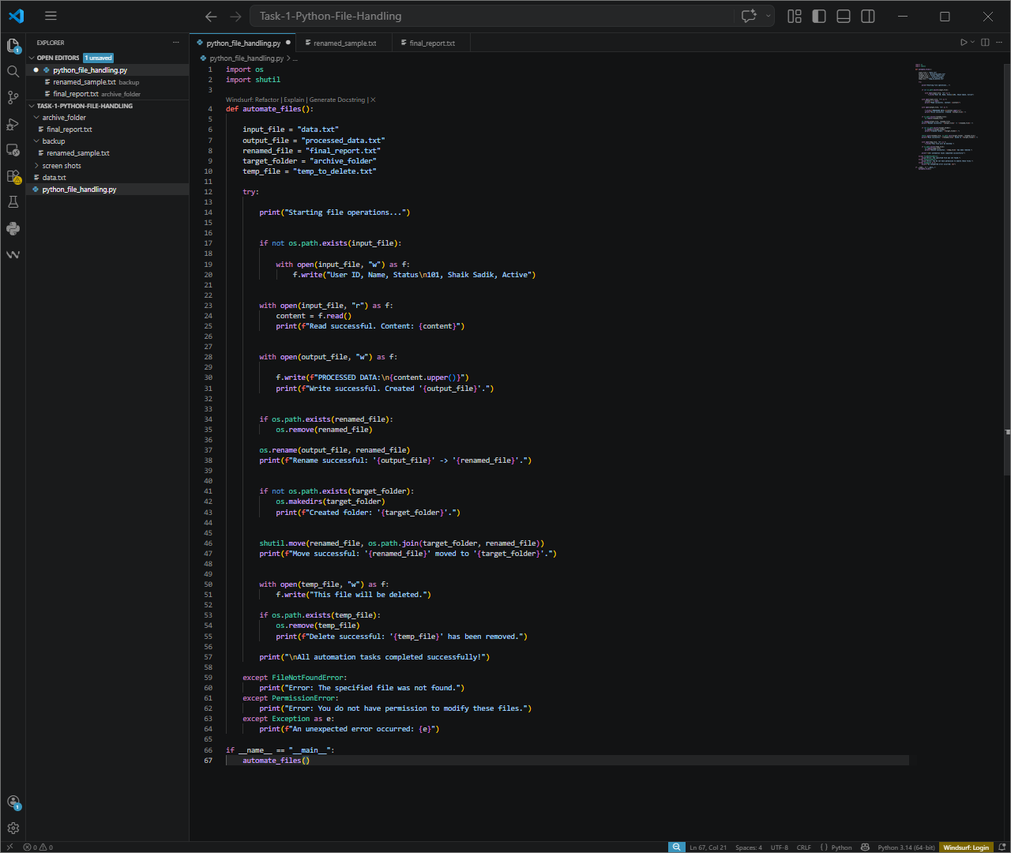
3. Output Screenshot
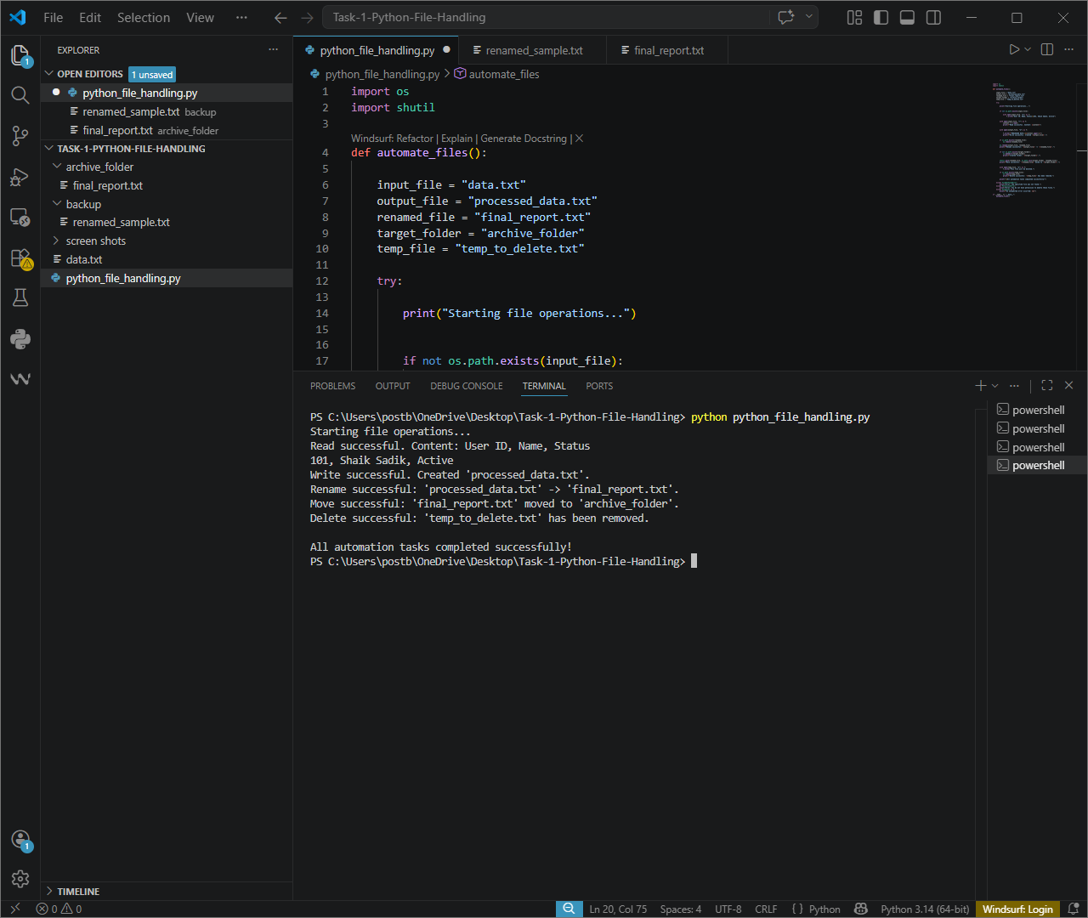

GitHub Link
https://github.com/Sadik-Shaik21/Task-1-Python-File-Handling

LinkedIn Post Link
https://www.linkedin.com/posts/sadik-shaik-83aa1b329_python-programming-automation-ugcPost-7457741496964993025-og3w

Output
The program successfully performs file handling and automation operations including reading, writing, renaming, moving, and deleting files.

