TASK 3: Data Analysis with Pandas

Student Details
Name: Shaik Sadik
Course: B.Tech – Computer Science and Engineering
Tools Used: Python, Pandas, VS Code

Aim
To perform data analysis using Pandas by loading and analyzing a CSV dataset.

Procedure
- Created student CSV dataset.
- Installed Pandas library.
- Loaded CSV data using Pandas.
- Performed filtering and grouping.
- Calculated average and highest marks.
- Generated insights from dataset.

Program
import pandas as pd
data = pd.read_csv("student_data.csv")
print("\n========== STUDENT DATASET ==========")
print(data)
print("\n========== MISSING VALUES ==========")
print(data.isnull().sum())
average_marks = data["Marks"].mean()
print("\n========== CLASS ANALYSIS ==========")
print(f"Average Marks : {average_marks}")
highest_marks = data["Marks"].max()
print(f"Highest Marks : {highest_marks}")
top_students = data[data["Marks"] > 85]
print("\n========== TOP PERFORMERS ==========")
print(top_students)
department_group = data.groupby("Department")["Marks"].mean()
print("\n========== DEPARTMENT ANALYSIS ==========")
print(department_group)
print("\n========== INSIGHTS ==========")
print("1. Average class performance is good.")
print("2. Students scoring above 85 are top performers.")
print("3. CSE department students performed well.")
print("4. Data analysis completed successfully.")

Screenshots
1. Folder Structure
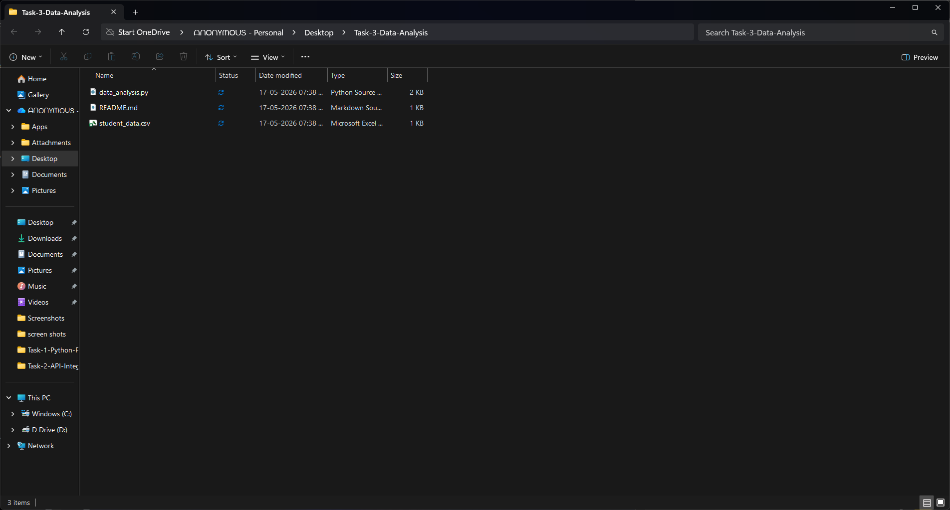

2. CSV Dataset
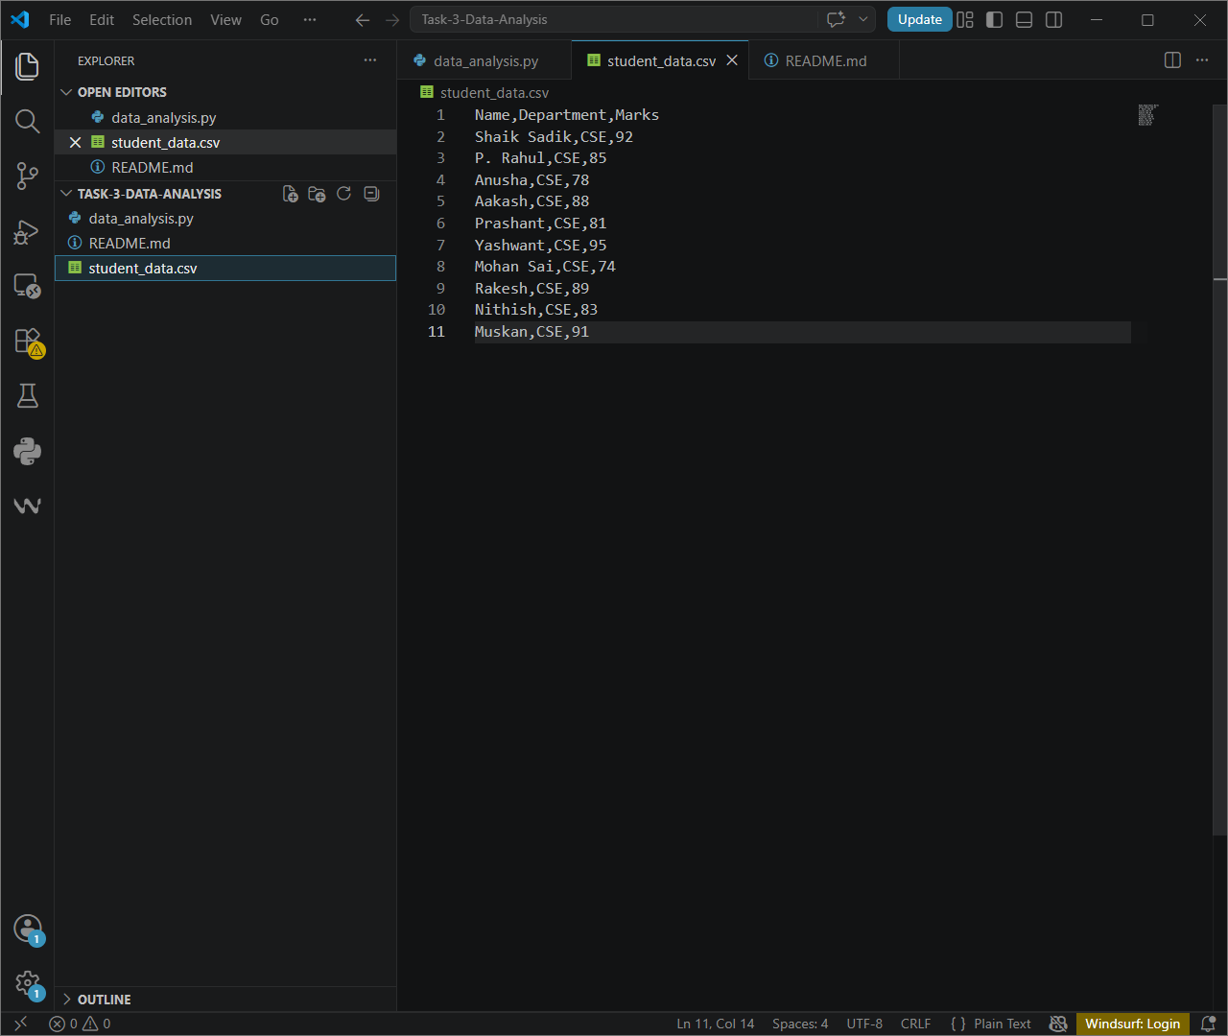

3. Python Code
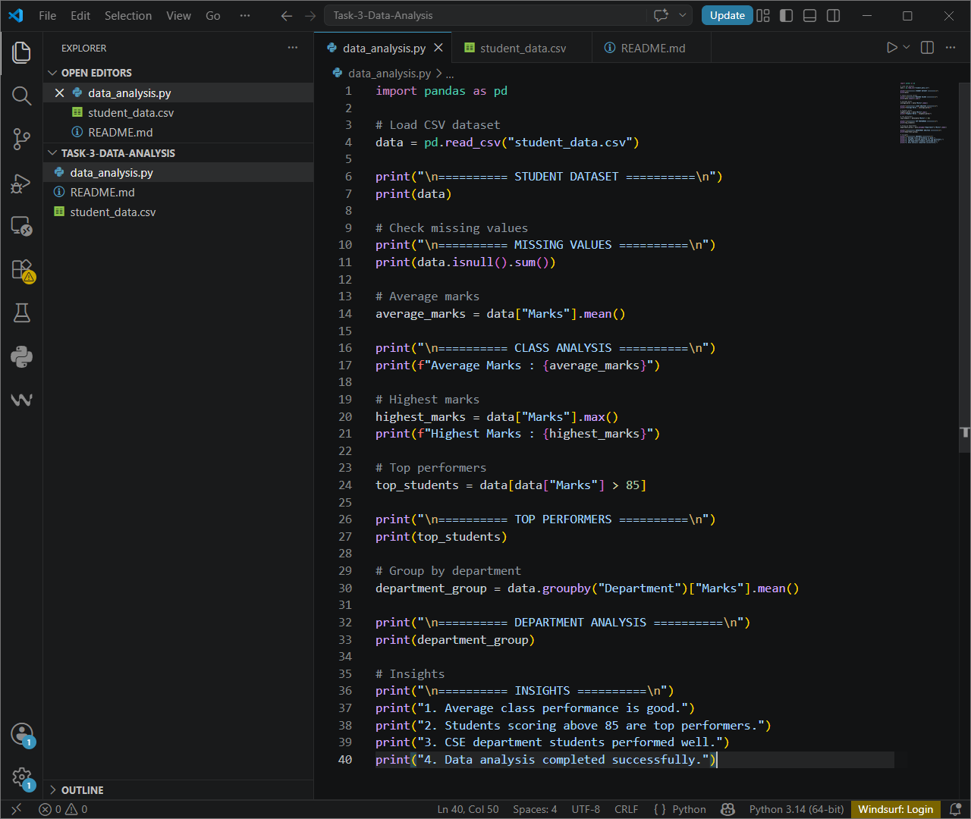

4. Program Output
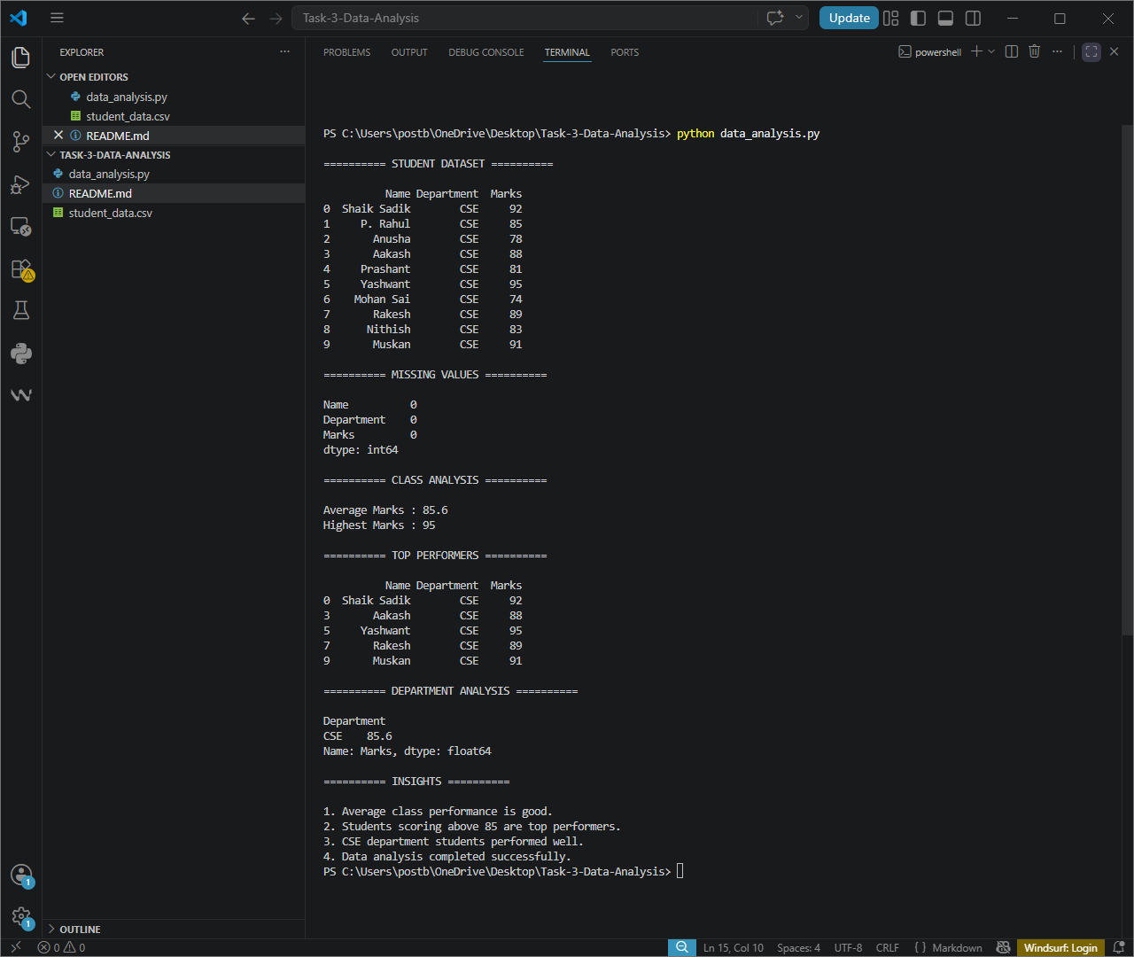

Output Summary
The program successfully analyzed student data using Pandas and generated insights.

