Final Term Project Report
Programming in Python - Summer 25-26
Project Title | Phishing Website Detection
Group Members | Kutub Ullah Sadik (25-62148-2), Md Imdadul Haque Bhuiyan (25-62768-2), Md Musfiqur Rahman Anik (25-63022-2), Abdullah Al Abir (25-62895-2)
Course / Section | Programming In Python [Sec: D]
Instructor | (MD. TANZEEM RAHAT)
Date of Submission | (9/12/2026)

1. What is this project about
Our project is trying to guess if a website is a phishing site or a legit site. We are not looking at the actual website page, we are just looking at 30 features about the url/site structure, like if the url too long, does it use https, does it have weird stuff like @ symbol in it.
We used a dataset we found online that already has these features and also tells us if the site was phishing or not, so this is basically a classification problem (2 classes only, phishing or legit).

2. Why we picked this topic
We are from cncs department and have interest in cybersecurity so we wanted something that is actually related to security instead of just doing normal stuff like predicting goods prices or student marks. Phishing detection felt like a good real world problem because its something that actually matters, people fall for phishing links these days so yes.
What we want to answer: can we tell if a url is phishing just from its structure, without needing to check the actual page content.

3. Dataset
We got the dataset from OpenML / UCI, its called "PhishingWebsites". Its a public dataset so anyone can use it for learning/research, no privacy issue since it doesnt have any personal user data, its just about url structure.
It has 11,055 rows and 30 feature columns, plus 1 target column called Result. Result is -1 for phishing and 1 for legit.
Full list of all 30 columns and what they roughly mean (based on the OpenML/UCI dataset docs):
Column | What it roughly means
having_IP_Address | if the url uses a raw ip address instead of a normal domain name
URL_Length | checks if the url is too long or not
Shortining_Service | if a url-shortening service (like bit.ly) was used
having_At_Symbol | if the url has an '@' symbol in it (used to hide the real destination)
double_slash_redirecting | if '//' shows up later in the url path, could mean a redirect
Prefix_Suffix | if the domain name has a '-' in it (common in fake/spoofed domains)
having_Sub_Domain | how many sub domains the url has
SSLfinal_State | if the site has a proper/trusted ssl certificate
Domain_registeration_length | if the domain was only registered for a short time (phishing domains usually dont last long)
Favicon | if the little site icon (favicon) is loaded from a different domain than the page itself
port | if the url uses a weird/non-standard port number
HTTPS_token | if the word 'https' is stuffed into the domain part itself just to look legit
Request_URL | if images/scripts on the page are loaded from a different domain
URL_of_Anchor | if the links on the page point somewhere totally different than the page's own domain
Links_in_tags | if meta/script/link tags point to external domains
SFH | if the form on the page submits to a blank or weird destination (Server Form Handler)
Submitting_to_email | if the page tries to submit form data straight to an email instead of a server
Abnormal_URL | if the url doesnt match the domain's real registration info
Redirect | how many times the page redirects before actually loading
on_mouseover | if the status bar text changes when you hover over a link (used to trick people)
RightClick | if right-click is disabled on the page (so you cant easily view source)
popUpWidnow | if the page pops up windows asking for info
Iframe | if the page uses hidden/invisible iframes
age_of_domain | if the domain is older or newer than a certain point
DNSRecord | if the domain actually has a valid DNS record
web_traffic | if the site gets a meaningful amount of traffic
Page_Rank | the site's google page rank value
Google_Index | if the site is actually indexed by google
Links_pointing_to_page | how many other pages/sites link to this page
Statistical_report | if the domain shows up on known phishing blacklists

4. Checking the data (data audit)
Before doing anything we checked the data first:
- 0 missing values found in any column
- 5,206 duplicate rows found and removed (out of 11,055 total rows) . almost half is out so it was worth flagging before splitting
- we also added a check that every feature column only has -1, 0 or 1 in it (so no impossible/weird values get in) every one of the 30 feature columns only contained those 3 values
- Result column is fairly balanced, not like 90% one side: 6,157 legit (1) vs 4,898 phishing (-1), roughly 56%/44%
We also made 2 graphs. First graph shows the count of phishing vs legit rows, which confirmed its balanced:
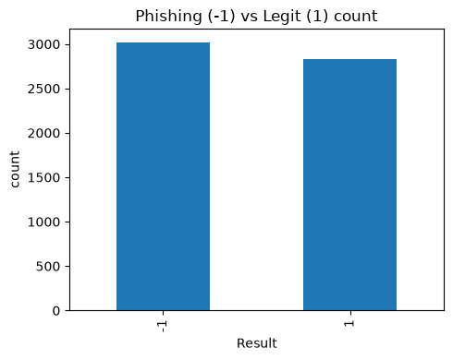
Second graph shows SSLfinal_State against Result, and from that we could kind of see that most legit sites (Result=1) have a proper ssl (SSLfinal_State=1), while most phishing ones have SSLfinal_State = -1 or 0, so this feature looked useful even before we built any model:
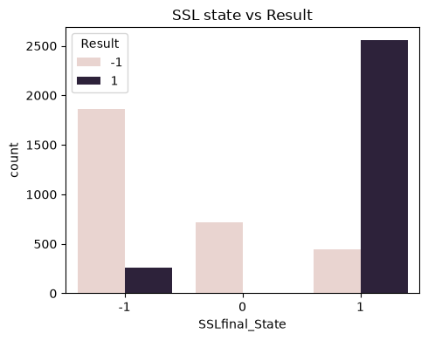
Both graphs and the data dictionary starter file get saved automatically into the outputs/ folder when the notebook runs.

5. How we split and prepared the data
We split the data 80% train and 20% test, using stratify so both sets have the same ratio of phishing/legit like the original data.
For scaling we used StandardScaler, but we put it inside a Pipeline together with the KNN model. We did this so that the scaler only learns from the training data, not the test data, otherwise that would be data leakage which is not allowed.

6. Our baseline model
Before making any real model we made a baseline using DummyClassifier, it just always guesses the most common class (legit in our case) no matter what the input is. This gave us something to compare our real models against. If our knn models cant beat this then somethings wrong.
Baseline accuracy on train data: 0.5161. On the untouched test set it scored 0.516 accuracy too, with 0.00 recall on the phishing class (-1) since it never predicts anything except the majority class this is exactly the number our real models needed to beat.

7. Our models - KNN (2 versions)
We used K-Nearest Neighbors (KNN). Knn looks at the closest k points to a new data point and takes a vote from them to decide the class.
Since knn works using distance between points, we had to scale the features first, otherwise columns with bigger number ranges would unfairly affect the distance calculation more than others.
Our project needed at least 2 models to compare, so we made 2 versions of knn.
- Version 1 - normal knn (uniform weights): every one of the k nearest neighbors gets an equal vote
- Version 2 - distance-weighted knn: neighbors that are closer get a bigger vote than ones that are farther, this is also something our handout showed
For each version we tried a few different k values (3, 5, 7, 9, 11, 15) and used 5-fold cross validation each time, then picked whichever k gave the best f1 score on average for that version:
- Uniform KNN: k=3 = 0.909, k=5 = 0.918, k=7 = 0.916, k=9 = 0.920, k=11 = 0.916, k=15 0.916. Best k = 9.
- Distance-weighted KNN: k=3 = 0.906, k=5 = 0.914, k=7 0.911, k=9 = 0.915, k=11 = 0.915, k=15 = 0.914. Best k = 9.
So both versions ended up picking k=9 as their best value based on actual cross-validation testing.

8. Results
After training both final knn versions with their best k, we tested everything 1 time on the test set (1,170 rows we never touched before this). The handout also computes ROC-AUC for each model, and saves everything into outputs/model_comparison.csv automatically:
model | accuracy | precision_-1 | recall_-1 | f1_-1 | precision_1 | recall_1 | f1_1 | roc_auc
Dummy baseline | 0.516 | 0.516 | 1.000 | 0.681 | 0.000 | 0.000 | 0.000 | 0.500
KNN uniform | 0.923 | 0.912 | 0.942 | 0.927 | 0.936 | 0.903 | 0.919 | 0.975
KNN distance-weighted | 0.917 | 0.907 | 0.935 | 0.921 | 0.929 | 0.898 | 0.913 | 0.958

Confusion matrices from the test set:
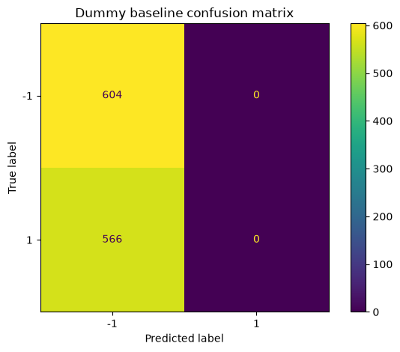
Dummy baseline: predicts every single row as class -1 (the majority in the raw pre-dedup data), so it misses all 566 actual legit rows and gets 0 right on class 1.
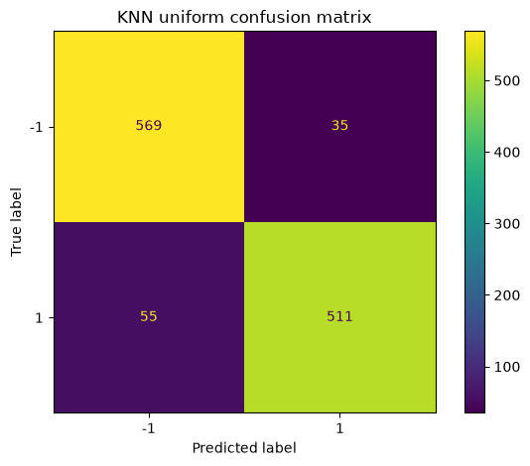
KNN uniform: 569 correct on class -1, 511 correct on class 1, only 35 false negatives and 55 false positives.
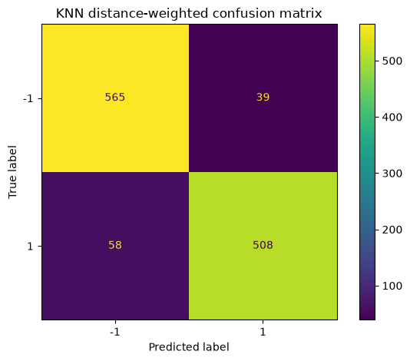
KNN distance-weighted: 565 correct on class -1, 508 correct on class 1, 39 false negatives and 58 false positives — very slightly worse than the uniform version across the board.
Both knn versions do way better than the dummy baseline in catching phishing sites (0.923/0.917 accuracy vs 0.516). Between the two knn versions, KNN uniform is very slightly better on every single metric accuracy (0.923 vs 0.917), recall on the phishing class (0.942 vs 0.935), and ROC-AUC (0.975 vs 0.958). So giving closer neighbors more voting power didn't actually help here the simpler uniform version won.

9. Problems we noticed
- dataset might not have very recent phishing tricks since its an old published dataset
- we are assuming the labels (-1/1) were correctly given when the dataset was made, we cant double check that ourselves
- this model only looks at url structure, so a phishing attempt that comes through email text with a normal-looking link would probably not get caught by this
- almost half our raw data (5,206 out of 11,055 rows) was duplicate rows — worth noting as a real data quality issue with this dataset, not just something to silently drop
- so this should be used as like a warning/helper tool, not the only line of defense

10. How to run our code
Everything is in the phishing_project.ipynb file. Just open and run all cells from top to bottom (restart kernel first so old variables dont mess things up). Needs internet the first time because it downloads the dataset.
We used random_state = 42 everywhere (splitting and cross validation) so if you run it again you should get the same results. Running the notebook also auto-creates an outputs/ folder (plots, comparison table, data dictionary starter csv) and a data/ folder (raw copy of the dataset) — these get regenerated fresh every time you run it.
Python: 3.13.14, scikit-learn: 1.9.0, pandas: 3.0.5.

11. Conclusion
Overall we think knn worked decently well for this task, way better than just guessing. Comparing the uniform vs distance-weighted version helped us see if giving closer neighbors more say actually changes the result or not turns out it didn't help, uniform voting was just as good or slightly better.
We'd go with KNN uniform (k=9) as our final model. The metric that decided it is recall on the phishing class: 0.942 for uniform vs 0.935 for distance-weighted. Since missing an actual phishing site is worse than a false alarm on a legit one, the version that catches slightly more phishing sites is the better pick, and it also happens to win on every other metric too (accuracy, ROC-AUC).
Also we want to be clear that this tool should only be used to warn people, not to fully block sites on its own, because it can still be wrong sometimes (about 5-6% of legit sites still got flagged as phishing in our test).

12. Who did what
Member | work
Kutub Ullah Sadik (25-62148-2) | both KNN models (uniform + distance-weighted) + k-tuning via cross-validation
Md Imdadul Haque Bhuiyan (25-62768-2) | data loading + checking the data + both EDA graphs
Md Musfiqur Rahman Anik (25-63022-2) | train/test split + baseline model
Abdullah Al Abir (25-62895-2) | final evaluation, confusion matrices, comparison table + writing conclusion

13. Where we got the dataset from
UCI Machine Learning Repository / OpenML, dataset name: PhishingWebsites (openml id 4534).
Source: https://www.openml.org/search?type=data&status=active&id=4534

