| **CSE331.4 Group-2 (Spring 2022)** | | | | | |
| --- | --- | --- | --- | --- | --- |
| **Arduino Uno Total Power Consumption with LED** | | | | | |
| **Input Logic** | **Output Logic** | **Current (mA)** | **Avg. Current (mA)** | **Ref. Voltage (V)** | **Power (mW)** |
| 0000 | 0000 | 57.9 | 57.87 | 5.0 | 289.35 |
| 58.3 |
| 57.4 |
| 0001 | 0001 | 52.9 | 52.93 | 5.0 | 264.65 |
| 53.0 |
| 52.9 |
| 0010 | 1011 | 61.3 | 60.92 | 5.0 | 304.6 |
| 60.9 |
| 60.5 |
| 0011 | 1011 | 61.1 | 60.9 | 5.0 | 304.5 |
| 61.0 |
| 60.6 |
| 0100 | 0101 | 52.5 | 54.17 | 5.0 | 270.85 |
| 54.5 |
| 55.5 |
| 0101 | 0100 | 52.1 | 51.8 | 5.0 | 259 |
| 51.8 |
| 51.5 |
| 0110 | 1011 | 59.8 | 56.6 | 5.0 | 283 |
| 59.5 |
| 59.1 |
| 0111 | 0101 | 56.8 | 54.43 | 5.0 | 272.15 |
| 56.5 |
| 55.9 |
| 1000 | 0011 | 55.6 | 55.03 | 5.0 | 275.15 |
| 55.2 |
| 54.3 |
| 1001 | 1011 | 58.9 | 57.7 | 5.0 | 288.5 |
| 57.2 |
| 57.0 |
| 1010 | 1101 | 59.0 | 58.5 | 5.0 | 292.5 |
| 58.3 |
| 58.2 |
| 1011 | 1100 | 55.7 | 55.46 | 5.0 | 277.3 |
| 55.5 |
| 55.2 |
| 1100 | 0000 | 42.0 | 42.56 | 5.0 | 212.8 |
| 42.9 |
| 42.8 |
| 1101 | 0110 | 58.0 | 57.63 | 5.0 | 288.15 |
| 57.4 |
| 57.5 |
| 1110 | 0000 | 43.0 | 42.86 | 5.0 | 214.3 |
| 42.9 |
| 42.7 |
| 1111 | 1100 | 55.9 | 55.27 | 5.0 | 276.35 |
| 55.7 |
| 54.2 |

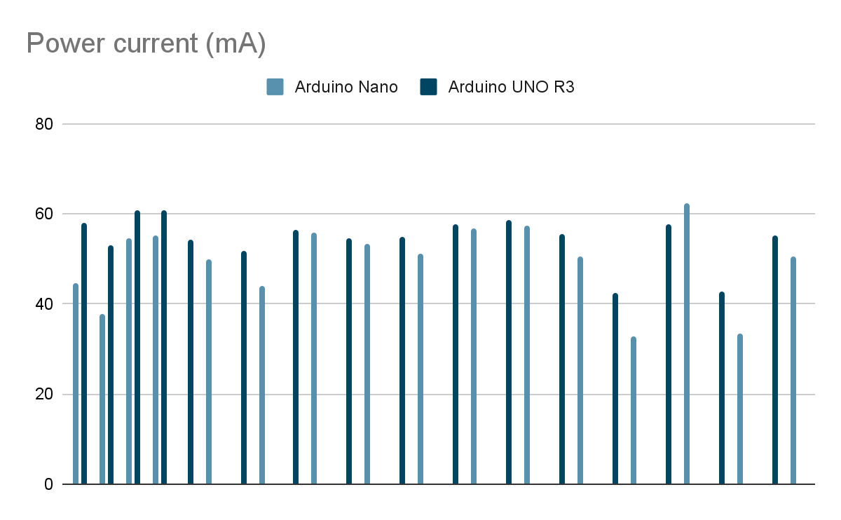

*Table: Total System Current with LEDs Consumption Comparison between the Arduino UNO and Arduino Nano.*