IAM role created for Lambda function

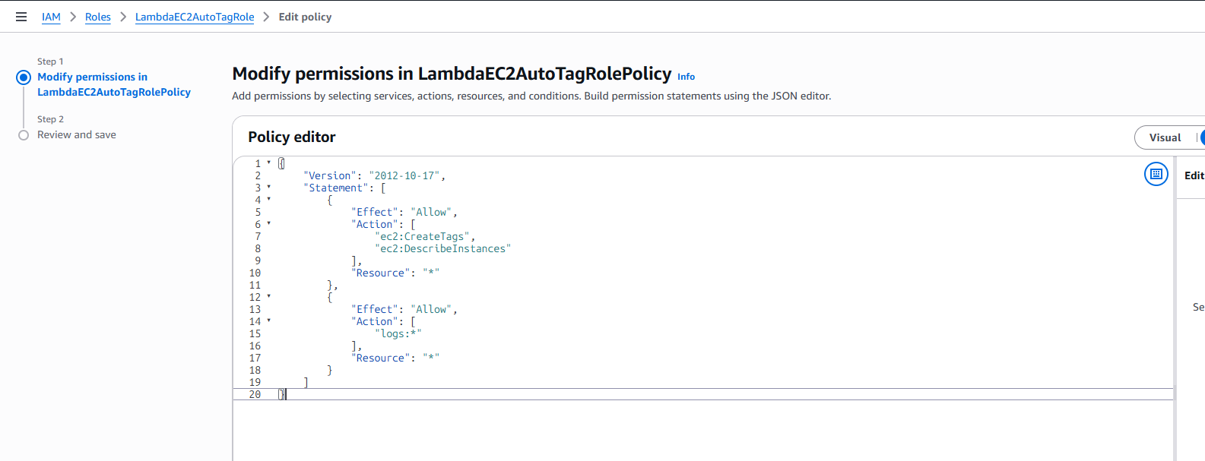

Lambda is created to automate the tagging process

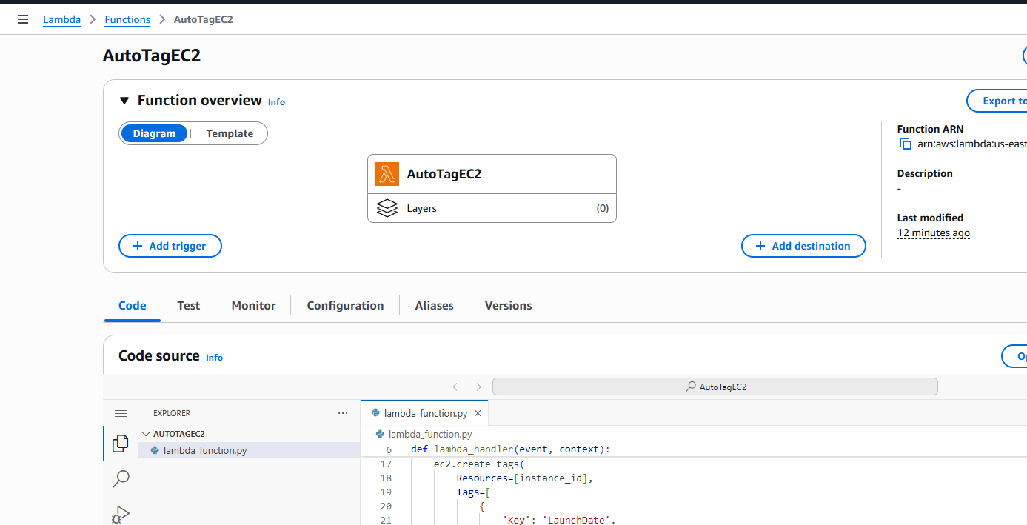

Amazon Event bridge rule is created to trigger the Lambda to create the tags

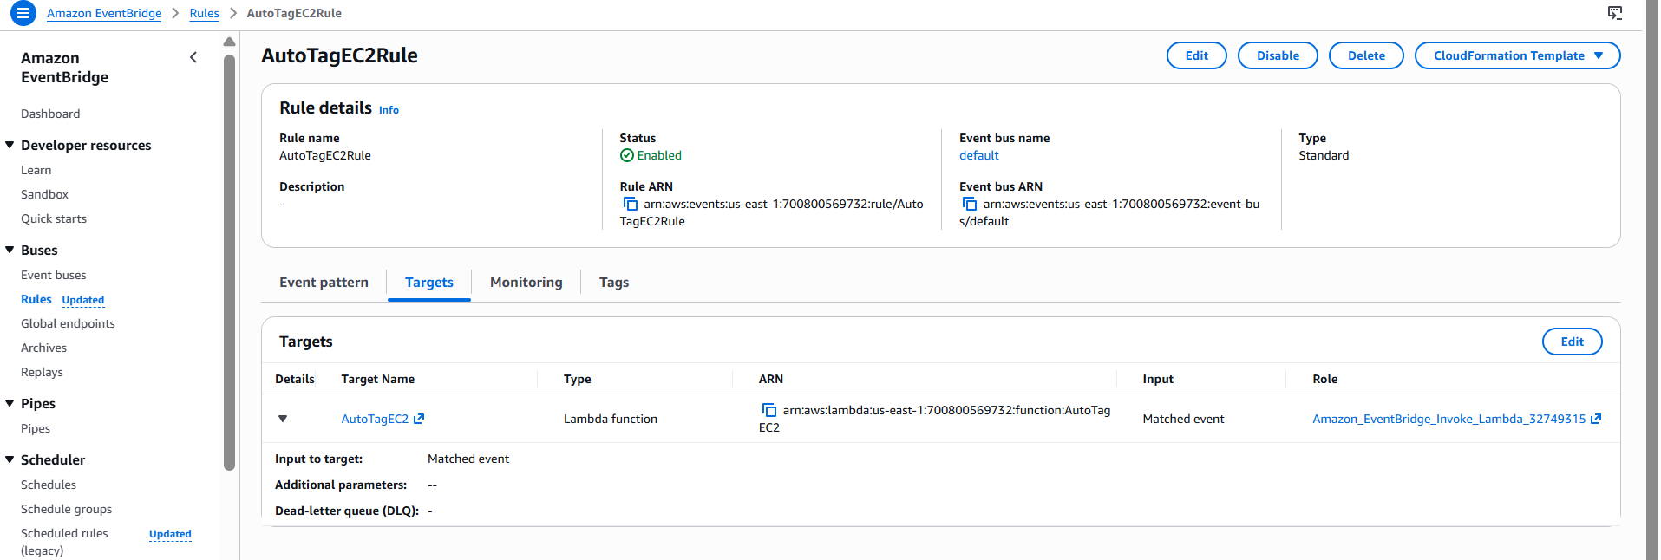

I have created the EC2 instant and once EC2 is in running state automatically Tags are created

