Created the S3 bucket and uploaded the 3 files added first two files at the same time and third file added with gap of 3 munities. If I run the Lamda function app it has to clean the first two files only.

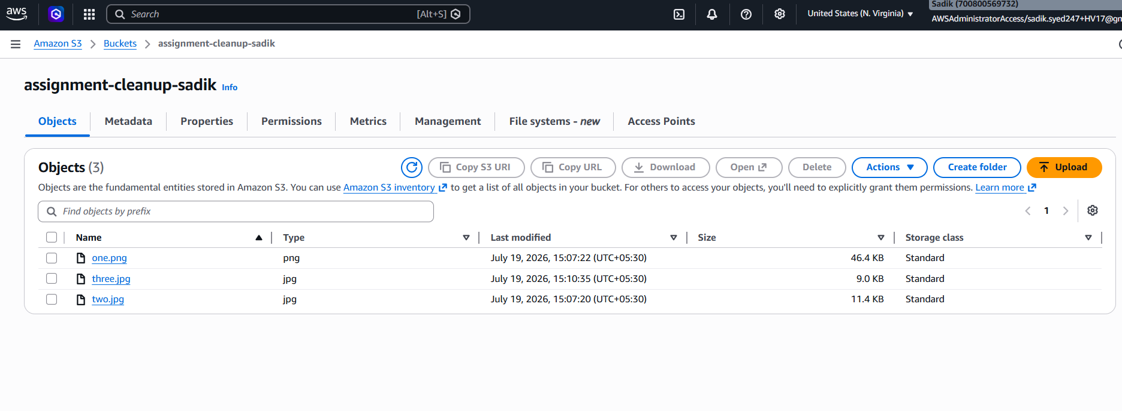
After execution of Lamda function

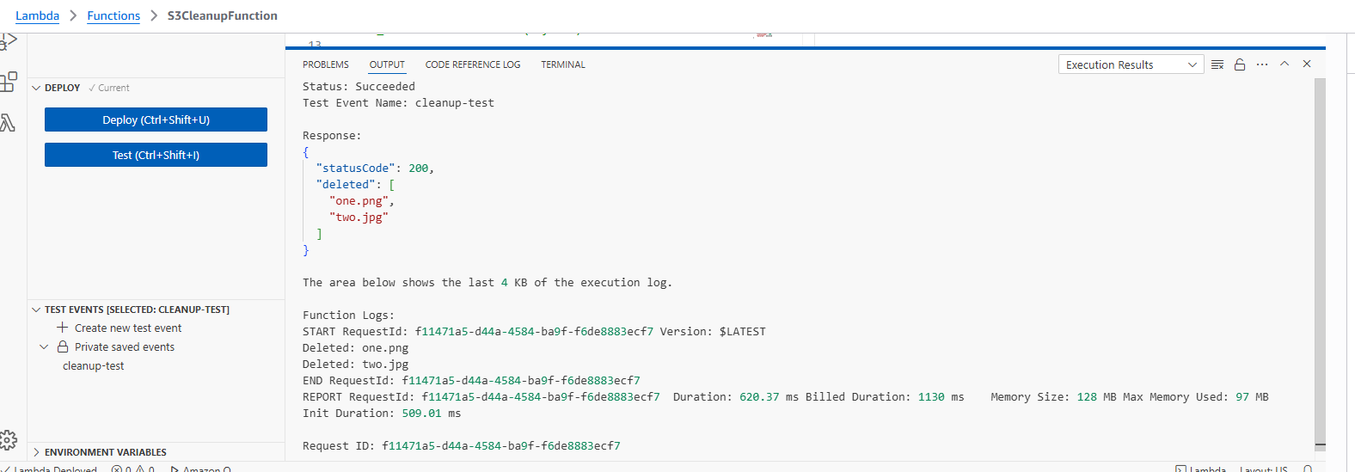

Output of s2 bucket, after Lamda function app execution
