Created the Ec2 and copied the volume ID
Volume ID - vol-0b8ba40cd11adb03c
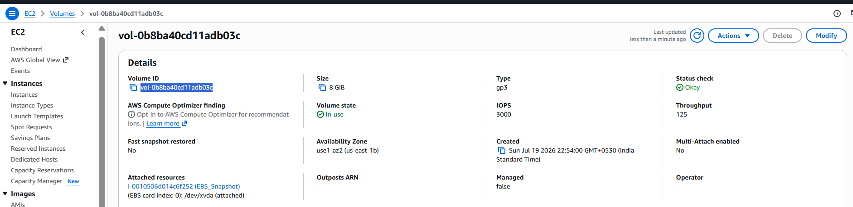
Created a IAM and created a role and add the policy for EC2 snapshot actions.
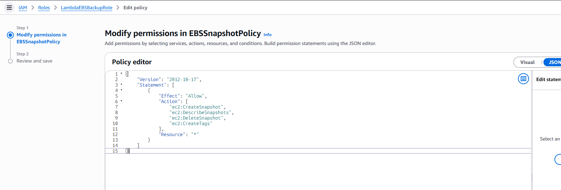
Created the Lambda Function and assigned the custom role created by us to operate the EC2 snapshot actions
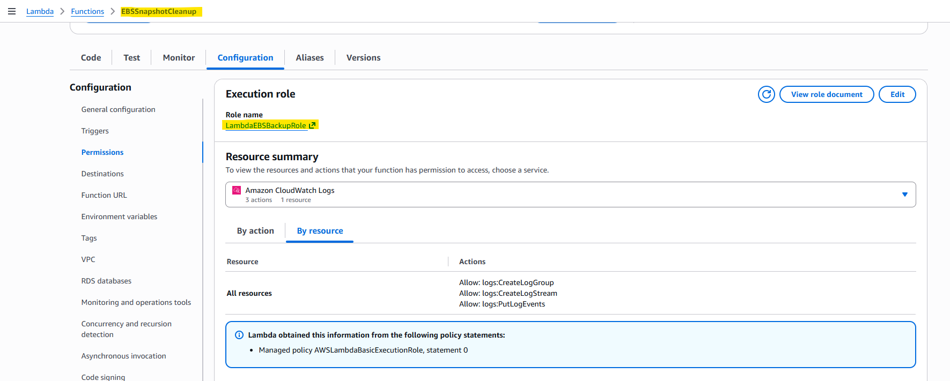
Output of Lambda and snapshot is created
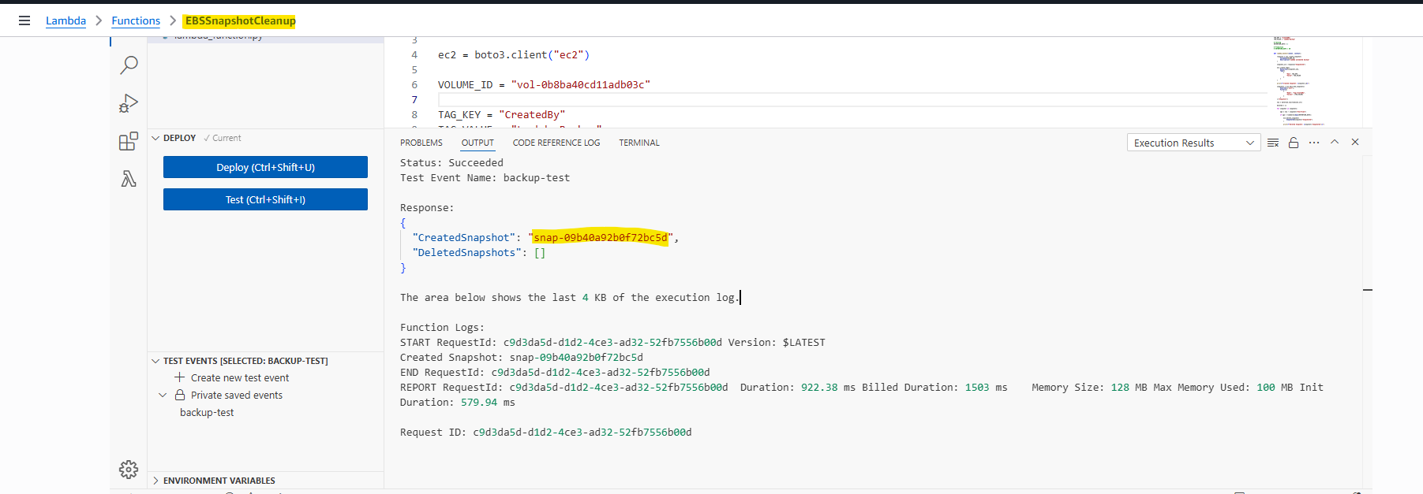
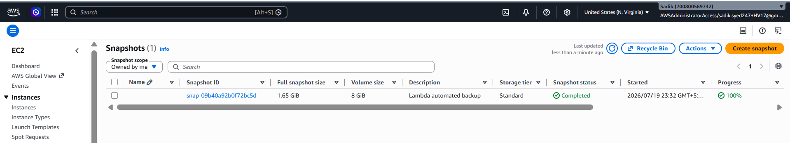
I have executed the Lambda function to check the deletion output for that I have changed the
RETENTION_DAYS=0
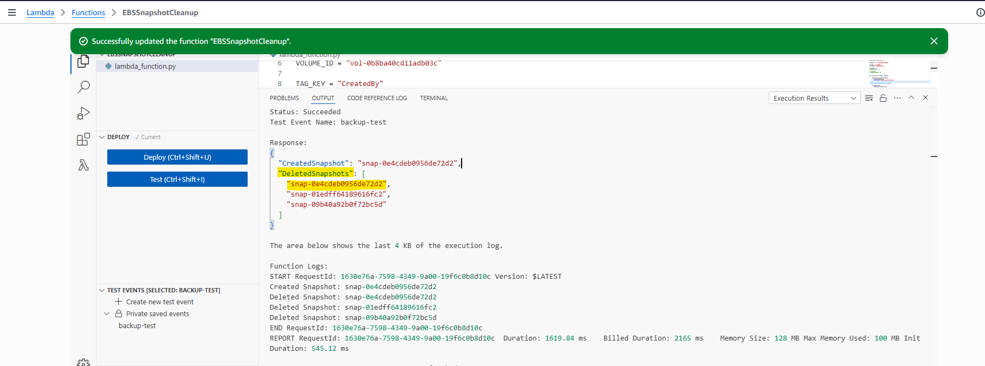
I have created the Amazon Event Bridge to schedule the lambda function trigger automatically to take the snapshot backup, for testing I have updated I have scheduled for every 2 minutes and I am able to see the snapshots are created for every 2 minutes as per below screenshot
