

**Ahsanullah University of Science & Technology Department of Computer Science & Engineering Semester Spring 2024**

**CSE 3118**

**Microprocessors and Microcontrollers Lab**

Project Name: Hydro-Vigilance System

**Submitted To,**

**Ms. Lomat Haider Chowdhury**

Assistant Professor, CSE, AUST

**Mr. Kazi Toufique Elahi**

Lecturer, CSE, AUST

**Submitted By,**

**Sadik Rahman**

ID: 20220104104

**Zawad Al Mahi**

ID: 20220104120

**Abdullah Al Jubair**

ID: 20220104123

**Hasibur Rahman Srijon**

ID: 20220104124

**Lab Group: C1**

# **Table of Contents**

Introduction 3

Objective 3

Safety Norms and Environmental Values 3

Required Components 4

Product Description 4

Estimated Budget 5

User-Friendly Design and Possible Stakeholders 5

Durability and Maintenance 6

Diverse Applications 6

Expected Outcomes 6

Future Improvements 7

Conclusion 7

# **Introduction**

The Hydro-Vigilance System is a monitoring and alert system for water levels, aimed at improving safety, preventing water-related risks, and supporting environmental sustainability. This initiative merges innovative design with affordable solutions to tackle water management issues in different areas, such as maritime safety, agriculture, and smart home technologies.

# **Objective**

The Hydro-Vigilance System includes:

- Monitoring water levels to detect leaks or dangerous situations.

- Using colored lights to clearly show water levels.

- Triggering loud alarms in emergencies to alert users.

- Giving real-time updates and monitoring of water levels.

- Enhancing safety with early warnings for water-related risks.

- Designed to be user-friendly with a simple layout.

-Aiming to reduce environmental damage and save money by enabling quick responses.

# **Safety Norms and Environmental Values**

* **Shipwreck Prevention:** Real-time water leak detection will prevent extensive damage which could lead to a shipwreck.
* **System for Life Saving:** Gives timely warnings to passengers and crew members, improving onboard safety.
* **Economic Benefit:** Prevents cargo loss and shipping damage; cash saved.
* **Protects the Environment:** No oil leaks, no shipwrecks, and protects our oceans.
* **Promotes Environmentally-friendly Practices:** Works in tandem with active safety measures to mitigate environmental disasters.
* Improves Long-Term Marine Ecosystem

**Safety Norms and Environmental Impact**

* **Safety Norms**:

1. To guarantee dependability and efficiency in identifying and warning of water-related hazards, the system complies with strict safety regulations.
2. Complies with maritime safety regulations.
3. Meets standards for electronic monitoring systems.

* **Environmental Impact**:
  1. Prevents the sinking of ships by indicating threats at the initial stage.
  2. Allows ship crews to take proper initiatives to repair the damage in time.
  3. Saves many lives.
  4. Prevents ship parts from drowning in the sea, especially oil cargos.
  5. Reduces pollution of seawater, affecting the ocean ecosystem.
  6. Integrates information on where the leakage has occurred.

# **Required Components**

|  |  |  |
| --- | --- | --- |
| Component | Quantity | Description |
| Arduino Uno R3 | 1 | Microcontroller for system control |
| Breadboard | 2 | For circuit assembly and connections |
| Small LEDs | 8 | Visual indicators for water levels |
| YL-44 Buzzer | 1 | Audible alarm for critical situations |
| Water Sensors | 5 | Detects water presence and levels |
| Jumper Wires | 3 sets | Connects components on the breadboard |

# **Product Description**

1. **Water Detection Sensors:**
   * Sensors are installed in ship compartments to detect water levels.
   * Each sensor sends electrical signals based on the water level detected.
2. **Color-Coded Indicators:**
   * **Green Light:** Normal water levels, no immediate action needed.
   * **Yellow Light:** Moderate water levels, signaling a cautionary alert.
   * **Red Light:** High water levels, indicating critical danger.
3. **Buzzer Activation:**
   * When the water level reaches extreme thresholds, the buzzer sounds to warn the crew immediately.
4. **Real-Time Monitoring:**
   * Continuously updates water level data for proactive safety measures.
5. **Ease of Repair:**
   * The system pinpoints the exact location of leaks, enabling quick repairs.

# **Block Diagram**

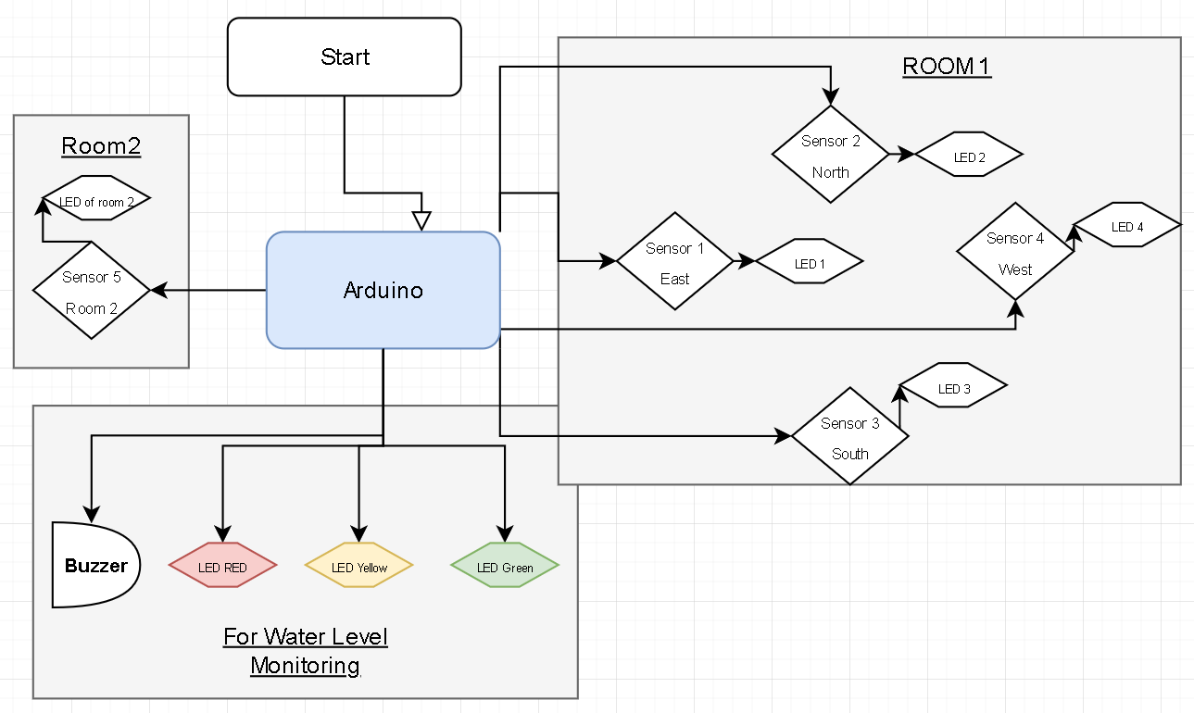

# **Circuit Diagram**

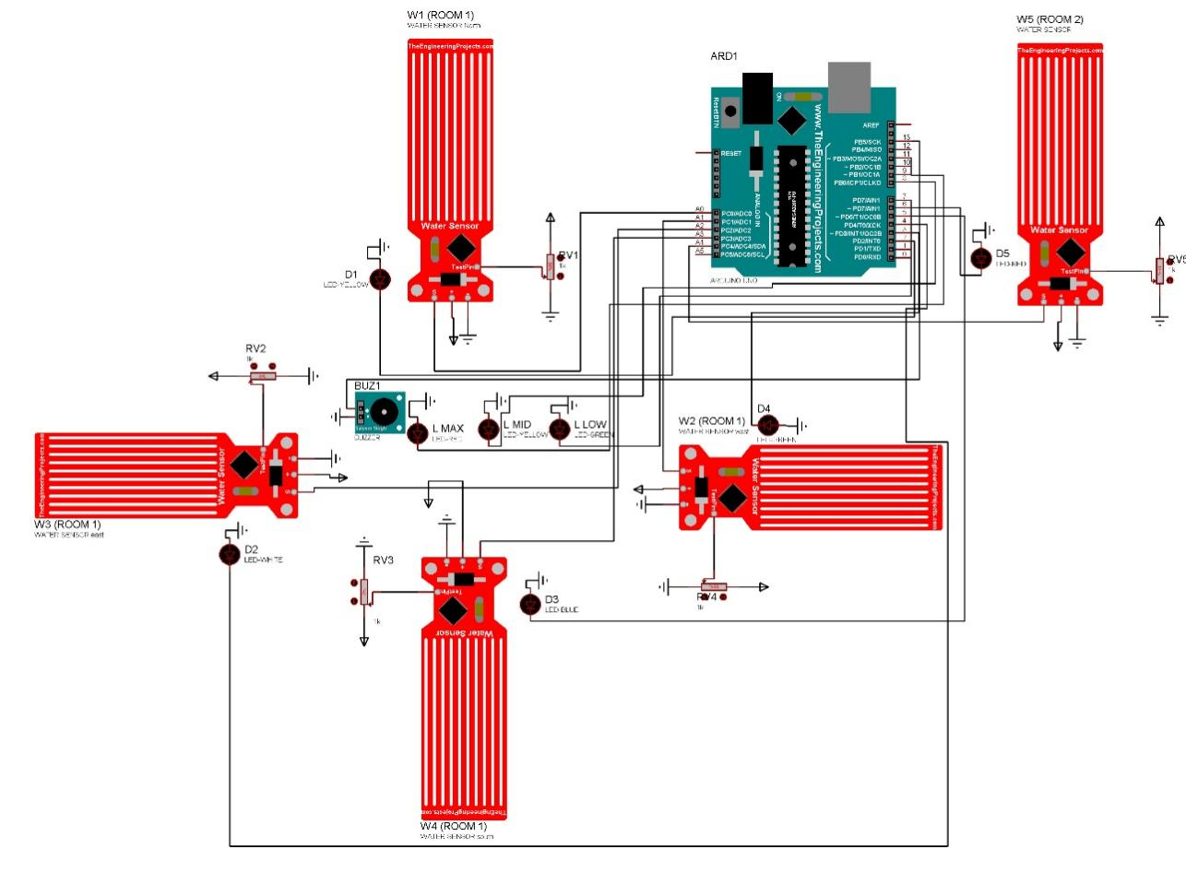

# **Estimated Budget**

|  |  |  |
| --- | --- | --- |
| **Component** | **Quantity** | **Estimated Price (BDT)** |
| Arduino Uno R3 | 1 | 600 |
| Breadboard | 3 | 240 |
| LEDs | 8 | 40 |
| YL-44 Buzzer | 1 | 20 |
| Water Level Sensors | 5 | 250 |
| Jumper Wires | 5 sets | 150 |
| **Total Estimated Cost** |  | **1,300 BDT** |

*Note: Costs may vary depending on the number of rooms or size of the ship.*

# **User-Friendly Design and Possible Stakeholders**

**Intuitive Operation:**

* Simple visual cues through LEDs.
* Audible alerts via a buzzer for critical warnings.

**Minimal Setup:**

* Plug-and-play components ensure quick assembly.
* Modular design for easy integration into various ship sizes.

**Compact and Portable:**

* Lightweight and easy to transport.
* Small form factor for seamless installation.

**Low Maintenance:**

* Durable components reduce repair costs.
* Regular inspections ensure consistent functionality.

**Possible Stakeholders or Beneficiaries**

* Maritime operators
* Environmental agencies
* Homeowners
* Agricultural communities

# **Durability and Maintenance**

**Maintenance Considerations:**

1. Conduct regular inspections for loose connections.
2. Replace affordable components like LEDs and sensors periodically.
3. Use protective enclosures for sensitive electronics to prevent damage from moisture or dust.

# **Diverse Applications**

1. **Flood Monitoring:** Early warning system in flood-prone areas.
2. **Marine Applications:** Ensures safety by monitoring ship compartments.
3. **Swimming Pool Management:** Maintains optimal water levels.
4. **Smart Home Integration:** Automates water management for household use.
5. **Aquarium Maintenance:** Supports aquatic life by managing water levels.
6. **Agriculture:** Improves irrigation efficiency and crop yields.

**Societal and Economical Issues and Mitigation Strategy**

* **Issues**:
* Cost of implementation.
* Maintenance requirements.
* Ensuring the system's reliability in harsh environments.
* **Mitigation Strategy**:
* Regular inspections.
* Using durable components.
* Providing training for users to ensure proper operation and maintenance.

# **Expected Outcomes**

• Increased security in areas involving water.

• Reduced damage from water.

• A more sustainable environment.

• A lower chance of marine catastrophes.

• Better water management efficiency.

• Water leak detection and prevention at an early stage.

• Financial savings by prompt repair and intervention.

• Improved shipboard safety for both crew and passengers.

• Less pollution of the environment from ship debris and oil spills.

**Future Improvements**

1. **IoT Integration:**
   * Enables real-time alerts via smartphone notifications.
   * Allows remote monitoring of water levels.
2. **Advanced Sensors:**
   * More precise detection of water levels.
   * Resistance to saline or polluted water.
3. **Solar Power Option:**
   * Makes the system eco-friendly and suitable for off-grid operations.
4. **AI Algorithms:**
   * Predicts water level trends for proactive safety measures.
   * Enhances decision-making for emergency protocols.
5. **Weather Data Synchronization:**
   * Integrates with weather forecasting systems for flood monitoring.

# **Conclusion**

The Hydro-Vigilance System is a flexible and affordable way to control water level. Its uses in homes, businesses, and agriculture guarantee efficiency, safety, and real-time monitoring. Future developments like IoT, AI integration, and environmentally friendly solutions will increase its usefulness even more and make it essential for water safety and management.