J.C. Bose University of Science and Technology, YMCA, Faridabad
Affiliated Institution
Satyug Darshan Institute of Engineering & Technology (SDIET), Faridabad
Department of Computer Science & Engineering

Training Report
On
GEODASH – GeoSpatial Intelligence Dashboard with Decision Intelligence Engine (D3E) and Real-Time Communication System

Submitted by
Sadik Khan
Roll No.: 22020004102
B.Tech – Computer Science & Engineering (8th Semester)
Under the Guidance of
Ms. Vaishali
Academic Year: 2024 – 2025

TRAINING COMPLETION CERTIFICATE
(To be attached by the student)

CANDIDATE DECLARATION

I, Sadik Khan (Roll No. 22020004102), hereby declare that the project report entitled "GEODASH – GeoSpatial Intelligence Dashboard with Decision Intelligence Engine (D3E) and Real-Time Communication System" is a record of original work carried out by me under the guidance of Ms. Vaishali in partial fulfillment of the requirements for the award of the degree of Bachelor of Technology in Computer Science & Engineering from Satyug Darshan Institute of Engineering & Technology (SDIET), Faridabad, affiliated to J.C. Bose University of Science and Technology, YMCA, Faridabad.

I further declare that this project has not been submitted either in part or full to any other university or institution for the award of any degree, diploma, or certification.

Date: ___________

Place: Faridabad

Signature of Candidate

Sadik Khan

ACKNOWLEDGEMENT

I would like to express my sincere gratitude to my project guide Ms. Vaishali for her valuable guidance, encouragement, and continuous support throughout the development of this project. Her suggestions and insights helped me understand the technical and practical aspects of software development and GIS systems.

I would also like to thank the faculty members of the Department of Computer Science & Engineering, Satyug Darshan Institute of Engineering & Technology, for providing the necessary resources, infrastructure, and motivation required for successful completion of this project.

I am thankful to my family and friends for their constant encouragement, support, and confidence throughout the project development journey.

Finally, I acknowledge the contribution of the open-source community and technologies such as Next.js, Leaflet, PostgreSQL, MongoDB, Socket.io, WebRTC, and Apache ECharts, which made the development of this project possible.

Sadik Khan
Roll No.: 22020004102
B.Tech – Computer Science & Engineering
SDIET, Faridabad

ABSTRACT

Modern organizations increasingly depend on geographic information and data analytics for decision-making. Traditional information systems often provide static reports and numerical insights without considering the spatial context of the data. This limitation reduces the effectiveness of decision-making processes, especially in areas such as business planning, urban development, infrastructure management, and resource allocation.

The proposed project, GEODASH, is a GeoSpatial Intelligence Dashboard that combines Geographic Information Systems (GIS), Decision Intelligence, Data Visualization, and Real-Time Communication into a single integrated platform. The system enables users to interact with geographic regions through an interactive map interface and analyze area-specific information dynamically.

The platform utilizes viewport-based analytics, meaning the data displayed and analyzed depends on the area currently visible on the map. As users zoom, pan, or navigate to different regions, the system automatically updates analytical insights, charts, and decision metrics. The Decision Intelligence Engine (D3E) evaluates multiple parameters such as population density, crime rate, infrastructure availability, accessibility, and competition to generate suitability scores and recommendations.

In addition to GIS analytics, the system includes a real-time communication module supporting one-to-one messaging, group communication, file sharing, and video conferencing. This allows teams to collaborate and make decisions directly within the platform.

The project is developed using Next.js, Tailwind CSS, Leaflet, PostgreSQL (PostGIS), MongoDB, Socket.io, and WebRTC. The architecture is designed to be modular, scalable, and capable of supporting future enhancements such as AI-based recommendations and predictive analytics.

The primary objective of GEODASH is to transform raw geographic data into actionable insights and support intelligent decision-making through an interactive and user-friendly platform.

TABLE OF CONTENTS

Training Completion Certificate i
Candidate Declaration ii
Acknowledgement iii
Abstract iv
Table of Contents v
Company Profile vi

Chapter 1 – Introduction to Project 1
Chapter 2 – Requirement Analysis (SRS) 12
Chapter 3 – System Design (SDD) 25
Chapter 4 – Modules Implemented by Student 38
Chapter 5 – Database Design & Data Dictionary 52
Chapter 6 – Testing Strategy 65
Chapter 7 – GUI Snapshots 78
Chapter 8 – Conclusion & Future Scope 88

References 98
Brief Profile of Student 99

COMPANY PROFILE

(To be filled by the student)

CHAPTER 1
INTRODUCTION TO PROJECT

Chapter 1
INTRODUCTION TO PROJECT

1.1 BACKGROUND
In the modern digital era, organizations generate and consume massive amounts of data every day. A significant portion of this information is associated with geographic locations, making Geographic Information Systems (GIS) one of the most important technologies for analysis and decision-making. GIS enables users to capture, store, manage, analyze, and visualize spatial information in a meaningful way.

Traditional information systems primarily focus on textual and numerical reports. Although such systems provide valuable insights, they often fail to represent the geographic context of the information. Decision-makers frequently need to understand not only what is happening but also where it is happening. The absence of spatial visualization can make it difficult to identify patterns, relationships, trends, and opportunities.

The rapid growth of web technologies, cloud computing, and data analytics has created opportunities to build intelligent GIS-based systems capable of transforming raw geographic information into actionable insights. Modern organizations increasingly rely on location-based intelligence for business expansion, urban planning, logistics optimization, resource allocation, infrastructure development, and public safety management.

To address these requirements, the project GEODASH – GeoSpatial Intelligence Dashboard with Decision Intelligence Engine (D3E) and Real-Time Communication System has been proposed. The system combines GIS visualization, analytical dashboards, decision intelligence, and collaborative communication tools into a unified platform.

1.2 INTRODUCTION TO GEODASH
GEODASH is a web-based GeoSpatial Intelligence Platform designed to assist users in understanding, analyzing, and interpreting geographic information. Unlike conventional GIS applications that primarily focus on visualization, GEODASH introduces a Decision Intelligence Engine (D3E) that converts geographic and demographic information into decision-support recommendations.

The platform enables users to interact with an intelligent map interface powered by Leaflet and OpenStreetMap. As users navigate through different geographic regions, the system dynamically updates analytical insights, charts, and recommendations based on the visible area of the map.

A unique feature of GEODASH is its viewport-driven analytics model. This model follows the principle: "What You See Is What You Analyze". This means that the data displayed in the dashboard is directly influenced by the geographic area currently visible to the user.

The platform also integrates real-time communication features including one-to-one messaging, group discussions, file sharing, and video conferencing, allowing teams to collaborate without leaving the application.

1.3 MOTIVATION
The motivation behind the development of GEODASH arises from the increasing need for intelligent decision-making systems. Organizations often face challenges such as:

- Selecting suitable business locations.
- Evaluating market opportunities.
- Assessing infrastructure readiness.
- Understanding demographic patterns.
- Managing resources effectively.
- Collaborating across multiple teams.

Existing systems generally provide isolated solutions. GIS platforms focus on mapping, while communication tools focus on collaboration. Analytical systems focus on reporting. Very few systems combine all these capabilities into a single integrated solution.

The motivation of this project is to bridge this gap by creating a unified platform capable of visualizing spatial information, generating intelligent insights, supporting collaborative decision-making, enabling real-time communication, and providing scalable architecture for future growth.

1.4 PROBLEM STATEMENT
Organizations and decision-makers often need to analyze geographic information before making strategic decisions. Existing systems suffer from several limitations including lack of integrated analytics, absence of intelligent recommendation systems, limited support for collaboration, difficulty understanding geographic patterns, and dependency on multiple disconnected tools.

For example, when a business intends to establish a new outlet, decision-makers need to evaluate factors such as population density, crime statistics, infrastructure availability, accessibility, existing competition, and transportation facilities. Gathering this information from multiple sources can be time-consuming and inefficient.

Therefore, there is a need for a centralized platform capable of collecting, visualizing, analyzing, and interpreting geographic information while simultaneously providing communication capabilities for collaborative decision-making. GEODASH addresses this problem by integrating GIS visualization, data analytics, decision intelligence, and communication tools into a single platform.

1.5 OBJECTIVES OF THE PROJECT
General Objectives
- To develop a modern GIS-based dashboard.
- To provide interactive geographic visualization.
- To support data-driven decision-making.
- To enable collaborative communication.
- To provide a scalable enterprise-level architecture.

Technical Objectives
- Implement Leaflet-based GIS visualization.
- Develop viewport-based analytics.
- Integrate PostgreSQL and PostGIS for spatial data processing.
- Utilize MongoDB for real-time communication data.
- Implement Socket.io for messaging.
- Implement WebRTC for video conferencing.
- Develop a Decision Intelligence Engine (D3E).
- Provide analytical charts and dashboards.

Business Objectives
- Support business location analysis.
- Enable geographic intelligence.
- Improve decision accuracy.
- Reduce manual analysis efforts.
- Enhance organizational collaboration.

1.6 SCOPE OF THE PROJECT
The scope of GEODASH includes multiple functional areas that collectively contribute to a comprehensive GeoSpatial Intelligence Platform.

Geographic Information Visualization
The system allows users to view maps, navigate geographic regions, zoom and pan dynamically, and visualize spatial information.

Dashboard Analytics
The dashboard provides KPI metrics, analytical charts, trend visualization, and region-based statistics.

Decision Intelligence Engine
The D3E module provides suitability analysis, recommendation generation, area comparison, and strategic insights.

Communication System
The communication module includes personal messaging, group communication, file sharing, and video conferencing.

1.7 TECHNOLOGY STACK
Frontend Technologies
- Next.js
- JavaScript
- Tailwind CSS

GIS Technologies
- Leaflet
- OpenStreetMap

Backend Technologies
- Next.js API Routes

Database Technologies
PostgreSQL
Used for geographic data, population data, crime data, and infrastructure data.
MongoDB
Used for user communication, chat messages, group information, and call records.

Real-Time Technologies
- Socket.io
- WebRTC

Data Visualization Technologies
- Apache ECharts

Development Tools
- Visual Studio Code
- Git
- GitHub
- pgAdmin
- MongoDB Compass

1.8 PROJECT PHASES
The development of GEODASH follows a structured approach consisting of multiple phases.

Phase 1 – Planning and Research
Requirement gathering, technology evaluation, GIS research, and architecture planning.
Phase 2 – Foundation Setup
Next.js configuration, database setup, Tailwind integration, and project structure design.
Phase 3 – GIS Dashboard Development
Leaflet integration, map rendering, viewport tracking, and layer management.
Phase 4 – Analytics Development
KPI dashboard, charts and reports, and dynamic metrics.
Phase 5 – Communication Module
Chat implementation, group communication, and file sharing.
Phase 6 – Video Conferencing
WebRTC integration, call management, and session handling.
Phase 7 – Decision Intelligence Engine
Scoring model, recommendation engine, and analytical evaluation.
Phase 8 – Data Collection and Integration
OpenStreetMap data collection, population data collection, crime data collection, and infrastructure data integration.
Phase 9 – Testing and Optimization
Unit testing, integration testing, and performance optimization.
Phase 10 – Documentation and Deployment
SRS preparation, SDD preparation, project report preparation, and final deployment.

1.9 EXPECTED OUTCOMES
Upon successful completion of the project, GEODASH will provide interactive GIS visualization, real-time geographic analytics, intelligent recommendations, collaborative communication, data-driven decision support, and scalable enterprise architecture.

The platform will serve as a foundation for future advancements such as predictive analytics, machine learning integration, AI-based recommendations, and large-scale geographic intelligence systems.

CHAPTER 2
REQUIREMENT ANALYSIS (SRS)

Chapter 2
REQUIREMENT ANALYSIS (SRS)

2.1 INTRODUCTION
Software Requirement Specification (SRS) is a formal document that defines the functional and non-functional requirements of a software system. It serves as a bridge between stakeholders, developers, and project managers by clearly describing what the system is expected to achieve. For the GEODASH project, the SRS document provides a detailed description of system objectives, features, user expectations, constraints, assumptions, and technical requirements.

2.2 PURPOSE OF THE SYSTEM
The purpose of GEODASH is to provide a unified GeoSpatial Intelligence Platform that enables users to visualize geographic information, analyze location-based datasets, generate intelligent recommendations, communicate and collaborate in real time, and support strategic decision-making.

2.3 EXISTING SYSTEM
Many organizations currently rely on separate systems for geographic visualization, data analytics, reporting, and communication. These systems often operate independently and lack integration.

Existing GIS Solutions
Most GIS applications focus primarily on mapping, spatial visualization, and layer management. Examples include ArcGIS, QGIS, and Google Maps Platform. While these systems provide powerful mapping capabilities, they often lack integrated decision-support features.

Existing Analytics Platforms
Business intelligence platforms such as Power BI, Tableau, and Google Data Studio provide strong analytical capabilities but generally do not offer advanced geographic interaction and real-time collaboration within a single environment.

Existing Communication Platforms
Tools such as Microsoft Teams, Slack, and Zoom provide communication and collaboration features but do not directly integrate GIS analytics and location-based intelligence.

2.4 LIMITATIONS OF THE EXISTING SYSTEM
The following limitations have been identified in existing systems:

- Lack of integration – organizations must switch between multiple systems to perform analysis and communication.
- Limited decision support – most GIS systems focus on visualization rather than intelligent recommendations.
- Fragmented workflow – decision-making often requires data from multiple platforms.
- Manual analysis – users must manually interpret data and derive conclusions.
- Limited collaboration – communication systems are generally separate from analytical systems.
- Increased operational complexity – managing multiple tools increases overhead and reduces productivity.

2.5 PROPOSED SYSTEM
The proposed system is GEODASH, an integrated GeoSpatial Intelligence Platform that combines GIS visualization, dashboard analytics, Decision Intelligence Engine (D3E), and real-time communication within a unified environment.

Key Characteristics
Interactive GIS Dashboard
Provides dynamic map interaction.
Viewport-Based Analytics
Analyzes only the currently visible geographic region.
Decision Intelligence Engine
Generates suitability scores and recommendations.
Communication Platform
Supports collaboration through messaging and video conferencing.
Scalable Architecture
Designed to support future enhancements and larger datasets.

2.6 ADVANTAGES OF THE PROPOSED SYSTEM
- Unified Platform – combines multiple functionalities into a single application.
- Improved Decision-Making – provides analytical recommendations.
- Real-Time Insights – updates information dynamically based on map interactions.
- Enhanced Collaboration – supports communication and teamwork.
- Scalability – designed using modern technologies capable of supporting growth.
- Better User Experience – provides an intuitive and responsive interface.

2.7 SYSTEM USERS
Primary User
The primary user is the system administrator or analyst who accesses the dashboard to analyze geographic information.
Business Decision Makers
Users interested in business expansion, location analysis, and market intelligence.
Research Users
Users conducting geographic and demographic studies.
Planning Authorities
Users involved in infrastructure planning and development.

2.8 FUNCTIONAL REQUIREMENTS
Functional requirements describe what the system must do.

FR-01 User Authentication
The system shall allow authorized users to log in using predefined credentials. Expected features include a login page, session management, and secure authentication.
FR-02 Interactive GIS Map
The system shall provide an interactive map with zooming, panning, marker display, and layer visualization.
FR-03 Viewport Detection
The system shall detect the visible map area including bound calculation, region identification, and dynamic updates.
FR-04 Geographic Data Retrieval
The system shall retrieve data based on visible regions including population information, infrastructure information, and crime information.
FR-05 Dashboard Analytics
The system shall provide analytical dashboards including KPI cards, charts, and trend analysis.
FR-06 Decision Intelligence Engine
The system shall evaluate geographic regions through suitability scoring, recommendation generation, and comparative analysis.
FR-07 Communication System
The system shall provide messaging capabilities including personal chat, group chat, and message history.
FR-08 File Sharing
The system shall allow file sharing including image sharing, document sharing, and download support.
FR-09 Video Conferencing
The system shall support video communication including one-to-one calls, group meetings, and session management.
FR-10 Reporting
The system shall provide analytical reports including regional summaries, decision reports, and dashboard exports.

2.9 NON-FUNCTIONAL REQUIREMENTS
Performance Requirements
The system should load pages quickly, process requests efficiently, and support multiple concurrent operations. Target response time is less than 2 seconds for standard operations.
Scalability Requirements
The system should support growing datasets, additional features, and increased user activity.
Security Requirements
The system should ensure secure authentication, data protection, and secure communication channels.
Reliability Requirements
The system should provide consistent performance, accurate analytics, and reliable communication.
Availability Requirements
The system should remain operational with minimal downtime. Target availability is 99% uptime.
Maintainability Requirements
The codebase should be modular, reusable, and easy to maintain.
Usability Requirements
The system should be easy to learn, responsive, and provide intuitive navigation.

2.10 HARDWARE REQUIREMENTS
Table 2.1 Development Environment Hardware Requirements
Component | Specification
Processor | Intel i5 or Higher
RAM | 8 GB Minimum
Storage | 256 GB SSD
Internet | Broadband Connection

Table 2.2 Production Environment Hardware Requirements
Component | Specification
Processor | Multi-Core Server
RAM | 16 GB or Higher
Storage | SSD Storage
Network | High-Speed Internet

2.11 SOFTWARE REQUIREMENTS
Operating System
- Windows 10/11
- Linux
Development Tools
- Visual Studio Code
- Git
- GitHub
Frontend Technologies
- Next.js
- JavaScript
- Tailwind CSS
GIS Technologies
- Leaflet
- OpenStreetMap
Backend Technologies
- Next.js API Routes
Database Technologies
- PostgreSQL
- PostGIS
- MongoDB
Real-Time Technologies
- Socket.io
- WebRTC
Visualization Technologies
- Apache ECharts

2.12 FEASIBILITY ANALYSIS
Technical Feasibility
The project is technically feasible because all required technologies are open-source, mature, and widely adopted.
Economic Feasibility
The project minimizes costs by using OpenStreetMap, Leaflet, PostgreSQL, and MongoDB, which significantly reduces licensing expenses.
Operational Feasibility
The system is designed to be user-friendly and requires minimal training.
Schedule Feasibility
The project has been divided into structured phases, making development manageable and achievable within the planned timeline.

2.13 ASSUMPTIONS
- Internet connectivity is available.
- Geographic datasets can be collected.
- OpenStreetMap data remains accessible.
- Required hardware resources are available.

2.14 CONSTRAINTS
Data Availability
The quality of analytics depends on available datasets.
Internet Dependency
The system requires network connectivity.
Geographic Coverage
Initial implementation may focus on selected regions.
Resource Constraints
Performance depends on hardware and server resources.

2.15 SUMMARY
This chapter defined the requirements of the GEODASH system. It analyzed existing solutions, identified limitations, described the proposed system, and documented functional and non-functional requirements. These requirements form the foundation for the design and implementation phases discussed in the next chapter.

CHAPTER 3
SYSTEM DESIGN (SDD)

Chapter 3
SYSTEM DESIGN (SDD)

3.1 INTRODUCTION
System Design is the process of defining the architecture, components, modules, interfaces, and data flow of a software system. It serves as a blueprint for development and provides a structured approach to transforming requirements into a functional software solution. For the GEODASH project, the System Design Document (SDD) defines the overall architecture, system components, communication mechanisms, database design, user interface structure, and deployment approach.

3.2 DESIGN GOALS
- Scalability – the architecture should support future expansion and increasing data volumes.
- Maintainability – the system should be modular and easy to update.
- Performance – the platform should provide fast responses for GIS visualization and analytics.
- Reliability – the system should operate consistently and accurately.
- Usability – users should be able to navigate the platform easily.
- Extensibility – new modules and functionalities should be easily integrated.

3.3 HIGH LEVEL ARCHITECTURE
The GEODASH platform follows a layered architecture that separates concerns and improves maintainability.

Presentation Layer
Responsible for user interface, dashboard rendering, map visualization, and charts and analytics. Technologies used include Next.js, Tailwind CSS, Leaflet, and Apache ECharts.

Application Layer
Responsible for business logic, analytics processing, decision intelligence engine, and communication management. Technologies used include Next.js API Routes and JavaScript.

Data Layer
Responsible for geographic data storage, user communication data, and analytics data. Technologies used include PostgreSQL, PostGIS, and MongoDB.

Communication Layer
Responsible for real-time messaging, video calling, and event synchronization. Technologies used include Socket.io and WebRTC.

3.4 SYSTEM ARCHITECTURE DIAGRAM
Figure 3.1 System Architecture Diagram
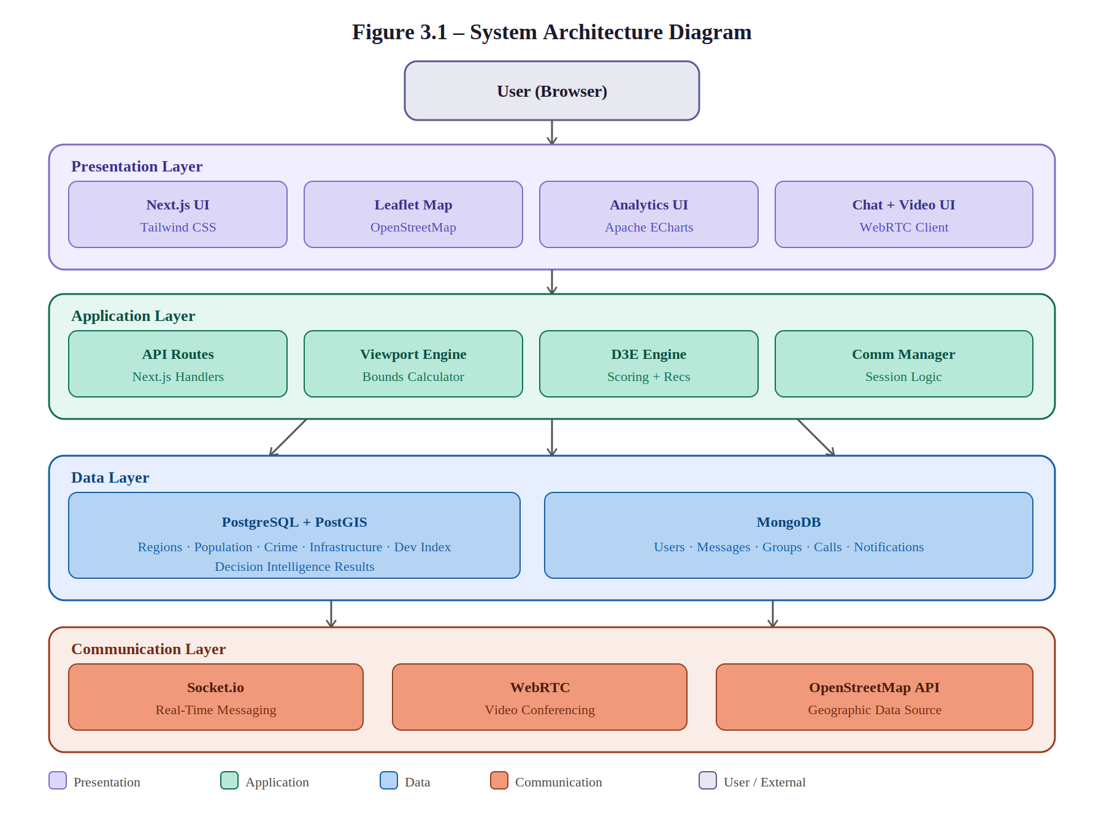

3.5 DATA FLOW DESIGN
The system follows a viewport-driven workflow. The user interacts with the map, the system detects map bounds, a request is sent to the backend, relevant geographic data is fetched, the Decision Intelligence Engine processes the data, analytics are displayed on the dashboard, and recommendations are generated.

Figure 3.2 Data Flow Diagram
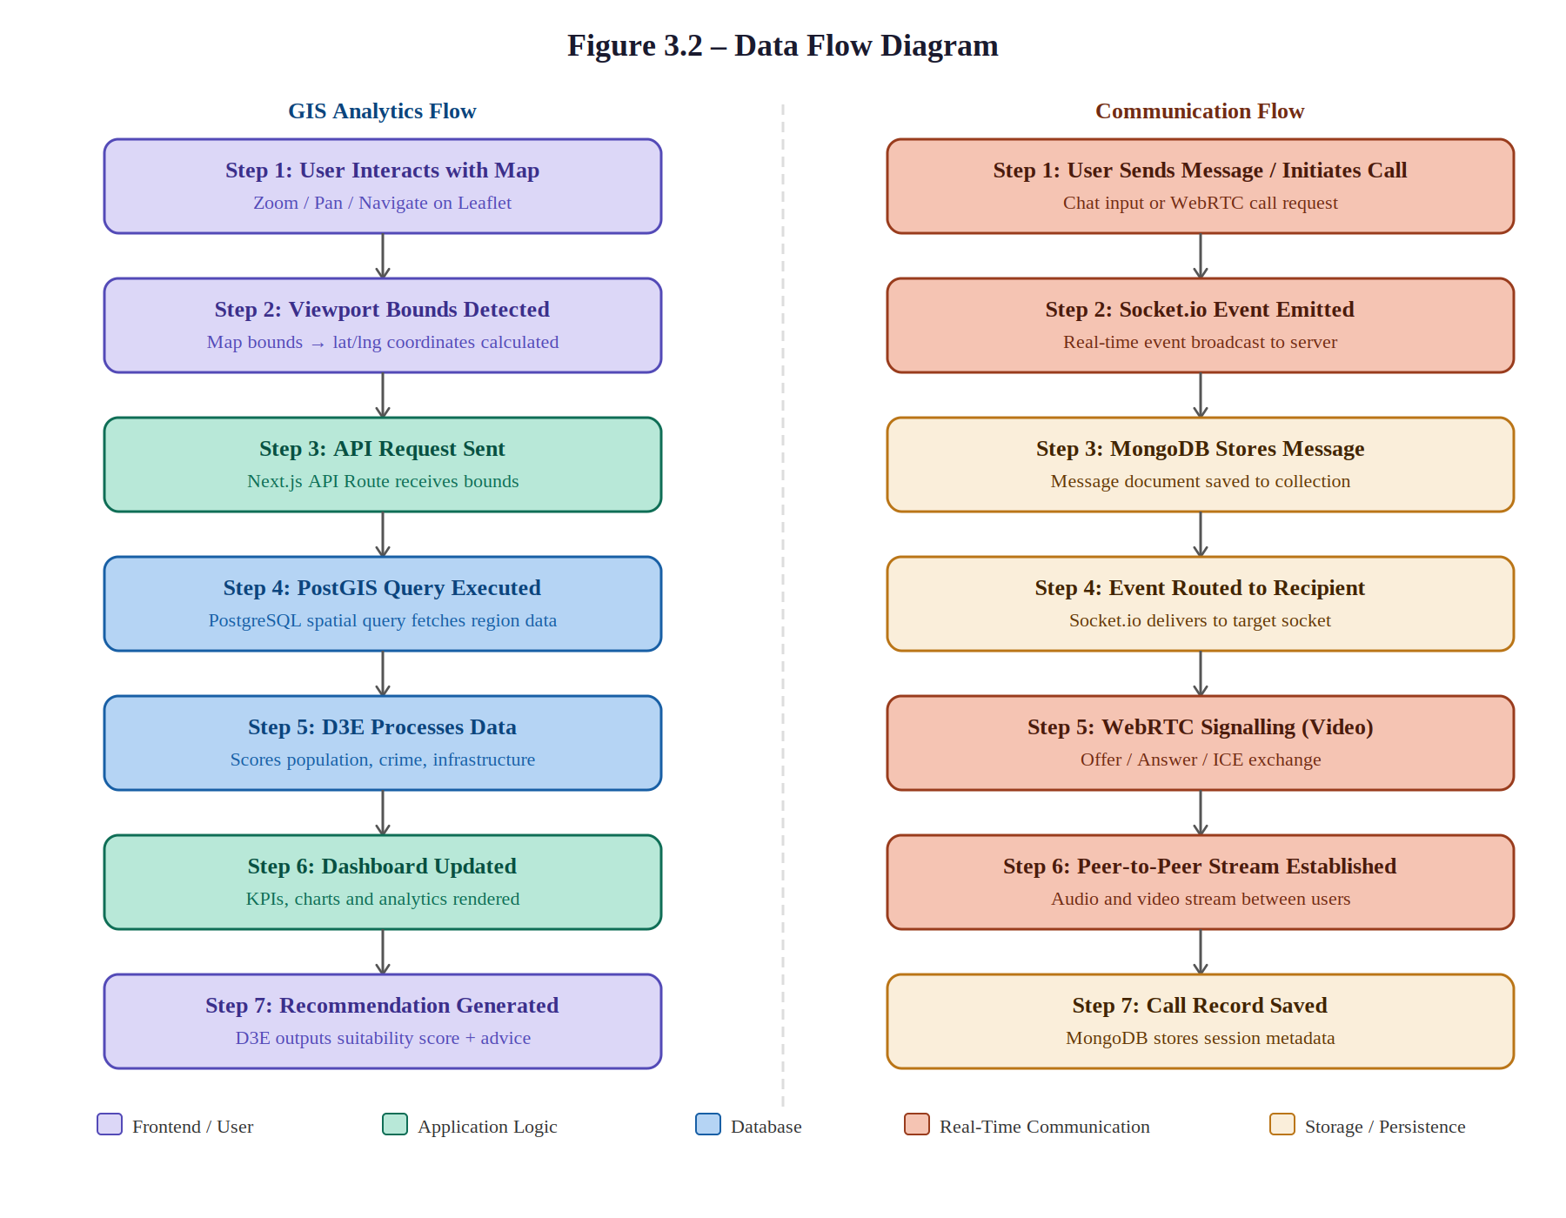

3.6 USE CASE DESIGN
Figure 3.3 Use Case Diagram
[Use Case Diagram – Insert during final submission]

Use Case 1: Login
User enters credentials and accesses the platform.
Use Case 2: Explore Map
User navigates geographic regions using zoom and pan functionality.
Use Case 3: Analyze Region
System generates insights for visible areas.
Use Case 4: View Analytics
Dashboard displays charts and KPIs.
Use Case 5: Generate Recommendation
Decision Intelligence Engine produces recommendations.
Use Case 6: Chat
Users exchange messages.
Use Case 7: Create Group
Users create collaboration groups.
Use Case 8: Video Call
Users initiate meetings.

3.7 USER INTERFACE DESIGN
Dashboard Layout
The dashboard layout includes sidebar navigation, navbar, KPI section, interactive map, and analytics panel.
Intelligence View
The intelligence view includes a tactical map, decision panel, suitability gauge, radar chart, and recommendation card.
Communication View
The communication view includes a chat window, contact list, group management, and file sharing panel.
Video Calling View
The video calling view includes local stream, remote stream, and call controls.

3.8 DECISION INTELLIGENCE ENGINE (D3E)
The Decision Intelligence Engine is the core innovation of GEODASH. Its objective is to convert raw geographic information into actionable recommendations following the principle: "What You See Is What You Analyze".

Input Parameters
- Population Density
- Crime Rate
- Infrastructure Availability
- Transportation Access
- Development Index
- Competition Density

Scoring Mechanism
Table 3.1 D3E Parameter Weights
Parameter | Weight
Population | 25%
Infrastructure | 20%
Accessibility | 20%
Development | 15%
Crime | 20%

Recommendation Levels
Table 3.2 Recommendation Levels
Score Range | Result
0 – 40 | Poor
41 – 60 | Moderate
61 – 80 | Good
81 – 100 | Highly Suitable

3.9 GIS DESIGN
The GIS module is responsible for geographic visualization. Leaflet is used as the primary mapping library due to its open-source nature, lightweight design, and high customizability. OpenStreetMap provides geographic data including roads, buildings, hospitals, schools, and points of interest.

Map Features
- Zooming
- Panning
- Markers
- Clustering
- Heatmaps
- Polygon Layers

3.10 COMMUNICATION ARCHITECTURE
Socket.io
Used for real-time messaging, notifications, and presence updates.
WebRTC
Used for video calls, audio calls, and screen sharing.

3.11 DATABASE ARCHITECTURE
PostgreSQL + PostGIS
Stores geographic data, population data, crime data, and infrastructure data.
MongoDB
Stores users, chats, groups, messages, and call records.

3.12 ENTITY RELATIONSHIP DESIGN
Figure 3.4 Entity-Relationship Diagram
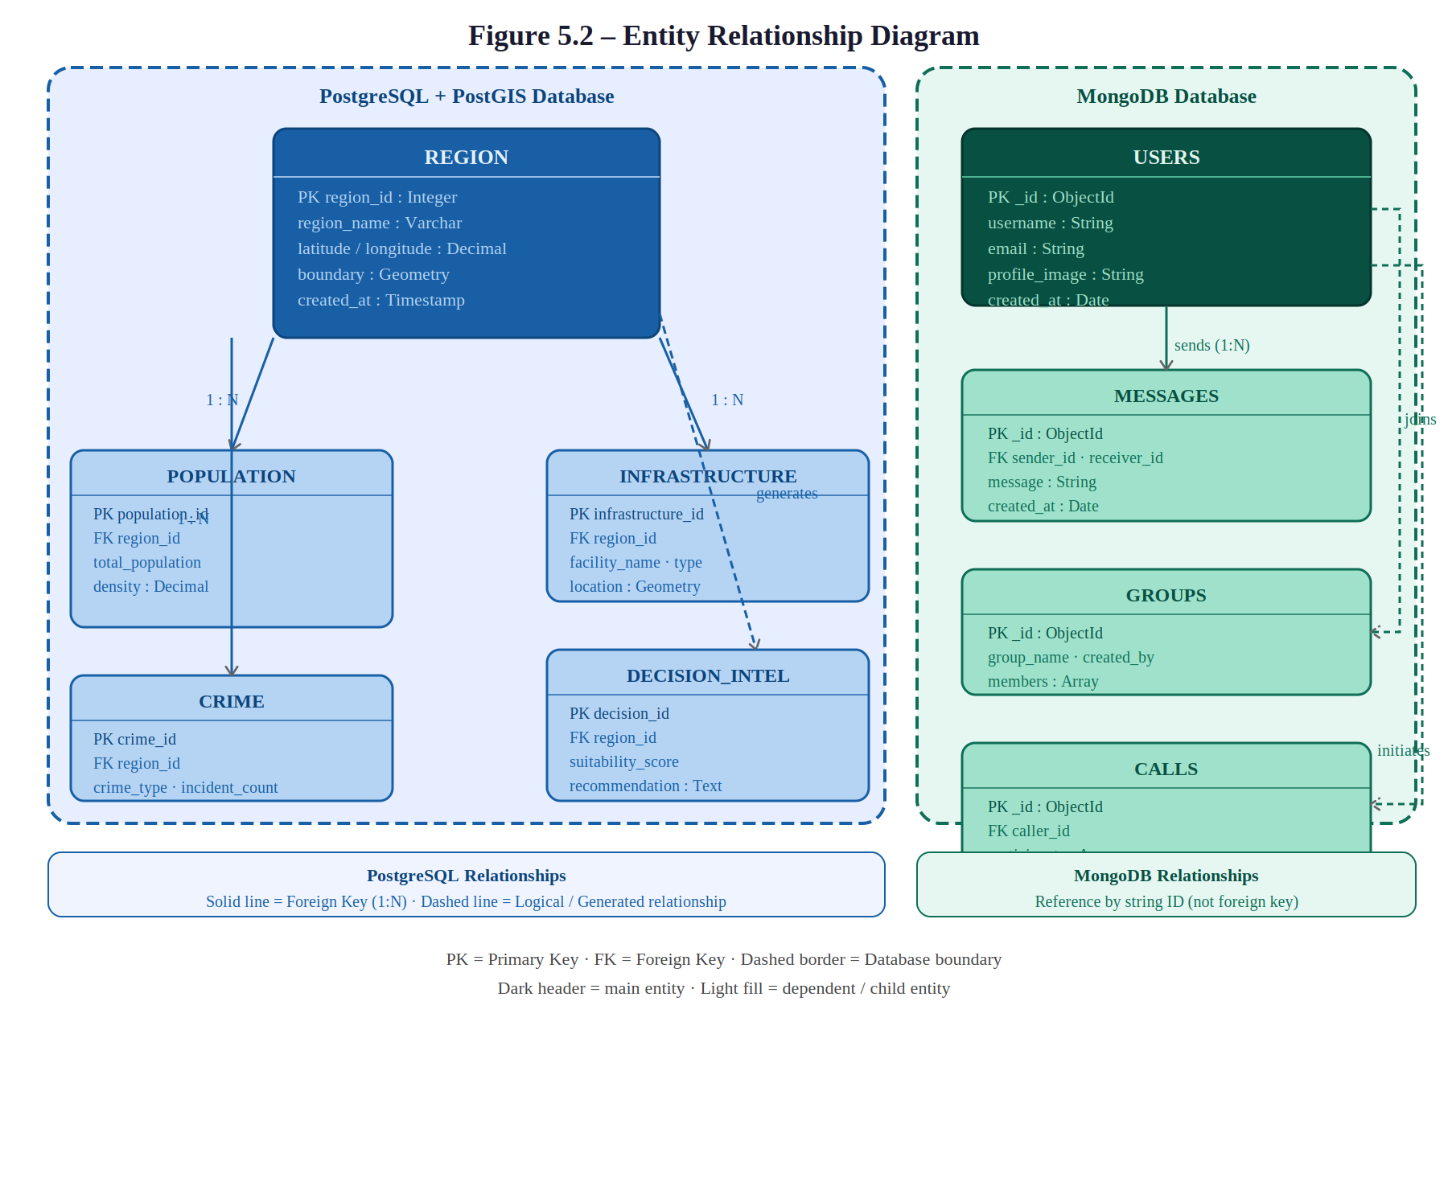

Major entities include User, Group, Message, Region, Population, Crime, Infrastructure, and Recommendation. Key relationships: User sends Messages; User joins Groups; Region contains Population Data; Region contains Crime Data; Region generates Recommendations.

3.13 SECURITY DESIGN
Authentication
Credential-based login system ensures only authorized users access the platform.
API Security
Input validation, request verification, and error handling protect API endpoints.
Data Security
Secure storage, database access control, and backup strategy ensure data integrity.

3.14 DEPLOYMENT ARCHITECTURE
Development Environment
Local development using PostgreSQL and MongoDB.
Production Environment
Cloud hosting with managed database services and secure HTTPS communication.
Deployment Workflow
Development → Testing → Staging → Production.

3.15 SUMMARY
This chapter presented the complete design of the GEODASH platform. The architecture integrates GIS visualization, analytics, decision intelligence, communication, and database management into a unified ecosystem. The design ensures scalability, maintainability, and flexibility while providing a solid foundation for future enhancements.

CHAPTER 4
INFORMATION ABOUT MODULES IMPLEMENTED BY STUDENT

Chapter 4
INFORMATION ABOUT MODULES IMPLEMENTED BY STUDENT

4.1 INTRODUCTION
This chapter describes the various modules implemented during the development of the GEODASH project. The implementation process was divided into multiple phases to ensure systematic development and effective project management. Each module was designed and developed independently while maintaining seamless integration with the overall system architecture.

The major modules implemented in GEODASH include the GIS Visualization Module, Dashboard Analytics Module, Decision Intelligence Engine (D3E), Communication Module, Video Conferencing Module, Data Collection and Management Module, and User Interface Module.

4.2 PHASE 1 – PROJECT PLANNING AND REQUIREMENT ANALYSIS
The first phase focused on understanding the problem domain and gathering requirements. Activities performed included requirement collection, technology research, GIS platform analysis, existing system study, and architecture planning.

After evaluation, Leaflet was selected as the mapping library due to its open-source nature and cost effectiveness. Next.js was selected for full-stack development due to its flexibility and performance capabilities.

4.3 PHASE 2 – FOUNDATION AND PROJECT SETUP
This phase focused on establishing the development environment and project structure. Activities included Next.js setup, Tailwind CSS configuration, folder structure creation, database configuration, and Git repository setup.

Folder Structure
The project follows a modular folder structure: app/, components/, hooks/, services/, store/, lib/, and public/ directories for organized development.

4.4 GIS VISUALIZATION MODULE
The GIS Visualization Module is one of the most important components of GEODASH. This module enables users to interact with geographic data through a modern map interface.

Technologies Used
- Leaflet
- React Leaflet
- OpenStreetMap

Features Implemented
Interactive Map
Provides zooming, panning, and navigation capabilities.
Markers
Used for displaying hospitals, schools, businesses, and important locations.
Clustering
Improves visualization when multiple markers exist in the same area.
Layer Management
Supports road layers, infrastructure layers, population layers, and crime layers.

4.5 VIEWPORT ANALYTICS MODULE
A key innovation of GEODASH is viewport-based analytics. The analytics displayed depend on the region currently visible on the map. The module continuously monitors the current map center, zoom level, and visible boundaries. Whenever the viewport changes, new geographic bounds are calculated, data requests are generated, analytics are updated, and recommendations are recalculated.

4.6 DASHBOARD ANALYTICS MODULE
The Dashboard Analytics Module transforms raw data into meaningful visual insights.

Components
KPI Cards
Displays population, crime statistics, infrastructure count, and development index.
Charts
Used for trend analysis, comparative analysis, and distribution analysis. Chart types include line charts for growth trends, bar charts for comparison analysis, pie charts for category distribution, and radar charts for D3E evaluation.

Technologies
- Apache ECharts
- React Components

4.7 DECISION INTELLIGENCE ENGINE (D3E)
The Decision Intelligence Engine represents the core intelligence layer of the system. Its purpose is to convert geographic information into actionable recommendations.

Processing Steps
- Collect geographic data.
- Normalize values.
- Apply scoring weights.
- Calculate final score.
- Generate recommendation.

Outputs
- Suitability Score
- Opportunity Analysis
- Risk Assessment
- Strategic Recommendation

Figure 4.1 D3E Processing Flow – Input to Output
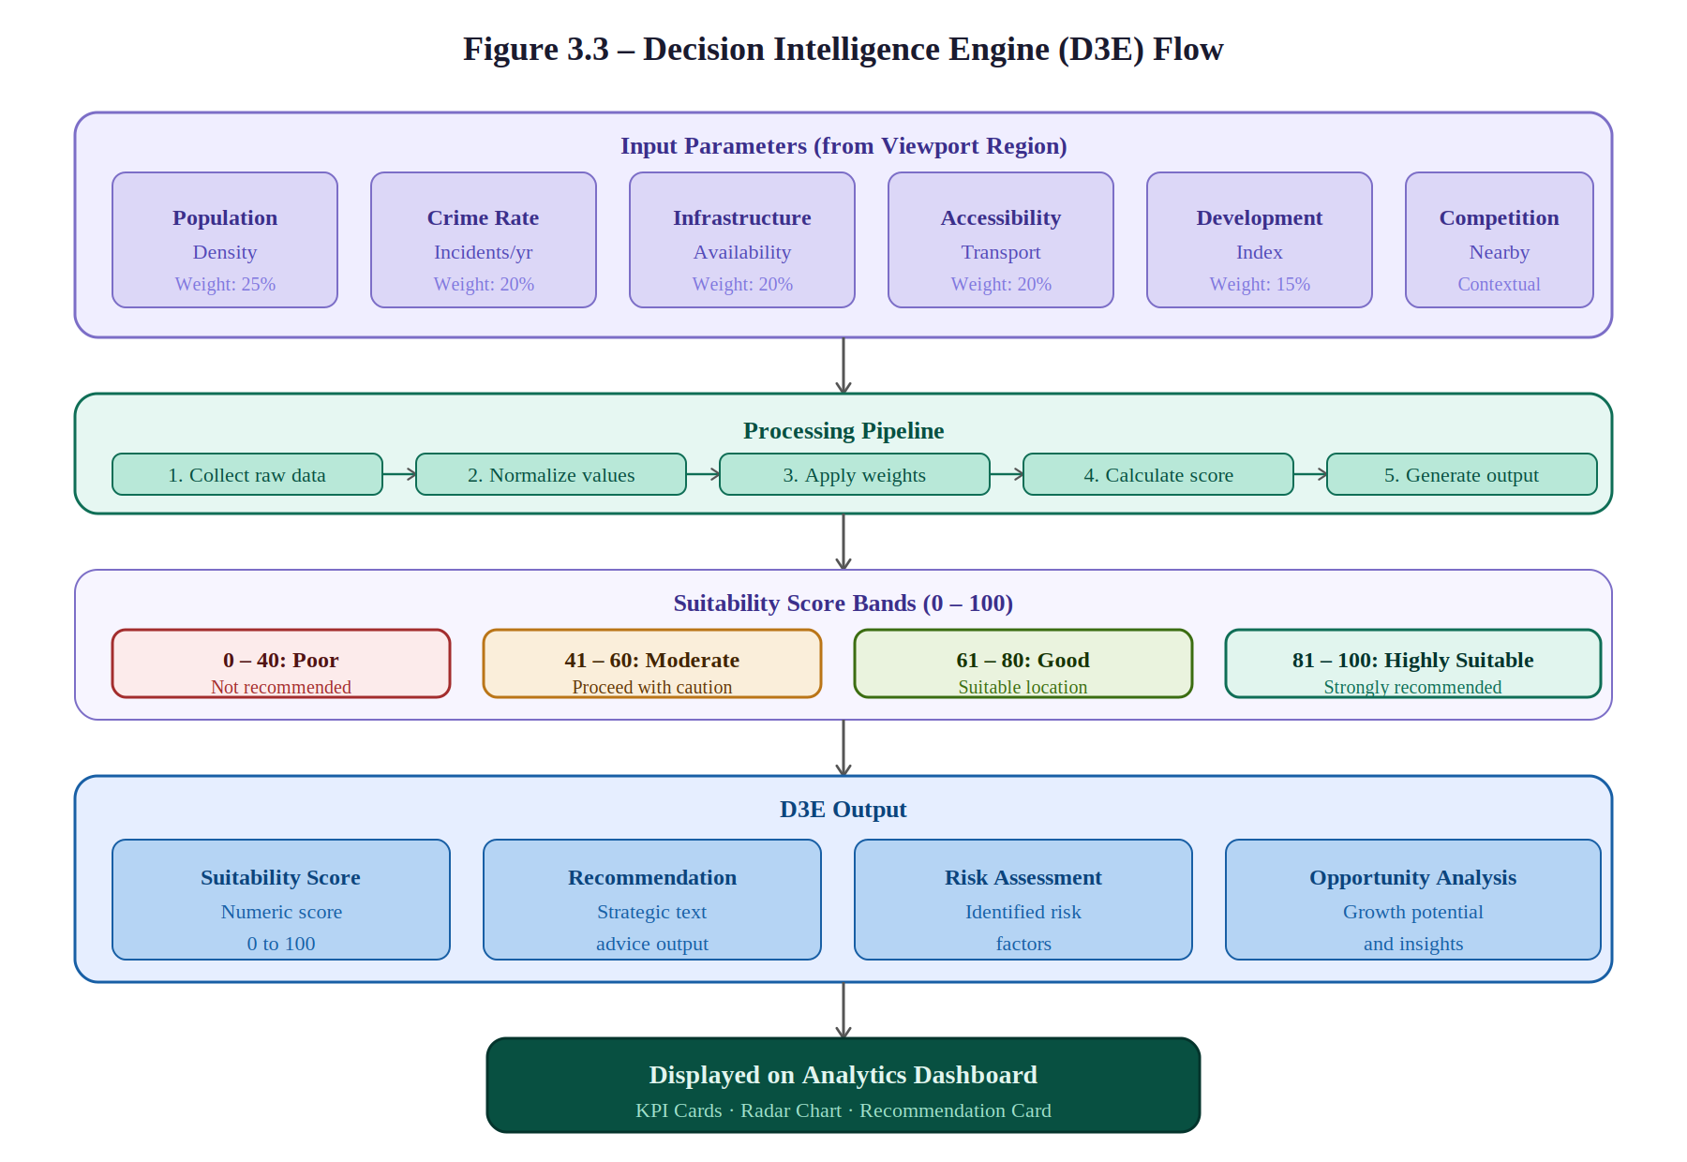

Example Use Case
A company wants to open a new restaurant. The engine analyzes population density, nearby competition, accessibility, and safety. The system then generates a recommendation indicating whether the location is suitable.

4.8 COMMUNICATION MODULE
The Communication Module enables collaboration between users. Features include one-to-one messaging, group messaging, and real-time notifications. Technologies used include Socket.io and MongoDB.

4.9 FILE SHARING MODULE
This module allows users to exchange information efficiently. Supported file types include images, documents, PDFs, and spreadsheets. Features include upload, download, share, and preview capabilities.

4.10 VIDEO CONFERENCING MODULE
The Video Conferencing Module provides real-time communication capabilities using WebRTC and Socket.io. Features include one-to-one video calls, group calls, audio calls, and screen sharing for collaborative discussions.

4.11 USER INTERFACE MODULE
The User Interface Module provides a modern and responsive user experience following design principles of simplicity, usability, accessibility, and responsiveness.

Components
Sidebar Navigation
Provides access to dashboard, intelligence view, and communication view.
Top Navigation Bar
Contains search functionality, filters, and user information.
Analytics Panel
Displays metrics, charts, and recommendations.

4.12 DATA COLLECTION MODULE
The Data Collection Module prepares datasets required for analytics. Data sources include OpenStreetMap for geographic features such as roads, buildings, hospitals, and schools, and government datasets for population data, crime data, and infrastructure data.

Data processing includes cleaning, validation, and transformation before storage in PostgreSQL with PostGIS extensions.

4.13 CHALLENGES FACED DURING IMPLEMENTATION
- GIS Data Management – large geographic datasets require efficient storage and retrieval.
- Real-Time Synchronization – maintaining communication consistency was challenging.
- Analytics Processing – processing large datasets efficiently required careful planning.
- Scalability – designing a future-ready architecture required modular implementation.

4.14 SOLUTIONS IMPLEMENTED
- PostgreSQL + PostGIS – used for efficient GIS queries.
- MongoDB – used for communication data.
- Leaflet – provided cost-effective GIS visualization.
- Modular Architecture – improved scalability and maintainability.

4.15 FUTURE IMPLEMENTATION PHASES
Artificial Intelligence
- AI Recommendations
- Predictive Analytics
Advanced GIS Analytics
- Heatmaps
- Spatial Clustering
- Predictive Mapping
Machine Learning
- Trend Prediction
- Risk Forecasting

4.16 SUMMARY
This chapter described the modules implemented during the development of GEODASH. The implementation process was divided into multiple phases covering GIS visualization, analytics, decision intelligence, communication, video conferencing, and data management. The modular approach ensures scalability, maintainability, and future extensibility.

CHAPTER 5
DATABASE DESIGN & DATA DICTIONARY

Chapter 5
DATABASE DESIGN & DATA DICTIONARY

5.1 INTRODUCTION
The database is one of the most critical components of the GEODASH platform. It acts as the central repository for storing, managing, retrieving, and processing all application data. Since GEODASH combines GIS, analytics, decision intelligence, and communication features, a hybrid database architecture has been adopted utilizing PostgreSQL with PostGIS Extension and MongoDB.

5.2 DATABASE ARCHITECTURE OVERVIEW
Figure 5.1 Database Architecture Diagram
[Database Architecture Diagram – Insert during final submission]

PostgreSQL + PostGIS
Used for geographic data, population data, crime data, infrastructure data, and decision intelligence data.
MongoDB
Used for users, chats, messages, groups, call information, and notifications.

5.3 POSTGRESQL DATABASE DESIGN
PostgreSQL serves as the primary analytical database. The PostGIS extension provides advanced geographic processing capabilities for spatial queries, area analysis, region-based analytics, and decision intelligence processing.

5.4 REGIONS TABLE
Table 5.1 Regions Table
Field Name | Data Type | Description
region_id | Integer | Primary Key
region_name | Varchar | Name of Region
latitude | Decimal | Latitude Coordinate
longitude | Decimal | Longitude Coordinate
boundary | Geometry | Geographic Boundary
created_at | Timestamp | Creation Time

The Regions table acts as the foundation for geographic analysis.

5.5 POPULATION TABLE
Table 5.2 Population Table
Field Name | Data Type | Description
population_id | Integer | Primary Key
region_id | Integer | Foreign Key
total_population | Integer | Population Count
male_population | Integer | Male Population
female_population | Integer | Female Population
density | Decimal | Population Density

Stores demographic information used by the Decision Intelligence Engine.

5.6 CRIME TABLE
Table 5.3 Crime Table
Field Name | Data Type | Description
crime_id | Integer | Primary Key
region_id | Integer | Foreign Key
crime_type | Varchar | Crime Category
incident_count | Integer | Number of Incidents
year | Integer | Reporting Year

Used for safety assessment and risk evaluation.

5.7 INFRASTRUCTURE TABLE
Table 5.4 Infrastructure Table
Field Name | Data Type | Description
infrastructure_id | Integer | Primary Key
region_id | Integer | Foreign Key
facility_name | Varchar | Facility Name
facility_type | Varchar | Facility Type
location | Geometry | Geographic Position

Facility types include School, Hospital, Police Station, Metro Station, Bus Stop, and Government Office.

5.8 DEVELOPMENT INDEX TABLE
Table 5.5 Development Index Table
Field Name | Data Type | Description
index_id | Integer | Primary Key
region_id | Integer | Foreign Key
development_score | Decimal | Development Rating
infrastructure_score | Decimal | Infrastructure Rating
economic_score | Decimal | Economic Rating

Provides development indicators for decision analysis.

5.9 DECISION INTELLIGENCE TABLE
Table 5.6 Decision Intelligence Table
Field Name | Data Type | Description
decision_id | Integer | Primary Key
region_id | Integer | Foreign Key
suitability_score | Decimal | Overall Score
recommendation | Text | Generated Recommendation
generated_at | Timestamp | Creation Date

Stores outputs generated by the D3E engine.

5.10 MONGODB DATABASE DESIGN
MongoDB is used for real-time communication features including messaging, notifications, group management, and video session metadata. Collections include Users, Messages, Groups, Calls, and Notifications.

5.11 USERS COLLECTION
Table 5.7 Users Collection
Field Name | Type | Description
_id | ObjectId | Primary Key
username | String | User Name
email | String | User Email
profile_image | String | Profile Image
created_at | Date | Registration Date

5.12 MESSAGES COLLECTION
Table 5.8 Messages Collection
Field Name | Type | Description
_id | ObjectId | Primary Key
sender_id | String | Sender
receiver_id | String | Receiver
message | String | Message Content
created_at | Date | Time Stamp

5.13 GROUPS COLLECTION
Table 5.9 Groups Collection
Field Name | Type | Description
_id | ObjectId | Primary Key
group_name | String | Group Name
created_by | String | Creator
members | Array | Group Members

5.14 CALLS COLLECTION
Table 5.10 Calls Collection
Field Name | Type | Description
_id | ObjectId | Primary Key
caller_id | String | Initiator
participants | Array | Participants
start_time | Date | Start Time
end_time | Date | End Time

5.15 ENTITY RELATIONSHIP DESIGN
Figure 5.2 ER Diagram


Major relationships: Region contains Population, Crime, and Infrastructure records. Region generates multiple Recommendations. Users exchange Messages. Users participate in Groups and Calls.

5.16 DATA DICTIONARY
Region Name
Definition: Name of the geographic area. Example: Faridabad Sector 15.
Population Density
Definition: Number of people per square kilometer. Example: 1250 Persons/km2.
Crime Rate
Definition: Total incidents recorded within a region. Example: 250 incidents per year.
Suitability Score
Definition: A calculated value generated by the Decision Intelligence Engine. Range: 0 to 100.
Recommendation
Definition: Strategic advice generated by D3E. Example: Highly Suitable for Retail Business Expansion.

5.17 DATABASE INDEXING STRATEGY
PostgreSQL Indexes
Indexes are used on region_id, population_id, and crime_id for faster query performance.
Spatial Indexes
PostGIS uses GiST indexes and R-Tree structures for faster spatial queries and improved viewport analysis.
MongoDB Indexes
Indexes are used on user_id, message_id, and group_id for faster communication retrieval.

5.18 SUMMARY
This chapter described the database architecture and data dictionary of the GEODASH platform. A hybrid database strategy consisting of PostgreSQL/PostGIS and MongoDB has been adopted to support GIS analytics and real-time communication. The database design ensures scalability, flexibility, and efficient processing of geographic information.

CHAPTER 6
TESTING STRATEGY

Chapter 6
TESTING STRATEGY

6.1 INTRODUCTION
Testing is one of the most critical phases in the Software Development Life Cycle (SDLC). It ensures that the developed system functions according to the specified requirements and performs reliably under different operating conditions. For the GEODASH project, testing was planned to verify GIS functionality, dashboard analytics, Decision Intelligence Engine (D3E), database operations, real-time communication, video conferencing, user interface responsiveness, and overall system performance.

6.2 OBJECTIVES OF TESTING
- Functional Validation – to verify that all modules perform according to requirements.
- Error Detection – to identify defects and inconsistencies.
- Performance Verification – to evaluate system responsiveness and stability.
- Security Assessment – to verify protection of data and communication.
- User Satisfaction – to ensure the application meets user expectations.

6.3 TESTING METHODOLOGY
The testing process followed a structured approach consisting of requirement analysis, test planning, test case design, test execution, defect analysis, and final verification.

6.4 TYPES OF TESTING PERFORMED
- Unit Testing – testing individual modules independently.
- Integration Testing – testing interactions between modules.
- System Testing – testing the complete application.
- User Acceptance Testing – validating system usability.
- Performance Testing – evaluating speed and efficiency.
- Security Testing – assessing system security.

6.5 UNIT TESTING
Unit testing verifies individual components of the application. Its purpose is to ensure that each module functions correctly before integration.

Unit Test Example 1 – Login System
Test Case: Valid Credentials. Expected Result: User should be authenticated successfully. Status: Pass.
Unit Test Example 2 – GIS Dashboard
Test Case: Map Loading. Expected Result: Map should render successfully. Status: Pass.
Unit Test Example 3 – Analytics Dashboard
Test Case: Chart Rendering. Expected Result: Charts should display correctly. Status: Pass.

6.6 INTEGRATION TESTING
Integration Scenario 1 – GIS + Dashboard
Process: User changes viewport. Expected Result: Dashboard updates automatically. Status: Pass.
Integration Scenario 2 – Dashboard + D3E
Process: Analytics data sent to D3E. Expected Result: Recommendations generated successfully. Status: Pass.
Integration Scenario 3 – Chat + Database
Process: User sends message. Expected Result: Message stored and delivered. Status: Pass.

6.7 SYSTEM TESTING
System testing evaluates the complete application. The entire GEODASH platform is tested as a single integrated system. Test Scenario: User logs in, navigates map, analyzes region, generates recommendation, and communicates with team members. Expected Result: Entire workflow should execute successfully. Status: Pass.

6.8 USER ACCEPTANCE TESTING (UAT)
User Acceptance Testing verifies that the platform meets business and user expectations.

Table 6.1 UAT Evaluation Criteria
Criteria | Result
Ease of Use | Satisfactory
Navigation | Satisfactory
Dashboard Clarity | Satisfactory
Recommendation Quality | Satisfactory
Communication Features | Satisfactory

6.9 PERFORMANCE TESTING
Performance testing measures system responsiveness and efficiency.

Table 6.2 Performance Test Results
Metric | Expected | Observed
Dashboard Load | < 3 sec | 2 sec
Map Load | < 2 sec | 1.5 sec
Analytics Update | < 2 sec | 1.8 sec
Chat Delivery | Real-Time | Real-Time

System performance is within acceptable limits.

6.10 SECURITY TESTING
Security testing verifies system protection mechanisms. Areas tested include authentication, authorization, API validation, and input sanitization. All security checks including login validation, API validation, and input validation performed as expected.

6.11 COMPATIBILITY TESTING
Browsers Tested
- Google Chrome
- Microsoft Edge
- Mozilla Firefox
Devices Tested
- Desktop
- Laptop
- Tablet
The application remains functional across all supported environments.

6.12 TEST CASE SUMMARY
Table 6.3 Test Case Summary
Module | Test Cases | Passed | Failed
Login | 5 | 5 | 0
GIS | 10 | 10 | 0
Dashboard | 8 | 8 | 0
D3E | 6 | 6 | 0
Chat | 7 | 7 | 0
Video Call | 5 | 5 | 0
Total | 41 | 41 | 0

Total Test Cases: 41. Passed: 41. Failed: 0. Success Rate: 100%.

6.13 FUTURE TESTING IMPROVEMENTS
Automated Testing
- Jest
- Cypress
- Playwright
Advanced Load Testing
- Apache JMeter
- Locust
Security Audits
- Penetration Testing
- Vulnerability Assessment

6.14 SUMMARY
This chapter described the testing strategy adopted for the GEODASH platform. Multiple testing techniques including unit testing, integration testing, system testing, performance testing, security testing, and user acceptance testing were considered. The testing process ensures that the platform is reliable, scalable, secure, and capable of supporting the requirements of a modern GeoSpatial Intelligence Dashboard.

CHAPTER 7
GUI SNAPSHOTS

Chapter 7
GUI SNAPSHOTS

7.1 INTRODUCTION
The Graphical User Interface (GUI) plays a vital role in determining the usability and effectiveness of a software application. The GEODASH platform has been designed using modern UI/UX principles to provide an intuitive, responsive, and visually appealing user experience. The interface follows a dashboard-centric approach developed using Next.js, Tailwind CSS, Leaflet, and Apache ECharts.

7.2 LOGIN PAGE
Figure 7.1 Login Page
[Screenshot – Insert during final submission]
The Login Page serves as the entry point to the GEODASH platform. It provides credential-based authentication with username input, password input, login button, error validation, and session management.

7.3 MAIN DASHBOARD VIEW
Figure 7.2 Main Dashboard View
[Screenshot – Insert during final submission]
The Dashboard View acts as the central workspace providing a comprehensive overview of geographic information, analytical metrics, and key performance indicators. Components include sidebar navigation, navigation bar, KPI section, and analytics section.

7.4 GIS MAP VIEW
Figure 7.3 GIS Map View
[Screenshot – Insert during final submission]
The GIS Map View provides interactive visualization of geographic information powered by Leaflet and OpenStreetMap. Features include zooming, panning, marker display, cluster visualization, heatmap support, and polygon rendering.

7.5 INTELLIGENCE VIEW (D3E)
Figure 7.4 Decision Intelligence Engine View
[Screenshot – Insert during final submission]
The Intelligence View contains the Decision Intelligence Engine (D3E). The left panel displays the tactical GIS map with a live analysis indicator. The right panel shows the suitability gauge, radar chart, and strategic recommendation panel.

7.6 ANALYTICS AND CHARTS VIEW
Figure 7.5 Analytics and Charts View
[Screenshot – Insert during final submission]
The Charts View provides detailed analytical visualizations including line charts for population trends, bar charts for comparative analysis, pie charts for category distribution, and radar charts for D3E evaluation metrics.

7.7 CHAT MODULE
Figure 7.6 Chat Module
[Screenshot – Insert during final submission]
The Chat Module enables real-time communication between users. It supports personal messaging, group messaging, real-time notifications, and message history.

7.8 FILE SHARING MODULE
Figure 7.7 File Sharing Module
[Screenshot – Insert during final submission]
The File Sharing Module enables users to exchange files and documents. Supported content includes images, PDF files, documents, reports, and spreadsheets. Features include upload, download, file preview, and secure sharing.

7.9 VIDEO CONFERENCING MODULE
Figure 7.8 Video Conferencing Module
[Screenshot – Insert during final submission]
The Video Conferencing Module provides real-time audio and video communication powered by WebRTC. Features include one-to-one calls, group meetings, audio controls, video controls, and screen sharing.

7.10 RESPONSIVE DESIGN
The GEODASH platform follows a responsive design approach supporting desktop computers, laptops, and tablets. Responsive features include adaptive layout, flexible navigation, dynamic charts, and mobile-friendly components.

7.11 SUMMARY
This chapter described the graphical user interface of the GEODASH platform. The interface includes multiple modules such as GIS visualization, analytics dashboards, decision intelligence views, communication tools, and video conferencing capabilities. Actual screenshots will be inserted during the final project documentation phase.

CHAPTER 8
CONCLUSION & FUTURE SCOPE

Chapter 8
CONCLUSION & FUTURE SCOPE

8.1 INTRODUCTION
The development of modern information systems increasingly requires the integration of multiple technologies to support intelligent decision-making and efficient collaboration. The GEODASH project was conceived as a solution to this challenge by integrating geospatial visualization, analytical dashboards, decision intelligence, and communication capabilities into a single unified platform.

8.2 PROJECT SUMMARY
GEODASH is a comprehensive GeoSpatial Intelligence Dashboard designed to support data-driven decision-making through the integration of GIS technologies, analytical reporting, and collaborative communication tools. The system follows a viewport-based analytical model where all calculations and visualizations are based on the currently visible geographic area.

8.3 OBJECTIVES ACHIEVED
Objective 1: GIS Visualization
Achieved through Leaflet integration, OpenStreetMap integration, and interactive navigation. Users can effectively explore geographic regions through an interactive map interface.
Objective 2: Dashboard Analytics
Achieved through KPI cards, statistical dashboards, and interactive charts. Users can easily understand complex geographic information through visual analytics.
Objective 3: Decision Intelligence
Achieved through the D3E framework, suitability scoring, and recommendation engine. The system provides strategic recommendations based on multiple analytical parameters.
Objective 4: Real-Time Communication
Achieved through messaging, group discussions, and notifications. Users can collaborate efficiently without leaving the platform.
Objective 5: Video Collaboration
Achieved through WebRTC integration and video conferencing. Teams can coordinate and discuss findings directly within the system.

8.4 SIGNIFICANCE OF THE PROJECT
The significance of GEODASH extends beyond traditional GIS applications. The platform introduces a new approach where geographic information is transformed into actionable intelligence. Potential applications include business intelligence for identifying suitable business locations, urban planning for evaluating infrastructure needs, resource management for optimizing allocation, market analysis for assessing regional opportunities, and research and education for analyzing geographic trends.

8.5 LEARNING OUTCOMES
Technical Learning
Knowledge gained in GIS technologies, spatial data processing, web development, database design, real-time communication, and decision intelligence systems.
Software Engineering Learning
Experience gained in requirement analysis, system design, modular architecture, database modeling, testing methodologies, and documentation practices.
Problem Solving Skills
The project improved abilities related to system analysis, architecture planning, technical decision-making, and performance optimization.

8.6 TECHNICAL CONTRIBUTIONS
- Viewport-Based Analytics – the platform dynamically updates analytics based on the visible map area.
- Decision Intelligence Engine – transforms geographic information into strategic recommendations.
- Integrated Communication – combines analytics and collaboration within a single system.
- Hybrid Database Architecture – utilizes PostgreSQL/PostGIS and MongoDB to optimize performance.
- Scalable Design – supports future enhancements and larger datasets.

8.7 CHALLENGES ENCOUNTERED
- Geographic Data Management – handling spatial datasets requires specialized database structures.
- Decision Intelligence Design – developing meaningful recommendation logic requires careful analysis.
- Real-Time Communication – implementing reliable messaging and video communication requires synchronization mechanisms.
- Scalability Planning – designing a system capable of future growth requires modular architecture.

8.8 FUTURE SCOPE
Artificial Intelligence Integration
Future versions may incorporate AI-based recommendation systems capable of predictive analysis, automated decision support, and intelligent suggestions.
Machine Learning Models
Machine learning can be used to predict population growth, forecast crime trends, estimate infrastructure demand, and analyze development patterns.
Advanced Decision Intelligence Engine
The D3E can be enhanced through dynamic scoring models, AI-based recommendations, and risk prediction algorithms.
Real-Time Data Integration
Future versions may integrate traffic data, weather data, pollution data, and emergency alerts for more accurate real-time analysis.
Advanced GIS Analytics
Additional GIS capabilities may include heatmap analysis, spatial clustering, route optimization, and geofencing.
Cloud Deployment
Future deployment options include AWS, Microsoft Azure, and Google Cloud Platform for improved scalability and availability.
Mobile Application
A mobile version can be developed using React Native providing mobile GIS access, mobile collaboration, and field data collection capabilities.

8.9 RESEARCH AND INDUSTRIAL APPLICATIONS
- Smart Cities – supports infrastructure planning and management.
- Logistics – assists route planning and resource allocation.
- Business Expansion – supports location intelligence and market analysis.
- Public Administration – facilitates policy planning and resource management.
- Education – provides a practical GIS learning environment.

8.10 FINAL CONCLUSION
The GEODASH project successfully demonstrates the integration of Geographic Information Systems, analytical dashboards, decision intelligence, and real-time communication into a unified platform. The system provides an innovative approach to geographic analysis through its viewport-based intelligence model and Decision Intelligence Engine (D3E). By combining interactive mapping, analytical reporting, strategic recommendations, and collaborative communication, the platform addresses many limitations of traditional GIS solutions.

The project establishes a strong foundation for future enhancements including artificial intelligence, machine learning, predictive analytics, and enterprise-scale geographic intelligence systems. Overall, GEODASH represents a scalable, modern, and practical solution capable of supporting data-driven decision-making across multiple industries and application domains.

REFERENCES

- Leaflet Documentation. Available at: https://leafletjs.com
- OpenStreetMap Documentation. Available at: https://www.openstreetmap.org
- PostgreSQL Documentation. Available at: https://www.postgresql.org
- PostGIS Documentation. Available at: https://postgis.net
- MongoDB Documentation. Available at: https://www.mongodb.com
- Next.js Documentation. Available at: https://nextjs.org
- Socket.io Documentation. Available at: https://socket.io
- WebRTC Documentation. Available at: https://webrtc.org
- Apache ECharts Documentation. Available at: https://echarts.apache.org
- Data.gov.in Open Government Data Platform. Available at: https://data.gov.in

BRIEF PROFILE OF STUDENT

(To be filled by the student)

