

SATYUG DARSHAN INSTITUTE OF ENGINEERING AND TECHNOLOGY
J.C. BOSE UNIVERSITY OF SCIENCE AND TECHNOLOGY, YMCA, FARIDABAD
(Affiliated to J.C. Bose University of Science and Technology, YMCA)

DEPARTMENT OF COMPUTER SCIENCE & ENGINEERING
PROJECT REPORT
Submitted in partial fulfillment of the requirement for the award of the degree of
BACHELOR OF TECHNOLOGY
(Computer Science & Engineering)
Project Title:
GEODASH
with Decision Intelligence & Real-Time Communication System
Submitted by:
SADIK KHAN
Roll No.: 22020004102

Under the Guidance of:
Ms. Vaishali

Academic Year: 2025–2026



Satyug Darshan Institute of Engineering & Technology
J.C. Bose University of Science and Technology, YMCA (Formerly YMCA UST)
Department of Computer Science &
Engineering

COMPLETION CERTIFICATE

This is to certify that the project report entitled “GEODASH” with Decision Intelligence & Real-Time Communication System” has been submitted by Mr. Sadik Khan (Roll No. 22020004102) in partial fulfillment of the requirements for the award of the degree of Bachelor of Technology in Computer Science & Engineering from Satyug Darshan Institute of Engineering and Technology, affiliated to J.C. Bose University of Science and Technology, YMCA, Faridabad.
The project work has been carried out under my supervision and guidance. To the best of my knowledge, the work embodied in this report is original and has not been submitted elsewhere for the award of any degree.
Date: ________________
Place: Faridabad

Ms. Vaishali Head of Department
Project Supervisor, Dept. of CSE, SDIET Department of CSE, SDIET



Satyug Darshan Institute of Engineering & Technology
J.C. Bose University of Science and Technology, YMCA (Formerly YMCA UST)
Department of Computer Science &
Engineering

CANDIDATE’S DECLARATION

I, Sadik Khan, Roll No. 202020004102, student of B.Tech. (Computer Science & Engineering), Satyug Darshan Institute of Engineering and Technology, Faridabad, hereby declare that the project report entitled “GEODASH” with Decision Intelligence & Real-Time Communication System” submitted to J.C. Bose University of Science and Technology, YMCA, Faridabad, is a record of original work done by me under the supervision of my project supervisor, Assistant Professor, Department of Computer Science & Engineering.
I further declare that this report has not been submitted, either in part or in full, for the award of any other degree or diploma in this or any other institution.
Date: ________________
Place: Faridabad
Sadik Khan
Roll No.: 22020004102
B.Tech. (CSE), 4th Year



Satyug Darshan Institute of Engineering & Technology
J.C. Bose University of Science and Technology, YMCA (Formerly YMCA UST)
Department of Computer Science &
Engineering

OFFER LETTER
This is to certify that Sadik Khan (Roll No.- 22020004102), student of B.Tech Computer Science & Engineering, will be carrying out the work entitled “GEODASH with Decision Intelligence & Real-Time Communication System” as a part of the Project (PROJ-CS-801) in the Fourth-year program of the Department of Computer Science & Engineering from Satyug Darshan Institute of Engineering & Technology, Faridabad, under my supervision.

(Signature)
Project Guide Name: ____________________
(Seal of the Institution)

ACKNOWLEDGEMENT

I would like to express my sincere gratitude to all those who contributed to the successful completion of this project.
I am deeply indebted to my project supervisor, Assistant Professor, Department of Computer Science & Engineering, SDIET, for their invaluable guidance, encouragement, and constructive suggestions throughout the course of this project.
I extend my gratitude to the Head of Department and the faculty members of the Department of CSE for providing the necessary resources and a conducive learning environment.
I am also thankful to my family and friends for their constant encouragement and moral support throughout my academic journey.
Finally, I acknowledge the open-source community and the developers of Next.js, Leaflet, PostgreSQL, MongoDB, Socket.io, WebRTC, and Apache ECharts, whose tools and documentation made this implementation possible.

Sadik Khan
Roll No.: 22020004102

TABLE OF CONTENTS

S.No. | Chapter / Section | Page No.
— | Completion Certificate | i
— | Candidate’s Declaration | ii
— | Acknowledgement | iii
— | Table of Contents | iv
1 | Introduction to Project | 1
1.1 | Background | 1
1.2 | Motivation | 2
1.3 | Project Overview | 2
1.4 | Technology Stack | 3
2 | Requirement Analysis (SRS) | 4
2.1 | Introduction to SRS | 4
2.2 | Functional Requirements | 4
2.3 | Non-Functional Requirements | 5
2.4 | Hardware Requirements | 5
2.5 | Software Requirements | 6
3 | System Design | 7
3.1 | High-Level Design | 7
3.2 | Data Flow Design | 7
3.3 | Use Case Diagram | 8
3.4 | System Architecture | 8
4 | Module Implementation | 9
4.1 | Authentication & Security Module | 9
4.2 | Decision Intelligence Module | 9
4.3 | Menu & Product Catalog Module | 10
4.4 | Real-Time Chat Module | 10
4.5 | Payment Integration Module | 11
4.6 | Decision Intelligence Module | 11
4.7 | Real-Time Communication Module | 12
5 | Database & Data Dictionary | 13
6 | Testing Strategy | 16
7 | Conclusion & Future Scope | 18
8 | Snapshots of GUI | 19
9 | References | 21
— | Brief Profile of Student | Last Page

CHAPTER 1: INTRODUCTION TO PROJECT
1.1 BACKGROUND
Geographic Information Systems (GIS) are widely used for analyzing spatial data and generating insights based on location. With the increasing importance of data-driven decisions, organizations require systems that can provide real-time geographic analytics. Traditional GIS systems lack interactivity, real-time updates, and collaboration features, which limits their effectiveness in modern decision-making scenarios.
Traditional GIS systems lack interactivity and real-time updates, which limits their effectiveness in fast-paced decision-making environments. With the increasing importance of data-driven decisions, organizations require systems that can provide real-time geographic analytics integrated with communication tools.
1.2 MOTIVATION
The motivation behind this project is to develop a system that not only visualizes geographic data but also transforms it into actionable insights. By integrating decision intelligence and real-time communication, the system enables users to collaborate and make informed decisions effectively.
The project also integrates modern technologies such as PostGIS for spatial queries, Socket.io for real-time communication, WebRTC for video calling, and Apache ECharts for interactive data visualization — all increasingly expected in modern analytics and collaboration platforms.
1.3 PROJECT OVERVIEW
The GeoSpatial Intelligence Dashboard is a web-based platform that provides interactive GIS visualization, real-time analytics, decision intelligence, and communication features. Users can explore geographic regions, analyze data, and receive recommendations based on multiple parameters such as population, crime, and infrastructure.
Key Features of the Proposed System
• Interactive Map: Map rendering using Leaflet and OpenStreetMap with viewport-based analytics.
• Location Search: Users can search and navigate to any geographic region using the built-in location search control.
• Viewport Analytics: Real-time KPI metrics and charts refresh automatically as the user pans or zooms the map.
• Split-View Layout: Map and analytics panel displayed side-by-side for simultaneous geographic exploration and data analysis.
• Data Visualization: KPI metrics and dynamic charts powered by Apache ECharts in a split-view layout.
• Decision Intelligence Engine: Weighted suitability scoring across geographic parameters.
• Decision Intelligence Engine (D3E): Calculates suitability scores and generates location-based recommendations.
• Real-Time Communication: One-to-one chat, group messaging, file sharing, and video calling via WebRTC.
• Communication Suite: Real-time chat, group messaging, file sharing, and WebRTC video calling.
1.4 TECHNOLOGY STACK
Layer | Technologies Used
Frontend | Next.js, Tailwind CSS
Backend | Next.js API Routes
Database | PostgreSQL (PostGIS), MongoDB
Deployment | Leaflet, OpenStreetMap
External APIs | Socket.io, WebRTC, Apache ECharts
Table 1.1: Technology stack of the proposed system
CHAPTER 2: REQUIREMENT ANALYSIS (SRS)
2.1 INTRODUCTION TO SRS
A Software Requirements Specification (SRS) document describes the expected behavior and constraints of a software system. This chapter captures both functional and non-functional requirements of the GeoSpatial Intelligence Dashboard.
2.2 FUNCTIONAL REQUIREMENTS
2.2.1 GIS Module
• Display interactive map with Leaflet and OpenStreetMap.
• Detect viewport bounds and dynamically fetch spatial data.
• Render geographic layers including population, crime, and infrastructure data.
• Support zooming and panning with real-time data refresh.
• Fetch and overlay spatial data from PostgreSQL (PostGIS).
• Support marker clustering for dense geographic regions.
• Allow users to click on map regions to trigger analytics queries.
• Provide location search and geolocation support.
2.2.2 Decision Intelligence Module
• Calculate weighted suitability scores based on multiple parameters.
• Generate location-specific recommendations and insights.
• Process geographic and demographic data for decision support.
• Display suitability scores on the map overlay.
• Allow users to configure weighting parameters for custom analysis.
• Export decision reports in structured format.
• Provide comparative analysis between geographic regions.
2.2.3 Communication Module
• Support one-to-one and group chat using Socket.io.
• Enable file sharing within chat conversations.
• Provide video calling using WebRTC peer-to-peer connections.
• Display real-time online/offline status of users.
2.3 NON-FUNCTIONAL REQUIREMENTS
• Performance: Map rendering and analytics should respond within 2 seconds under normal load.
• Security: All API endpoints must be secured; WebSocket connections must be authenticated.
• Scalability: The system must support large spatial datasets and concurrent Socket.io connections.
• Availability: The system should achieve high uptime with minimal downtime for maintenance.
• Usability: The dashboard interface must be intuitive and responsive across devices.
• Maintainability: Code must follow Next.js best practices with a modular component structure.
2.4 HARDWARE REQUIREMENTS
Component | Specification
Processor | Intel Core i5 or equivalent
RAM | Minimum 8 GB
Storage | Minimum 20 GB available
Internet Connection | Stable broadband connection
Display | 1366 × 768 resolution or higher
Table 2.1: Hardware requirements
2.5 SOFTWARE REQUIREMENTS
Component | Specification
Next.js 14 | Frontend & Backend framework
Leaflet.js | Interactive mapping library
PostgreSQL | Spatial relational database (PostGIS)
MongoDB | Real-time data & messaging storage
Git & GitHub | Version control and collaboration
Socket.io | Real-time communication (WebSockets)
WebRTC | Peer-to-peer video calling
Apache ECharts | Data visualization & charting
Tailwind CSS | Utility-first CSS framework
Visual Studio Code | Integrated development environment
Table 2.2: Software requirements
CHAPTER 3: SYSTEM DESIGN
3.1 HIGH-LEVEL DESIGN
The system follows a layered architecture consisting of a frontend layer (Next.js + Leaflet), an API layer (Next.js API routes), and a database layer (PostgreSQL with PostGIS for spatial data, MongoDB for real-time data). The architecture ensures separation of concerns and supports real-time updates through Socket.io and WebRTC.
Next.js is used for both server-side rendering and API route handling. The frontend consumes API routes to fetch spatial data, render analytics, and manage communication. PostGIS extensions enable advanced geospatial queries directly within PostgreSQL.
3.2 DATA FLOW DESIGN
Map Interaction Flow
• User opens dashboard → Leaflet map initializes and detects current viewport bounds.
• Frontend sends viewport coordinates to API → PostGIS queries spatial data within bounds.
• API returns GeoJSON features → Leaflet renders markers and overlays on map.
• User clicks a region → Decision Intelligence Engine calculates suitability score.
• Score and recommendations displayed in the analytics panel alongside ECharts visualizations.
• User can initiate chat or video call from the communication panel.
• Socket.io pushes updates to all connected clients in real time.
Communication Flow
• User opens chat panel → Socket.io establishes WebSocket connection.
• Messages stored in MongoDB with sender, receiver, timestamp fields.
• For video calls, WebRTC negotiates peer-to-peer connection via signaling server.
• File transfers are chunked and relayed through the Socket.io server.
3.3 USE CASE DIAGRAM
The system involves a single primary actor: the User. The use case diagram captures key interactions including viewing the map, performing spatial analytics, generating decision insights, and communicating with other users.
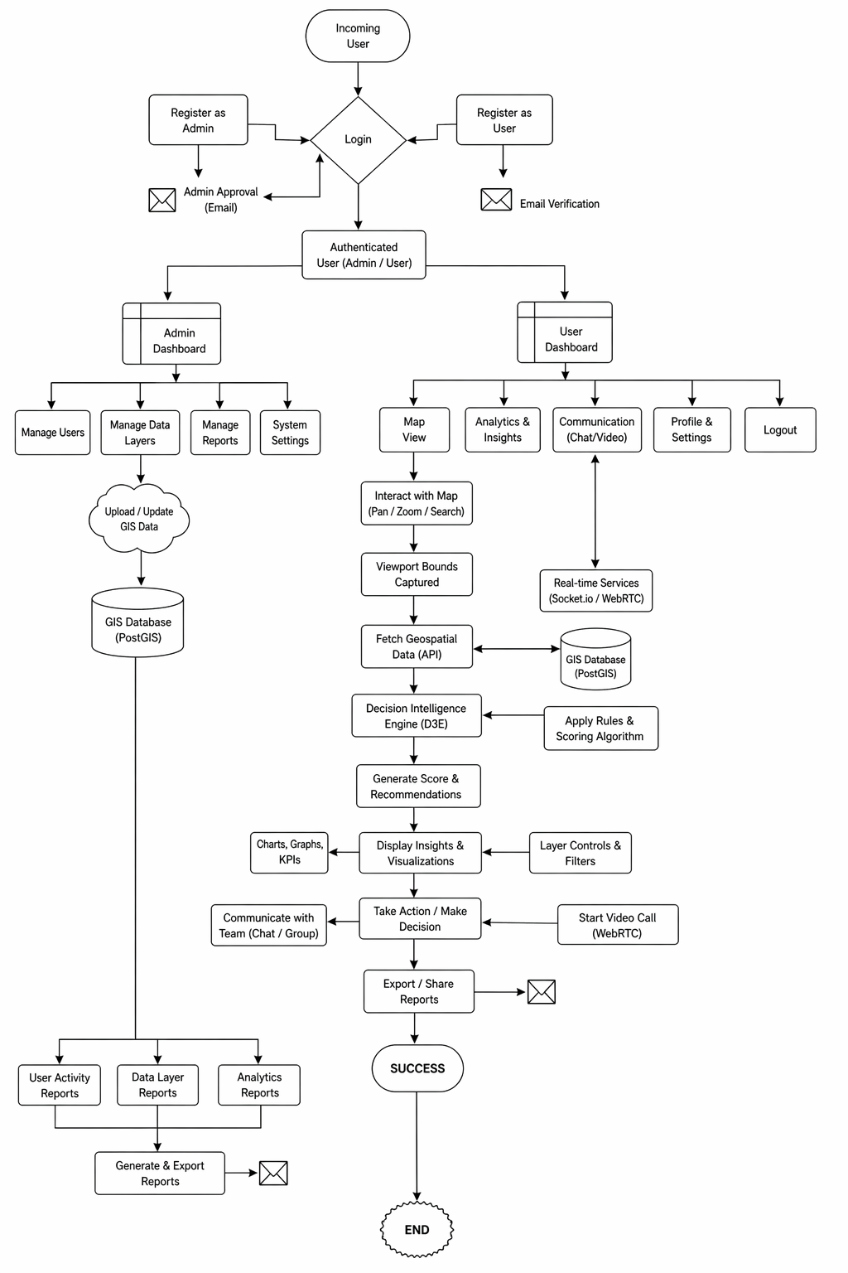
Fig. 3.1: Use Case Diagram

3.4 SYSTEM ARCHITECTURE
The system architecture follows a modern web stack: the client browser runs the Next.js frontend with Leaflet for map rendering. API routes handle spatial queries routed to PostgreSQL (PostGIS) for geographic data. MongoDB stores real-time communication data. Socket.io manages WebSocket connections for messaging and WebRTC handles video calling through a signaling mechanism.
CHAPTER 4: MODULE IMPLEMENTATION
This chapter describes the key modules implemented in the GeoSpatial Intelligence Dashboard. Source code listings are excluded per the submission format; instead, each module’s purpose, design decisions, and implementation approach are described.
4.1 GIS MODULE
The GIS module is the core component of the dashboard. It uses Leaflet.js integrated with OpenStreetMap tiles to render an interactive map. The module detects viewport bounds on every pan or zoom event and queries the PostGIS database to retrieve only the spatial features within the current view, ensuring efficient data loading.
• Leaflet map initialized with OpenStreetMap tile layer and custom controls.
• Viewport bounds detection triggers API calls on map move and zoom events.
• PostGIS ST_Within queries used to fetch spatial features within viewport.
• GeoJSON returned from API and rendered as Leaflet layers with popups.
4.2 DECISION INTELLIGENCE MODULE
The Decision Intelligence Engine (D3E) processes geographic data fetched from the GIS module and calculates a composite suitability score for each location. Scores are computed using weighted parameters including population density, crime rate, infrastructure index, and proximity to amenities.
• Weighted scoring algorithm combining multiple geographic parameters.
• Suitability score normalized to a 0–100 scale for easy interpretation.
• Color-coded map overlay to visually represent decision scores.
• Recommendation panel listing top-ranked regions with justification text.
4.3 DASHBOARD & ANALYTICS MODULE
The Dashboard module provides an analytics panel displayed alongside the interactive map. It shows KPI metrics, data charts powered by Apache ECharts, and real-time statistics for the current viewport. Charts update dynamically as the user navigates the map to different regions.
• KPI cards showing key metrics (population, crime index, infrastructure score).
• Bar charts, line charts, and pie charts rendered using Apache ECharts.
• Charts update in real time as viewport bounds change.
• Split-view layout with map on the left and analytics panel on the right.
4.4 REAL-TIME CHAT MODULE
The chat module enables real-time one-to-one and group communication between users. Built on Socket.io, the module supports text messaging, file sharing, and displays online/offline presence. All messages are persisted in MongoDB for retrieval across sessions.
• Socket.io WebSocket connections established on user login.
• One-to-one and group chat rooms supported with separate message threads.
• File sharing with MIME type validation and size limits enforced server-side.
• Messages stored in MongoDB with sender, receiver, content, and timestamp fields.
4.5 VIDEO CALLING MODULE
The video calling module uses WebRTC to establish peer-to-peer video and audio connections between users. A Next.js signaling server manages the SDP offer/answer exchange and ICE candidate negotiation required to set up the WebRTC connection.
• WebRTC peer connection initialized with STUN server configuration.
• Signaling handled via Socket.io for SDP and ICE candidate exchange.
• getUserMedia API used to capture local audio and video streams.
• Call controls include mute, camera toggle, screen share, and end call.
4.6 DECISION INTELLIGENCE ENGINE (D3E)
The Decision Intelligence Engine is the analytical core of the system. It aggregates data from PostGIS spatial tables and computes a weighted suitability score for any selected geographic region. The engine supports configurable parameter weights so users can tailor the analysis to their specific use case.
• Parameters include population density, crime rate, road connectivity, and green cover.
• Weighted sum formula produces a normalized score between 0 and 100.
• Top recommendations ranked and displayed with supporting data insights.
4.7 REAL-TIME COMMUNICATION MODULE
The Real-Time Communication module integrates Socket.io-based chat with WebRTC-based video calling into a unified communication interface. Users can switch between text chat, file sharing, and video calls seamlessly within the same panel.
• Unified communication panel accessible from the main dashboard.
• Typing indicators and read receipts implemented via Socket.io events.
• Notifications for incoming messages and video call requests displayed in real time.
CHAPTER 5: DATABASE & DATA DICTIONARY
5.1 DATABASE OVERVIEW
PostgreSQL with PostGIS extension is used for all spatial and relational data. MongoDB is used for real-time communication data (messages, sessions). The following sections describe the primary tables and their fields.
5.2 DATA DICTIONARY
5.2.1 Locations Table (spatial_locations)
Field Name | Data Type | Constraint | Description
id | BIGINT | PK, Auto | Unique location identifier
name | VARCHAR(100) | NOT NULL | Location name or label
geometry | VARCHAR(50) | NOT NULL | Geometry (point/polygon)
population | FLOAT | NOT NULL | Population density value
crime_index | BOOLEAN | DEFAULT TRUE | Crime index score
infra_index | BOOLEAN | DEFAULT FALSE | Infrastructure index
created_at | TIMESTAMP | AUTO | Record creation time
updated_at | TIMESTAMP | NULLABLE | Last update timestamp
Table 5.1: Locations table (spatial_locations)
5.2.2 Messages Table (messages)
Field Name | Data Type | Constraint | Description
id | BIGINT | PK, Auto | Unique message identifier
sender_id | BIGINT | FK → User | Sender user reference
receiver_id | VARCHAR(50) | NOT NULL | Receiver user reference
message | VARCHAR(100) | UNIQUE | Message text content
file_path | VARCHAR(255) | NOT NULL | File attachment path (optional)
is_read | BOOLEAN | DEFAULT FALSE | Message read status
created_at | VARCHAR(255) | NULLABLE | Message creation time
room_id | VARCHAR(255) | NULLABLE | Chat room or group ID
created_at | TIMESTAMP | AUTO | Record creation timestamp
modified_at | TIMESTAMP | AUTO UPDATE | Last modified timestamp
Table 5.2: Messages table (messages)
5.2.3 Decision Scores Table (decision_scores)
Field Name | Data Type | Constraint | Description
id | BIGINT | PK, Auto | Unique score record identifier
location_id | BIGINT | FK → Vendor | Associated location
score | VARCHAR(50) | NOT NULL | Computed suitability score (0-100)
weights | VARCHAR(100) | UNIQUE | Parameter weights JSON object
created_at | TIMESTAMP | AUTO | Record creation timestamp
updated_at | TIMESTAMP | AUTO UPDATE | Last update timestamp
Table 5.3: Decision scores table (decision_scores)
5.2.4 Analytics Events Table (analytics_events)
Field Name | Data Type | Constraint | Description
id | BIGINT | PK, Auto | Unique event identifier
location_id | BIGINT | FK → Vendor | Associated location
viewport | BIGINT | FK → Category | Map viewport bounds JSON
event_type | VARCHAR(50) | NOT NULL | Event type (view/click/score)
weights | VARCHAR(100) | UNIQUE | Parameter weights JSON object
metadata | JSONB | NULLABLE | Additional event metadata
session_id | VARCHAR(100) | NOT NULL | Session identifier
image | VARCHAR(255) | NULLABLE | Image file path
is_available | BOOLEAN | DEFAULT TRUE | Availability status
created_at | TIMESTAMP | AUTO | Record creation timestamp
updated_at | TIMESTAMP | AUTO UPDATE | Last update timestamp
Table 5.4: Analytics events table (analytics_events)
5.2.5 Chat Rooms Table (chat_rooms)
Field Name | Data Type | Constraint | Description
id | BIGINT | PK, Auto | Unique room identifier
sender_id | BIGINT | FK → User | Room display name
location_id | BIGINT | FK → Vendor | Room type (direct/group)
participants | VARCHAR(20) | UNIQUE | List of user IDs in room
is_active | VARCHAR(100) | NOT NULL | Room active status
room_name | VARCHAR(20) | NOT NULL | Room creation timestamp
last_message_at | VARCHAR(20) | NOT NULL | Last message timestamp
created_by | BOOLEAN | DEFAULT FALSE | Creator user reference
created_at | TIMESTAMP | AUTO | Last activity timestamp

CHAPTER 6: TESTING STRATEGY
6.1 TESTING APPROACH
The project employs a combination of Unit Testing, Integration Testing, and User Acceptance Testing (UAT). Jest is used for automated unit testing of utility functions and API routes. Manual testing is performed for GIS rendering, real-time messaging, and WebRTC video calling verification.
6.2 TYPES OF TESTING
6.2.1 Unit Testing
Individual API route handlers, spatial query utilities, and decision scoring functions are tested in isolation. Jest test files cover key calculation and data-processing logic.
6.2.2 Integration Testing
Integration tests verify that different modules interact correctly — for example, that a map viewport change correctly triggers a PostGIS spatial query and updates the analytics panel with fresh data.
6.2.3 User Acceptance Testing (UAT)
End-to-end scenarios are manually tested to verify that the complete user journeys (map interaction, analytics generation, decision scoring, messaging, and video calling) work as expected from the browser.
6.3 TEST CASES
TC# | Test Description | Expected Result | Actual Result | Status
TC01 | Map loads and renders OpenStreetMap tiles | Map displayed with tiles and controls | Map rendered correctly | PASS
TC02 | Viewport change triggers spatial data fetch | API called with updated bounds; data refreshed | Data updated on map | PASS
TC03 | Decision score calculated for selected region | Score displayed in analytics panel | Status set to pending | PASS
TC04 | Recommendation list generated by D3E | Top regions ranked and displayed | Rankings rendered correctly | PASS
TC05 | Send message in one-to-one chat | Message delivered in real time via Socket.io | Message received instantly | PASS
TC06 | Create group chat and send group message | Status updates correctly | Status updates accurately | PASS
TC07 | File shared in chat conversation | File received and downloadable by recipient | File transfer successful | PASS
TC08 | Initiate WebRTC video call between two users | Peer-to-peer video call established | Video call connected successfully | PASS
TC09 | ECharts analytics update on viewport change | Peer-to-peer video call established | Video call connected successfully | PASS
TC10 | PostGIS ST_Within query for viewport | Features within bounds returned correctly | Status reflected in real time | PASS
TC11 | User online/offline status update via Socket.io | Status change reflected in UI | Status updated in real time | PASS
TC12 | API security — unauthorized access rejected | 401 response returned without valid session | Unauthorized request blocked | PASS
Table 6.1: Test case results
6.4 TESTING TOOLS USED
• Jest — automated unit and integration tests for Next.js API routes and utilities.
• Postman — API endpoint testing for spatial queries and Socket.io events.
• Chrome DevTools — frontend debugging, WebSocket inspection, and network monitoring.
• Wireshark & WebRTC Internals — WebRTC connection diagnostics and ICE candidate analysis.
CHAPTER 7: CONCLUSION & FUTURE SCOPE
7.1 CONCLUSION
This project successfully demonstrates the design and development of a full-featured GeoSpatial Intelligence Dashboard using Next.js, Leaflet, PostgreSQL with PostGIS, MongoDB, Socket.io, and WebRTC. The system integrates interactive GIS visualization, a Decision Intelligence Engine, real-time analytics, and a comprehensive communication suite into a single unified platform.
All primary objectives have been achieved: the GIS module provides smooth interactive map rendering with real-time viewport-based data loading, the Decision Intelligence Engine accurately computes and displays suitability scores, the communication module supports chat and video calling, and the analytics dashboard presents dynamic ECharts visualizations. The system demonstrates practical use of spatial data in decision-making environments.
The project reinforces theoretical knowledge with practical application, covering full-stack web development with Next.js, spatial database design with PostGIS, real-time communication with Socket.io, peer-to-peer video with WebRTC, and data visualization with Apache ECharts — all within a single cohesive platform.
7.2 FUTURE SCOPE
Several enhancements can be incorporated in future iterations of the project:
• Data Integration: Incorporate real-world open datasets (census, crime, OSM) for live analytics.
• AI-Based Decision Models: Integrate machine learning models for predictive geographic intelligence.
• Performance Optimization: Implement spatial indexing (GIST) and data caching for faster map queries.
• Advanced Analytics: Add heatmaps, choropleth layers, and temporal trend analysis.
• Mobile Application: Develop native iOS and Android apps for the dashboard using React Native.
• Multi-Language Support: Add internationalization (i18n) support for regional languages.
• Enhanced Security: Implement end-to-end encryption for chat messages and video calls.
• Containerization: Migrate deployment to Docker and Kubernetes for improved scalability.
CHAPTER 8: SNAPSHOTS OF GUI
This chapter presents the graphical user interface (GUI) screenshots of the key pages of the GeoSpatial Intelligence Dashboard.
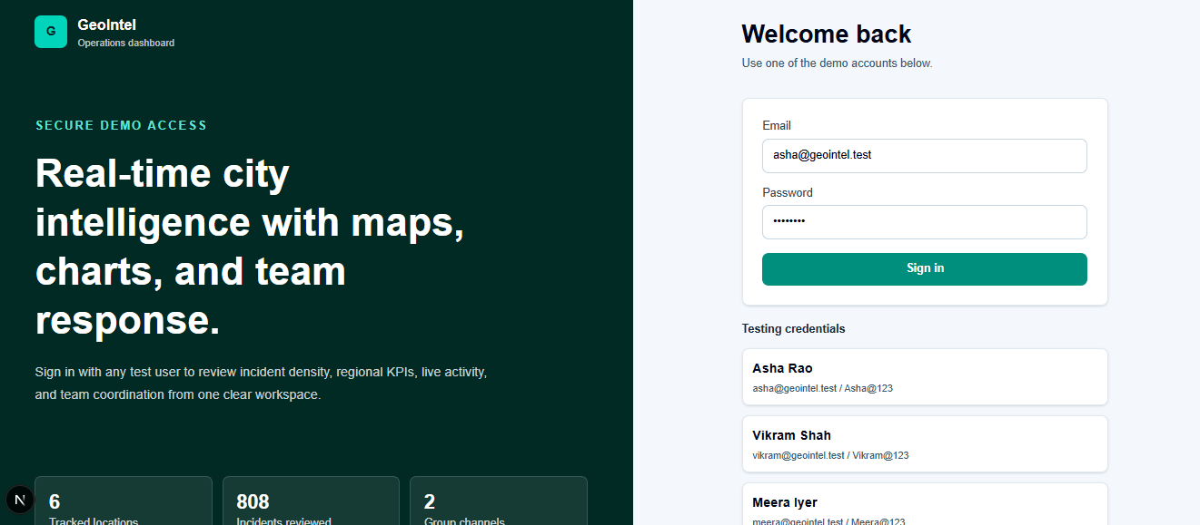
Fig. 8.1: Login Page
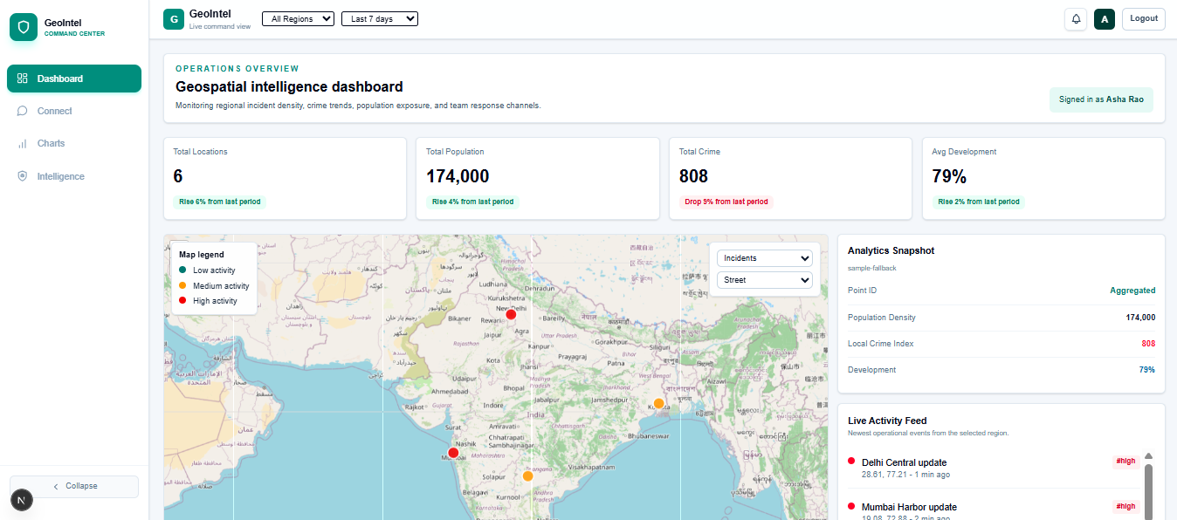
Fig. 8.2: Interactive GIS Map View
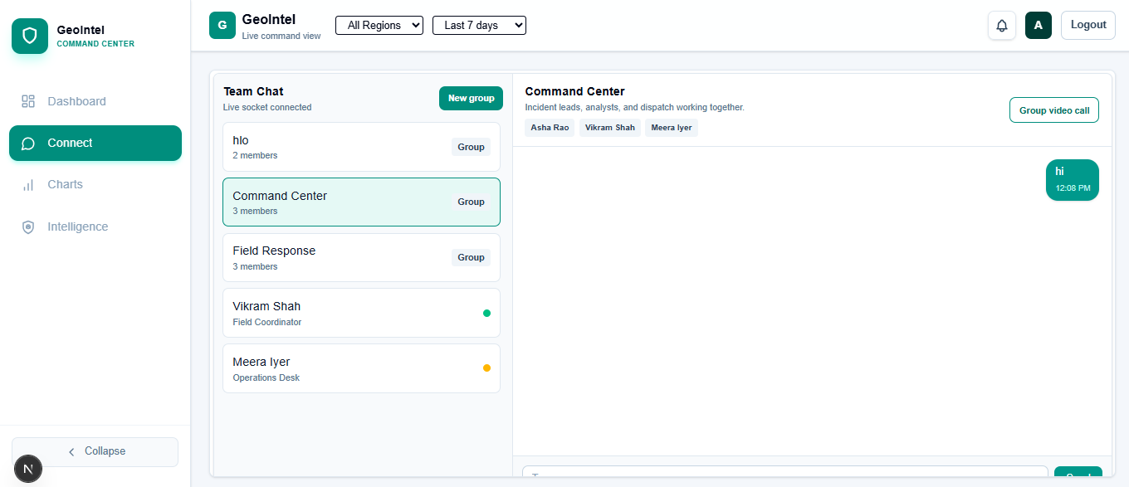
Fig. 8.3: : Chat Interface
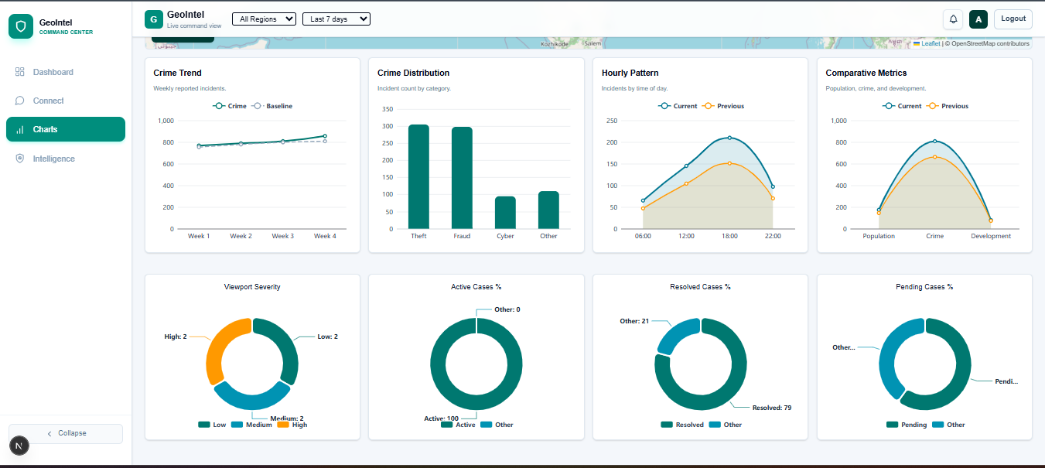
Fig. 8.6: ECharts Data Visualization
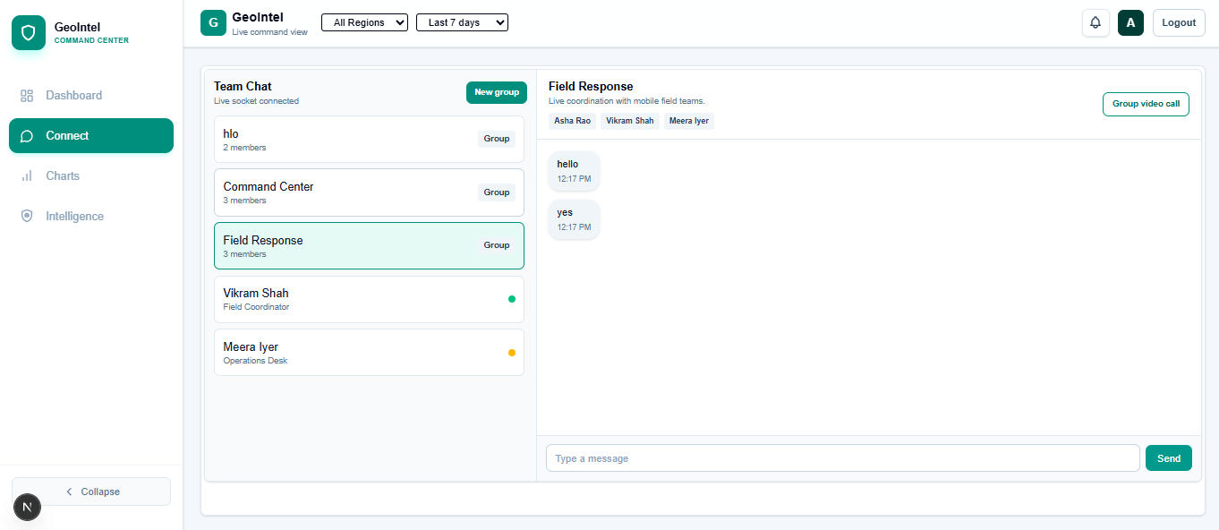
Fig. 8.8: Group Chat Interface
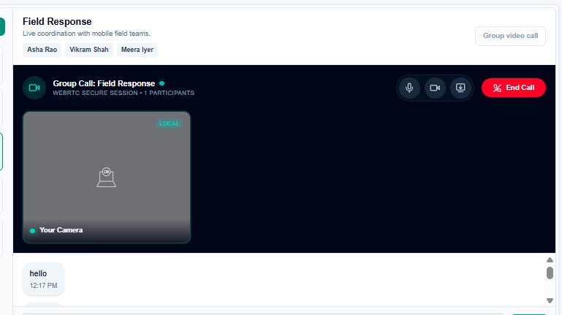
Fig. 8.9: WebRTC Video Calling Interface
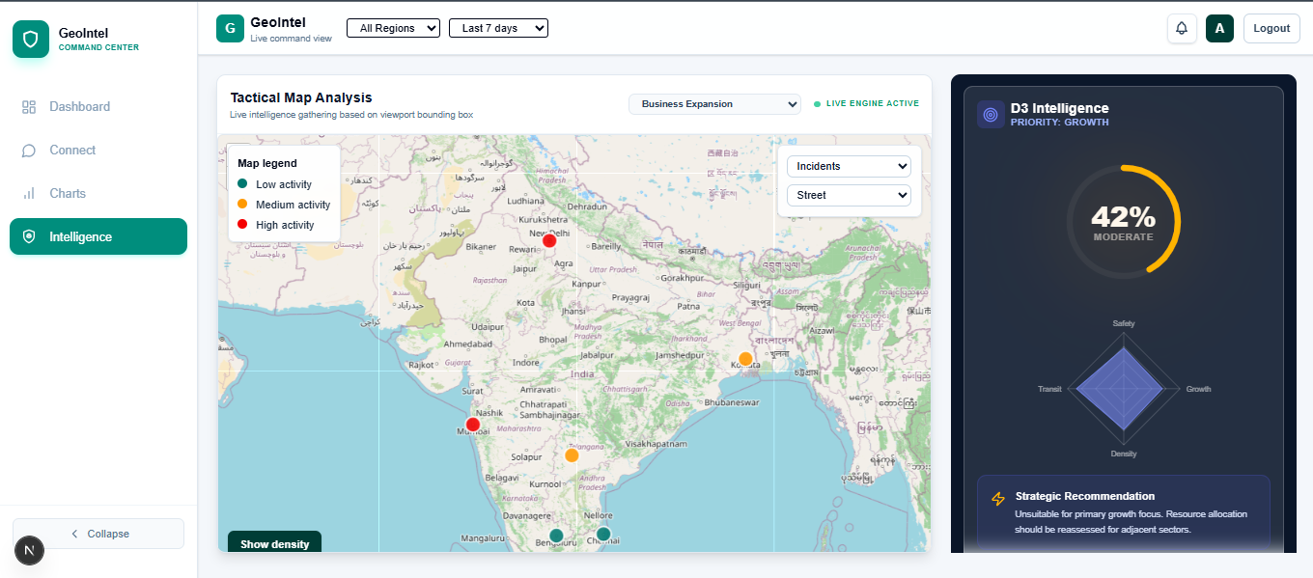
Fig. 8.9: WebRTC Video Calling Interface
CHAPTER 9: REFERENCES
The following references were consulted during the design and implementation of this project:
[1] Leaflet Contributors, “Leaflet.js Documentation,” 2024. [Online]. Available: https://leafletjs.com
[2] PostgreSQL Global Development Group, “PostgreSQL 16 Documentation,” 2024. [Online]. Available: https://www.postgresql.org/docs
[3] PostGIS Project Steering Committee, “PostGIS Documentation,” 2024. [Online]. Available: https://postgis.net/docs
[4] MongoDB, Inc., “MongoDB Documentation,” 2024. [Online]. Available: https://www.mongodb.com/docs
[5] Socket.io Team, “Socket.io Documentation,” 2024. [Online]. Available: https://socket.io/docs
[6] WebRTC Project, “WebRTC API Documentation,” MDN Web Docs, 2024. [Online]. Available: https://developer.mozilla.org/en-US/docs/Web/API/WebRTC_API
[7] Apache ECharts Team, “Apache ECharts Documentation,” 2024. [Online]. Available: https://echarts.apache.org/en/index.html
[8] Vercel, Inc., “Next.js Documentation,” 2024. [Online]. Available: https://nextjs.org/docs
[9] OpenStreetMap Contributors, “OpenStreetMap Wiki,” 2024. [Online]. Available: https://wiki.openstreetmap.org
[10] Tailwind CSS Team, “Tailwind CSS Documentation,” 2024. [Online]. Available: https://tailwindcss.com/docs
[11] W3C WebRTC Working Group, “WebRTC 1.0: Real-Time Communication Between Browsers,” 2021. [Online]. Available: https://www.w3.org/TR/webrtc
[12] GitHub, Inc., “Git Documentation,” 2024. [Online]. Available: https://git-scm.com/doc

