# MongoDB Installation.

## Create an EC2 instance in AWS.

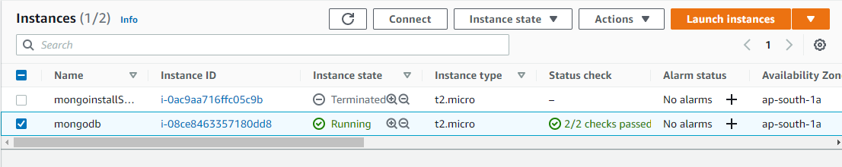

## 2. Check for the connectivity through SSH of the instance is reachable.

command: ssh -i sadiksha-mongo.pem [ubuntu@15.206.171.205](mailto:ubuntu@15.206.171.205)

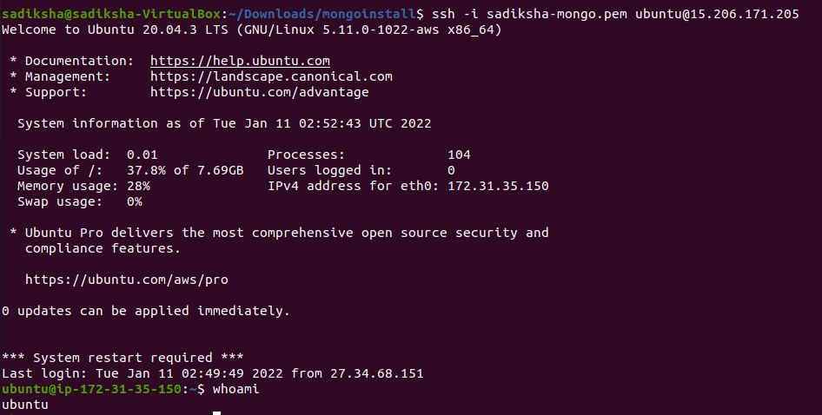

## Now, write an ansible playbook to upgrade packagaes, add repository for mongodb key, packages and install mongodb. Then, start the mongod service.

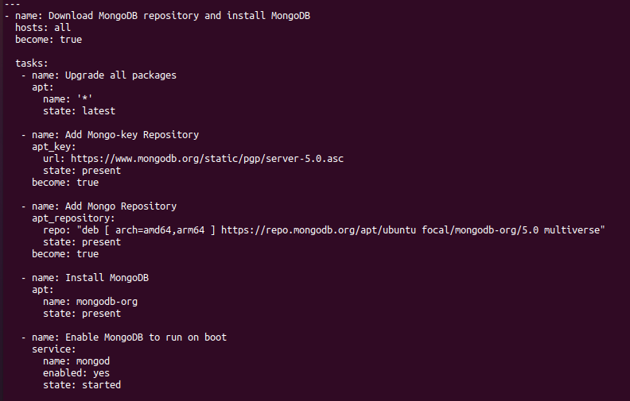

## 3. Add the remote IP in ansible host file at /etc/ansible/hosts.

command: sudo nano /etc/ansible/hosts

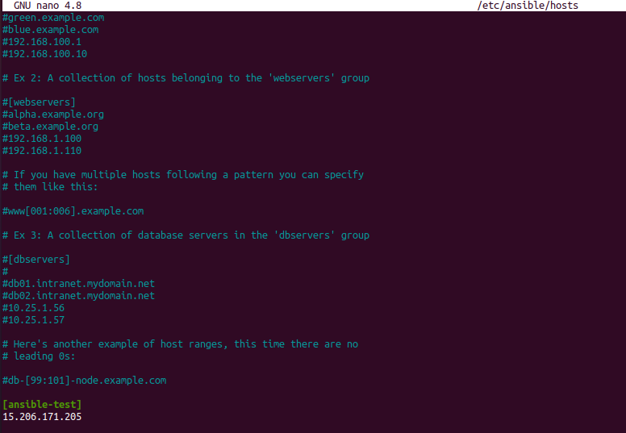

## 4. Run the playbook to install mongodb remotely.

command: ansible-playbook -u ubuntu --private-key sadiksha-mongo.pem mongo.yml

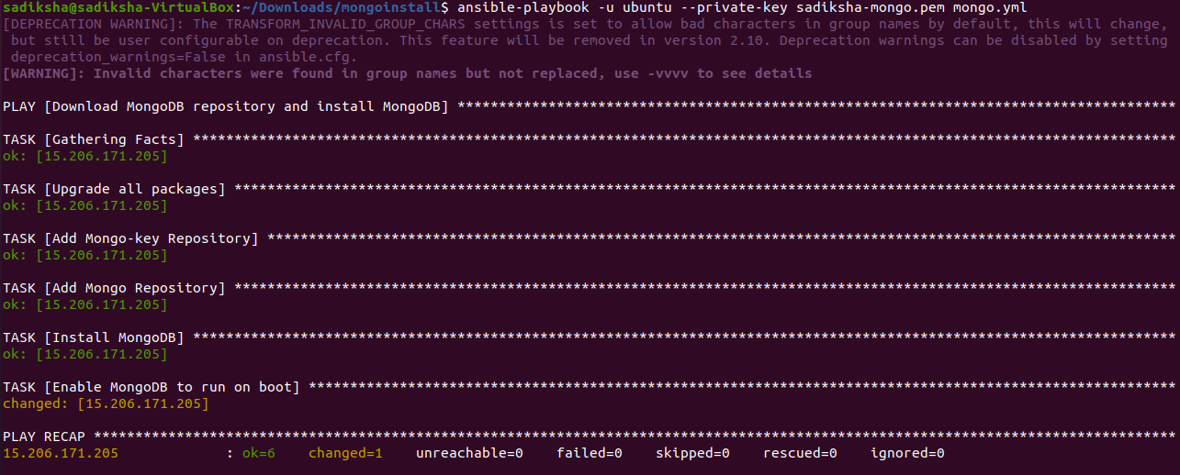

## 5. Check if mongodb is installed or not.

command: ssh -i sadiksha-mongo.pem ubuntu@15.206.171.205

command: mongod –version

