This workshop will test your knowledge of basic C concepts such as variable types, conditions, and loops.
- Create a program to classify a student’s grade into 3rd, 2:2, 2:1, and first from taking in a percentage number (integers). 3rd is <50, 2:2 is <60, 2:1 is <70 and first is >=70.

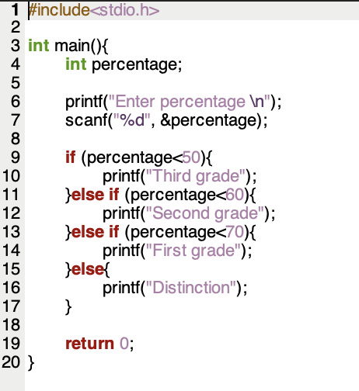

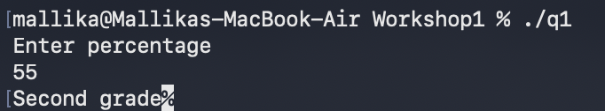

- Create a program that uses a while loop to print the first 50 triangular numbers. This question requires two bits of research: one is the formula to detect a triangular number (look online), and the other is to figure out when to stop. HINT – every time you print a triangular number, increment the loop variable!

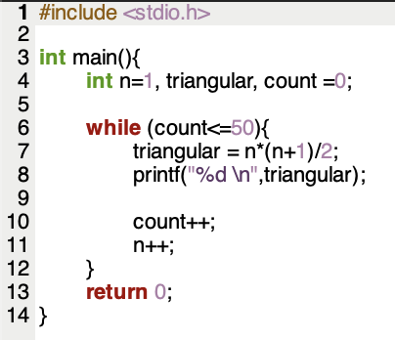

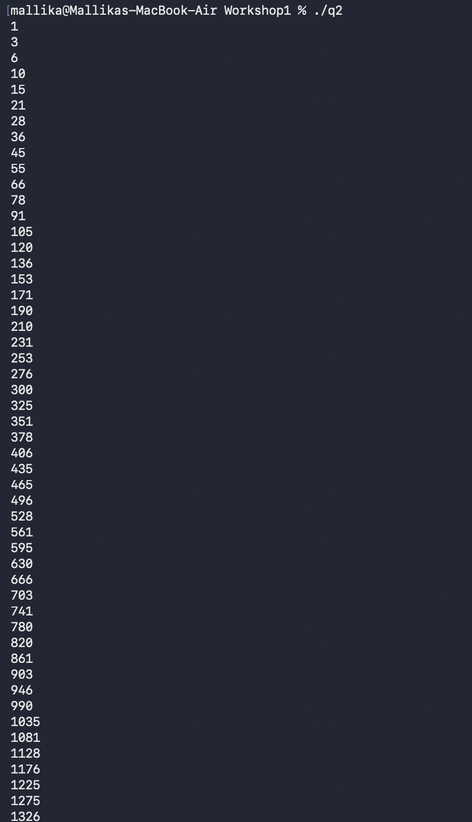

- Declare an array of at least 11 integers; the numbers can be random, so you can choose them. Create a program to loop through that list and print the:
  - Smallest value
  - Largest value
  - Average (use float or double)

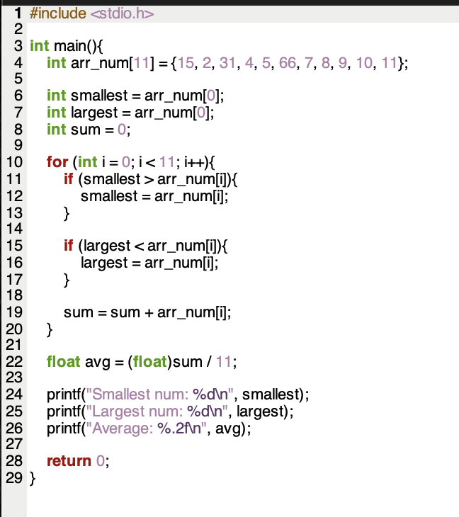

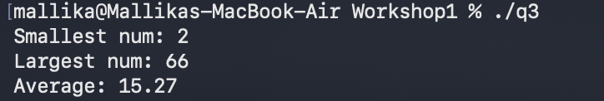

- Create a simple login system with a fixed pin. Create an integer called pin and set this to any 4-digit number. Then ask the user to type in a value; if this does not match, the user is given another 5 attempts. Your program should also log how many attempts it took to get the user to type in the correct pin.

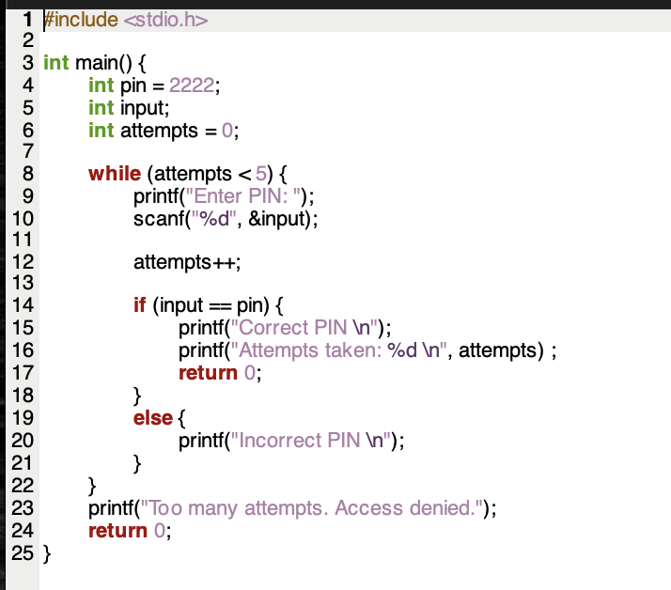

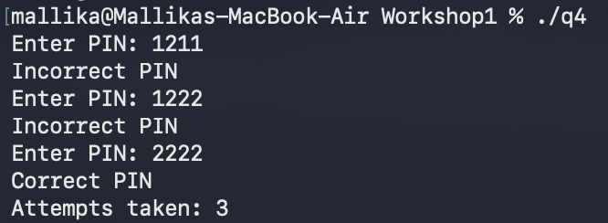

- Ask the user for “n” and print the first n Fibonacci numbers

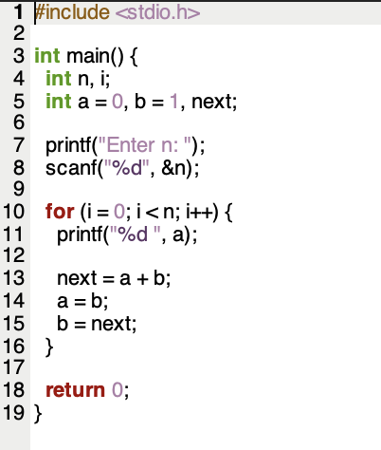

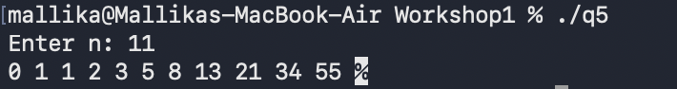

- Create a program to ask a user for a number, then check if this is a prime number.
  - Extend this program by continuingly asking the user for a number until they type in a prime number to end the script

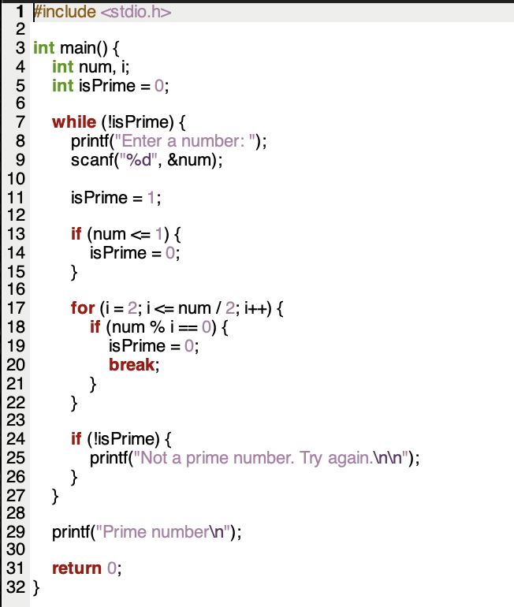

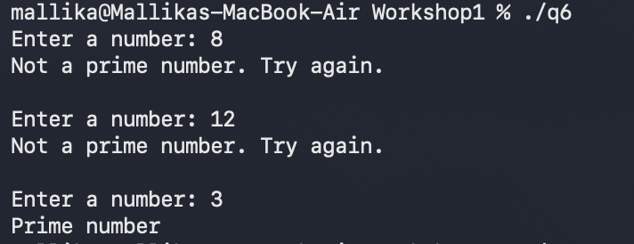

- Create a vending machine algorithm in C. For this program, you will need to start with 3 variables: one is the input (money put into the machine), the cost (product/s total), and the change to be dispensed. Your program should print out the coin value and coin amount for the change. For example, if my input was 250 pence (£2.50), the cost is 167 pence (£1.97),and the change is 53p. Your program should print the following
£2 x 0
£1 x 0
50p x 1
20p x 0
10p x 0
5 x 0
2 x 1
1 x 1
For this question, try to first create it without a loop if you do not understand how to use loops properly.
This workshop will not be assessed but it is important to understand basic C
