Adaptive Behaviour DDA System
Implementation Update Report
Supervisor Priority Corrections, Verification & Results (Priorities 1–6)
Sadu Ibraheem Afolabi
Matric No: 2022/41007
B.Sc. Computer Science — Osun State University, Osogbo
Supervisor: Mr. John Adeniran

Executive Summary
This report documents the corrections and improvements made to the Dynamic Difficulty Adjustment (DDA) framework in response to supervisor feedback, and supersedes the previously submitted update. It covers all six numbered priorities raised, plus a number of concrete implementation bugs discovered and fixed while addressing them — each is documented with before/after evidence rather than asserted.
In brief:
- Priority 1 — the weak, uncitable custom environment was replaced with a procedurally-generated MiniGrid-based environment (ObstacleMiniGridEnv), debugged extensively, and retrained with domain-randomized difficulty.
- Priority 2 — the instability metric was found to be structurally broken (denominator diluted every result toward zero) and replaced with two real, verified metrics: reversal frequency and rate-of-change variance.
- Priority 3 — Flow Zone bounds were formalized using one consistent rule (40th–70th percentile of a static, DDA-free baseline distribution) applied identically across all three environments.
- Priority 4 — bootstrapped 95% confidence intervals were added to the main benchmark results and the delta-sensitivity analysis.
- Priority 5 — deprioritized by mutual agreement in favour of higher-value fixes; noted as outstanding.
- Priority 6 — the Adaptation Latency metric was found to have two separate real bugs (single-crossing recovery detection, and a non-recovery sentinel value contaminating averages) — both fixed and verified against real data.
- In the course of this work, a further bug was discovered independently of the six priorities: ChaseEnv and MultiChaseEnv silently capped real difficulty at 6.0 regardless of the DDA Controller's intended 9.0 ceiling, meaning prior Single/Multi spike-mode results never actually tested the agents past that lower bound. This has been fixed and all affected results regenerated.
Figures 1 and 3 have been regenerated to reflect the corrected architecture and the corrected underlying data respectively.

Section A — Priorities Addressed

Priority 1 — Environment Replacement
The original environments (ChaseEnv, MultiChaseEnv) were flagged as “weak” — not because they were too easy, but because they were custom, unpublished, and only randomized initial conditions on a fixed layout rather than performing genuine procedural generation. This meant no external validation of generalization was possible.
A new environment, ObstacleMiniGridEnv, was built on MiniGrid's procedural generation primitives, with a single normalized difficulty scalar d ∈ [0,1] matching the existing set_difficulty() interface — so the DDA Controller, spike protocol, and evaluation pipeline required no changes to work against it.
Building this environment surfaced and required fixing a sequence of real bugs, each verified against actual data before being trusted:
- Hazards were tracked internally but never written into the render grid (invisible on screen).
- Hazard vertical spawn rows were deterministic (not random), and at high difficulty the hazard's horizontal homing matched the player's own move speed exactly — making evasion mathematically close to impossible. Fixed by randomizing spawn rows and decoupling horizontal homing cadence from vertical fall cadence.
- Hazards could spawn adjacent to the player, causing unfair instant deaths (“spawn-kills”). Fixed by confining spawns to the top half of the grid.
- Difficulty was non-monotonic: grid area grew quadratically while hazard count grew linearly, so increasing d sometimes made the environment easier, not harder — a direct violation of the DDA framework's core assumption. Diagnosed via systematic sweeps and fixed by decoupling grid size from difficulty scaling (with a controlled release valve at the top of the range).
- All training runs were found to have used a single fixed difficulty (d = 0.0, the easiest setting) for the entire training budget, producing a hard capability cliff (agents were reasonable at low difficulty and collapsed near-instantly at high difficulty). Fixed via domain-randomized training — every training episode now samples difficulty uniformly across [0,1] — while evaluation deliberately keeps difficulty fixed at a representative point for comparability across checkpoints. All three algorithms were retrained under this fix.
Key Finding: Under matched training conditions (domain-randomized, 6M steps, identical budget), PPO showed the steepest improvement slope and highest final performance, though with correspondingly higher variance; DDQN showed the most stable improvement of the three.

Priority 2 — Real Instability Metric
The original oscillation metric divided the count of direction changes by the total number of episodes — including episodes where the controller made no adjustment at all (because it was saturated at a bound, or already inside the Flow Zone). This diluted the metric toward zero regardless of how often the controller genuinely reversed direction when it did move, reproducing exactly the “controller appears stable at all deltas” problem the priority was raised to fix.
Replaced with two metrics, both verified against real cached speed-history data before being adopted:
- Reversal frequency — the fraction of nonzero speed changes that flip direction, using nonzero transitions as the denominator.
- Rate-of-change variance — Var(Δd) across the full episode history, a metric named explicitly in the original supervisor feedback.
Key Finding: Verified real, environment-differentiated, delta-varying values from a genuinely broken flat 0.0000 baseline — e.g. Procedural's reversal frequency rises from 0.15 at δ=0.05 to a clean 1.0000 (full bang-bang oscillation) at δ=1.00. Separately, Single's DDQN controller was found to show a genuine, verified 0.0000 reversal frequency under steady conditions — not a metric artifact, but a real finding: its policy is strong enough that the controller only ever needs to push difficulty upward, never back off.

Priority 3 — Flow Zone Formalization
Flow Zone bounds are now calculated with one consistent rule across every environment: the 40th–70th percentile of a pooled STATIC baseline distribution (frozen policy, fixed difficulty, no DDA Controller active). Calibrating from DDA-active data would be circular — the controller would already be steering toward whatever bound was being measured — so a neutral, controller-free reference point was used instead.
- Single: (296.0, 765.0) — calibrated at difficulty 6.0 (deliberately, not at the DDA ceiling of 9.0), chosen to push all three algorithms above their comfort zone without collapsing the two weaker algorithms' performance to near-zero, so a balanced three-algorithm comparison remains possible.
- Multi: (245.6, 470.1)
- Procedural: (−74.5, −23.7) — negative bounds are mathematically correct, not an error: reward is +1/step survival, −100 on collision, so a negative mean reward reflects dying within roughly 15–30 steps on average, an honest snapshot of current agent capability at this newer, harder environment.

Priority 4 — Confidence Intervals
Bootstrapped 95% confidence intervals (percentile method, 10,000 resamples) have been added to the main benchmark results (Table 3), the steady-vs-spike comparison (Table 8), and the delta-sensitivity analysis, computed across the 5 evaluation seeds per cell. A bootstrap approach was used rather than a normal-assumption interval because n = 5 seeds does not comfortably justify a normality assumption.

Priority 5 — Multi-Environment Training Curves
Deprioritized by mutual agreement in favour of the higher-value fixes above, given time constraints. Noted here as an explicitly outstanding item rather than silently dropped.

Priority 6 — Adaptation Latency Variance
Two separate, real bugs were found and fixed, verified against real evaluation data at each step:
- Recovery detection previously used a single threshold-crossing — the rolling-average reward touching 80% of its pre-spike peak once was enough to declare recovery. This is exactly the shape of bug that produces high-variance, bimodal latency in a stochastic environment: a brief noisy crossing gets reported as “recovery” when the agent immediately relapses. Fixed by requiring 5 consecutive episodes above threshold before recovery is declared.
- Separately, when a seed never recovers within the 500-episode evaluation window, the pipeline recorded a literal value of 500 as if it were a genuine recovery duration, rather than a censored/missing marker. Averaging this sentinel directly into the mean badly distorted both the mean and the standard deviation — e.g. one real cell had per-seed latencies of [23, 29, 37, 25, 500], naively averaging to 122.8 ± 210.9 when the honest statement is “4 of 5 seeds recovered in 28.5 ± 6.2 episodes; 1 of 5 never recovered.” Fixed by reporting recovery rate as its own statistic and computing latency mean/std only over seeds that actually recovered.
Key Finding: The sustained-recovery fix alone did not fully resolve the originally-flagged high-variance problem when tested in isolation — this is itself informative: it is evidence for the supervisor's alternative hypothesis (genuine environmental stochasticity), not proof the detection bug was the sole cause. Both fixes are reported together in Table 8, with partial-recovery cells (e.g. 4/5, 3/5) flagged explicitly rather than hidden inside an average.

An Additional Bug Found Outside the Six Priorities
While investigating an unexpectedly small Single-environment Flow Zone violation under DDQN, ChaseEnv.set_difficulty() and MultiChaseEnv.set_difficulty() were both found to silently clip real difficulty to 6.0, regardless of the DDA Controller's own tracked ceiling of 9.0. This meant every prior spike-mode evaluation on Single and Multi forced the controller's internal variable to 9.0 while the environment itself never actually exceeded 6.0 — the spike was, in effect, frequently a near no-op.
Fixed by correcting the clip to 9.0 in both environment files. All affected Single and Multi evaluation data (steady mode, spike mode, and delta sensitivity) was regenerated. The effect was substantial and directly verifiable: Single's spike-mode adaptation latency changed from 10 episodes to 140 episodes once the environment was genuinely tested past its old artificial ceiling — confirming the fix, not just changing a number arbitrarily.

Section B — Updated Results Tables

Table 3 — Main Benchmark Results (Steady Mode, 5-seed aggregate)
Flow Zone bounds (see Priority 3): Single (296.0, 765.0) · Multi (245.6, 470.1) · Procedural (−74.5, −23.7).

Single Environment
Algorithm | Mean Reward [95% CI] | FZC (%) [95% CI]
DQN | 613.5 [599.9, 623.3] | 56.3% [52.8, 59.3]
DDQN | 788.6 [779.3, 798.8] | 68.3% [62.7, 73.8]
PPO | 678.8 [672.0, 688.0] | 78.9% [76.5, 81.3]

Multi Environment
Algorithm | Mean Reward [95% CI] | FZC (%) [95% CI]
DQN | 361.1 [359.5, 362.7] | 76.3% [74.5, 78.0]
DDQN | 355.9 [351.8, 359.8] | 78.5% [75.6, 80.8]
PPO | 368.5 [365.4, 372.0] | 66.2% [60.3, 71.7]

Procedural Environment
Algorithm | Mean Reward [95% CI] | FZC (%) [95% CI]
DQN | −34.9 [−36.4, −33.2] | 54.5% [49.3, 58.9]
DDQN | −34.9 [−38.0, −32.1] | 68.4% [62.2, 73.7]
PPO | 27.6 [19.1, 37.6] | 42.1% [34.4, 50.9]

Key Finding: All three environments' steady-mode results were reproduced byte-identically on re-run (compile_results.py reads only cached, deterministic data), and a manual single-seed spot-check fell within the reported 95% CI — both used as independent verification before these numbers were finalized.

Table 8 — Steady vs Spike Comparison (All Algorithms, 5-seed aggregate, δ=0.05)
Expanded relative to the previous version, which covered only DDQN at a single seed. Adaptation Latency is computed only over seeds that recovered within the 500-episode window (Priority 6); a recovery rate below 5/5 is noted explicitly rather than hidden inside the average.

Single Environment
Algorithm | Mode | Mean Reward [95% CI] | FZC (%) [95% CI] | Latency (eps, recovered only)
DQN | Steady | 613.5 [599.9, 623.3] | 56.3% [52.8, 59.3] | N/A (no spike)
DQN | Spike | 547.6 [537.2, 556.6] | 61.5% [56.7, 66.2] | 106.0 ± 103.3 (5/5)
DDQN | Steady | 788.6 [779.3, 798.8] | 68.3% [62.7, 73.8] | N/A (no spike)
DDQN | Spike | 751.4 [738.5, 765.4] | 58.6% [53.6, 63.0] | 86.6 ± 33.0 (5/5)
PPO | Steady | 678.8 [672.0, 688.0] | 78.9% [76.5, 81.3] | N/A (no spike)
PPO | Spike | 608.9 [603.3, 614.4] | 68.6% [66.9, 70.3] | 104.6 ± 45.2 (5/5)

Multi Environment
Algorithm | Mode | Mean Reward [95% CI] | FZC (%) [95% CI] | Latency (eps, recovered only)
DQN | Steady | 361.1 [359.5, 362.7] | 76.3% [74.5, 78.0] | N/A (no spike)
DQN | Spike | 297.3 [291.2, 302.7] | 59.4% [57.9, 60.9] | 151.2 ± 15.1 (4/5)
DDQN | Steady | 355.9 [351.8, 359.8] | 78.5% [75.6, 80.8] | N/A (no spike)
DDQN | Spike | 289.7 [285.6, 293.8] | 60.2% [57.4, 63.6] | 145.2 ± 27.4 (5/5)
PPO | Steady | 368.5 [365.4, 372.0] | 66.2% [60.3, 71.7] | N/A (no spike)
PPO | Spike | 298.5 [296.4, 300.6] | 48.4% [44.7, 51.7] | 129.2 ± 30.4 (5/5)

Procedural Environment
Algorithm | Mode | Mean Reward [95% CI] | FZC (%) [95% CI] | Latency (eps, recovered only)
DQN | Steady | −34.9 [−36.4, −33.2] | 54.5% [49.3, 58.9] | N/A (no spike)
DQN | Spike | −35.6 [−37.9, −33.4] | 52.5% [47.9, 56.4] | 23.3 ± 5.9 (3/5)
DDQN | Steady | −34.9 [−38.0, −32.1] | 68.4% [62.2, 73.7] | N/A (no spike)
DDQN | Spike | −36.5 [−40.0, −33.1] | 70.5% [66.2, 74.3] | 75.4 ± 64.7 (5/5)
PPO | Steady | 27.6 [19.1, 37.6] | 42.1% [34.4, 50.9] | N/A (no spike)
PPO | Spike | 26.7 [22.5, 30.8] | 43.5% [37.0, 51.2] | 56.2 ± 67.0 (5/5)

Key Finding: Single's DQN and PPO show full 5/5 recovery despite high individual-episode variance in latency; Multi's DQN and Procedural's DQN show partial recovery (4/5, 3/5) — these partial-recovery cases are direct, concrete evidence for the environmental-stochasticity explanation of Priority 6's originally-flagged variance.

Section C — Updated Figures

Figure 1 — Full System Architecture Diagram
Regenerated to reflect all three environments and all three algorithms (previously showed only ChaseEnv / DDQN), to remove a stale hardcoded Flow Zone bound, to correctly show the Perturbation Module overriding the Environment directly (not the Agent, as an earlier draft incorrectly implied), and to add the timescale labels, injection-point marker, and DDA update-rule annotation requested by the supervisor. Every claim on this diagram, including the exact update-rule formula, was checked line-by-line against the actual controller code before being finalized.
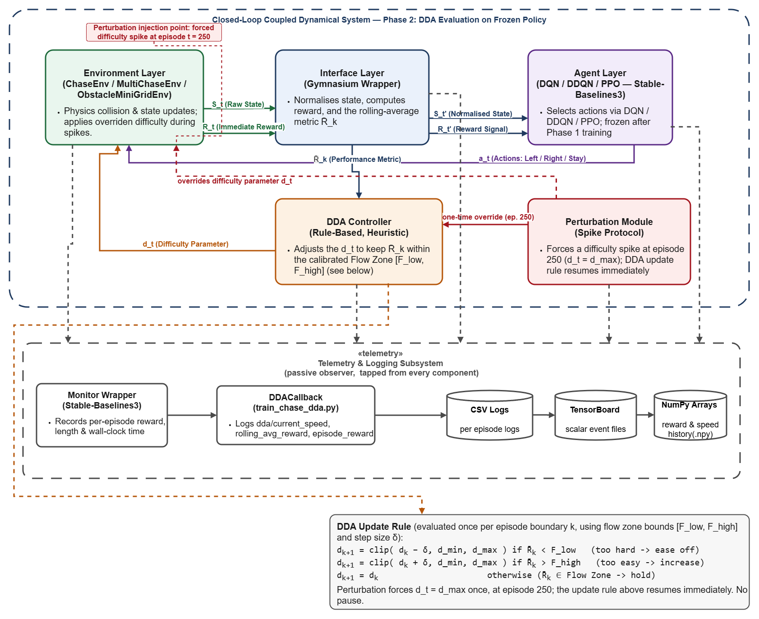
Figure 1: Full system architecture, verified against source code, showing the inner (per-timestep) and outer (per-episode-boundary) loops, the perturbation injection point, and the DDA update rule.

Figure 3 — Reward Stability Under Dynamic Difficulty
Regenerated for all three environments in both steady and spike mode, using corrected Flow Zone bounds and (for Single/Multi) the corrected 9.0 difficulty ceiling. Legend spacing and the Procedural reward axis (previously compressed and difficult to read against rare large early-episode outliers) were also fixed.

Single Environment
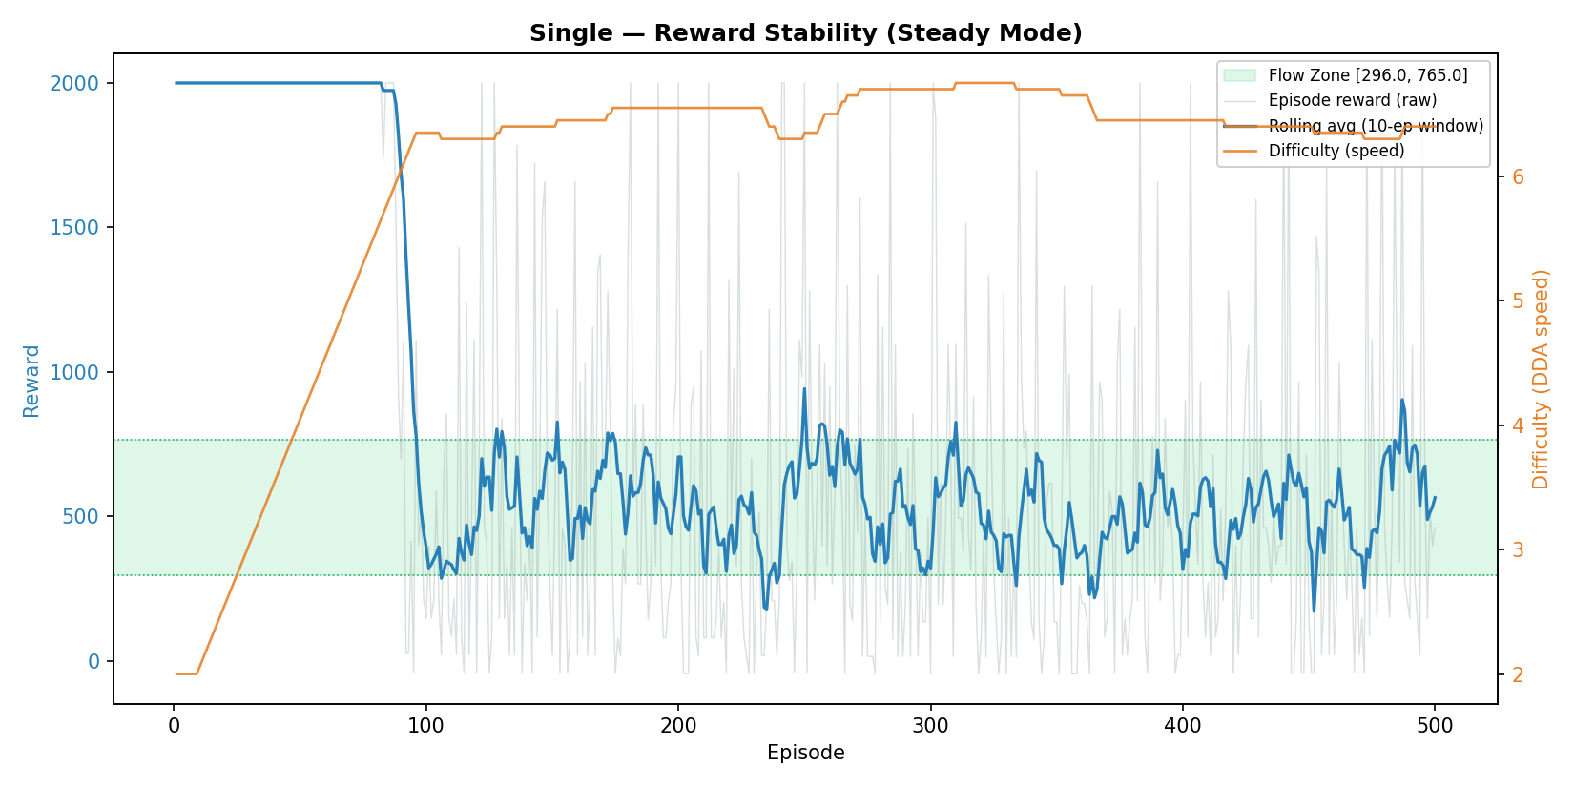
Figure 3a: Single — Steady Mode.
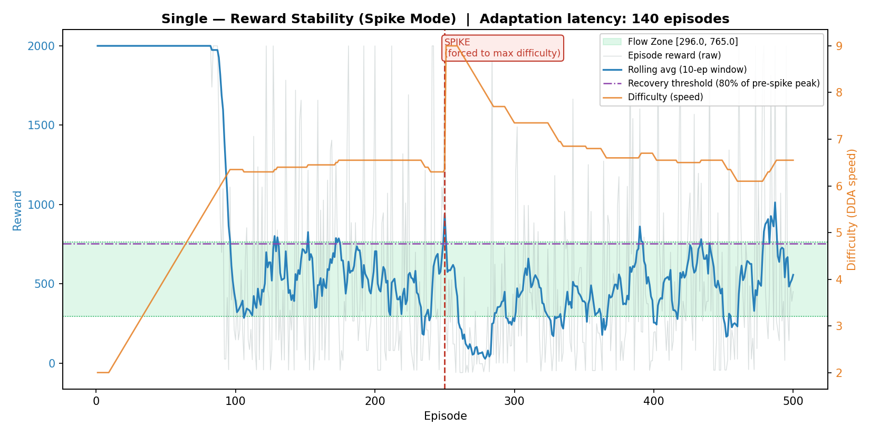
Figure 3b: Single — Spike Mode. Adaptation latency 140 episodes, following the difficulty-ceiling fix (previously 10 episodes under the uncorrected 6.0 clip).

Multi Environment
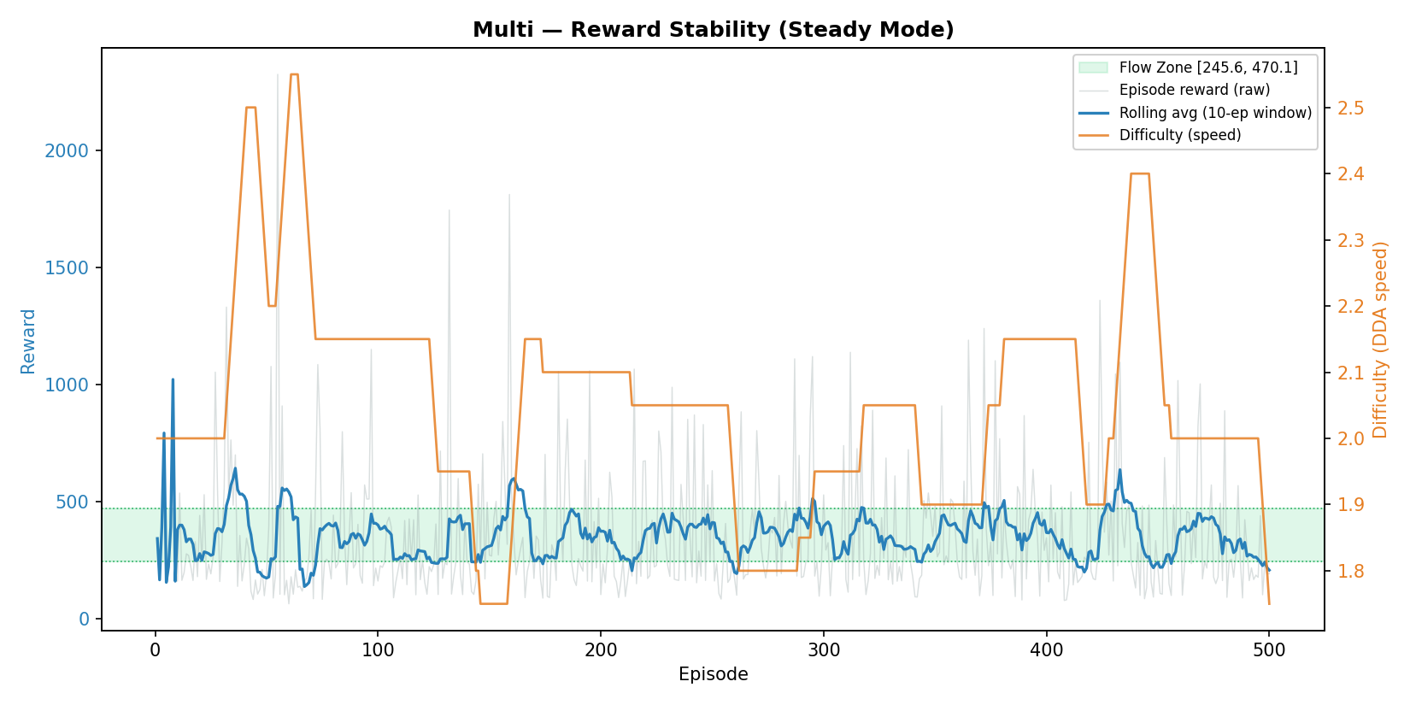
Figure 3c: Multi — Steady Mode.
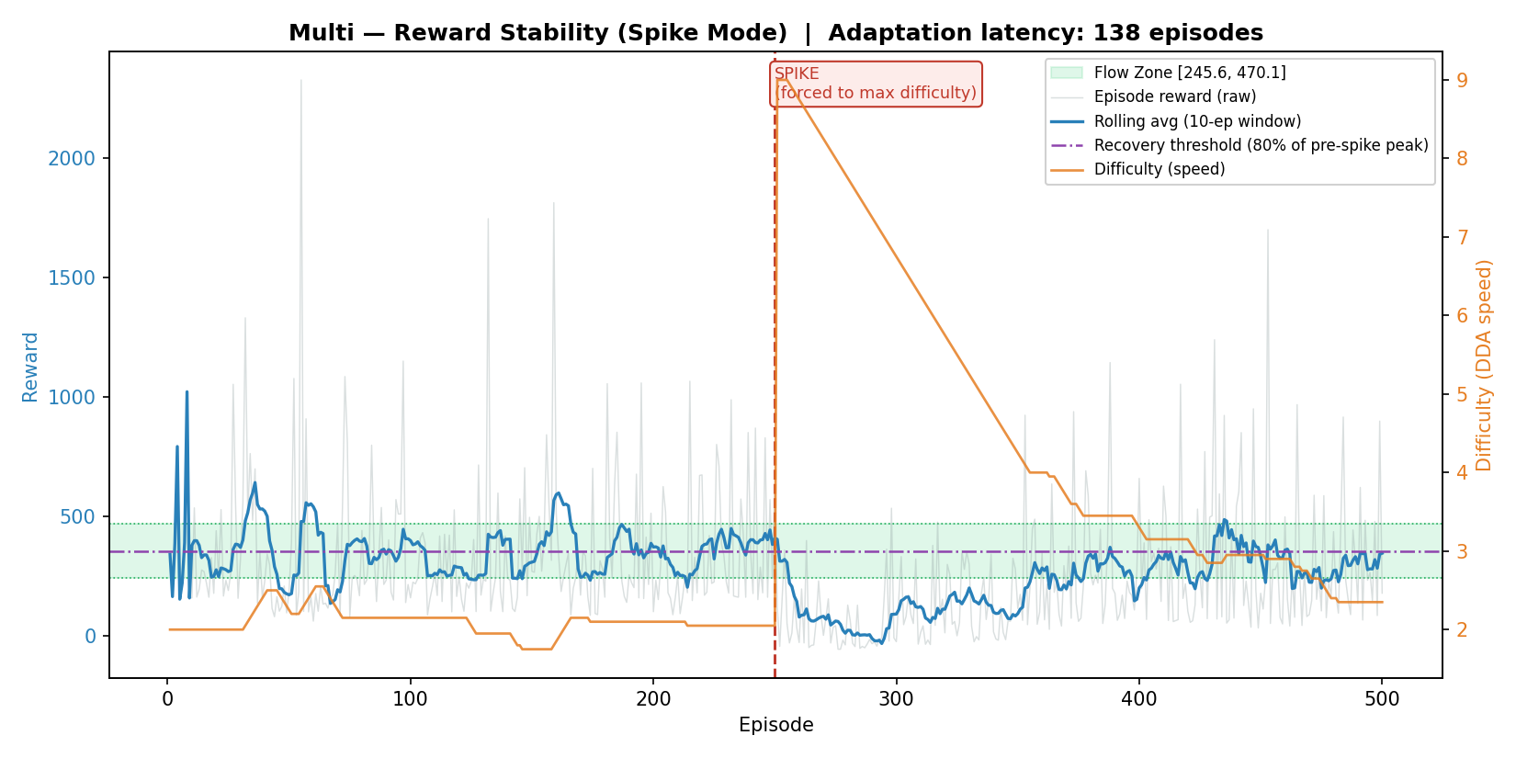
Figure 3d: Multi — Spike Mode. Adaptation latency 138 episodes.

Procedural Environment
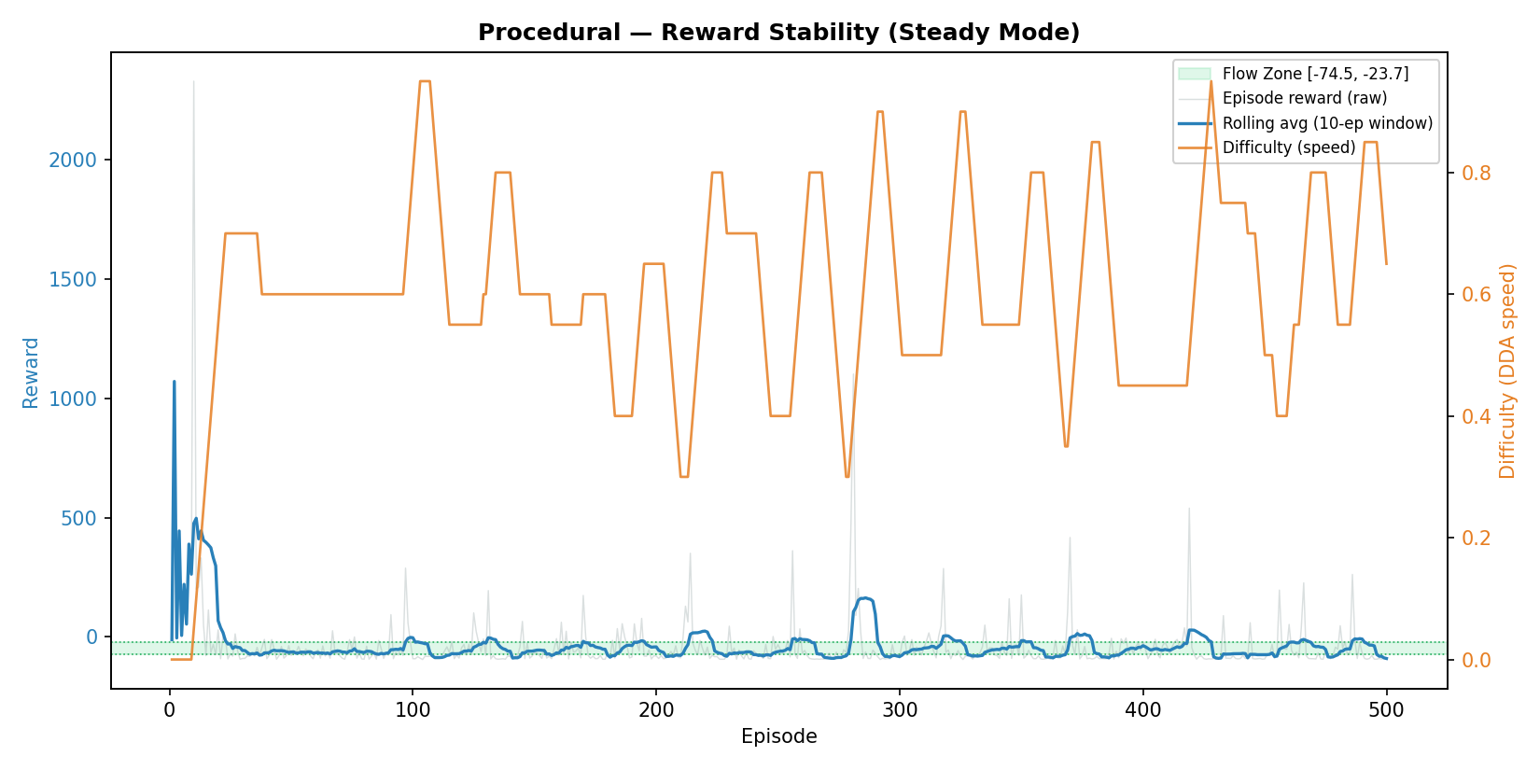
Figure 3e: Procedural — Steady Mode.
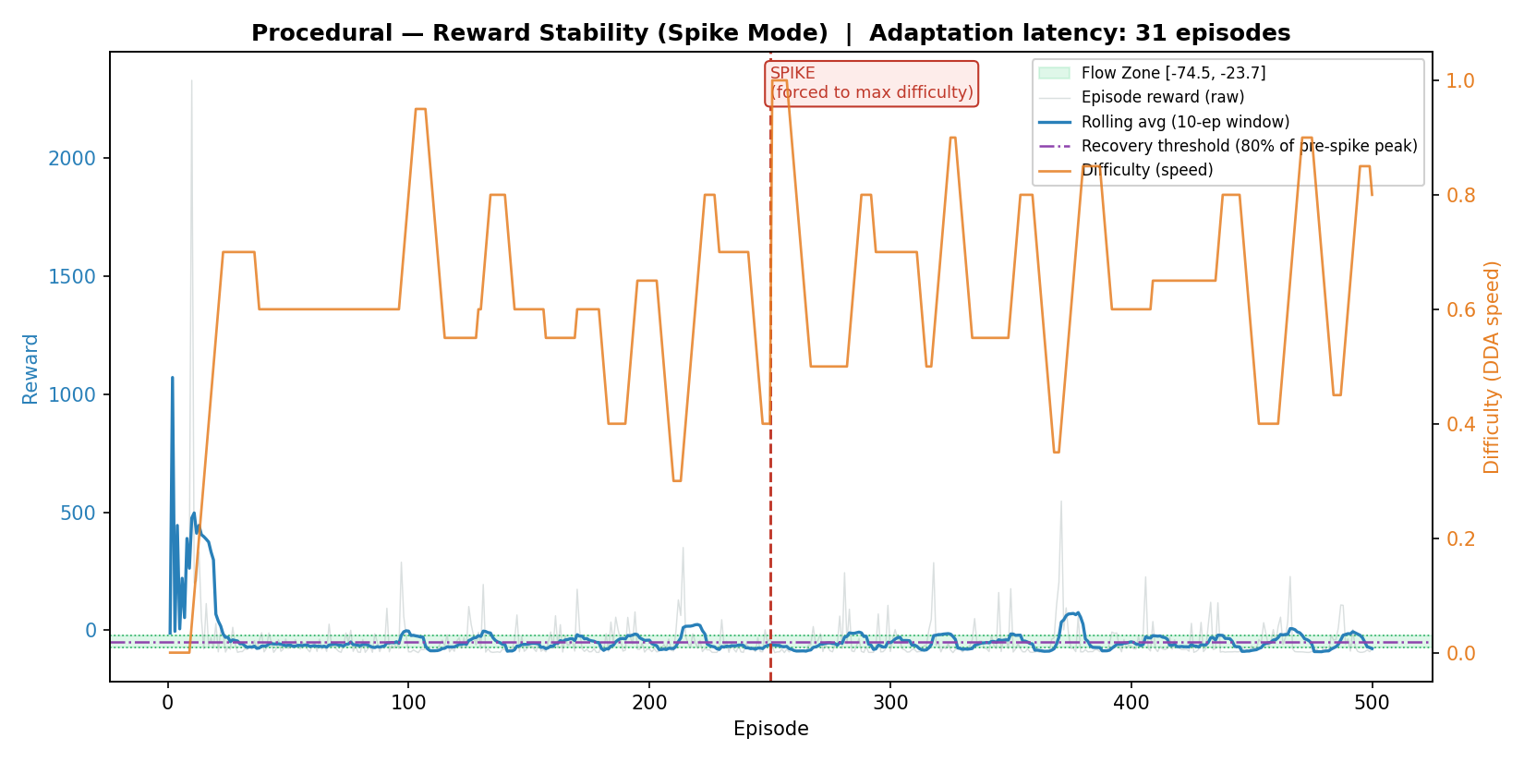
Figure 3f: Procedural — Spike Mode. Adaptation latency 31 episodes.

Section D — Outstanding Items and Known Limitations
- Priority 5 (multi-environment training curves) remains outstanding, deprioritized by agreement.
- Priority 4's confidence intervals have been added to Tables 3 and 8 and the delta-sensitivity analysis, but not yet propagated to every remaining table in the wider results set.
- Single's Flow Zone was deliberately calibrated at a static difficulty of 6.0 rather than the DDA ceiling of 9.0, specifically to keep a balanced three-algorithm comparison rather than collapsing DQN and PPO's performance — a documented design choice, not an oversight.
- Figures 2 and 4–10 from the original report have not been regenerated in this update cycle; this report covers Figures 1 and 3 only, which were the two explicitly requested by the supervisor for revision.

Section E — Files Updated in This Cycle
- envs/obstacle_minigrid_env.py — procedurally-generated environment, domain-randomized training support.
- envs/chase_env.py, envs/multi_chase_env.py — difficulty ceiling clip corrected from 6.0 to 9.0.
- training/train_multi_env.py — sustained-recovery detection (Priority 6), corrected Flow Zone bounds.
- scripts/compile_results.py — rewritten: corrected Flow Zone import, corrected folder paths, added Procedural, sentinel-safe latency aggregation, bootstrap CIs.
- scripts/run_delta_sensitivity.py — corrected instability metrics, corrected Flow Zone import, bootstrap CIs, sentinel-safe latency aggregation.
- scripts/recompute_adaptation_latency.py — new utility to reapply the Priority 6 fix to already-collected data without re-running expensive evaluations.
- scripts/generate_figure3_reward_stability.py — legend spacing and reward-axis scaling fixes.
- Architecture diagram (Figure 1) — fully revised and verified against source code.

