ASSIGNMENT 1
Student Name: Sadip Tamang
TASK 1: Ground Truth SQL Benchmark Dataset & Output Log

Q1. List all products
SQL Query: SELECT * FROM products;
Logic Explanation: Selects all columns and all records from the products table
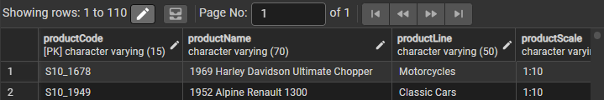

Q2. Get all customers
SQL Query: SELECT * FROM customers;
Logic Explanation: Selects all columns and all records from the customers table
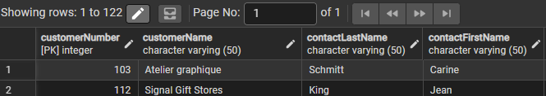

Q3. Show all orders
SQL Query: SELECT * FROM orders;
Logic Explanation: Selects all records and columns from the ordres table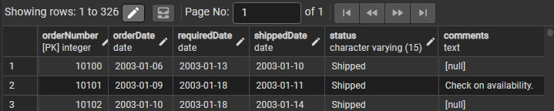

Q4. List all employees

SQL Query: SELECT * FROM employees;
Logic Explanation: Returns all records from the employees table to view the full staff directory and reporting lines.
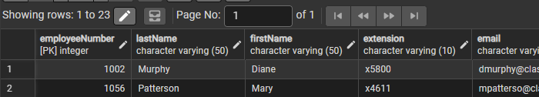

Q5. Get all offices
SQL Query: SELECT * FROM offices;
Logic Explanation: Retrieves all global office location records, including addresses and telephone details.
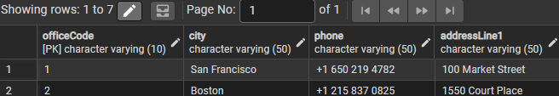

Q6. Show all product lines
SQL Query: SELECT * FROM productlines;
Logic Explanation: Fetches all rows from the productlines table to review macro product classifications and descriptions.
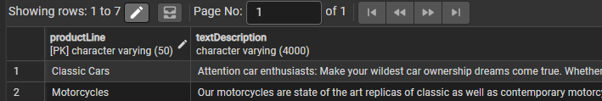

Q7. List all payments
SQL Query: SELECT * FROM payments;
Logic Explanation: Queries the full history of customer payments, check references, and associated dates.
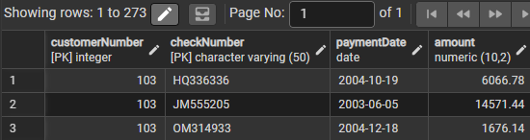
Q8. Get product names and prices
SQL Query: SELECT "productName", "buyPrice" FROM products;
Logic Explanation: Filters the products table to only display catalog names, procurement costs, and suggested retail prices.
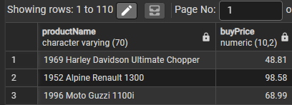

Q9. Get customer names and cities
SQL Query: SELECT "customerName", "city" FROM customers;
Logic Explanation: Extracts specific geographical customer insights by retrieving name and city columns.
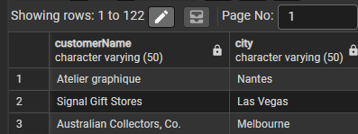

Q10. List employee first and last names
SQL Query: SELECT "firstName", "lastName" FROM employees;
Logic Explanation: Extracts only the full name components from the employee table for directory compiling.
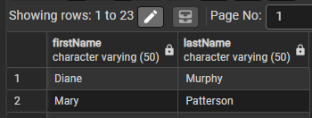

Q11. Get all order dates
SQL Query: SELECT "orderDate" FROM orders;
Logic Explanation: Isolates the order timestamps across all orders to identify transaction dates.

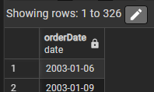
Q12. Show product vendor list
SQL Query: SELECT DISTINCT "productVendor" FROM products;
Logic Explanation: retrieves unique list of product vendors
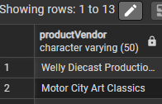\

13. Get all product codes
SQL Query: SELECT DISTINCT "productCode" FROM products;
Logic Explanation: Extracts all unique SKU identifiers from the product catalog inventory table.
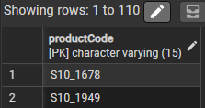

Q14. List all countries from offices
SQL Query: SELECT DISTINCT "country" FROM offices;
Logic Explanation: Returns the host nations of all operational corporate offices.

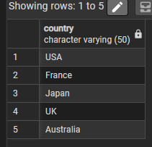

Q15. Show all order statuses
SQL Query: SELECT DISTINCT "status" FROM orders;
Logic Explanation: Lists fulfillment statuses across the entire transactional order database.

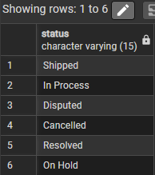

Q16. Get all payment amounts
SQL Query: SELECT "amount" FROM payments;
Logic Explanation: Isolates individual financial payment amounts collected from customers.
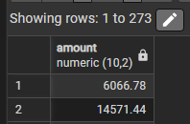

Q17. List all job titles
SQL Query: SELECT DISTINCT "jobTitle" FROM employees;
Logic Explanation: Fetches all unique job titles.
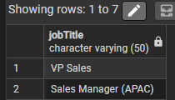

Q18. Get customer phone numbers
SQL Query: SELECT "phone" FROM customers;
Logic Explanation: Extracts telephone numbers for all customer records for billing or follow-up communications.
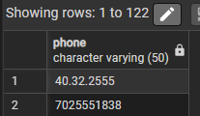

Q19. Show product MSRP values
SQL Query: SELECT "MSRP" FROM products;
Logic Explanation: Isolates manufacturer suggested list pricing data for catalog metrics evaluation.:
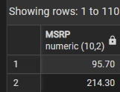

Q20. List order numbers
SQL Query: SELECT "orderNumber" FROM orders;
Logic Explanation: Retrieves sequence numbers across the historical ledger records of orders.
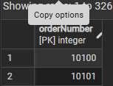

Part 2: Multi-Table JOIN Queries (Questions 21-30)

Q21. Get orders with customer names

SQL Query: SELECT o."orderNumber", c."customerName" FROM "orders" o JOIN "customers" c ON o."customerNumber" = c."customerNumber";
Logic Explanation: Executes an INNER JOIN between orders and customers matching on customerNumber to map transaction identifiers with real human-readable company titles.
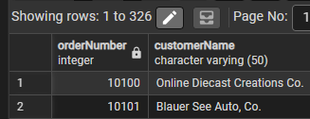

Q22. Get employees with office city
SQL Query: SELECT e."employeeNumber", e."firstName", e."lastName", o."city" FROM employees e JOIN offices o ON e."officeCode" = o."officeCode";
Logic Explanation: Combines employee directories with geographic corporate office entities on officeCode to present exact staff desk cities.
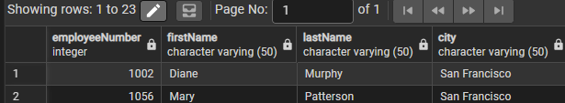

Q23. Get payments with customer names
SQL Query: SELECT e."firstName", e."lastName", o."city" FROM "employees" e JOIN "offices" o ON e."officeCode" = o."officeCode";
Logic Explanation: Joins payment histories with the customers table to provide business audit trails showing client names against transaction codes.
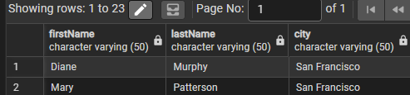

Q24. Get order details with product names
SQL Query: SELECT od."orderNumber", od."productCode", p."productName", od."quantityOrdered", od."priceEach" FROM orderdetails od JOIN products p ON od."productCode" = p."productCode";
Logic Explanation: Resolves specific items within order details lines into plain language names by joining with the products inventory table.
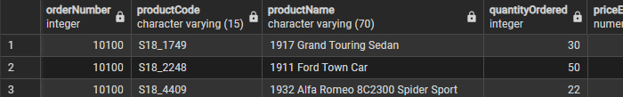
Q25. Get products with product line description
SQL Query: SELECT p."productCode", p."productName", pl."productLine", pl."textDescription" FROM products p JOIN productlines pl ON p."productLine" = pl."productLine";
Logic Explanation: Connects products with documentation tables to return item names side-by-side with general line narratives.
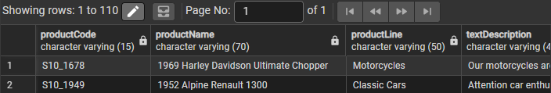

Q26. Get customers with sales rep names
SQL Query: SELECT c."customerNumber", c."customerName", e."firstName" AS "repFirstName", e."lastName" AS "repLastName" FROM customers c JOIN employees e ON c."salesRepEmployeeNumber" = e."employeeNumber";
Logic Explanation: Links corporate buyers with their specific dedicated account manager using an explicit key match on manager primary keys.
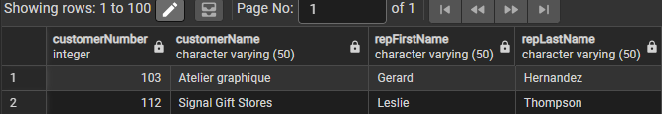

Q27. Get orders with customer city
SQL Query: SELECT o."orderNumber", o."orderDate", c."city" FROM orders o JOIN customers c ON o."customerNumber" = c."customerNumber";
Logic Explanation: Retrieves structural transaction logs paired up with location demographics from customer accounts.
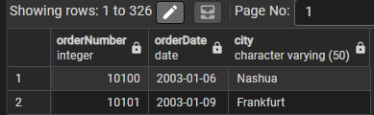

Q28. Get employees and their manager
SQL Query: SELECT e."employeeNumber", e."firstName" AS "empFirstName", e."lastName" AS "empLastName", m."firstName" AS "mgrFirstName", m."lastName" AS "mgrLastName" FROM employees e LEFT JOIN employees m ON e."reportsTo" = m."employeeNumber";
Logic Explanation: Implements a self-join mapping on reportsTo to compile employee relationships with supervisors. LEFT JOIN retains high-level executives like the President.
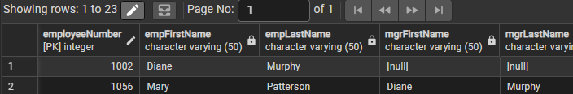

Q29. Get orderdetails with product vendor
SQL Query: SELECT od."orderNumber", od."productCode", p."productVendor", od."quantityOrdered" FROM orderdetails od JOIN products p ON od."productCode" = p."productCode";
Logic Explanation: Joins lines details to inventory items to outline distributor names against real volumes fulfilled.
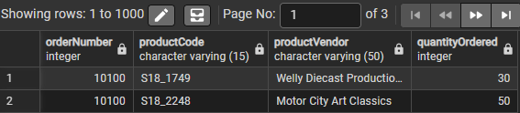

Q30. Get payments with customer country
SQL Query: SELECT p."checkNumber", p."amount", c."country" FROM payments p JOIN customers c ON p."customerNumber" = c."customerNumber";
Logic Explanation: Maps client geographic regions directly with their receipts details ledger via foreign key link.
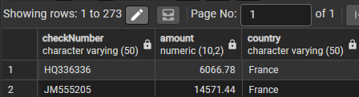

Part 3: Grouped Aggregations [GROUP BY] (Questions 31-40)

Q31. Count customers per country
SQL Query: SELECT "country", COUNT(*) AS "customerCount" FROM customers GROUP BY "country" ORDER BY "customerCount" DESC;
Logic Explanation: Aggregates buyer accounts by geographic country and ranks them descending using COUNT(*).
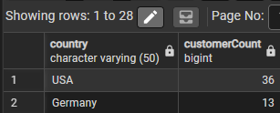

Q32. Total payments per customer
SQL Query: SELECT c."customerNumber", SUM(p."amount") AS "totalPayments" FROM customers c JOIN payments p ON c."customerNumber" = p."customerNumber" GROUP BY c."customerNumber", c."customerName" ORDER BY "totalPayments" DESC;
Logic Explanation: Groups client profiles to add financial ledger volumes via SUM(p.amount) descending to surface highest spending customers.
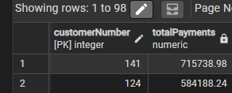

Q33. Number of orders per status
SQL Query: SELECT "status", COUNT(*) AS "orderCount" FROM orders GROUP BY "status" ORDER BY "orderCount" DESC;
Logic Explanation: Segments order quantities into tracking states to analyze business fulfillment velocity metrics.
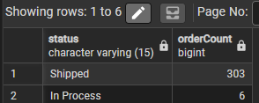

Q34. Products per product line
SQL Query: SELECT "productLine", COUNT(*) AS "productCount" FROM products GROUP BY "productLine" ORDER BY "productCount" DESC;
Logic Explanation: Summarizes catalog listing volumes across standard operational groups.
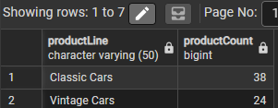

Q35. Employees per office
SQL Query: SELECT o."officeCode", o."city", COUNT(e."employeeNumber") AS "employeeCount" FROM offices o LEFT JOIN employees e ON o."officeCode" = e."officeCode" GROUP BY o."officeCode", o."city" ORDER BY "employeeCount" DESC;
Logic Explanation: Aggregates human resource headcount distribution per city hub.
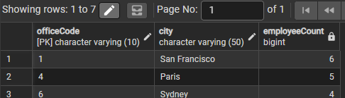

Q36. Total stock per product vendor
SQL Query: SELECT "productVendor", SUM("quantityInStock") AS "totalStock" FROM products GROUP BY "productVendor" ORDER BY "totalStock" DESC;
Logic Explanation: Combines inventory stocks grouped by distribution firms to pinpoint warehouse supplier exposure.

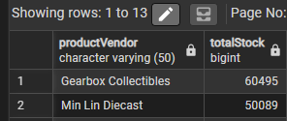

Q37. Average buy price per product line
SQL Query: SELECT "productLine", ROUND(AVG("buyPrice"), 2) AS "averageBuyPrice" FROM products GROUP BY "productLine" ORDER BY "averageBuyPrice" DESC;
Logic Explanation: Computes baseline raw manufacturing costs averaged by item lines to model segment margin targets.
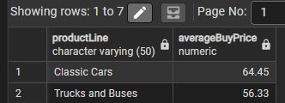

Q38. Orders per customer
SQL Query: SELECT c."customerNumber", c."customerName", COUNT(o."orderNumber") AS "orderCount" FROM customers c LEFT JOIN orders o ON c."customerNumber" = o."customerNumber" GROUP BY c."customerNumber", c."customerName" ORDER BY "orderCount" DESC;
Logic Explanation: Ranks client loyalty by total transactions created using a LEFT JOIN to catch non-purchasing accounts.
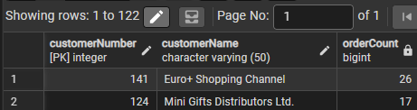

Q39. Max MSRP per product line
SQL Query: SELECT "productLine", MAX("MSRP") AS "maxMSRP" FROM products GROUP BY "productLine" ORDER BY "maxMSRP" DESC;
Logic Explanation: Identifies premium benchmark values across product classifications via MAX evaluation.
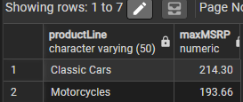

Q40. Min buy price per vendor
SQL Query: SELECT "productVendor", MIN("buyPrice") AS "minBuyPrice" FROM products GROUP BY "productVendor" ORDER BY "minBuyPrice" ASC;
Logic Explanation: Finds entry-level wholesale catalog items grouped by vendor channels using MIN pricing flags.
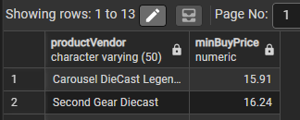

Part 4: Global Summary Aggregations (Questions 41-50)

Q41. Total number of customers
SQL Query: SELECT COUNT(*) AS "totalCustomers" FROM customers;
Logic Explanation: Performs a global table row scan to return the complete dataset volume of active consumer records.
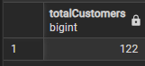

Q42. Total number of products
SQL Query: SELECT COUNT(*) AS "totalProducts" FROM products;
Logic Explanation: Extracts the absolute count metric of active items listed in the enterprise database catalog.
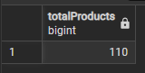

Q43. Total revenue from payments
SQL Query: SELECT SUM("amount") AS "totalRevenue" FROM payments;
Logic Explanation: Aggregates all incoming customer credit logs to yield total business turnover revenue.
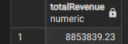

Q44. Average product price
SQL Query: SELECT ROUND(AVG("buyPrice"), 2) AS "averageBuyPrice", ROUND(AVG("MSRP"), 2) AS
"averageMSRP" FROM products;
Logic Explanation: Generates enterprise macro baseline price points for general cost vs catalog ratio modeling.
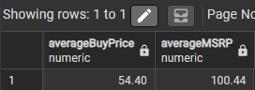

Q45. Max payment amount
SQL Query: SELECT MAX("amount") AS "maxPayment" FROM payments;
Logic Explanation: Isolates the single highest lump-sum remittance record processed through accounts receivable.
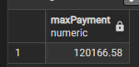

Q46. Min payment amount
SQL Query: SELECT MIN("amount") AS "minPayment" FROM payments;
Logic Explanation: Surfaces the smallest non-zero transaction value recorded in customer receipts history.
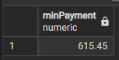

Q47. Count total orders
SQL Query: SELECT COUNT(*) AS "totalOrders" FROM orders;
Logic Explanation: Counts structural order confirmations across history to measure global trading frequency.
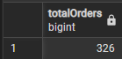

Q48. Total quantity in stock
SQL Query: SELECT SUM("quantityInStock") AS "totalQuantityInStock" FROM products;
Logic Explanation: Tally up all items across global physical depots to calculate net physical volume assets. 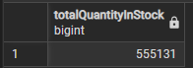

Q49. Average MSRP
SQL Query: SELECT ROUND(AVG("MSRP"), 2) AS "averageMSRP" FROM products;
Logic Explanation: Provides the absolute geometric average listing catalog price across all product entries.
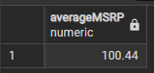

Q50. Number of employees
SQL Query: SELECT COUNT(*) AS "totalEmployees" FROM employees;
Logic Explanation: Calculates net internal staff headcount records stored within corporate databases.
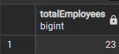

TASK 2: Text-to-SQL Agent Evaluation Framework

The Five Core Pillars of Evaluation

- Pillar A: Schema Mapping & Syntactic Alignment (The Compilation Layer)
  - Exact Set Matching (ESM): Checks if the agent selects the correct tables, columns, and logical conditions by converting queries into standardized relational algebraic blocks rather than character-by-character matching.
  - Join Accuracy: Verifies that foreign key relationships are correctly identified and traversed, completely eliminating unintended Cartesian products.
- Pillar B: Execution Integrity & Data Accuracy (The Runtime Layer)
  - Execution Accuracy (EX): Runs the query against a live database instance and cross-references the row/column output array directly with the ground-truth benchmark data.
  - Null & Empty-Set Gracefulness: Assures that queries pointing to non-existent data boundaries cleanly return 0 rows instead of throwing fatal runtime exceptions.
- Pillar C: Autonomous Resiliency & Self-Healing (The Agentic Layer)
  - Initial Compilation Success Rate: Tracks the percentage of generated SQL strings that execute error-free on the first attempt.
  - Dynamic Feedback Loop Performance: Evaluates the agent's ability to ingest database error logs (e.g., camelCase column quote errors), rewrite the query, and self-correct within a maximum of 3 retries.
- Pillar D: Computational Efficiency & Resource Consumption (The Infrastructure Layer)
  - Query Execution Latency: Monitors query execution times, penalizing poorly designed subqueries where indexed joins are viable.
  - Token Overhead: Minimizes context window costs by tracking token consumption inside prompts and schema descriptions.
- Pillar E: Contextual Interpretation & Interactive Quality (The Human Layer)
  - Ambiguity Disambiguation: Maps vague human requests (e.g., "top items") into exact SQL aggregate functions like SUM() or COUNT().
  - Natural Language Synthesis: Evaluates the final conversational response layer that summarizes the resulting dataset into clean human speech.

2. Combined Agent Performance Score (CAPS) Metric Scorecard
Evaluation Category | Operational Validation Methodology | Weight
Execution Accuracy (EX) | Live comparison of data rows, column arrays, and output cell values. | 40 Pts
Schema & Join Precision | Structural verification of tables, explicit columns, and key relationship blocks. | 25 Pts
Self-Healing Resiliency | Autonomous parsing of compiler exceptions and query repair within 2 retries. | 15 Pts
Ambiguity Resolution | Translation of abstract human goals into valid database sorting and groupings. | 10 Pts
Operational Efficiency | Generation and execution completed under an absolute 3-second system latency limit. | 10 Pts
Total Benchmark Score | Comprehensive Agent Performance Metric | 100 Pts

