Dynamic User Modeling and Contextual Recommendation
with LLM Agents
  - Building Consistent, Auditable, and Deeply Nigerian-Aware Behavioral Agents for Review Simulation and Personalization
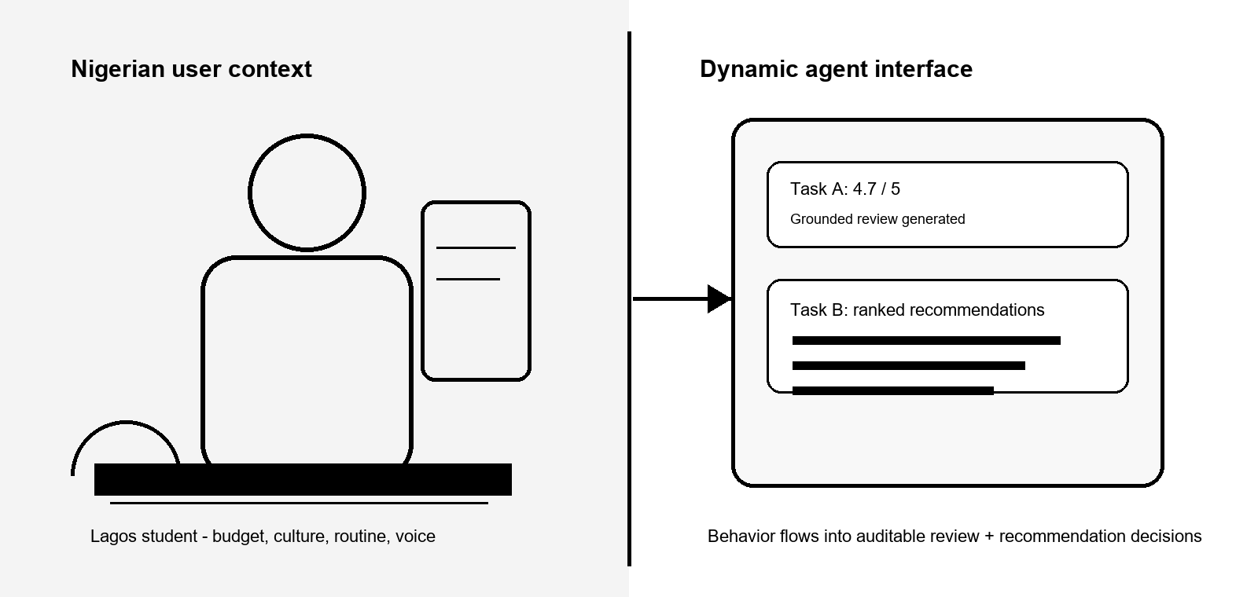
Team Ace
Teslim Sadiq | Yasir Oyebo | Abiodun Mark
Contact: sadiqadetola08@gmail.com
Data & AI Summit Hackathon 3.0
DSN x BCT LLM Agent Challenge
May 2026

Executive Summary
In a world of static user profiles, Team Ace introduces dynamic behavioral personas: living representations of users that evolve with every interaction, context, and cultural signal. The submitted system is one unified agent studio that handles both challenge tasks through the same behavioral memory core.
Task | What the Agent Does | Output
Task A: User Modeling | Predicts realistic star ratings and generates grounded, tone-aware reviews for unseen items. | Rating, review, confidence, reasoning, evidence
Task B: Recommendation | Produces contextual, cross-domain rankings that work for cold-start and history-rich users. | Top recommendations, reasons, matched preferences

What Makes Team Ace Different
- Local transparent scoring makes decisions auditable before any LLM text is generated.
- Groq is used as a controlled language layer for fluency, not as an opaque decision maker.
- Nigerian context is treated as product-relevant behavior: budget pressure, family use, local routines, weather, language, and taste.
- The app is production-minded: FastAPI, web UI, Docker/Render deployment, tests, real subset metrics, and no-key fallbacks.
Key Result | Team Ace | Baseline | Why It Matters
Task A RMSE | 0.7357 | 1.3133 | Lower error from user-aware rating behavior
Task B NDCG@10 | 0.0481 | 0.0194 | About 2.5x the popularity baseline
Reproducibility | Container, tests, fallback | Manual-only demos | Judges can run and inspect the system

1. Why Static Profiles Fail Nigerian Consumers
Real consumer behavior is dynamic, contextual, and culturally rich. A Lagos student may value affordability, transport convenience, multiplayer entertainment, and quick meals in the same week. An Abuja professional may care more about dependable weekday routines, heat-friendly skincare, and polished media choices. A Port Harcourt family shopper may optimize for guests, children, home use, and value packs. A static profile misses those shifts.
Traditional recommenders are strong at repeated patterns but weak at explanation, cold-start, and cross-domain context. Pure LLM systems can sound fluent but often hide the decision logic. Our opportunity is to combine both: measurable behavioral intelligence first, controlled language generation second.
"Users are not fixed vectors; they are changing stories."

2. Our Philosophy: Transparent Intelligence Meets Cultural Depth
Team Ace takes a hybrid agentic approach that stands apart from pure LLM sprawl and black-box recommenders. The same persona object powers both tasks, but the architecture separates memory, retrieval, scoring, generation, and evaluation.
Aspect | Typical Solutions | Team Ace Approach | Advantage
Scoring | Opaque LLM calls | Local interpretable ensembles | Auditable and reproducible
Language | LLM does everything | Groq only after decisions | Controllable and consistent
User model | Static embeddings | Dynamic traces plus Nigerian signals | Culturally relevant
Architecture | Monolithic | Bounded agentic workflow | Reliable for judges
The result is a system that is both measurable and human: numerical decisions are transparent, while the final review and recommendation explanations still feel natural.

3. System Architecture
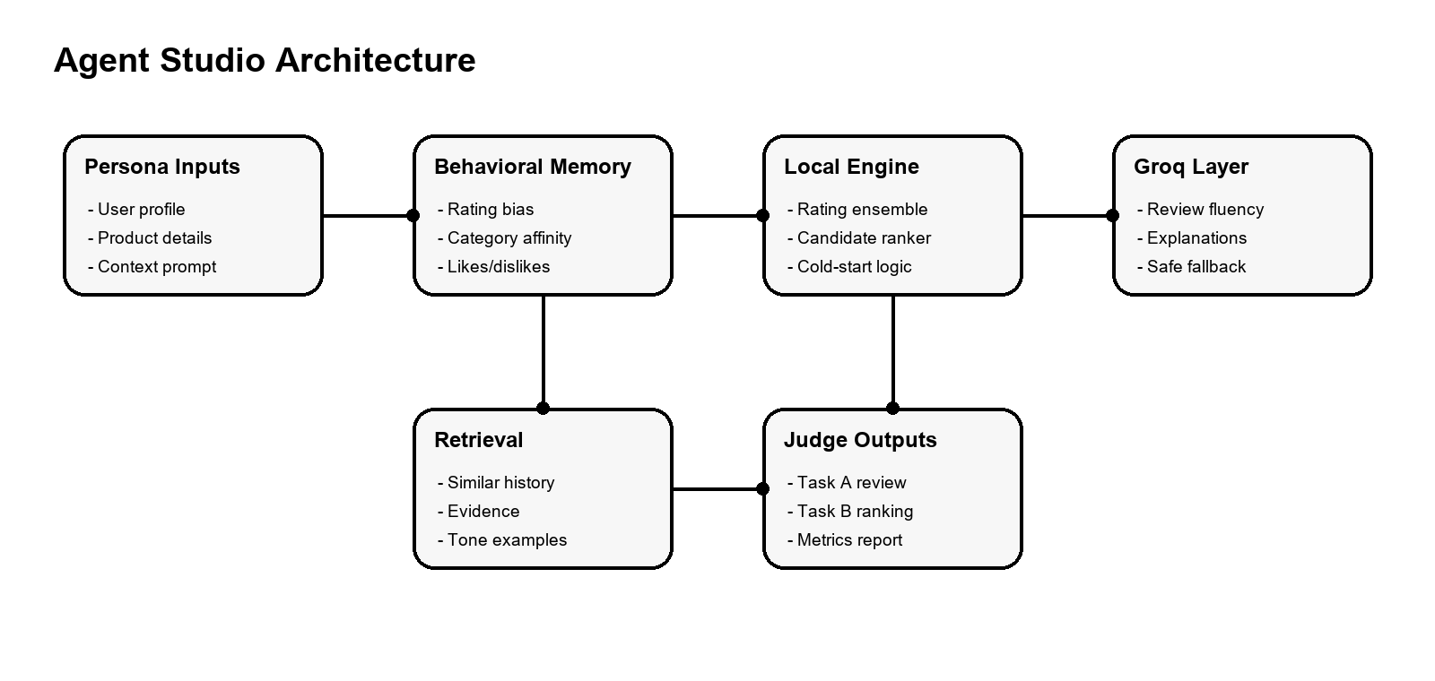
Figure 1. The Agent Studio keeps behavioral scoring local and uses Groq only after structured validation.
Layer | Role | Implementation
Persona Modeling | Compress history and context | Rating bias, category affinity, likes/dislikes, budget, tone, location
Retrieval Memory | Ground behavior | Similar reviews by category, keywords, and user signals
Behavior Engine | Make local decisions | Rating ensemble and recommendation ranker
Groq Layer | Improve language | Validated review/explanation generation with fallback
UI/API/Eval | Expose and measure | FastAPI endpoints, web UI, metrics scripts, Docker/Render

Agentic Workflow
- Read the persona, stated context, and historical interactions, then summarize rating bias, category affinity, likes, dislikes, tone, and budget pressure.
- Retrieve the most relevant prior interactions for the current product or recommendation context.
- Score the behavioral decision locally: Task A predicts stars; Task B ranks candidates before any LLM text is requested.
- Ask Groq to verbalize only the validated result, with evidence and constraints included in the prompt.
- Validate the response shape and fall back to deterministic local text when the hosted model is unavailable.

4. Dataset Strategy and Experiments
The competition plan uses Amazon Reviews 2023 because it provides review text, ratings, user histories, item identifiers, and product categories at real platform scale. The repository now ships two data tracks: curated cross-domain fixtures for instant demos and a checked-in real Amazon Reviews 2023 subset for measurable experiments.
Real Amazon Subset | Value | Meaning
Source | Amazon Reviews 2023 | Official McAuley Lab review files; metadata stream supported when available
Categories | All_Beauty, Grocery_and_Gourmet_Food, Movies_and_TV, Video_Games | The four challenge demo domains are represented
Products | 252 | Normalized candidate products in the checked-in subset
Reviews | 265 | Real review texts and star ratings after filtering
Users | 70 | Users contributing chronological behavior for train/test splits
Holdout | 179 train / 86 test | Most recent interaction held out by user when possible
Splitting holds out the most recent interaction for users with enough history. Cold-start behavior leans more heavily on explicit persona preferences, category priors, popularity, budget level, and context text.
Experiment | Purpose | Expected Signal
Item-average baseline | Measure whether personalization improves rating prediction | Lower RMSE from persona and category features
Popularity-only ranking | Benchmark non-personalized recommendation quality | Higher NDCG@10 when persona/context features are enabled
No retrieval evidence | Test whether grounding improves review fidelity | Lower qualitative fidelity and weaker review specificity
No Groq generation | Separate language quality from behavioral scoring | Metrics remain runnable; human readability drops
Cold-start personas | Validate behavior with little/no history | Reasonable rankings from metadata and stated preferences
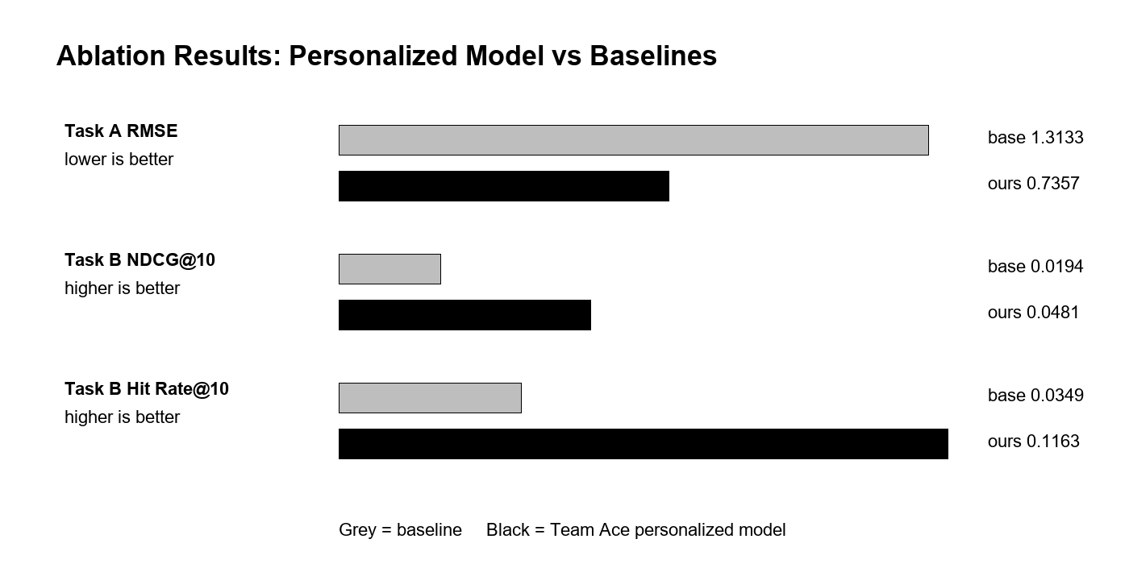
Figure 2. Ablation chart comparing personalized models to baselines.

5. Implementation and Technical Details
The application is a single FastAPI service that serves the web UI and the REST API. Task A uses POST /api/v1/generate-review. Task B uses POST /api/v1/recommend. The same service also exposes /health, demo personas, evaluation outputs, Yarn Mode localization, and YarnGPT audio.
Component | Implementation Detail
Backend | FastAPI, Pydantic schemas, modular service layer, deterministic fallbacks
Task A | User bias, item average, category affinity, text match, budget and dislike penalties
Task B | Popularity, context match, preference match, diversity, cold-start and cross-domain ranking
LLM | Groq improves review/explanation fluency after local scoring
Voice | Browser speech input plus YarnGPT hosted audio for localized output
Persona | Context Signal | Behavioral Effect
Lagos student | Low budget, classes, transport cost | Quick meals, value picks, local comedy, multiplayer games
Abuja professional | Work routine, heat, polished daily use | Dependable coffee, political drama, lightweight skincare
Port Harcourt family shopper | Visitors, children, home use | Family-safe media, easy drinks, gentle skincare
Yarn Mode converts explanations into Nigerian Pidgin, Yoruba-flavoured English, Hausa-flavoured English, Igbo-flavoured English, or a formal judge summary. This is an output layer, not a scoring shortcut, so the underlying metrics remain stable.

6. Results and Evaluation
The real subset is intentionally bounded so the repository remains lightweight, but it proves that the pipeline can stream official Amazon data, create chronological splits, and compare personalized models against non-personalized baselines.
Metric | Personalized | Baseline | Lift
Task A RMSE | 0.7357 | 1.3133 | 0.5776
Task B NDCG@10 | 0.0481 | 0.0194 | 0.0287
Task B Hit Rate@10 | 0.1163 | 0.0349 | More held-out items recovered in top 10
The ranking values are modest because the checked-in subset is small and sparse. The key signal is the direction of the ablation: personalization beats global rating and popularity baselines while preserving interpretability.

7. Demo and Reproducibility
The submitted application is designed for judge inspection. The landing page explains the agent promise, Task A exposes the simulated review workflow, and Task B exposes the ranked recommendation workflow. The app runs locally, in Docker, or on Render.
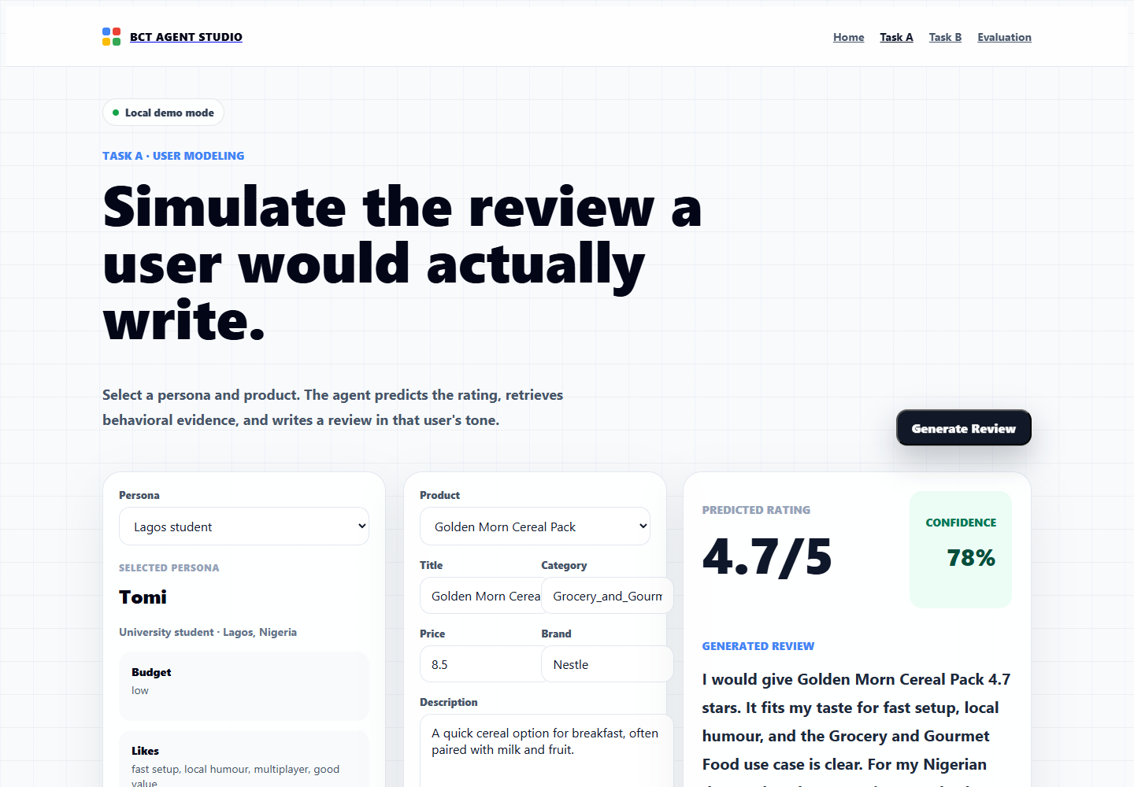 | 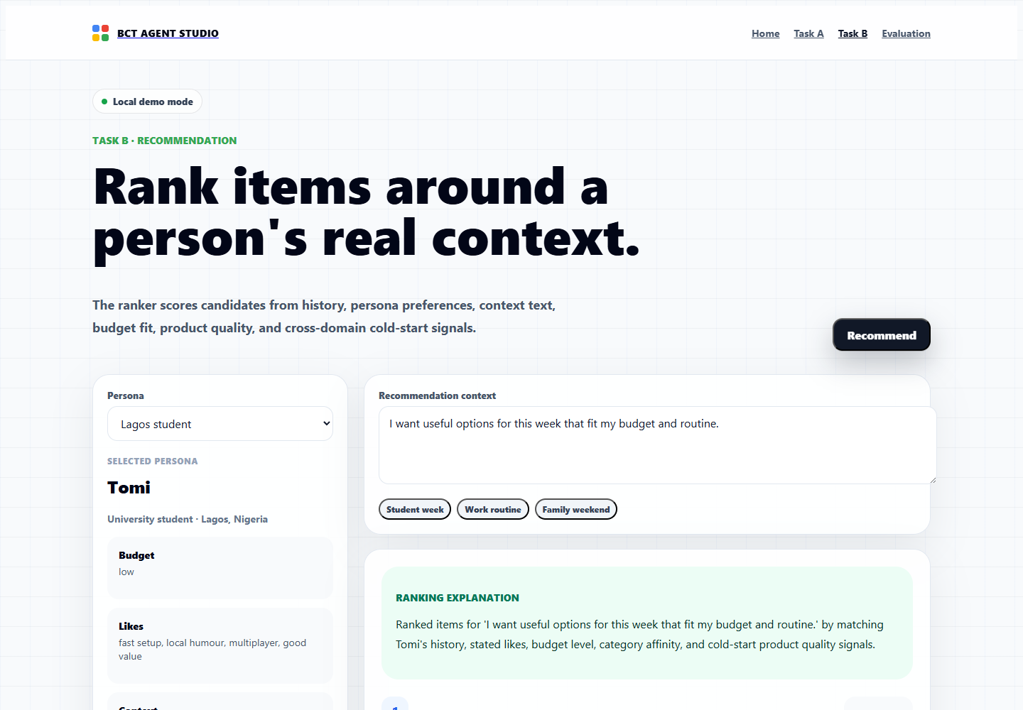
Figure 3. Task A and Task B workspaces after generation.
Artifact | Purpose
Dockerfile / docker-compose.yml | Containerized local verification for judges
render.yaml | Deployment blueprint for the hosted demo
tests/ | Unit and integration checks for schemas, scoring, generation, fallback, and API behavior
data/amazon_subset | Checked-in real Amazon Reviews 2023 subset used for the latest paper metrics
data/fixtures | Deterministic cross-domain UI demo data that works without network access

8. Limitations and Future Work
The current build is optimized for deadline reliability and judge reproducibility. The main limitation is that the checked-in Amazon subset is still much smaller than the full corpus, and some product metadata in the bounded subset is review-derived when official metadata streaming is incomplete. With more time, we would add embedding indexes, larger sampled evaluation, rating calibration, multi-turn conversational memory, richer BERTScore evaluation, and real Nigerian marketplace data.
The strongest next experiment would be a larger four-category run with dense product metadata and an embedding index for candidate generation. That would let the same agent workflow scale from a polished hackathon demo into a stronger production recommender.

Team and Conclusion
Team Ace Member | Role / Strength
Teslim Sadiq | Product engineering, backend/API integration, deployment, and demo flow
Yasir Oyebo | Data strategy, evaluation, experiments, and model reasoning
Abiodun Mark | UX polish, Nigerian contextualization, storytelling, and judge presentation
Team Ace is passionate about building practical, culturally aware AI that solves real African problems. This project is not just an agent submission; it is a demonstration of a new standard for interpretable, reproducible, and deeply contextual LLM agents built for Nigeria and the world.

References and Appendix
- Amazon Reviews 2023 official dataset, McAuley Lab.
- Groq hosted chat model for controlled review and explanation generation.
- YarnGPT hosted voice layer for Nigerian-localized audio output.
- Evaluation artifacts: docs/evaluation_report.json and scripts/evaluate_dataset.py.

