# Solution to Updated ER Diagram Mapping

## Problem Statement

f) Explain how you did the mapping in the previous question based on the mapping rules stated in the material.  
  
g) Map the ER diagram below into a relational schema.

## ER Diagram

Below is the updated ER Diagram provided for mapping:

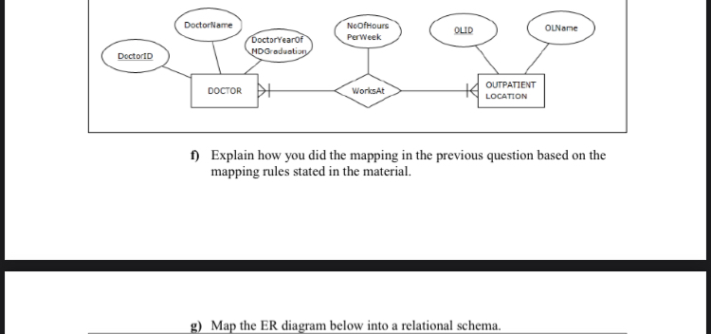

## Solution to Part (g)

The updated ER diagram consists of two entities, DOCTOR and OUTPATIENT LOCATION, and a relationship WorksAt with an additional attribute.  
  
Relational Schema:  
  
1. DOCTOR(DoctorID, DoctorName, DoctorYearOfMDGraduation)  
 - DoctorID: Primary Key  
 - DoctorName: Name of the doctor  
 - DoctorYearOfMDGraduation: Year of graduation  
  
2. OUTPATIENT_LOCATION(OLID, OLName)  
 - OLID: Primary Key  
 - OLName: Name of the outpatient location  
  
3. WORKS_AT(DoctorID, OLID, NoOfHoursPerWeek)  
 - DoctorID: Foreign Key referencing DOCTOR(DoctorID)  
 - OLID: Foreign Key referencing OUTPATIENT_LOCATION(OLID)  
 - NoOfHoursPerWeek: Number of hours per week  
 - Composite Key: (DoctorID, OLID)

## Solution to Part (f)

Mapping Explanation:  
  
1. Entity Mapping: Each entity in the ER diagram is mapped to a relation (table). The attributes of the entity become the columns of the table.  
 - DOCTOR entity is mapped to the DOCTOR table with attributes DoctorID, DoctorName, and DoctorYearOfMDGraduation.  
 - OUTPATIENT LOCATION entity is mapped to the OUTPATIENT_LOCATION table with attributes OLID and OLName.  
  
2. Relationship Mapping: The relationship between entities is mapped to a separate relation (table) which includes the primary keys of the related entities as foreign keys and any additional attributes of the relationship.  
 - The WorksAt relationship is mapped to the WORKS_AT table with DoctorID and OLID as foreign keys and NoOfHoursPerWeek as an additional attribute. The combination of DoctorID and OLID forms the composite key for the WORKS_AT table.  
  
This mapping ensures that the relationship between DOCTOR and OUTPATIENT LOCATION is maintained and the referential integrity is preserved, along with capturing the number of hours per week that a doctor works at a particular outpatient location.