**MS EXCEL PROJECT**

This Project is on Bike Buyers dataset

In this Project/Case study I have explained how I performed the

Data Cleaning,Created PIVOT Table,Charts and Dashboards in MS

Made by: Sadiq Ahmed

Excel

**OVERVIEW OF DATASET**

This dataset is taken by the Alex github page for the project purpose.

Dataset’s location at the github is follow below:

[https://github.com/AlexTheAnalyst/Excel-](https://github.com/AlexTheAnalyst/Excel-Tutorial/blob/main/Excel%20Project%20Dataset.xlsx)

[Tutorial/blob/main/Excel%20Project%20Dataset.xlsx](https://github.com/AlexTheAnalyst/Excel-Tutorial/blob/main/Excel%20Project%20Dataset.xlsx)

**Dataset name--** Bike_Buyers_dataset

Column names

ID, Marital Status, Gender, Income, Children, Education, Occupation, Home Owner, Cars, Commute Distance, Region, Age, Purcahsed Bike

Dataset is about the customer who purchase the bike or not and his/her all demographic and personal details **Column name explanation:**

ID: Unique ID of the customer

Marial Status: If they are Married or Single

Gender: Female or Male

Income: How much they earn

Children: How many children they have

Education: How much they have studied

Occupation: What they do

Home Owners: Are they home owners or not, Yes or No

Cars: How many cars they have

Commute Distance: How much they drive everyday

Region: In which region they live

Age: Age details

Purchased Bike- Did they purchase the bike or not, Yes or No

# STEP 1: DATA CLEANING

We understood about the dataset now 1st step performing the Data Cleaning where I looked for any Duplicate record, redundant data, Null value, Missing records/values , wrong data type etc.

**Steps followed during Data Cleaning are:**

1. Freezed the top row by using Freeze pane option under View tab

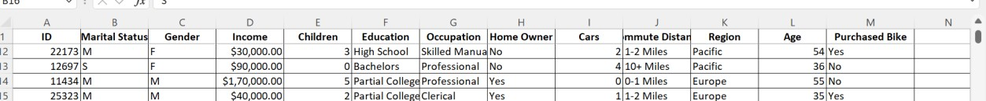

1. Selected all the data and Remove duplicates under Data tab

Before removing duplicates,we have 1027 rows

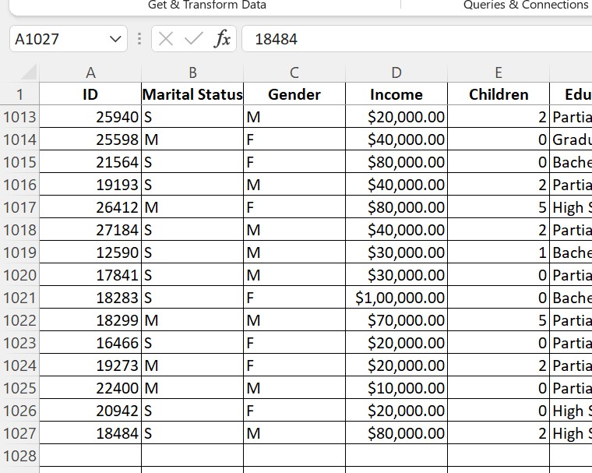

26 duplicates values were removed.

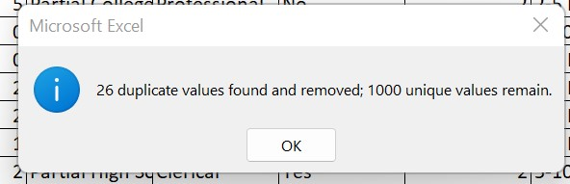

1000 Unique rows in dataset remains

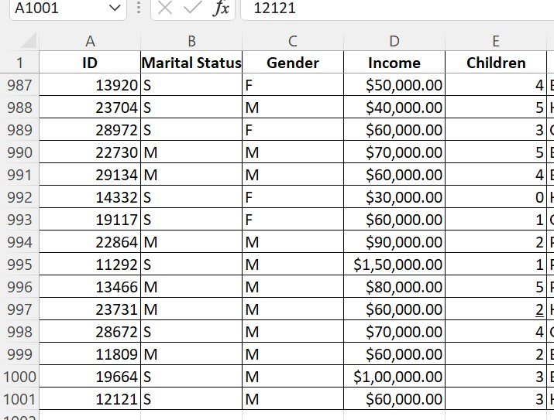

1. Replaced the Marital status Column’s value from

M to Married

S to Single, for better understanding

Same for Gender column from M to Male and F to Female

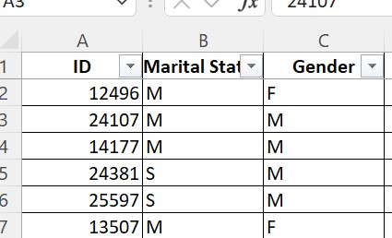

1. Created one more column Age Bracket and used the Nested IF statement to categorize the age for more analysis.

**=IF(L8 > 54,"Old",IF(L8>=31,"Middle Age",IF(L8<31,"Adult","Invalid")))**

* + If they are less than 31, Adult and if they are more than 30, else Invalid
  + Greater than or equal to 31, then Middle Age
  + Greater than 54, then Old

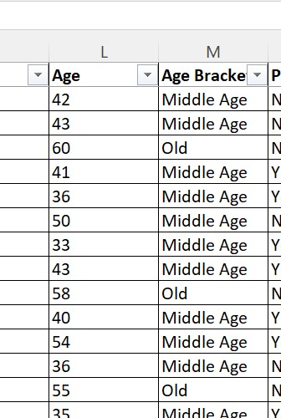



# STEP 2: CREATING PIVOT TABLE

Created Pivot table in Pivot table new sheet, **Selected Option:**

Insert and selected the Range from bike_buyers sheet.

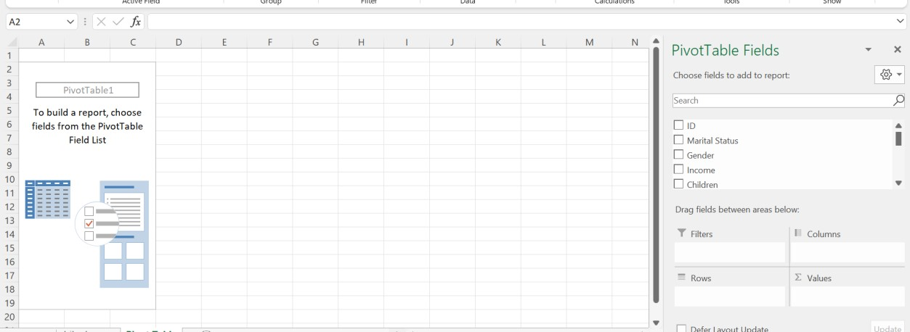

1.First analysis using Pivot table

What’s the average salary of Male and Female customer and If they bought the bike or not?

Rows- Gender

Columns-Purchased bike

Values-Income

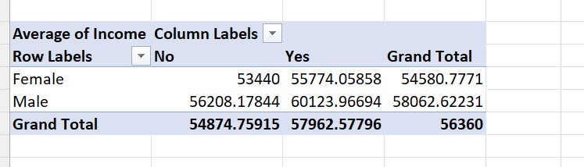

From above analysis,

Female have average salary of Rs 53440 and Male have Rs 56208.17 who didn’t bought the bike

Female have average salary of Rs 54580.77 and Male have Rs 58062.62 who bought the bike

* Converted the decimal values to whole values
* Selected the cell and Right click Format cells

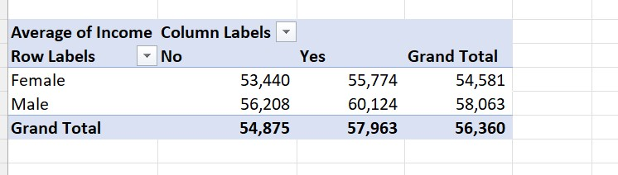

## • Created Clustered Column chart

Insert-Recommended Chart and edited the title,axes,data labels etc.

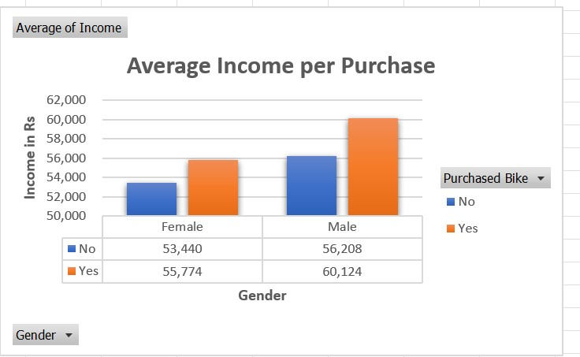

2.Second analysis

About their Salary,Why did they buy bike if they have more money or depend on the commute distance they wanted a bike to travel.

Rows-Commute Distance

Columns/Values-Purchased Bike

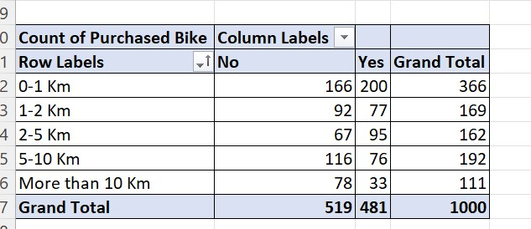

## Created Stacked Line chart

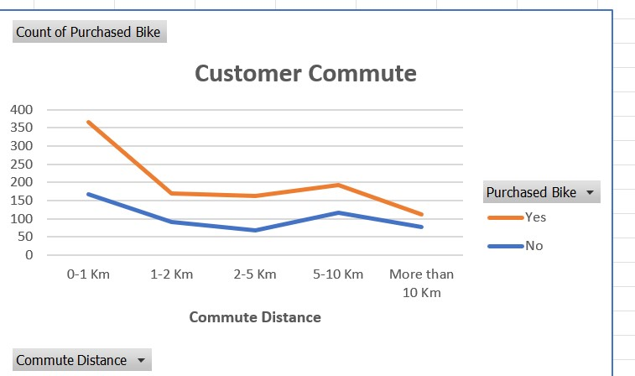

3.Third Anlaysis

From age bracket column,Did they purchase the bike or not?

How many bike was purchased from each age group?

Row-Age Bracket

Column/Values-Purchased Bike

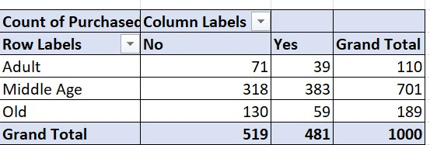

**Created Column chart** and It shows Middle age bought more number of Bike

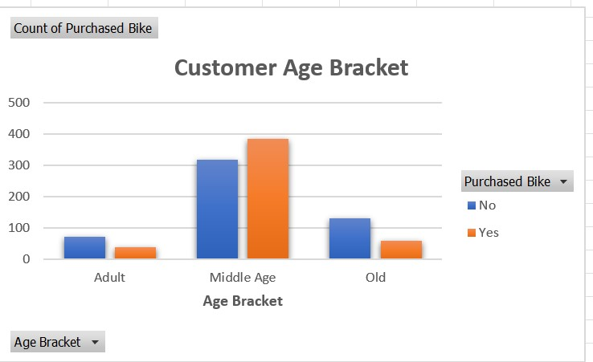

4.Fourth Analysis

How many bike were bought from each region?

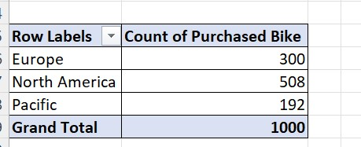

From North America Region ,more bike were purchased by the customer.

## Created Pie chart

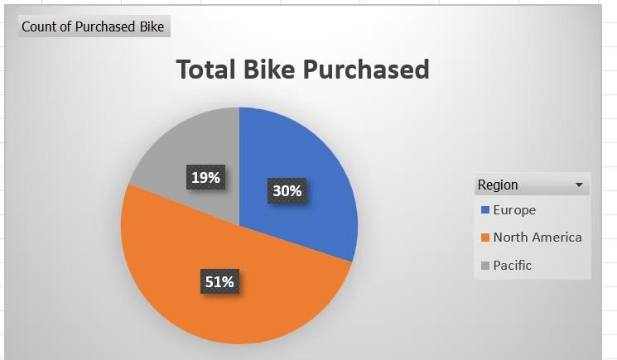

51% bike was purchased from North America Region

## Created Dashboard using all 4 charts

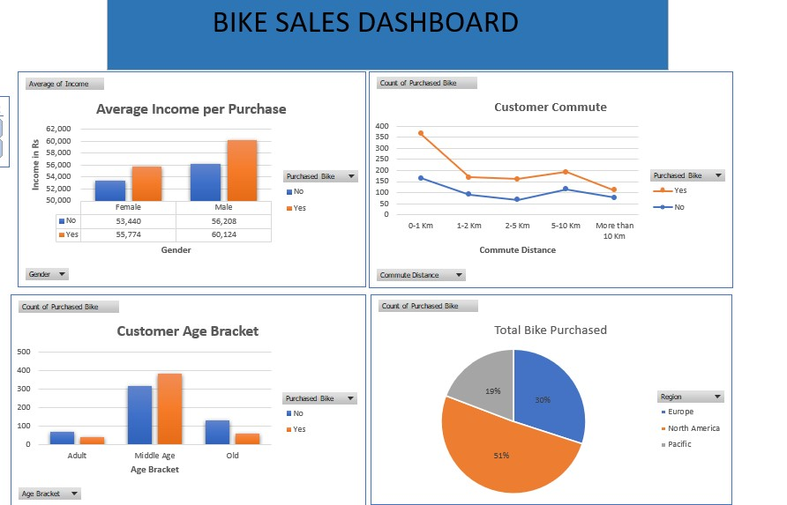

Added 3 slicer Region,Education,Marital status and now we can filter the data what we want ,

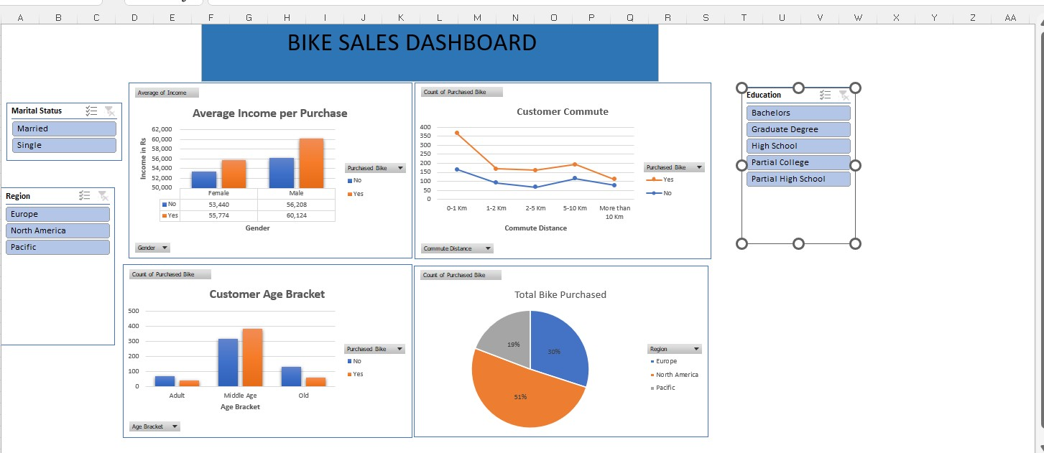

If we want to see the customer who is in High School ,from North America and single,Filtered the data easily using Slicer to get the desired results.

