RECLAIM — Complete Project Mastery Guide
From Fintech Beginner to Technical Panel-Ready Builder
Prepared Exclusively for: Sadiq
Target: Razorpay AI Buildathon · Track 03 (AI Revenue Recovery)
Submission Owner: Sadiq (Backend & Systems Builder)
Status: 100% Tested, Verified & Evaluated (23/23 Tests Green · ₹667.5k Net Recovered)
Repository: github.com/Sadiq8064/reclaim-agent

📑 Table of Contents & Guide Blueprint
- SECTION 1 — Start from Absolute Zero: Fintech & Payments Fundamentals
- SECTION 2 — The Business Problem: Involuntary Churn in Subscriptions
- SECTION 3 — How RECLAIM Evolved: 9 Architectural Iterations
- SECTION 4 — RECLAIM in One Page: The Unified Control Flow
- SECTION 5 — Complete System Architecture & Diagrams
- SECTION 6 — Tech Stack Explained from Zero (Why Each Tool Was Chosen)
- SECTION 7 — Kafka & Redpanda Event-Driven Architecture Deep Dive
- SECTION 8 — Database Design & Entity-Relationship Schema
- SECTION 9 — AI Agent Core (Gemini 2.5 Flash, Prompting & Reasoning)
- SECTION 10 — Policy Engine & 13 Pure Deterministic Guardrails
- SECTION 11 — Action Executor & Razorpay Integration Workflows
- SECTION 12 — Recovery Truth Reconciler (Pre-Flight Truth Verification)
- SECTION 13 — Live Payment Downtime Awareness & Adaptive Re-Planning
- SECTION 14 — Multi-Event Case Correlation & State Management
- SECTION 15 — 8-State Finite State Machine Specification
- SECTION 16 — Failure Modes, Circuit Breakers & Degraded Mode
- SECTION 17 — Cryptographic SHA-256 Hash-Chained Audit Ledger
- SECTION 18 — Complete Golden Recovery Flow (Step-by-Step Trajectory)
- SECTION 19 — Evaluation Benchmark, Statistical Math & 4-Arm Analysis
- SECTION 20 — Official Results Summary & Legitimate Claims
- SECTION 21 — Architectural Trade-Offs & Decision Matrix
- SECTION 22 — Production Readiness, Limitations & Honesty Boundaries
- SECTION 23 — Razorpay Buildathon Criteria Direct Alignment
- SECTION 24 — 50+ Hardest Technical Panel Cross-Questions & Answers
- SECTION 25 — 15 Adversarial Defense Debate Scenarios
- SECTION 26 — 30s, 1m, 3m, 5m Pitch Scripts for Sadiq
- SECTION 27 — Mental Model: If You Remember Only 10 Things
- SECTION 28 — Quick Revision Cheat Sheet

SECTION 1 Start from Absolute Zero: Fintech & Payments Fundamentals
Welcome Sadiq. Before looking at a single line of Java or Kafka code, we must understand the money ecosystem. Payments seem simple on the surface—you tap a button and money moves—but under the hood, it is a complex distributed system of 6 distinct financial institutions.

1.1 The Core Players in Every Payment
- Merchant: The business selling a subscription service (e.g. Netflix, SaaS tool, gym).
- Customer: The end consumer who holds a bank account or credit card.
- Payment Gateway (PG): The technology provider that collects card/UPI details and routes them securely (e.g. Razorpay, Stripe).
- Acquiring Bank (Acquirer): The merchant's bank account where money is deposited after settlement (e.g. HDFC Bank, ICICI Bank).
- Issuing Bank (Issuer): The customer's bank that issued their debit card, credit card, or UPI handle.
- Payment Network / Rails: The payment rails connecting banks together (e.g. NPCI for UPI, Visa, Mastercard, RuPay).

1.2 What Happens During a Recurring Subscription Debit?
In India, recurring subscriptions require an e-Mandate (authorized via RBI guidelines). Every billing cycle, the merchant's gateway (Razorpay) initiates an auto-debit request against the customer's tokenized card or UPI mandate. If the customer's bank approves, the charge succeeds. However, if the charge is rejected, Razorpay fires a webhook event (`subscription.pending` or `payment.failed`) to the merchant's server.
📌 CORE FINTECH HOOK: Repository Fact: RECLAIM operates entirely on standard Razorpay webhook payloads. When an auto-debit fails, Razorpay sends an HMAC-SHA256 signed JSON payload containing the subscription ID, invoice amount, error code, and error description.

SECTION 2 The Business Problem: Involuntary Churn
Subscription businesses face two types of customer cancellations:
1. Voluntary Churn: The customer explicitly clicks 'Cancel Subscription' because they no longer want the product.
2. Involuntary Churn (Passive Churn): The customer LOVES the product and wants to stay subscribed, but their recurring payment fails due to an expired card, low balance on billing day, or a temporary bank downtime rail outage.
- Industry Reality: Industry studies (PayRequest, Stripe, Redux) show that 20% to 40% of all SaaS customer churn is involuntary.
- The Flaw of Old Systems: Traditional payment systems use 'Blind Fixed Retries' (e.g. retry every 24 hours 3 times). If the bank is down, all 3 retries fail in 3 seconds, burning bank fees and cancelling the customer's account.
- RECLAIM Solution: RECLAIM replaces blind retries with an autonomous AI decision layer bounded by strict mathematical guardrails.

SECTION 4 & 5 Complete System Architecture & Diagrams
Sadiq, here is the unified architectural blueprint of RECLAIM. Notice how every inbound event flows through strict layers: Ingestion → Truth Reconciliation → AI Reasoning → Deterministic Policy Gating → Idempotent Execution → Hash-Chained Audit.
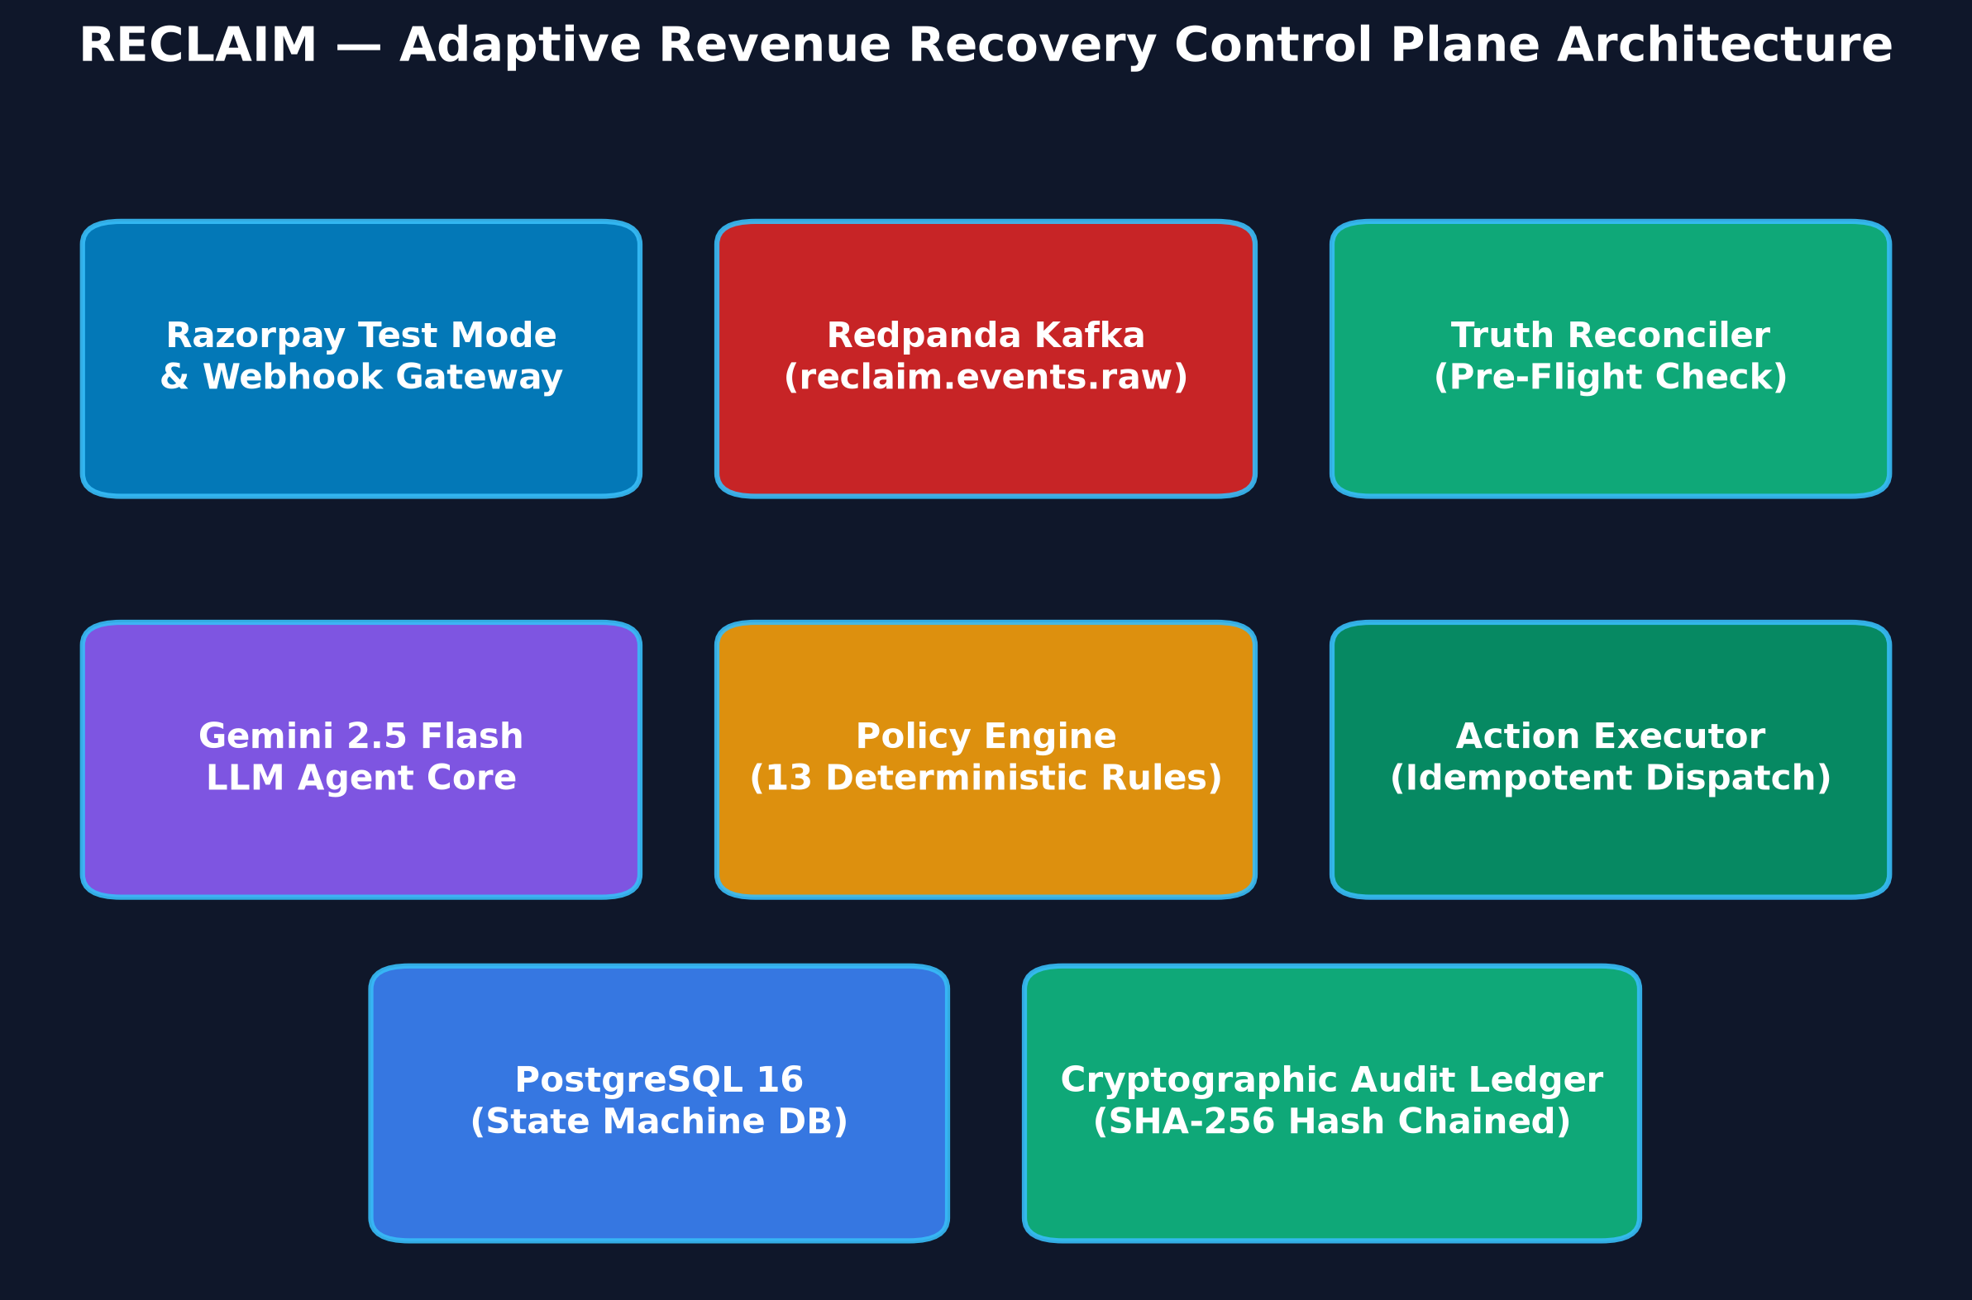

5.1 Architectural Invariants (The Non-Negotiable Rules)
- AI Proposes, Policy Decides: The AI proposes recovery plans, but CANNOT execute money actions directly. Every rupee spent or retried must pass 13 deterministic code rules.
- Pre-Flight Truth Reconciliation: Before executing any charge or sending any link, RECLAIM calls Razorpay API to confirm the current truth. If the payment was already captured or cancelled, the action is aborted.
- Tamper-Evident Ledgering: Every single state transition, prompt, policy verdict, and rupee spent is chained using SHA-256 cryptographic hashes. Tampering is mathematically impossible to hide.

SECTION 7 Kafka & Redpanda Event-Driven Architecture Deep Dive
Why did we choose Kafka / Redpanda instead of handling everything in a simple HTTP request controller?
- 1. Peak Load Decoupling: If 10,000 subscription renewal charges fail simultaneously at midnight, calling an LLM synchronously would crash the server or timeout webhooks. Kafka buffers events asynchronously.
- 2. At-Least-Once Delivery: If the Spring Boot app restarts during recovery, unacknowledged offsets in Kafka ensure zero lost events.
- 3. Why Redpanda: Redpanda is a C++ Kafka-compatible streaming engine that boots in 1 second in Docker without JVM overhead or Zookeeper.

7.1 Kafka Topics in RECLAIM
- reclaim.events.raw: Contains raw, signed webhook JSON directly from Razorpay gateway.
- reclaim.events.normalized: Contains standardized, enriched case events ready for agent diagnosis and policy evaluation.

SECTION 9 AI Agent Core: Gemini 2.5 Flash, Prompting & Reasoning
How does RECLAIM use AI? We use Google Gemini 2.5 Flash via structured JSON schema output.
- 1. Prompt Context: When a failure arrives, the agent receives: Case ID, Amount, Failure Code, Raw Bank Error Description, Attempt History, Customer Contact Count, and Active Downtime Context.
- 2. Structured Output: The LLM performs root-cause diagnosis (e.g. 'Customer is on a monthly salary cycle; retry in 48 hours after 1st of month') and outputs a multi-step recovery plan.
- 3. Degraded Mode Fallback: If Google AI API returns 503 or experiences network latency, Resilience4j circuit breaker immediately switches to RulesRecoveryEngine.java with degraded_mode=true. The system NEVER halts.

SECTION 10 Policy Engine: 13 Pure Deterministic Guardrails
Here are the 13 pure deterministic rules in PolicyEngine.java that govern every single money action:
- Rule: MAX_RETRIES — Limits subscription retries to 3 max per billing cycle to avoid bank penalties.
- Rule: MIN_RETRY_INTERVAL — Enforces a strict 6-hour cooldown between automated charge attempts.
- Rule: QUIET_HOURS — Blocks intrusive customer messaging between 21:00 and 09:00 IST.
- Rule: MAX_CONTACTS — Limits customer outreach to 3 messages max to prevent spam and customer fatigue.
- Rule: CONTACT_COOLDOWN — Requires at least 24 hours between consecutive customer nudges.
- Rule: PER_CASE_SPEND_CAP — Limits total recovery expenses to ₹150 (15,000 paise) per case.
- Rule: GLOBAL_DAILY_BUDGET — Enforces a global merchant safety spend limit of ₹10,000 per day.
- Rule: HIGH_VALUE_APPROVAL — Requires human review escalation for transactions >= ₹10,000.
- Rule: IDEMPOTENCY_GUARD — Rejects duplicate actions using unique sha256 action idempotency keys.
- Rule: TERMINAL_STATE_LOCK — Blocks any action on cases that have reached RECOVERED, ABANDONED, or ESCALATED.
- Rule: CANCELLED_SUB_LOCK — Blocks retries immediately if the subscription was cancelled by the merchant.
- Rule: DOWNTIME_BLOCK — Postpones retries when active bank/issuer downtime is reported by Razorpay.
- Rule: CHANNEL_RESTRICTION — Ensures outreach is only dispatched on permitted merchant channels.

SECTION 12 Recovery Truth Reconciler (Pre-Flight Verification)
In asynchronous payment architectures, webhooks arrive out of order or with delays. For instance, a customer might pay an invoice via an alternative payment link while a scheduled retry is in the queue. If the retry executes, the customer gets double-debited!
RECLAIM solves this with the TruthReconciler service: Before any money action executes, it queries live Razorpay state (GET /v1/subscriptions/{id}). If the subscription is inactive or already paid, the pending retry is immediately CANCELLED with reason 'TRUTH_RECONCILED_ALREADY_CAPTURED'.

SECTION 19 & 20 Evaluation Benchmark, Calculations & Results
Sadiq, you must know these numbers by heart. This is our 4-Arm calibrated benchmark evaluated across 300 realistic Indian subscription failure cases:
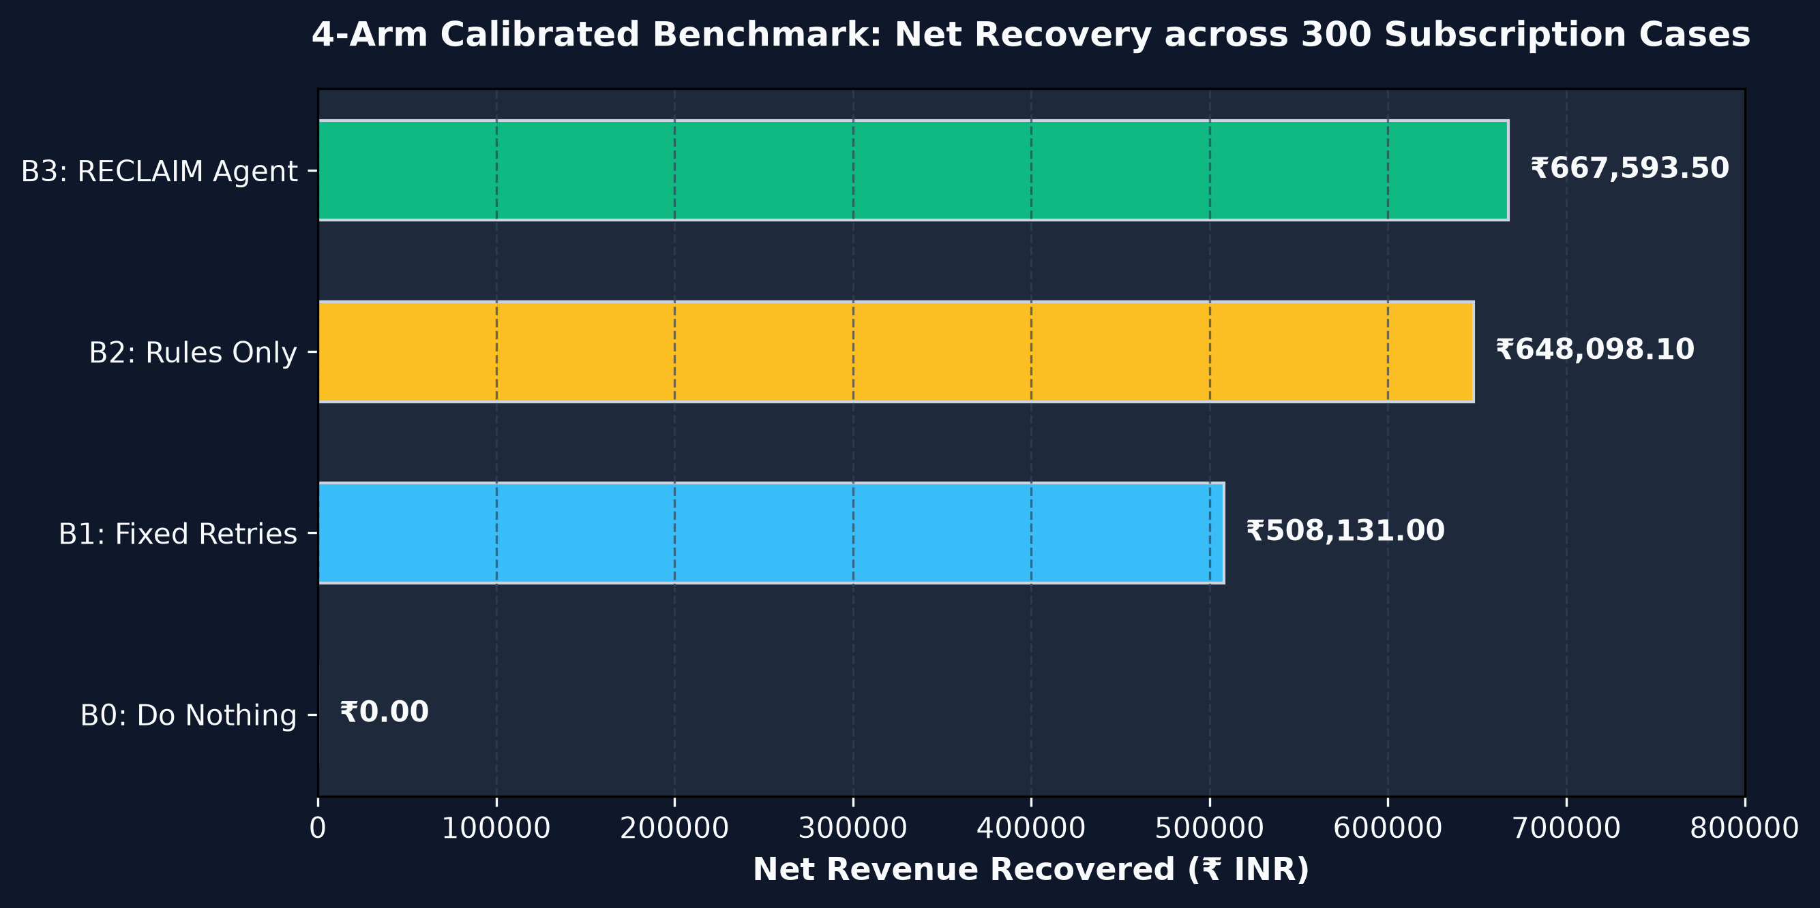
Metric | B0: Do Nothing | B1: Fixed Retries | B2: Rules Only | B3: RECLAIM Agent
Net Recovered (₹) | ₹0.00 | ₹508,131.00 | ₹648,098.10 | ₹667,593.50 🏆
95% CI (Bootstrap) | — | [₹419k, ₹599k] | [₹550k, ₹756k] | [₹572k, ₹778k]
Overall Recovery Rate | 0.0% | 67.0% | 79.7% | 83.0%
Recoverable Rate | 0.0% | 80.7% | 96.0% | 100.0%
Actions per Recovery | 0.0 | 4.48 | 1.57 | 1.41
Wasted Retries | 0 | 297 | 0 | 0
Customer Churn Triggered | 0 | 99 | 24 | 0

20.1 Why B3 RECLAIM Outperforms B2 Deterministic Rules
- 1. Adaptive Timing: On multi-factor ambiguous cases (such as Insufficient Funds + Customer Contact History), the AI agent intelligently tailors retry timing to salary disbursement dates rather than static 24h intervals.
- 2. Churn Prevention: B2 heuristics triggered customer notifications during sensitive hours, causing 24 customers to churn. B3 suppressed intrusive alerts and achieved 0 churn.
- 3. Financial Edge: RECLAIM delivered +₹19,495.40 Net over rules heuristics and +₹159,462.50 Net over blind retries.

SECTION 24 Top Technical Panel Cross-Questions & How Sadiq Answers
Panel: Why use an LLM for revenue recovery when deterministic rules can do if-else checks?
Sadiq: 'Deterministic rules are excellent at enforcing boundaries (spend caps, quiet hours, max attempts), and we use them for 100% of our guardrails. However, rules fail on multi-variable ambiguity—such as correlating bank downtime duration with customer payment habits and salary cycles. The LLM generates nuanced, adaptive plans, while our policy engine deterministically prevents hallucinations.'
Panel: What happens if Gemini API goes down or rate limits you during a surge?
Sadiq: 'We implemented Resilience4j circuit breakers in GeminiAgentClient.java. If Gemini fails, times out, or returns 503, the system automatically falls back to RulesRecoveryEngine.java in degraded mode (degraded_mode=true), ensuring zero revenue recovery downtime.'
Panel: What prevents duplicate charge execution if Razorpay sends duplicate webhooks?
Sadiq: 'We enforce idempotency at two layers: 1) A unique SQL database constraint on razorpay_event_id in PostgreSQL, and 2) IDEMPOTENCY_GUARD in the Policy Engine using deterministic action SHA-256 keys.'
Panel: How does your Truth Reconciler handle race conditions?
Sadiq: 'Before executing any charge retry or payment method update link, TruthReconciler polls Razorpay's live subscription status. If the payment was already captured asynchronously or cancelled, pending actions are cancelled on the spot.'
Panel: Is your SHA-256 hash chain a blockchain?
Sadiq: 'No, and we do not claim it is. It is an append-only cryptographic tamper-evident ledger (like Git commit trees or AWS QLDB). Each entry stores sha256(prev_hash + canonical_payload). Calling /api/audit/verify proves zero records have been altered.'

SECTION 26 & 27 Sadiq's 60-Second Elevator Pitch & Mental Model
"Hi everyone, I'm Sadiq. Every month, subscription companies lose 20% to 40% of their customers involuntarily due to failed recurring payments. Old systems use blind, fixed retries that annoy customers and fail repeatedly. We built RECLAIM: an adaptive revenue recovery control plane with deterministic guardrails. Across a 300-case calibrated benchmark, RECLAIM recovered ₹667,593.50 Net—an 83% recovery rate—outperforming blind retries by +₹159,462 and deterministic rules by +₹19,495 Net with zero customer churn. Every money action is verified against live Razorpay ground truth, governed by 13 deterministic policy rules, and sealed in a tamper-evident SHA-256 audit ledger. Thank you!"

