ACTU302_Assignment_4

2025-08-07

11285620

11283404

11116371

11338974

10977800

Question1.

1. A package in R is a collection of functions, datasets and documentation. The types of packages are CRAN package (FinancialMath), Archived package (evir ),Base package (stats)
2. I would search the package archive on the internet and download the file. Go to the packages section, click on install. From the install dialogue box, choose Packages Archive File from the install from dialogue box. Select the file you downloaded and hit install. RStudio would alert you on the dependencies needed to use the package.
3. Code:

|  |
| --- |
| library(ReIns) ExpQQ |

Results:

|  |
| --- |
| function (data, plot = TRUE, main = "Exponential QQ-plot", ...)  ## { ## .checkInput(data, pos = FALSE) ## X <- as.numeric(sort(data)) ## n <- length(X) ## eqq.the <- -log(1 - (1:n)/(n + 1)) ## eqq.emp <- X ## .plotfun(eqq.the, eqq.emp, type = "p", xlab = "Quantiles of standard exponential",  ## ylab = "X", main = main, plot = plot, add = FALSE, ...) ## .output(list(eqq.the = eqq.the, eqq.emp = eqq.emp), plot = plot,  ## add = FALSE) ## } ## <bytecode: 0x000001ec79a1dd60> ## <environment: namespace:ReIns> |

Code:

|  |
| --- |
| My_ExpQQ <- function (data, plot = TRUE, main = "") {  X <- as.numeric(sort(data))  n <- length(X)  # Theoretical quantiles for standard exponential  quat_func<- -log(1 - (1:n) / (n + 1))  exp.the<- quat_func  exp.emp <-log(X)  plot(exp.the,exp.emp, type = "p", xlab = "Quantiles of standard exponential",  ylab = "log(X)", main = main) } |

d)

|  |
| --- |
| library(insuranceData) data("AutoClaims")  Sample_Autoclaim <- sample(x=AutoClaims$PAID,size = 500, replace= FALSE) par(mfrow=c(1,2)) ExpQQ(Sample_Autoclaim) My_ExpQQ(Sample_Autoclaim) |

Results:

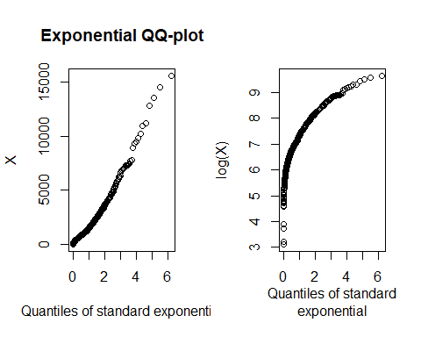Fig 1.1

Q-Q plot fits small to medium values well but does not fit the extreme values well.Fitting of extreme value is very important in insurance. For the Pareto Q-Q plot fits the extreme values a bit better that the exponential but does not fit the small-medium values well.

Question2.

a)

|  |
| --- |
| library(mice)  Wind_data <-windspeed$Dublin head(Wind_data)  tail(Wind_data) |

Results:

|  |
| --- |
| 3.71 16.08 1.71 8.46 8.71 6.54  7.17 4.38 8.38 10.34 4.54 14.33 |

|  |
| --- |
| summary(windspeed$Dublin) |

Results:

|  |
| --- |
| Min. 1st Qu. Median Mean 3rd Qu. Max.  0.370 5.880 9.250 9.907 12.960 26.870 |

The data is slightly skewed to the right with mean of 9.907 and few outliers. The mean is greater than the median.

|  |
| --- |
| boxplot(Wind_data, main = "") |

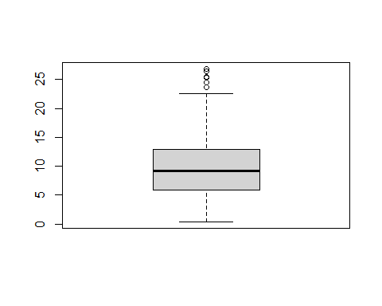Fig 1.2

The boxplot confirms the fact that the data is right skewed and containing some outliers.

b)

|  |
| --- |
| log_likehood <- **function**(par,x) {  n <- **length**(x)  lam <- par[1]  s <- par[2]  log_lik <- n **\*log**(lam)**-**(n **\*** **log**(s))**+**(lam **-** 1) **\*** **sum**(**log**(x **/** s)) **-**(**sum**((x **/** s)**^**lam))    **return**(**-**log_lik) } |

Code:

|  |
| --- |
| MLE.weibull<-suppressWarnings(optim(par = c(2,1),fn=log_likehood_2, method = "Nelder-Mead",x=Wind_data,hessian = TRUE)) MLE.weibull$par |

Results:

|  |
| --- |
| 2.010508 11.195909 |

b)

|  |
| --- |
| cov_matrix <- solve(MLE.weibull$hessian) std_errors <- sqrt(diag(cov_matrix)) names(std_errors) <- c("SE_alpha", "SE_s") std_errors |

Results:

|  |
| --- |
| ## SE_alpha SE_s  ## 0.07450932 0.28230068 |

c)

|  |
| --- |
| sorted_data <- sort(Wind_data) quantile(x= sorted_data,probs = 0.95) |

Results:

|  |
| --- |
| ## 95%  ## 19.966 |

d)

|  |
| --- |
| alpha_hat <- MLE.weibull$par[1] s_hat <- MLE.weibull$par[2]  p_exceed_95 <- exp(-(19.966/s_hat)**alpha_hat)  round(p_exceed_95,5) |

Results:

|  |
| --- |
| 0.04078 |

We can see that the probability that x exceeds 19.966 is 0.04078 which is slightly less than 0.05 we expected

Question3.

|  |
| --- |
| library(FinancialMath) Net_cash_flows <- c(-10000, -10000,-10000,   -8000, 28000, 38000, 33000, 23000, 13000, 8000) NPV(cf0 = -80000,i= 0.15, cf = Net_cash_flows,times =1:10) |

Results:

|  |
| --- |
| ## [1] -51459.33 |

Code:

|  |
| --- |
| IRR(cf0 = -80000,cf = Net_cash_flows,times =1:10) |

Results:

|  |
| --- |
| 0.72643855 0.03217979 0.72643855 |

c)

|  |
| --- |
| my_NPV <- function(cf0, cf, i, years)  {  cf0+sum(cf / (1 + i) ^ years) } my_NPV(cf0=-80000,cf = Net_cash_flows,i=0.15,years=1:10) |

Results:

|  |
| --- |
| 51459.33 |

NPV is -51459.33 which is less than 0. So this investment is not viable.