Machine Learning in Cyber
COMP70049 — Assignment Report
Applying classic machine learning and deep learning to phishing detection, network intrusion classification, anomaly detection and ransomware identification
Student ID: CB018287
CB018287@students.apiit.lk

1. Introduction
This report presents four machine-learning case studies spanning the main defensive workloads of a modern security operations centre: filtering phishing email, classifying network intrusions, detecting anomalous traffic without labels, and identifying ransomware from host behaviour. In each section one classic machine-learning model and one deep-learning model were implemented in Python (scikit-learn and TensorFlow/Keras), trained on a public benchmark dataset, and compared using precision, recall, F1-score and threshold-free measures (ROC and precision-recall curves). All experiments use a fixed random seed, fit every preprocessing transform on training data only, and are reproducible via the four standalone scripts submitted alongside this report. Implementation details of each pipeline are summarised per section; the code itself is not reproduced here, per the brief.

2. Section 1 — Email Security and Phishing Detection

2.1 Dataset
The Enron Spam Dataset (one of the datasets suggested in the brief) contains 33,716 real emails — 17,171 spam/phishing and 16,545 legitimate (ham) messages built from the mailboxes of six Enron employees. Official source: https://www2.aueb.gr/users/ion/data/enron-spam/; the single-CSV compilation used here is https://github.com/MWiechmann/enron_spam_data. After discarding 51 empty messages, a balanced stratified subsample of 16,000 emails was used (80/20 train/test split: 12,800/3,200) so that the LSTM trains in reasonable time on CPU; the script exposes a single constant to run on the full corpus instead.

2.2 Preprocessing
Subject and body were concatenated into one text field. Each email was lower-cased; URLs were replaced by a dedicated token (their presence is itself a phishing cue), digits and punctuation were stripped, NLTK English stopwords were removed and the remaining tokens were lemmatized with WordNet. For the classic model the cleaned text was vectorised with TF-IDF (unigrams and bigrams, 30,000 features, sublinear term frequency). For the deep model a 20,000-word tokenizer produced integer sequences, pre-padded/truncated to 200 tokens, with masking so the LSTM ignores padding.

2.3 Models
Classic ML: Logistic Regression (C = 10, 1,000 iterations) on the TF-IDF matrix — a strong, fast, interpretable baseline for high-dimensional sparse text. Deep learning: a 64-dimensional trainable embedding feeding a 64-unit LSTM, dropout 0.3, a 32-unit ReLU layer and a sigmoid output, trained with Adam on binary cross-entropy for up to six epochs with early stopping on a 10% validation split.

2.4 Results
Model | Accuracy | Precision | Recall | F1-score | ROC-AUC
TF-IDF + Logistic Regression | 0.9906 | 0.9834 | 0.9981 | 0.9907 | 0.9994
Embedding + LSTM | 0.9866 | 0.9832 | 0.9900 | 0.9866 | 0.9973

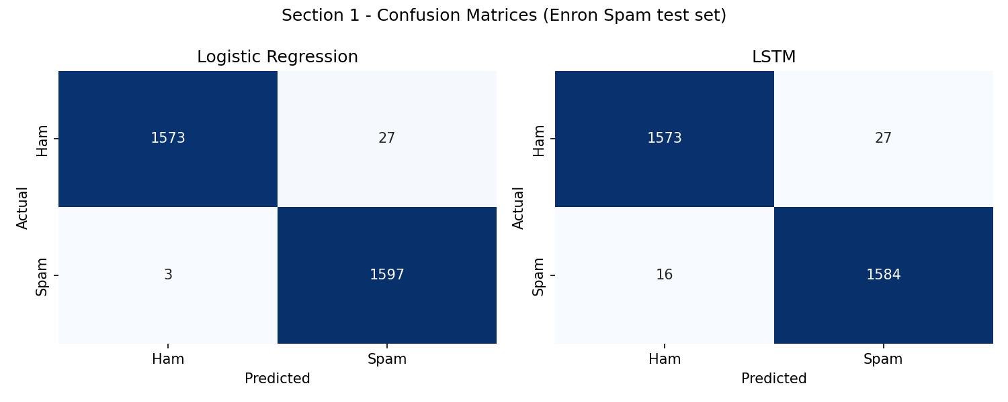
Figure 1.1 — Confusion matrices on the 3,200-email test set.
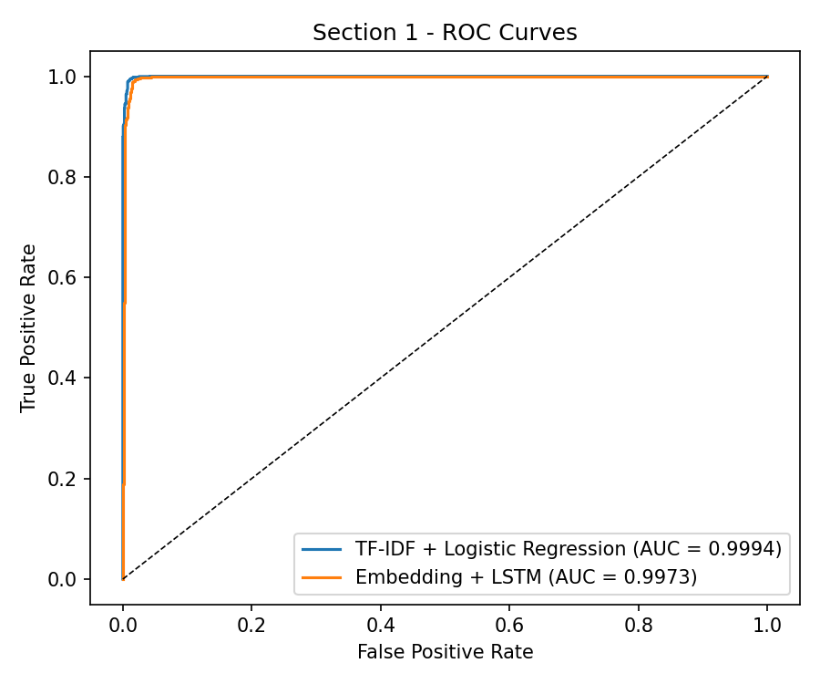
Figure 1.2 — ROC curves for both models.
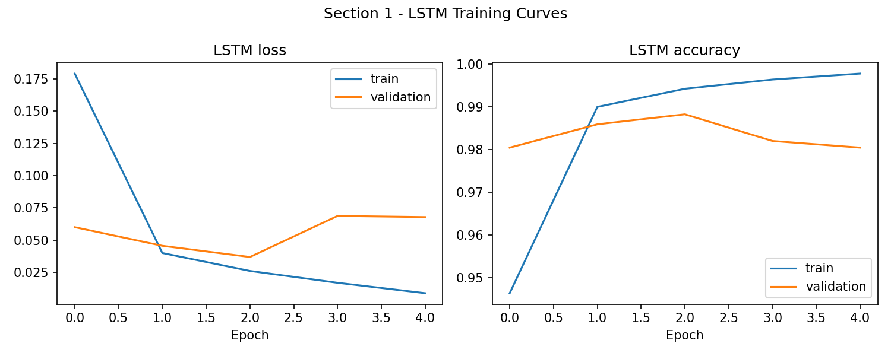
Figure 1.3 — LSTM training/validation loss and accuracy.

2.5 Discussion
Both models are near-ceiling on this benchmark, and the classic pipeline actually edges out the LSTM (F1 0.9907 vs 0.9866). This is a recurring finding in spam filtering: TF-IDF n-grams already capture the highly discriminative lexical cues of bulk phishing (inspection of the largest logistic-regression weights shows tokens such as pricing/currency terms, urgency words and the URL marker driving spam predictions, while Enron-specific business vocabulary marks ham). The LSTM must learn its embedding space from only 12,800 emails, so its extra expressiveness buys nothing here; with masking and pre-padding it converged smoothly (Figure 1.3) but plateaued marginally below the linear model. Operationally the choice favours the classic model: it trains in seconds, scores in microseconds, and its evidence is auditable — a real advantage when a security team must explain why a message was quarantined. Recall matters most in this application (a missed phishing email costs more than a flagged newsletter), and at matched 0.5 thresholds logistic regression also has the higher recall (0.998). A caveat: Enron spam is 2000s-era; against modern spear-phishing, models pretrained on large corpora (e.g. fine-tuned transformers) would be expected to generalise better than either model trained from scratch.

3. Section 2 — Cyber Attack Detection (Network Intrusion Classification)

3.1 Dataset
NSL-KDD (suggested in the brief) is the cleaned successor of KDD'99: 125,973 training and 22,544 test connection records, each with 41 features (basic connection, content, and time/host-based traffic statistics). Official page: https://www.unb.ca/cic/datasets/nsl.html (mirror used: https://github.com/defcom17/NSL_KDD). The 39 fine-grained attack names were mapped to the standard five classes: Normal, DoS, Probe, R2L and U2R. Crucially, evaluation uses the official KDDTest+ split, which contains 17 attack types absent from training and a deliberately shifted class mix — a much harder, more realistic test than a random hold-out.

3.2 Preprocessing
The constant num_outbound_cmds column was dropped; protocol, service and flag were one-hot encoded (yielding 121 features, with test columns aligned to the training scheme); all features were standardised with a scaler fitted on training data only. A PCA analysis showed 89 components retain 95% of the variance — the one-hot space is only mildly redundant, so both models were trained on the full 121 features and PCA was retained as an analysis rather than a lossy reduction step.
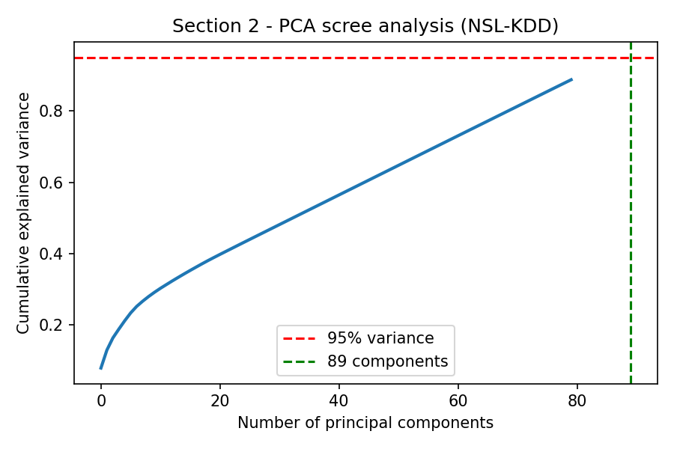
Figure 2.1 — PCA cumulative explained variance (89 components reach 95%).

3.3 Models
Classic ML: a 150-tree Random Forest. Deep learning: a 1-D CNN — two Conv1D/BatchNorm/MaxPool blocks (64 and 128 filters) over the feature vector, a 128-unit dense layer with dropout 0.4 and a 5-way softmax, trained with Adam and early stopping (8 epochs, batch 256).

3.4 Results
Model | Accuracy | Macro Precision | Macro Recall | Macro F1 | Weighted F1
Random Forest | 0.7555 | 0.8263 | 0.4967 | 0.5121 | 0.7134
1-D CNN | 0.7516 | 0.8205 | 0.5283 | 0.5599 | 0.7234

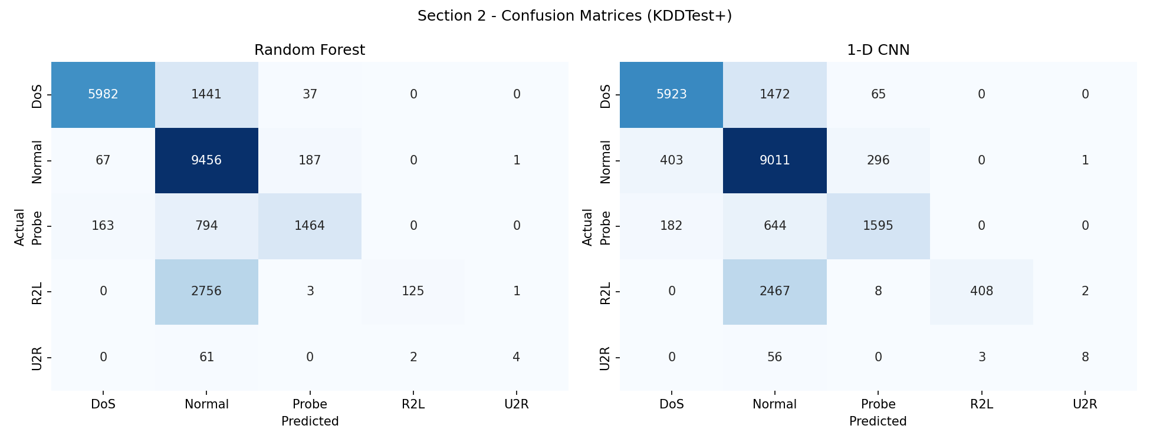
Figure 2.2 — Confusion matrices on KDDTest+ (five classes).
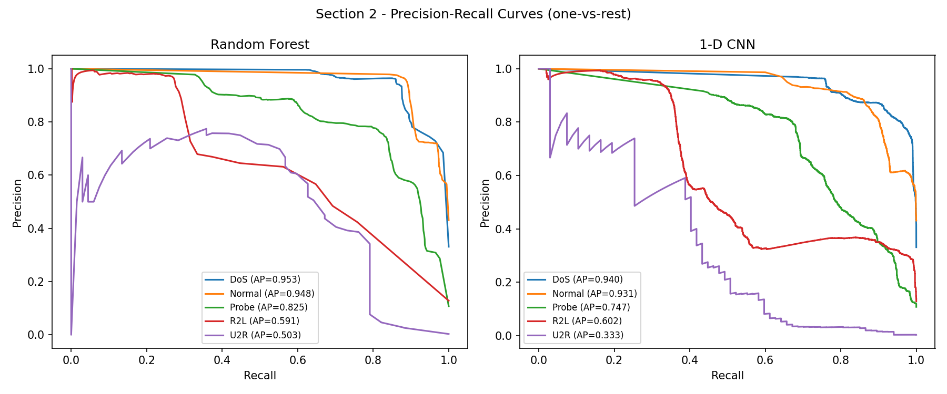
Figure 2.3 — One-vs-rest precision-recall curves per class.

3.5 Discussion
Accuracies of ~75% look modest but are the well-documented norm for KDDTest+ (published results for models trained on KDDTrain+ typically fall between 72% and 80%), because the test split contains novel attack variants. The per-class breakdown is more informative than accuracy: both models detect DoS (F1 ≈ 0.85-0.88) and Probe (F1 ≈ 0.71-0.73) reliably, but recall collapses on R2L (RF 0.04, CNN 0.14) and U2R (RF 0.06, CNN 0.12) — rare classes (2,885 and 67 test records) whose unseen variants dominate the test set and whose content-based footprints resemble normal logins. Nearly all their misses are absorbed into Normal (Figure 2.2), which drags Normal precision to ~0.65-0.66. The CNN and the forest tie on accuracy, but the CNN wins on what matters for a minority-attack IDS — macro recall (0.528 vs 0.497) and macro F1 (0.560 vs 0.512), roughly tripling R2L recall and doubling U2R recall — evidence that its learned feature interactions generalise slightly better to unseen variants, at the cost of longer training and lower interpretability (the forest's importances directly name diagnostic features such as same_srv_rate, dst_host_srv_count and flag values). Security implication: a deployed IDS cannot rely on either model alone for R2L/U2R; cost-sensitive training, oversampling of rare classes, or pairing with the anomaly-detection approach of Section 3 are the natural mitigations.
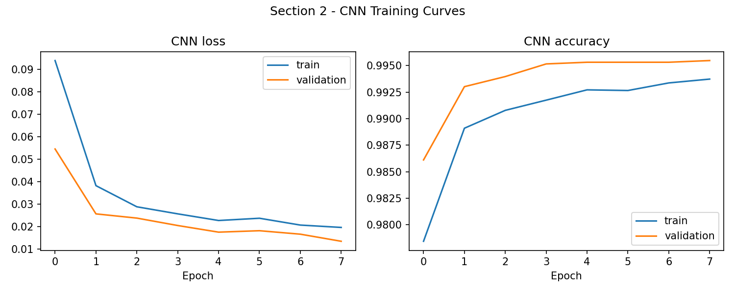
Figure 2.4 — CNN training/validation curves.
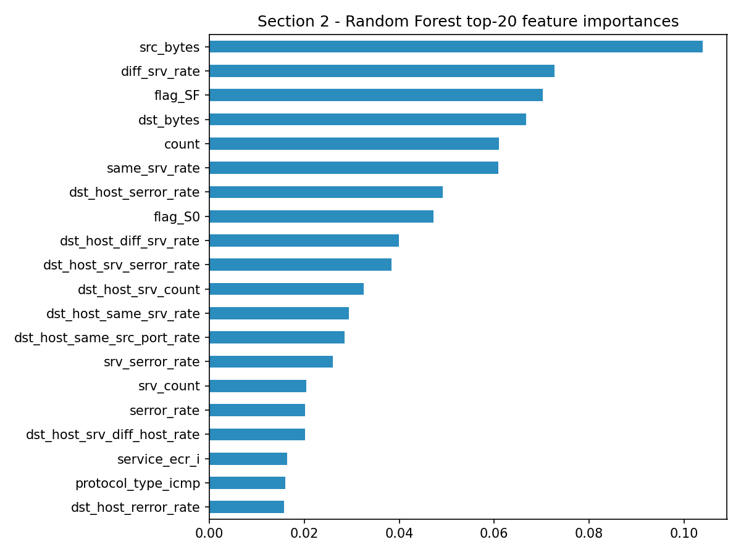
Figure 2.5 — Random Forest top-20 feature importances.

4. Section 3 — Anomaly Detection for Cyber Threats

4.1 Dataset
UNSW-NB15 (suggested in the brief) blends real modern normal traffic with nine synthetic attack families (Fuzzers, DoS, Exploits, Reconnaissance, Shellcode, Worms, etc.). The official partitions were used: 175,341 training and 82,332 test records with 42 features. Official page: https://research.unsw.edu.au/projects/unsw-nb15-dataset (mirror: https://github.com/InitRoot/UNSW_NB15; this mirror ships proto/service/state already integer-coded, and its two CSVs name-swapped relative to the official splits — the script detects the swap by row count and corrects it). To mimic zero-day detection, both models were fitted on normal training traffic only (a 50,000-record sample); attack labels were used exclusively for evaluation on the mixed test set (37,000 normal / 45,332 attack).

4.2 Preprocessing
Duplicate records were removed from the training data only, so repeated identical flows cannot bias the notion of “normal”; the test split is evaluated exactly as distributed. Missing values were median-imputed defensively. Because traffic statistics (bytes, rates, loads, jitter) are extremely heavy-tailed, all features were log1p-transformed before Min-Max scaling to [0,1] (scaler fitted on normal training traffic; test values clipped to the same range). This transform was decisive: without it the autoencoder's ROC-AUC drops from ~0.91 to ~0.79, because a handful of huge raw magnitudes dominate the reconstruction loss.

4.3 Models
Classic ML: Isolation Forest (200 trees, 5% contamination) — anomalies are isolated in fewer random splits. Deep learning: a symmetric dense autoencoder (64-32-16-32-64, sigmoid output, MSE loss) trained for up to 15 epochs with early stopping; the anomaly score is the per-record reconstruction error, thresholded at the 95th percentile of the error on normal training traffic, giving both detectors the same 5% false-alarm budget.

4.4 Results
Model | TPR | FPR | Precision | Recall | F1 | ROC-AUC | PR-AUC
Isolation Forest | 0.498 | 0.110 | 0.847 | 0.498 | 0.628 | 0.822 | 0.806
Autoencoder | 0.730 | 0.068 | 0.929 | 0.730 | 0.817 | 0.909 | 0.931

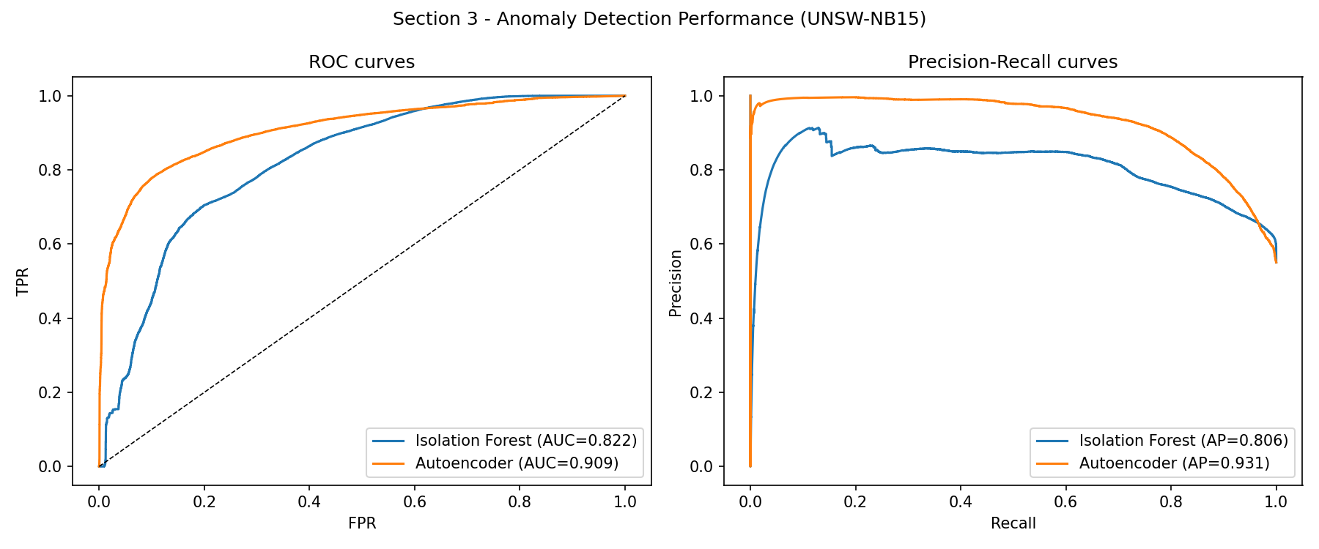
Figure 3.1 — ROC and precision-recall curves (TPR/FPR annotated in Section 4.4 table).
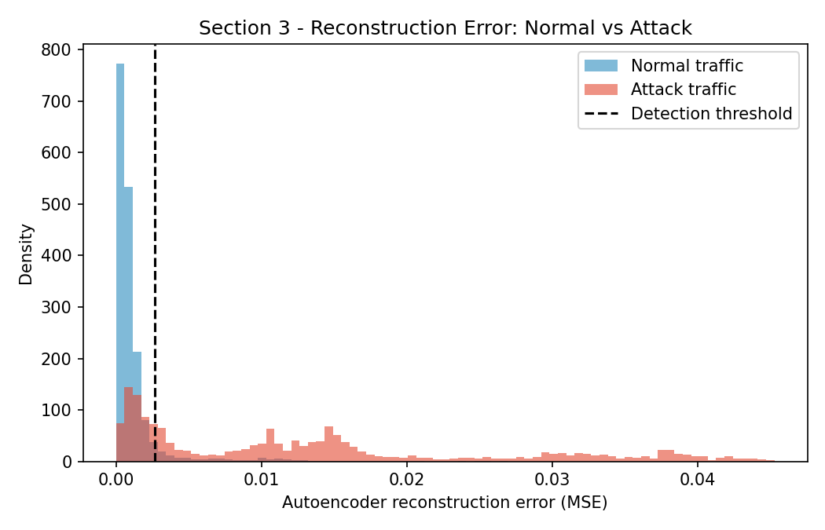
Figure 3.2 — Reconstruction-error distributions for normal vs attack traffic with the detection threshold.

4.5 Discussion
The autoencoder dominates on every measure: at comparable false-alarm budgets it detects 73.0% of attacks at 6.8% FPR versus 49.8% at 11.0% FPR for the Isolation Forest (ROC-AUC 0.909 vs 0.822, PR-AUC 0.931 vs 0.806). Figure 3.2 explains why: normal traffic reconstructs with tightly concentrated error while attack traffic spreads far beyond the threshold, i.e. the autoencoder has learned a compact manifold of normality that attacks violate feature-by-feature; the Isolation Forest's axis-aligned random splits capture coarser structure and rank many low-rate attacks as unremarkable. The practical trade-off is the classic one for SOC deployment: at a 5% alert budget the autoencoder converts roughly 3 in 4 attacks into alerts with 93% precision — genuinely useful triage — but the residual 27% miss rate means anomaly detection complements rather than replaces the supervised detector of Section 2. Its strength is exactly where Section 2 failed: it needs no attack labels at all, so novel/zero-day behaviour is detectable in principle. Both scores also degrade gracefully into a ranking, so analysts can work the queue from the most anomalous down rather than depending on a fixed threshold.
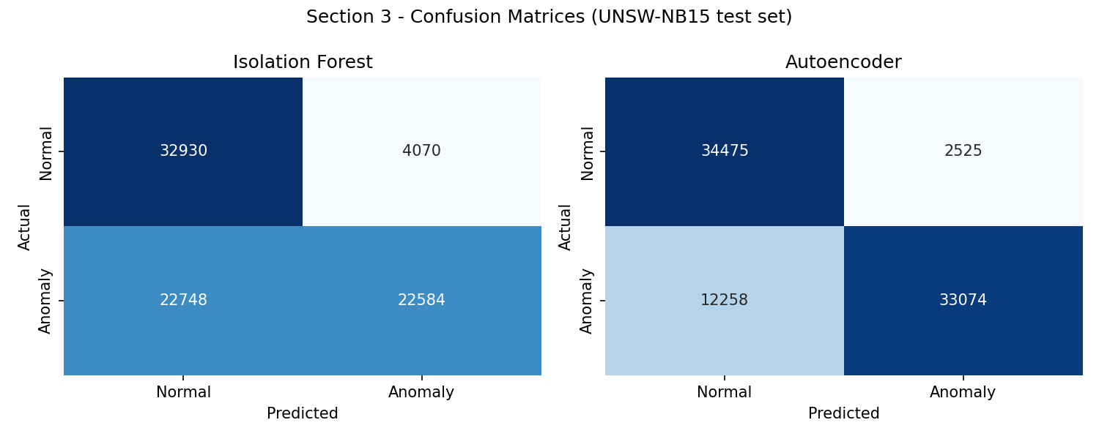
Figure 3.3 — Confusion matrices at the operating thresholds.
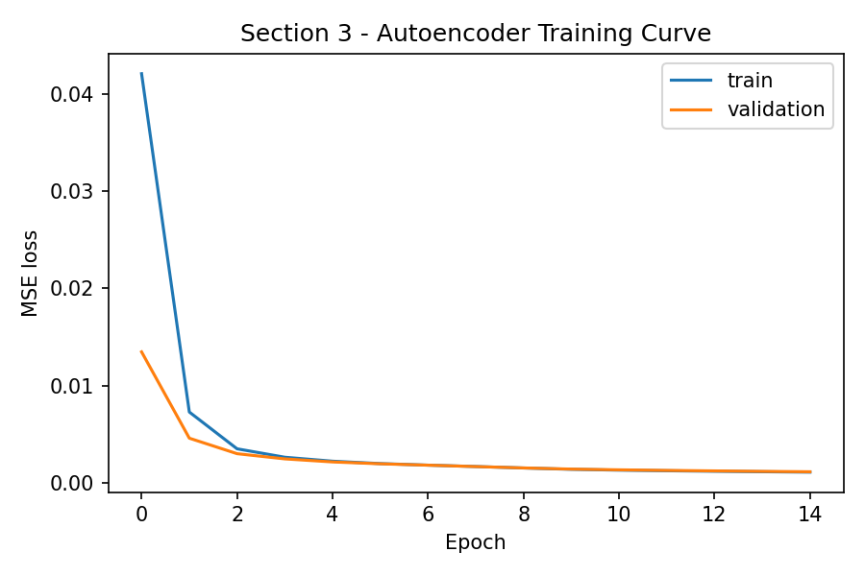
Figure 3.4 — Autoencoder training curve (MSE).

5. Section 4 — Ransomware Detection and Prevention

5.1 Dataset
The CSU Ransomware Behavioural Dataset (CSCRC-SCREED) was selected as a public, behaviour-based alternative to the datasets named in the brief (the Windows API-call corpora suggested there are either not publicly downloadable or contain no ransomware class). It comprises 352,876 Sysmon events — 271,993 from benign software use and 80,883 generated by executing modern ransomware families including LockBit, Medusa, Akira and BlackBasta in a controlled sandbox. Each event carries 19 engineered behavioural features: event-type indicators (file created/deleted, registry value set, process created, pipe created), path and process-name statistics (suspicious path, path length, directory depth, entropy of file names) and process-lineage features (parent/child frequency ratio, system-executable flags). Source: https://github.com/CSCRC-SCREED/CSU-Ransomware-Data.

5.2 Preprocessing
Labels were mapped to binary (ransomware = 1). Exact duplicate events (316,391 — telemetry naturally repeats identical events) were removed so the per-event train/test split cannot share identical rows, leaving 36,485 distinct events (5,880 ransomware). Features were standardised with a scaler fitted on training data. For the sequence model, the standardised event stream was sliced into windows of 10 consecutive events (stride 5) within each class segment, yielding 7,295 windows; windows were split chronologically per class (first 80% train, last 20% test) so overlapping windows can never leak between train and test.

5.3 Models
Classic ML: a Histogram Gradient Boosting Classifier (300 boosting iterations) classifying single events — the per-event task is deliberately the harder, more granular problem. Deep learning: a stacked LSTM (64 then 32 units, dropout 0.3, sigmoid output) classifying event windows, i.e. modelling how system behaviour evolves over time, which is where ransomware is most distinctive (bursts of file creation/deletion interleaved with registry and process activity).

5.4 Results
Model | Accuracy | Precision | Recall | F1-score | ROC-AUC
Gradient Boosting (per event) | 0.9581 | 0.8246 | 0.9396 | 0.8784 | 0.9922
LSTM (10-event windows) | 0.9993 | 0.9958 | 1.0000 | 0.9979 | 1.0000

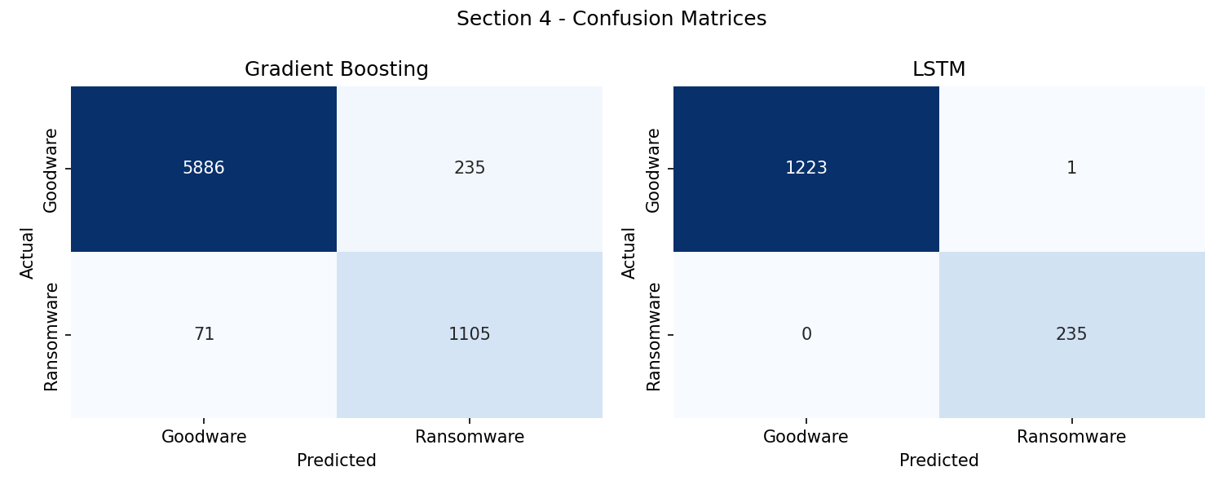
Figure 4.1 — Confusion matrices: per-event GBM vs windowed LSTM.
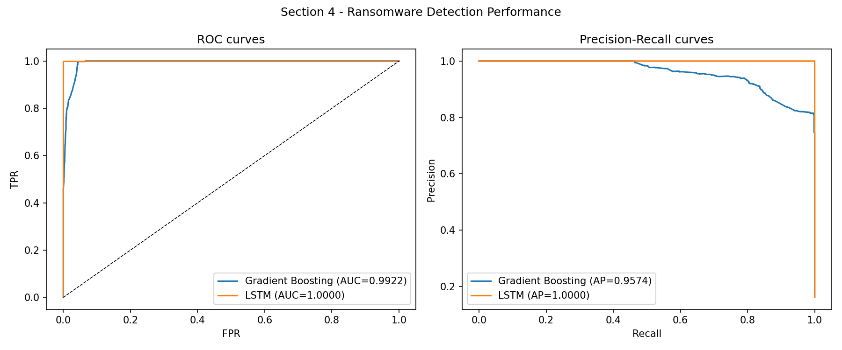
Figure 4.2 — ROC and precision-recall curves.

5.5 Discussion
The two models answer different operational questions. The gradient-boosted model must judge each event in isolation and still reaches F1 0.878 with 94.0% recall — permutation importance shows it leans on exactly the indicators an analyst would: file-deletion/creation event types, suspicious paths and file-name entropy (the statistical signature of mass encryption). Its 175 missed events and 1,174 false alarms per ~7,300 test events reflect the genuine ambiguity of single events — installers also create files at speed. Giving the LSTM ten consecutive events removes almost all of that ambiguity (F1 0.998, one false alarm, no misses): ransomware's temporal rhythm — sustained bursts of homogeneous file operations — is nearly unmistakable over even a short window. The near-perfect score should still be read with care: sandbox recordings are cleaner than production telemetry, windows are class-pure by construction, and a determined adversary can throttle encryption to blur the temporal signature. The deployment lesson survives these caveats: aggregate host telemetry over short windows before classifying, keep the per-event model as a low-latency first pass, and pair detection with automatic response (process suspension, snapshotting) since at ransomware encryption speeds even seconds of delay cost files.
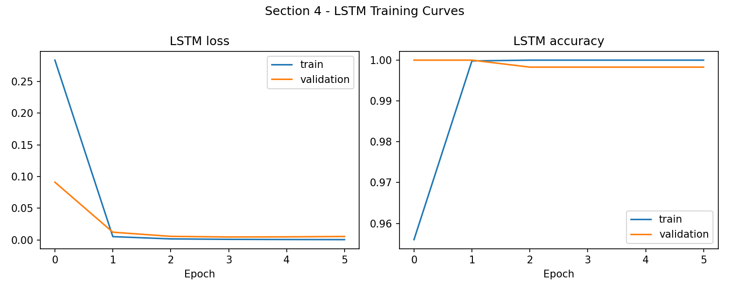
Figure 4.3 — LSTM training curves.
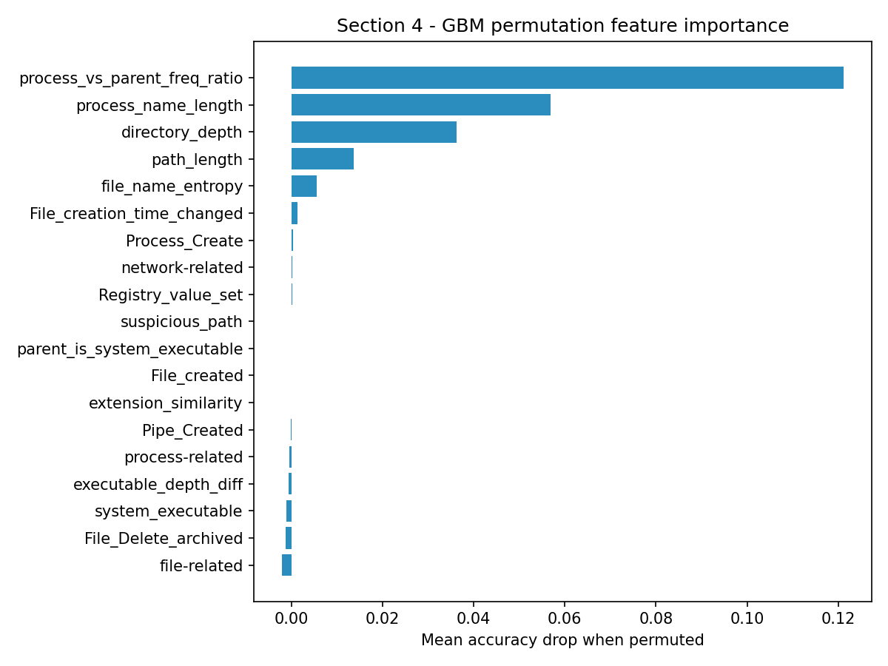
Figure 4.4 — GBM permutation feature importance.

6. Conclusions and Key Takeaways
Across the four security tasks, no single family of models wins everywhere; the deciding factors were data volume, label availability and whether the discriminative signal is lexical, tabular or temporal. Where the signal is lexical and abundant (spam), a linear TF-IDF model matches deep learning at a fraction of the cost and with auditable evidence. Where evaluation demands generalisation to unseen attack types (NSL-KDD), both paradigms degrade the same way — rare R2L/U2R classes collapse — though the CNN retains measurably more minority-class recall. Where labels are absent entirely (UNSW-NB15), the autoencoder's learned manifold of normality clearly beats the Isolation Forest, showing deep unsupervised models are the stronger zero-day safety net. And where the signal is temporal (ransomware), sequence modelling turns a good per-event detector into a near-perfect windowed one.
Three improvements would add the most value. First, class-imbalance handling — cost-sensitive losses, focal loss or SMOTE-style oversampling — directly targets the R2L/U2R failure and the per-event ransomware false alarms. Second, pretrained representations (a fine-tuned transformer for email; flow embeddings for traffic) would lift the deep models where training data is the bottleneck, at EU-deployable inference cost. Third, evaluation should move closer to deployment: temporal cross-validation, attacker-aware perturbations (throttled encryption, low-and-slow scans) and per-alert cost analysis, because precision at a fixed analyst budget — not accuracy — is the metric a SOC actually buys. Finally, every detector here is a triage aid, not an autonomous gate: given non-zero false-positive rates on benign business activity, quarantine and blocking decisions should keep a human analyst in the loop.

