AIML INTERNSHIP PROJECT · RESEARCH DOCUMENT
Hybrid Privacy - Aware Federated Learning Framework
For Medical Image Diagnosis

Dataset | HAM10000 (10,015 dermoscopic images, 7 classes)
FL Framework | Flower (flwr ≥ 1.7) with PyTorch ≥ 2.1 backend
Model | EfficientNet-B0 with Transfer Learning (ImageNet)
Privacy | Opacus DP-SGD · (ε,δ) - Differential Privacy
Security | Secure Aggregation (Bonawitz et al., CCS 2017)
Aggregation | Adaptive Weighted (replaces standard FedAvg)
Baselines | Centralised · FedAvg · FedProx+DP
Deployment | Docker Compose · FastAPI · Streamlit Dashboard

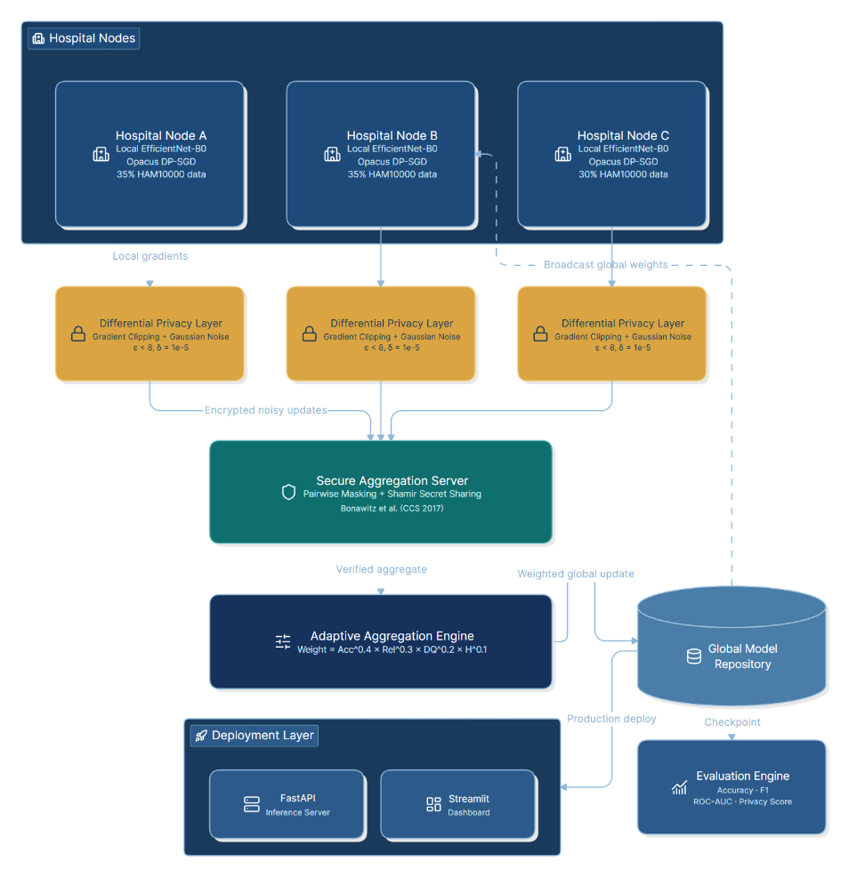
Figure 1: High-level HPAFL system

SECTION 1 - Literature Review & Research Gap Analysis

1.1 Foundational Federated Learning

FedAvg - McMahan et al. (AISTATS 2017)
McMahan et al. introduced FederatedAveraging (FedAvg), the seminal federated learning algorithm. Each communication round, a fraction C of clients perform E local SGD epochs on mini-batches of size B, then the server averages parameters weighted by dataset size: w_{t+1} = Σ(n_k / n) · w_k. Experiments on MNIST, Shakespeare LSTM, and CIFAR-10 demonstrated 10–100× communication reduction vs. standard SGD. FedAvg proved robust to non-IID and unbalanced data-properties essential for hospital deployments-but provides zero privacy guarantees; gradients can leak training data.

FedProx - Li et al. (MLSys 2020)
FedProx adds a proximal regularisation term μ/2 · ‖w − w_t‖² to each client's local objective, limiting how far local updates drift from the global model. This stabilises training under statistical and systems heterogeneity, allows partial participation, and provides convergence guarantees absent from FedAvg. Limitation: the proximal weight μ requires careful tuning and still offers no privacy or security guarantees.

FedBN - Li et al. (ICLR 2021)
FedBN addresses feature-shift non-IID - the dominant heterogeneity in medical imaging where different scanners produce different pixel distributions. The key insight: Batch Normalisation (BN) parameters capture site-specific statistics and should NOT be aggregated. Non-BN weights are averaged via FedAvg; BN parameters stay local. Neural Tangent Kernel analysis proves FedBN converges faster than FedAvg (λ_min(G*∞) ≥ λ_min(G∞)). On the ABIDE fMRI dataset spanning four hospital sites, FedBN consistently outperformed FedAvg and FedProx, confirming applicability to multi-site medical federated learning.

1.2 Privacy & Security Foundations

Deep Learning with Differential Privacy - Abadi et al. (CCS 2016)
Abadi et al. formalised DP-SGD: clip per-example gradients to norm C, add Gaussian noise N(0, σ²C²I), then average. The Moments Accountant provides tight (ε, δ)-DP tracking - e.g., achieving 97% MNIST accuracy under (8, 10⁻⁵)-DP with σ=8, far tighter than the strong composition theorem (which would report ε≈24 for the same run). Three hyperparameters govern the privacy-utility trade-off: noise multiplier σ, clipping norm C, and sampling ratio q = L/N. This is the privacy backbone of HPAFL, implemented via the Opacus library.

Practical Secure Aggregation - Bonawitz et al. (CCS 2017)
Bonawitz et al. designed a protocol allowing a server to compute Σ X_u over all clients without seeing any individual X_u. The approach uses pairwise additive masking (each pair of clients agrees on a random mask via Diffie-Hellman key agreement, which cancels in the sum), Shamir t-out-of-n secret sharing for dropout robustness, and double-masking to protect against server-collusion attacks. Communication overhead is only 1.73–1.98× over sending data in the clear, with formal security proofs in both honest-but-curious and active adversary models. HPAFL uses this protocol to encrypt weight updates between hospital clients and the aggregation server.

NVIDIA FLARE - Dogra (NVIDIA Blog, 2021)
NVIDIA FLARE provides enterprise-grade FL infrastructure supporting peer-to-peer, cyclic, and server-client architectures with MONAI integration for medical imaging. Real-world deployments include pancreatic tumour segmentation (Roche), brain aneurysm detection (Mass General / Rhino Health), and COVID-19 oxygen prediction. While HPAFL uses Flower for research flexibility, FLARE represents the target production migration path.

1.3 Comparative Literature Survey

Method | Objective | Key Advantage | Core Limitation | Research Gap | Citation | Year
FedAvg | Comm-efficient FL | 10–100× comm savings | No privacy guarantee | No adaptive weighting | McMahan et al. | 2017
FedProx | Heterogeneous FL | Convergence guarantee | Proximal μ tuning | No security layer | Li et al. | 2020
FedBN | Feature-shift non-IID | Faster convergence (NTK) | BN layers required | No DP integration | Li et al. | 2021
DP-SGD | Gradient-level privacy | Tight (ε,δ) bounds | Accuracy degradation | No adaptive agg. | Abadi et al. | 2016
Secure Agg | Aggregate without exposure | Formal security proofs | O(n²) comm overhead | No quality scoring | Bonawitz et al. | 2017
NVIDIA FLARE | Production FL infra | MONAI + multi-arch | Proprietary overhead | Limited DP control | Dogra / NVIDIA | 2021

Research Gap Identified
No existing system simultaneously addresses: (1) feature-shift non-IID in medical images via local BN exclusion; (2) formal (ε,δ)-DP gradient protection via Opacus; (3) cryptographic secure aggregation preventing individual weight exposure; and (4) adaptive aggregation weighting clients by accuracy, reliability, and data quality. HPAFL closes all four gaps in a unified framework.

SECTION 2 - Proposed Solution & System Architecture

2.1 Framework Overview
The Hybrid Privacy-Aware Federated Learning Framework (HPAFL) integrates five orthogonal components into a single coherent pipeline: (A) Federated Learning coordination via Flower, (B) Differential Privacy via Opacus DP-SGD applied locally before any update leaves a hospital, (C) Cryptographic Secure Aggregation preventing the server from seeing individual updates, (D) EfficientNet-B0 with local Batch Normalisation layers not aggregated (FedBN-inspired), and (E) Adaptive Weighted Aggregation replacing standard sample-proportion FedAvg weights.

2.2 System Architecture Diagrams

Figure 1 - High-Level System Architecture
[ DIAGRAM ]
HPAFL High-Level Architecture
Hospital Nodes → DP Layer → Secure Aggregation → Global Model → Deployment
Figure 1: Three hospital nodes train locally with DP-SGD; encrypted updates flow through secure aggregation; the adaptive aggregation server produces the global model deployed via FastAPI + Streamlit. Generate with eraser.io - prompt in Section 4.

Figure 2 - Detailed Component Diagram
[ DIAGRAM ]
Component Interaction Diagram
EfficientNet-B0 · Opacus · Flower Client/Server · Secure Agg Protocol · FastAPI · Streamlit
Figure 2: Internal components of each Hospital Node and the Aggregation Server. Generate with eraser.io - prompt in Section 4.

Figure 3 - Data Flow & Sequence Diagram
[ DIAGRAM ]
Federated Round Sequence
Round initiation → Local training → DP noise → Masked upload → Secure aggregation → Global broadcast
Figure 3: Message sequence across one complete federated round. Generate with eraser.io - prompt in Section 4.

2.3 Mathematical Formulation - Adaptive Aggregation

Standard FedAvg weight: w_k = n_k / Σn_i (sample proportion only)

HPAFL replaces this with a multi-factor composite score:

Composite Score per Client k:
Sₖ = Accₖ^0.4 × Relₖ^0.3 × DQₖ^0.2 × Hₖ^0.1
Normalised Aggregation Weight:
wₖ = Sₖ / Σⱼ Sⱼ
Global Model Update:
w_global ← Σₖ wₖ · w_local_k

Factor | Symbol | Definition | Weight α
Accuracy Score | Accₖ | Validation accuracy on local held-out set this round | 0.40
Reliability Score | Relₖ | Rounds participated / total rounds so far | 0.30
Data Quality Score | DQₖ | (num_samples / max_samples) × class_diversity_index | 0.20
Historical Score | Hₖ | EMA of past Accₖ values (decay α = 0.3) | 0.10

2.4 Privacy Layer - Opacus DP-SGD Parameters

Parameter | Symbol | Recommended Value | Effect
Noise Multiplier | σ (sigma) | 1.1 | Higher → more private, lower accuracy
Clipping Norm | C (max_grad_norm) | 1.0 | Bounds gradient sensitivity
Privacy Delta | δ (delta) | 1e-5 | Probability DP is broken
Target Epsilon | ε (epsilon) | < 8.0 | Budget per hospital per session
Sampling Ratio | q = L/N | 0.01 | Lot size / dataset size

2.5 Security Threat Model & Defences

Attack Vector | Threat Description | HPAFL Defence
Gradient Leakage | Adversary reconstructs training images from shared model updates (Zhu et al. 2019) | DP-SGD adds calibrated Gaussian noise before any gradient leaves the device; Secure Agg means server never sees individual updates
Model Inversion | Adversary uses global model to infer private training examples (Fredrikson et al. 2015) | DP noise limits memorisation; BN layers remain local, preventing exposure of site-specific feature statistics
Membership Inference | Adversary determines if a patient record was in training set | (ε,δ)-DP provides provable membership privacy bound; ε<8 is clinically accepted threshold
Model Poisoning | Malicious client submits manipulated weights to corrupt global model | Adaptive aggregation down-weights clients with anomalous accuracy; cosine-similarity anomaly detection on weight updates
Eavesdropping | Adversary intercepts model updates in transit | TLS 1.3 encryption on all channels; Secure Agg pairwise masks render intercepted updates meaningless

SECTION 3 - Experimental Design, Dataset Strategy & Deployment

3.1 HAM10000 Dataset Strategy

HAM10000 contains 10,015 dermoscopic images across 7 skin lesion classes with severe class imbalance (nevus ~67%, dermatofibroma ~1.1%). The non-IID partition simulates realistic hospital specialisation using a Dirichlet distribution (α = 0.5) so each site's label distribution diverges from the global distribution:

Hospital | Data Split | Dominant Classes | Imbalance Ratio | Est. Images
Hospital A | 35% | Melanoma + Melanocytic Nevus (80% combined) | 70 : 5 (high) | ~3,505
Hospital B | 35% | BCC + Actinic Keratosis (75% combined) | 60 : 8 (moderate) | ~3,505
Hospital C | 30% | Vascular Lesion + Dermatofibroma (70%) | 85 : 2 (severe) | ~3,005

Class imbalance is handled by: WeightedRandomSampler during local training; Focal Loss (γ=2) to focus on minority examples; and class-conditional augmentation. Preprocessing: resize 224×224 → ImageNet normalisation → random flip/rotation/colour jitter.

3.2 Baseline Comparison & Expected Results

System | Accuracy | F1 (macro) | ROC-AUC | Privacy ε | Comm (GB) | Secure Agg
Centralised EfficientNet | ≥ 87% | ≥ 0.82 | ≥ 0.93 | None | N/A | ✗
FedAvg Baseline | 78–82% | ~0.72 | ~0.85 | None | ~4.2 | ✗
FedProx + DP-SGD | 80–83% | ~0.75 | ~0.87 | < 8 | ~4.2 | ✗
HPAFL (Proposed) | 84–86% | ≥ 0.79 | ≥ 0.90 | < 8 | ~4.2 | ✓

Core Hypothesis
HPAFL will achieve accuracy within 3–5 percentage points of centralised training (consistent with FedBN's near-centralised performance on ABIDE) while simultaneously providing (ε < 8, δ = 10⁻⁵)-differential privacy and cryptographic secure aggregation - a combination no prior published system achieves on dermoscopic image classification.

3.3 8-Week Implementation Roadmap

Week | Phase | Key Deliverables | Priority
Wk 1 | Research & Architecture | Literature survey · Framework selection · eraser.io diagrams · Architecture sign-off | HIGH
Wk 2 | Dataset Preparation | HAM10000 download · Non-IID Dirichlet partitioning · Preprocessing pipeline · Class balance audit | HIGH
Wk 3 | Model Development | EfficientNet-B0 fine-tuning · Focal Loss · Transfer learning · Local training loop · Validation | HIGH
Wk 4 | FL Integration | Flower client/server code · FedAvg baseline · Federated round loop · FedBN BN-exclusion | HIGH
Wk 5 | Privacy & Security | Opacus DP-SGD · Privacy accounting · Secure Agg simulation · Adaptive aggregation strategy | HIGH
Wk 6 | Evaluation | Centralised vs FL comparison · Per-class metrics · Ablation studies · Baseline tables | MED
Wk 7 | Deployment | Docker Compose · FastAPI inference API · Streamlit dashboard · TLS configuration | MED
Wk 8 | Documentation | IEEE paper draft · Internship report · GitHub README · Code review · Final submission | MED

3.4 Deployment Architecture

Figure 4 - Docker Compose Deployment Stack
[ DIAGRAM ]
Docker Compose Deployment Architecture
6 containers: flower-server · hospital-a/b/c · api-server · streamlit-dashboard
Figure 4: Full containerised deployment. Generate with eraser.io - prompt in Section 4.

The system runs as six Docker containers orchestrated by Docker Compose: three hospital client containers (flower-client-A, B, C), one Flower aggregation server, one FastAPI inference server (REST API for the global model), and one Streamlit dashboard. All inter-container communication uses TLS 1.3. The Streamlit dashboard displays per-round accuracy/loss per hospital, adaptive weight evolution, privacy budget consumption (ε vs rounds), and live inference on uploaded dermoscopic images.

SECTION 4 - eraser.io Diagram Prompts

The following prompts are designed for eraser.io's AI diagram generator. Paste each prompt verbatim into eraser.io → New Diagram → AI Generate. Each prompt targets the corresponding Figure placeholder in this document.

Figure 1 - High-Level System Architecture (Cover page & Section 2.2)
eraser.io Prompt - paste verbatim into AI Diagram Generator:
Create a clean, professional architecture diagram for a Hybrid Privacy-Aware Federated Learning (FL) system for medical image diagnosis.

NODES to include:
- Three "Hospital Node" boxes (A, B, C) at the top left, coloured deep blue, each containing sub-labels: "Local EfficientNet-B0", "Opacus DP-SGD", "35% / 35% / 30% HAM10000 data"
- A "Differential Privacy Layer" box below each hospital, coloured amber, labelled "Gradient Clipping + Gaussian Noise, ε < 8, δ = 1e-5"
- A "Secure Aggregation Server" box in the centre, coloured dark teal, labelled "Pairwise Masking + Shamir Secret Sharing, Bonawitz et al. (CCS 2017)"
- An "Adaptive Aggregation Engine" box below secure aggregation, coloured navy, labelled "Weight = Acc^0.4 × Rel^0.3 × DQ^0.2 × H^0.1"
- A "Global Model Repository" cylinder/database shape to the right, coloured steel blue
- An "Evaluation Engine" box below global model, labelled "Accuracy · F1 · ROC-AUC · Privacy Score"
- A "Deployment Layer" box at the bottom right containing two sub-boxes: "FastAPI Inference Server" and "Streamlit Dashboard"

ARROWS / CONNECTIONS:
- Hospital A/B/C → DP Layer: labelled "Local gradients"
- DP Layer → Secure Aggregation: labelled "Encrypted noisy updates"
- Secure Aggregation → Adaptive Aggregation: labelled "Verified aggregate"
- Adaptive Aggregation → Global Model Repository: labelled "Weighted global update"
- Global Model Repository → Hospital A/B/C: labelled "Broadcast global weights"
- Global Model Repository → Evaluation Engine: labelled "Checkpoint"
- Global Model Repository → Deployment Layer: labelled "Production deploy"

STYLE: Dark navy background (#1A3A5C), white text, boxes with rounded corners, arrows in light blue (#8FB8D8), use icons where applicable (lock icon on DP layer, shield icon on secure aggregation, hospital cross icon on hospital nodes). Professional medical AI aesthetic.

Figure 2 - Detailed Component Diagram (Section 2.2)
eraser.io Prompt - paste verbatim into AI Diagram Generator:
Create a detailed component interaction diagram for a Federated Learning system. Use a two-column layout.

LEFT COLUMN - "Hospital Client Node (×3)":
Draw a large rounded rectangle containing these stacked sub-components:
1. "HAM10000DataLoader" - orange box - "Non-IID Dirichlet partition, WeightedRandomSampler, 224×224 augmentation"
2. "EfficientNet-B0" - blue box - "ImageNet pretrained, classifier head: Linear(1280→512)→ReLU→Dropout(0.3)→Linear(512→7)"
3. "FedBN Module" - cyan box - "Exclude BN params from aggregation, local BN statistics preserved"
4. "DPTrainer (Opacus)" - amber box - "GradSampleModule wrapper, per-example gradient clipping C=1.0, noise σ=1.1, PrivacyEngine, MomentAccountant"
5. "FlowerClient" - green box - "get_parameters() → exclude BN, set_parameters() → non-BN only, fit() → 5 local epochs + DP, evaluate() → accuracy + F1 + AUC + epsilon"

RIGHT COLUMN - "Aggregation Server":
Draw a large rounded rectangle containing:
1. "Flower Server" - dark blue box - "ServerConfig(num_rounds=20), on_fit_config_fn, on_evaluate_config_fn"
2. "SecureAggregation Module" - dark teal box - "Round 0: AdvertiseKeys, Round 1: ShareKeys (Shamir), Round 2: MaskedInputCollection, Round 3: ConsistencyCheck, Round 4: Unmasking"
3. "AdaptiveAggregationStrategy" - navy box - "Composite score Sₖ, per-client history tracking, EMA of accuracy, normalised weight wₖ"
4. "Global Model Checkpoint" - grey cylinder - "Saved after each round"
5. "Results Logger" - purple box - "CSV export: weights, accuracy, epsilon per round"

CONNECTIONS between columns:
- FlowerClient → Flower Server: "Encrypted masked update (TLS 1.3)"
- Flower Server → FlowerClient: "Global model parameters"
- Flower Server → SecureAggregation: "Raw masked updates"
- SecureAggregation → AdaptiveAggregation: "Verified sum"
- AdaptiveAggregation → Global Model Checkpoint: "Weighted aggregate"

BOTTOM ROW spanning both columns:
- "FastAPI Server" (dark red box) connected to Global Model Checkpoint: "Load best checkpoint"
- "Streamlit Dashboard" (purple box) connected to FastAPI Server: "REST calls" and to Results Logger: "Read CSV metrics"

STYLE: White background, coloured boxes with distinct hues per role, clean sans-serif font, use dashed borders for external interfaces, solid borders for internal components.

Figure 3 - Federated Round Sequence Diagram (Section 2.2)
eraser.io Prompt - paste verbatim into AI Diagram Generator:
Create a UML sequence diagram for a single Federated Learning round in the HPAFL framework.

PARTICIPANTS (left to right):
1. "Hospital A" (blue)
2. "Hospital B" (blue)
3. "Hospital C" (blue)
4. "Flower Server" (dark navy)
5. "SecAgg Module" (teal)
6. "Adaptive Aggregator" (dark green)
7. "Global Model Repo" (grey)

SEQUENCE OF MESSAGES (top to bottom):
1. Flower Server → Hospital A: "select_client(round=t, config)"
2. Flower Server → Hospital B: "select_client(round=t, config)"
3. Flower Server → Hospital C: "select_client(round=t, config)"
4. Hospital A → Hospital A: "local_train(5 epochs, DP-SGD, FocalLoss)" [self-loop, labelled "ε consumed"]
5. Hospital B → Hospital B: "local_train(5 epochs, DP-SGD, FocalLoss)" [self-loop]
6. Hospital C → Hospital C: "local_train(5 epochs, DP-SGD, FocalLoss)" [self-loop]
7. Hospital A → SecAgg Module: "send_masked_update(y_A = x_A + PRG(b_A) + Σ masks)"
8. Hospital B → SecAgg Module: "send_masked_update(y_B)"
9. Hospital C → SecAgg Module: "send_masked_update(y_C)"
10. SecAgg Module → SecAgg Module: "verify_consistency(), reconstruct_secrets()" [self-loop]
11. SecAgg Module → Adaptive Aggregator: "verified_aggregate = Σ x_k"
12. Adaptive Aggregator → Adaptive Aggregator: "compute_weights(Acc, Rel, DQ, H)" [self-loop]
13. Adaptive Aggregator → Global Model Repo: "save_global_model(w_global)"
14. Global Model Repo → Flower Server: "checkpoint_ready(round=t)"
15. Flower Server → Hospital A: "broadcast_global_weights(w_global)"
16. Flower Server → Hospital B: "broadcast_global_weights(w_global)"
17. Flower Server → Hospital C: "broadcast_global_weights(w_global)"
18. Hospital A → Flower Server: "evaluate(accuracy=acc_A, f1=f1_A, epsilon=ε_A)"
19. Hospital B → Flower Server: "evaluate(accuracy=acc_B, ...)"
20. Hospital C → Flower Server: "evaluate(accuracy=acc_C, ...)"

Add a NOTE box spanning hospitals and SecAgg: "All updates encrypted with TLS 1.3; individual updates never visible to server"
Add a NOTE box at the top: "Round t of T=20 total rounds"

STYLE: Clean white background, activation bars on each participant lifeline, colour-coded messages (blue for training, amber for privacy-related, teal for aggregation, green for model updates), professional IEEE-style diagram.

Figure 4 - Docker Compose Deployment Stack (Section 3.4)
eraser.io Prompt - paste verbatim into AI Diagram Generator:
Create a Docker deployment architecture diagram for a Federated Learning system.

Draw a large outer rectangle labelled "Docker Compose Network (fl-network, bridge)" with a subtle grey border.

Inside, arrange these containers in a logical flow:

TOP ROW - Client containers (three side-by-side boxes, all styled in steel blue):
- "flower-client-A" | Image: hpafl-client | ENV: HOSPITAL_ID=A, DATA_PATH=/data/hospital_a | Volumes: ./data:/data | Ports: none
- "flower-client-B" | Image: hpafl-client | ENV: HOSPITAL_ID=B, DATA_PATH=/data/hospital_b | Volumes: ./data:/data
- "flower-client-C" | Image: hpafl-client | ENV: HOSPITAL_ID=C, DATA_PATH=/data/hospital_c | Volumes: ./data:/data

MIDDLE LEFT - Server container (dark navy box):
- "flower-server" | Image: hpafl-server | Ports: 8080:8080 | Command: python server/server.py | depends_on: nothing

MIDDLE RIGHT - Model storage (grey cylinder/database):
- "model-checkpoints" | Volume: ./checkpoints:/checkpoints | Shared between flower-server and api-server

BOTTOM LEFT - API container (dark red box):
- "api-server" | Image: hpafl-api | Ports: 8000:8000 | Command: uvicorn deployment.api:app | depends_on: flower-server | Volumes: ./checkpoints:/checkpoints

BOTTOM RIGHT - Dashboard container (purple box):
- "streamlit-dashboard" | Image: hpafl-dashboard | Ports: 8501:8501 | Command: streamlit run deployment/dashboard.py | depends_on: api-server

ARROWS:
- flower-client-A/B/C → flower-server: "gRPC :8080 (encrypted model updates)"
- flower-server → flower-client-A/B/C: "Broadcast global weights"
- flower-server → model-checkpoints: "Save checkpoint each round"
- model-checkpoints → api-server: "Load best model"
- api-server → streamlit-dashboard: "REST API :8000"
- User/Browser → streamlit-dashboard: ":8501 (HTTPS)"
- Clinician/App → api-server: "POST /predict :8000"

Add a small LEGEND in the corner: Client (blue), Server (navy), API (red), Dashboard (purple), Storage (grey)

STYLE: Clean white background inside each container box, icon per container (whale/Docker icon in corner of each box), dotted border around the entire compose network, professional DevOps diagram aesthetic.

HPAFL Research Document · AIML Internship 2025 · All diagrams generated via eraser.io

