Enterprise Data Cleaning & ETL Orchestration Framework
Using Python, Apache Airflow & Streamlit
Team Members:
Sadiya Sadaf
Rachi Rajpal
Keerthana

Introduction

Retail businesses generate large volumes of transactional data daily.
This data is often unstructured, inconsistent, and contains missing values.
Manual processing is inefficient, so automation is required.

2. Problem Statement

Unclean and inconsistent data
Manual processing is time-consuming
No automation or monitoring
Lack of real-time insights

Solution:
Build an automated ETL pipeline with visualisation.

3. Project Objective

Automate the ETL pipeline
Clean and standardise data
Store data in a database
Build a dashboard for insights
Enable monitoring using Airflow

4. Technology Stack

Python (Core Programming)

Pandas (Data Transformation)

Apache Airflow (Workflow Orchestration)

PostgreSQL (Database)

Streamlit (Dashboard)

Docker (Containerization)

5. Architecture
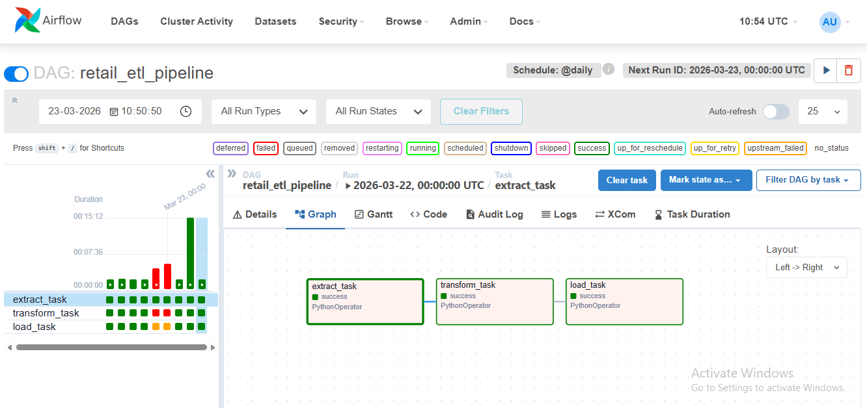

Pipeline Flow:
Raw Data → Airflow ETL → Processed Data → PostgreSQL → Dashboard

6. ETL Pipeline
Extract:

Read CSV
Validates data availability


Transform:

Handles missing values
Converts data types
Removes invalid records
Creates new column: TotalAmount

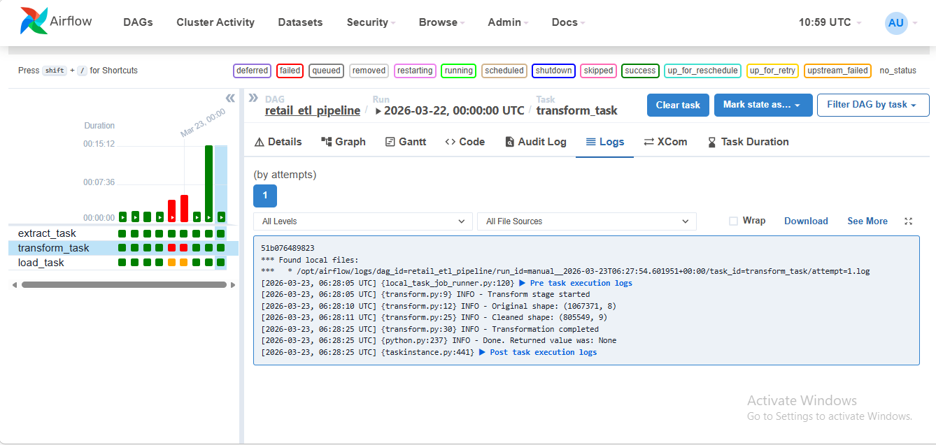

Load:

Stores cleaned data into PostgreSQL
Uses optimised bulk insert
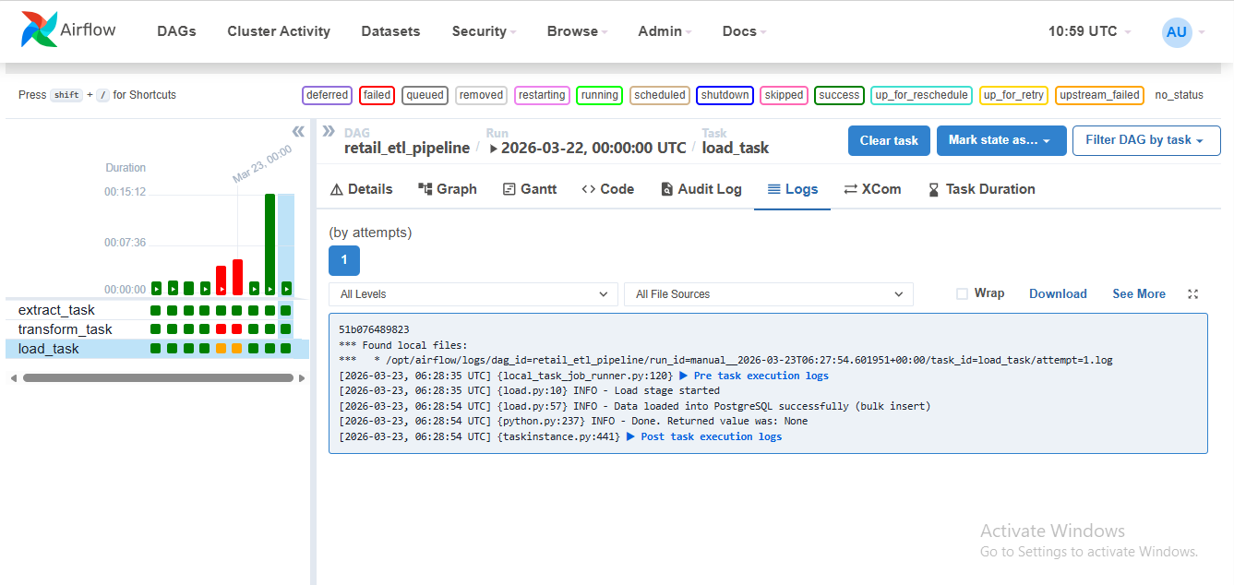

Each stage is implemented as an Airflow task.

7. Monitoring

Airflow DAG scheduling
Retry mechanism on failure
Logging for debugging
Email alerts on task failure

8. Dashboard

Interactive Dashboard Features:

Total Revenue & Orders (KPIs)

Sales trend over time

Top countries by revenue

Top products analysis

Filters (Date & Country)
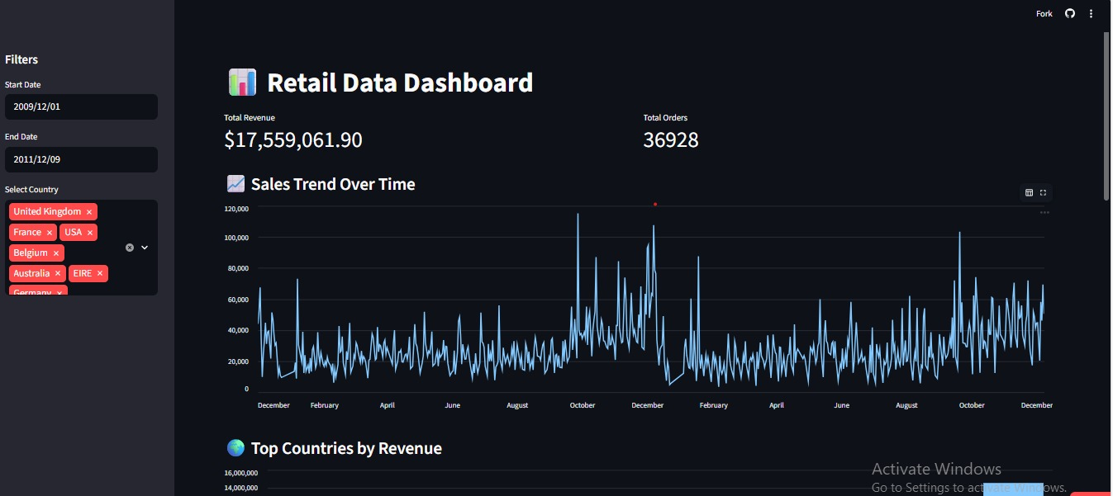
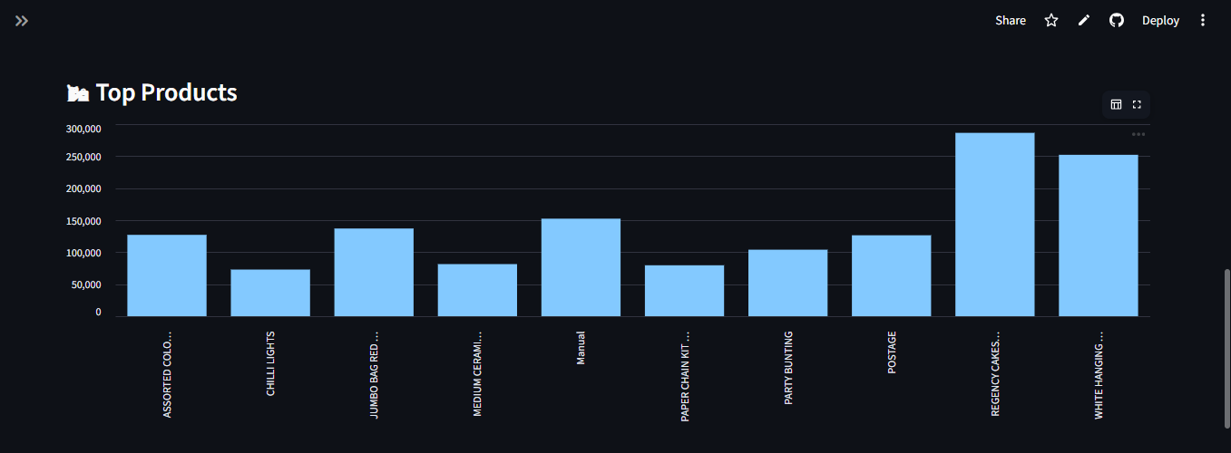

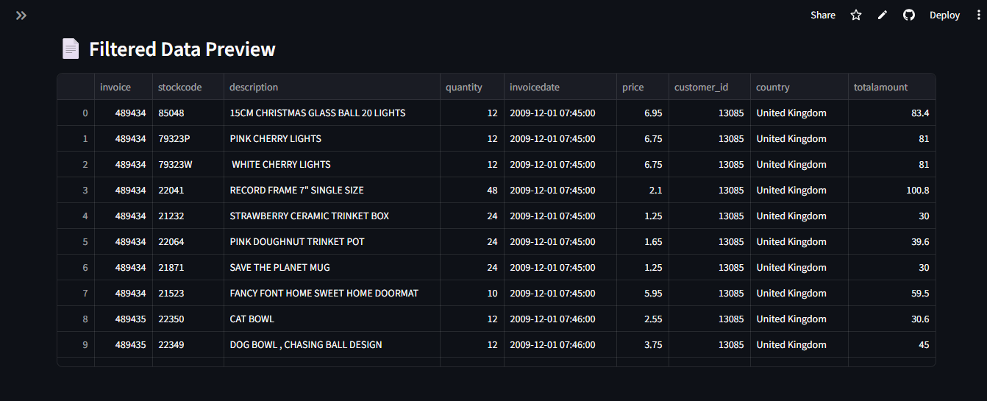

9. Live Demo

Deployed using Streamlit Cloud

Live Dashboard:

https://etl-project-6yhxaiayboddqrusnjtdsh.streamlit.app/

10. Challenges & Solutions

Challenges:

File path issues in Docker

Column inconsistencies

Slow database loading

Solutions:

Mounted volumes correctly

Standardised column names

Used bulk insert for performance

11. Conclusion

Successfully built an end-to-end ETL pipeline

Automated data processing using Airflow

Created an interactive dashboard

Deployed the project on the cloud

12. Future Scope

Real-time data processing
Cloud integration
Advanced analytics dashboard

