For this project, we will use the MERN stack, which stands for MongoDB, ExpressJS, ReactJS, and Node.js.

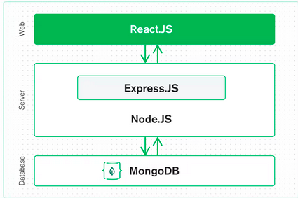

We use this stack because MERN is a full-stack solution, meaning that it includes a stack for both the back-end and front-end. Moreover, these technologies synchronize with each other well.

**React.JS** is for the frontend part and serves for creating dynamic pages with reusable components. React is also designed for handling errors, events, etc.   
  
**Express.JS** serve for creating a server-side platform inside the Node.JS server. In meanwhile, **Node.JS** is responsible for creating a Javascript web server. Express has powerful functions that handle HTTP requests and responses. Meanwhile

**MongoDB** is a database system. MongoDB is perfectly suited for working with Node.JS and has great functionality with JSON data.

The stacks mentioned above, allow a natural flow of JSON from *front* to *back*. Also, it requires knowing only javascript instead of learning a bunch of different languages for each tier.

The given project involves a lot of database management and login-registering of new users. For that purpose, MongoDB suits well.

The drawback of MERN is despite the fact that MERN uses only javascript language, it involves a deep knowledge of javascript, which would require a lot of time to get to know it. Instead of using MongoDB, there is a possibility of using backend-as-a-service Firebase, which would significantly decrease the development process.

Though, the choice of Database document will be fully decided later after the first prototype.