
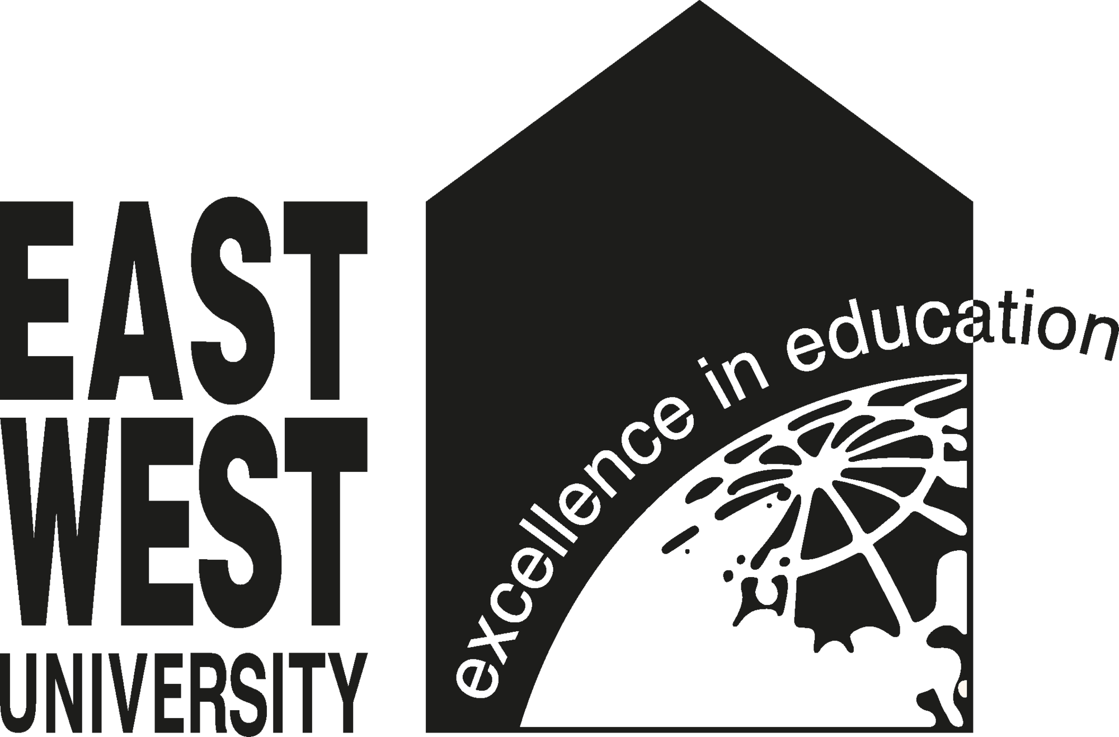


- Course Code: ENG7102
- Course Title: Composition and Communication Skills
COURSE INFORMATION
PORTFOLIO

Date of submission: 22-04-2026
East West University
- Student Name : Sadman Showmik Anik
- ID : 2025-1-60-055
- Section : 45
- Department : CSE
SUBMITTED BY
SUBMITTED TO
- Syeda Shabnam Mahmud,
- Senior Lecturer, Department of English,
- East West University.

