

CSE103: Structured Programming [Spring 2025]

Project Report
SuperShop Billing System

Course Code : CSE103
Course Title : Structured Programming
Instructor : Md. Asif Khan Rifat
Section : 10
Group Number : 01
Group Name : The Hecker’s
Date of Submission : 20-05-2025

Submitted by:
Page 01
Student ID | Student Name | Contribution
2025-1-60-062 | Most. Sabina Khatun | Login Function
2025-1-60-061 | Mahmudur Rahman Harry | Daily Sales Report
2025-1-60-056 | Atiqur Rahman | Inventory Management
2025-1-60-055 | Sadman Showmik Anik | Customer Billing

Introduction

Objective and Purpose

- This project aims to simulate a simple supermarket billing system that will help a seller to manage the store items more efficiently and makes it easier for a customer to buy grocery items. It includes inventory management, customer billing with VAT, stock updates and daily sales reporting.

Tools and IDE

- Programming Language: C.
- IDE: Code::Blocks, Visual Studio Code.
- Compiler: GCC

Problem Statement

Problem-Definition:
Large supermarkets often struggle with managing complex billing and inventory tasks without an integrated digital system, leading to potential errors and inefficiencies.

Significance:
This project aims to solve that issue by offering a user-authenticated, streamlined solution for handling inventory management, customer transactions, and daily sales tracking in a super shop.

Functional Requirements
- Admin Login : Authenticate user with username and PIN.
- Inventory Management: Add, update, and display product details
- Customer Billing: Add products, calculate total with VAT
- Daily Sales Report: Shows all sold items.
- Data Validation: Check unique ID for item.

Page 02


Project Design
Scan this to view this flowchart

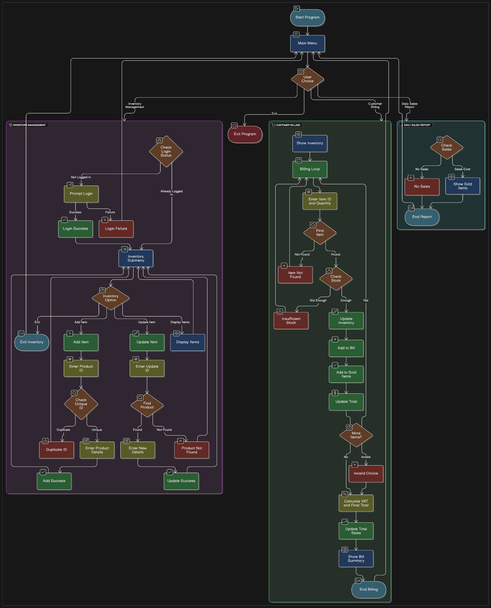
Flow Chart:
Page 03

Modular Design:
- main(): Menu navigation.
- inventoryManagment (): Inventory functions [add(), update(), display(): Sub-functions].
- customerBilling(): Customer Cart & Billing, Update stocks.
- showSoldItems(): Sales data.
- login(): Authenticates.
- display(): Display all available items.
- findIndex(), isUnique(): (Helping functions for efficiency.)

Code Implementation

5.1 Main Function
- Code Snippet:
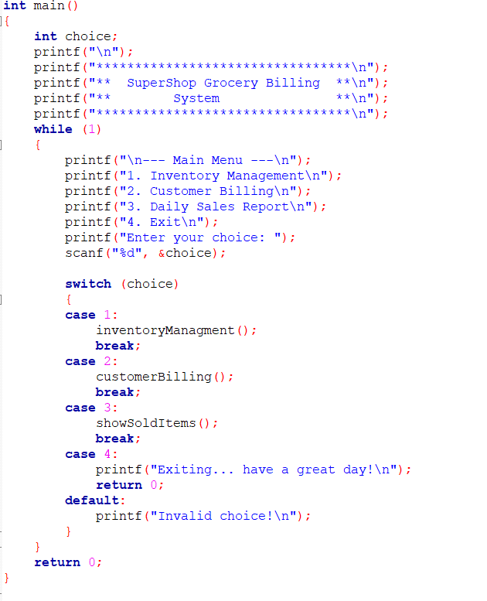
Page 04

Explanation:

The main function acts as the central hub of the Event Management System, presenting a menu- driven interface that allows users to perform tasks such as creating events, registering participants, and generating reports. It continuously loops to handle user inputs, calling the appropriate module functions until the user chooses to exit.

5.2 Functions Description

- inventoryManagement():
- Purpose: The purpose of the inventoryManagment() function is to provide a user interface for managing an inventory system. This function handles user authentication and allows logged-in users to perform core inventory operations.
- Code Snippet:

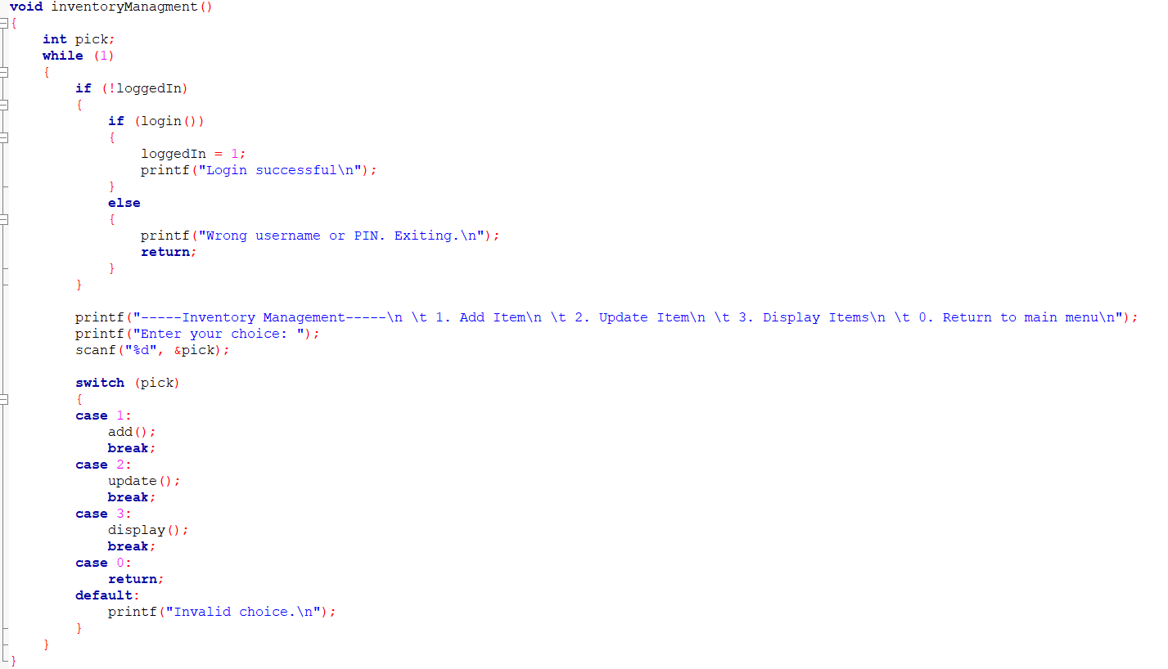

Page 05
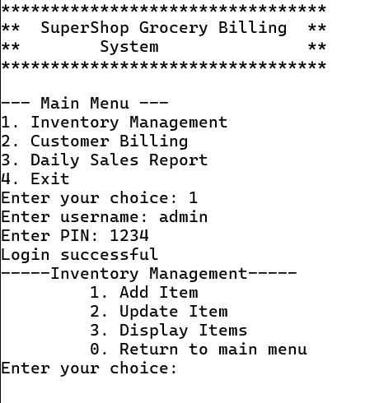
- Sample Output:

5.2.1 Sub Functions Descriptions

- add():
- Purpose: The add() function allows the user to add a new product to the inventory.
- Code Snippet:
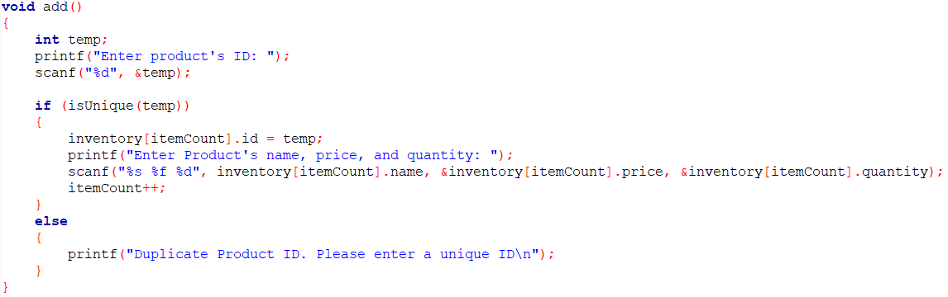

Page 06

  - Sample Output:

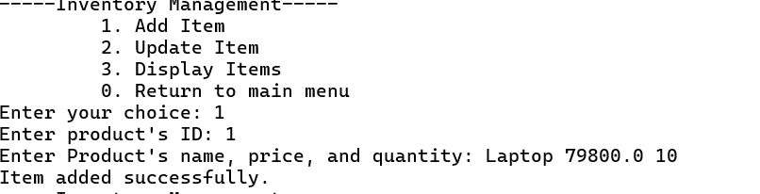

- update():
- Purpose: The update() function enables the user to modify the quantity and price of an existing product in the inventory.
- Code Snippet:
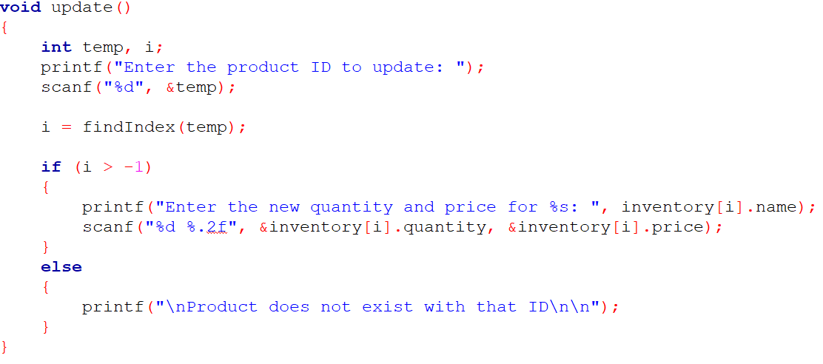

  - Sample Output:

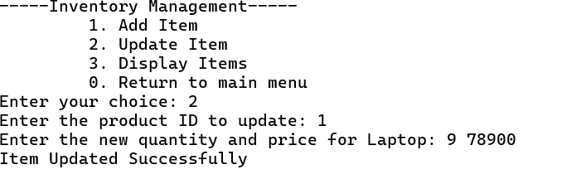

Page 07
- display():
- Purpose: The display() function enables the user to modify the quantity and price of an existing product in the inventory.
- Code Snippet:
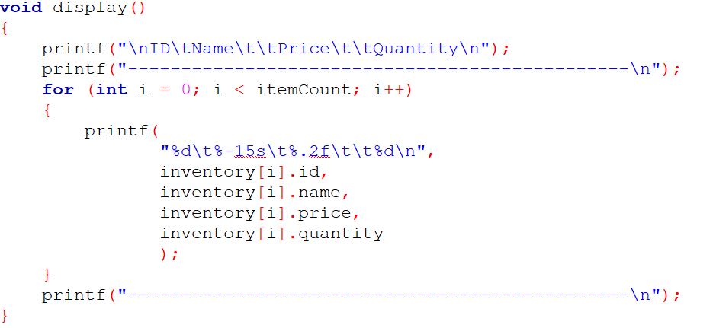

  - Sample Output:
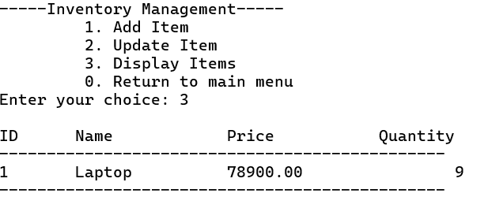

Page 08
- CustomerBilling():

Purpose:
- The customerBilling() function handles the billing process for customers by allowing them to purchase items from the inventory. It performs the following key operations:
- Displays the current inventory using the display() function.
- Accepts multiple item purchases by allowing the user to input item IDs and desired quantities in a loop.
- Checks for valid item IDs and ensures sufficient stock is available before processing.
- Updates the inventory by reducing the quantity of sold items.
- Records sold items in a sales tracking structure (sold[]) for later use or analysis.
- Calculates the subtotal, applies a 10% VAT, and computes the final total.
- Updates the total sales record.
- Displays a clear bill summary showing each item purchased, its quantity, price, and the final amount due.
- This function simulates a point-of-sale system, ensuring accurate billing and real-time inventory updates.

- Code Snippet:

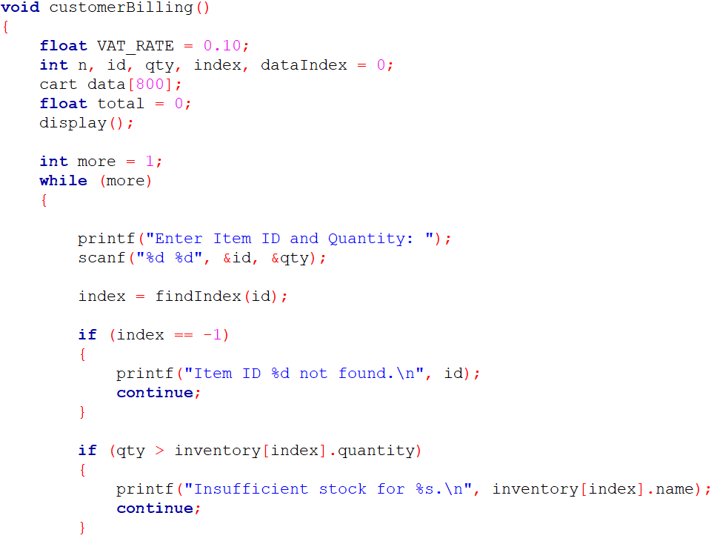
Page 09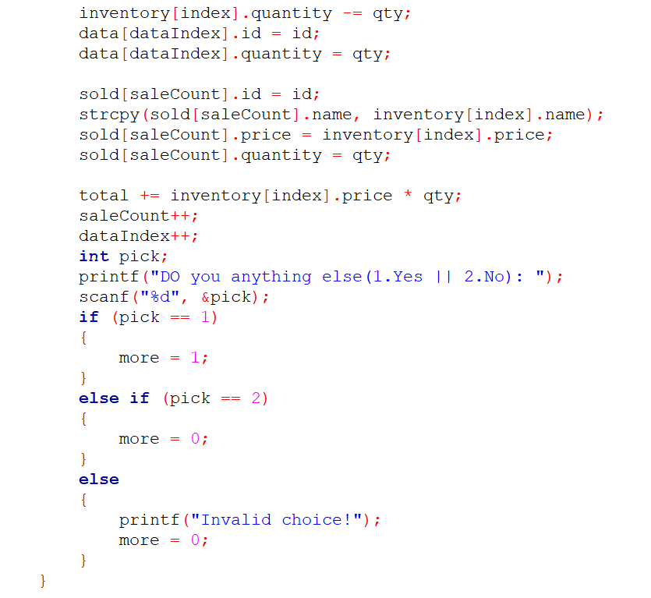
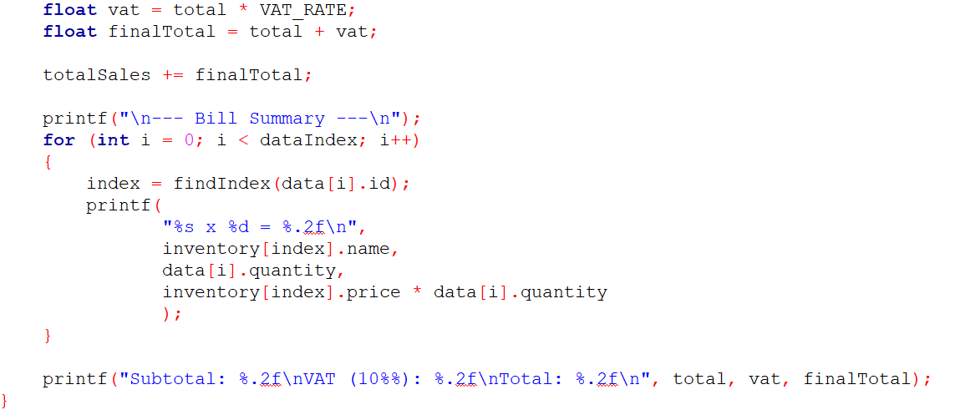

Page 10
  - Sample Output:

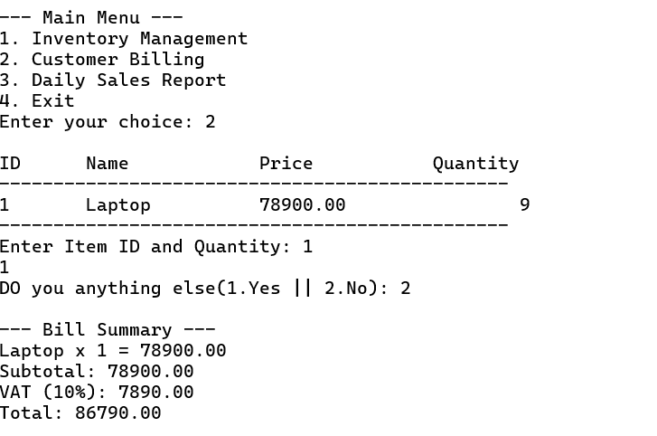

- showSoldItems():
- Purpose: The showSoldItems() function is used to display a summary of all items that have been sold.
- Code Snippet:
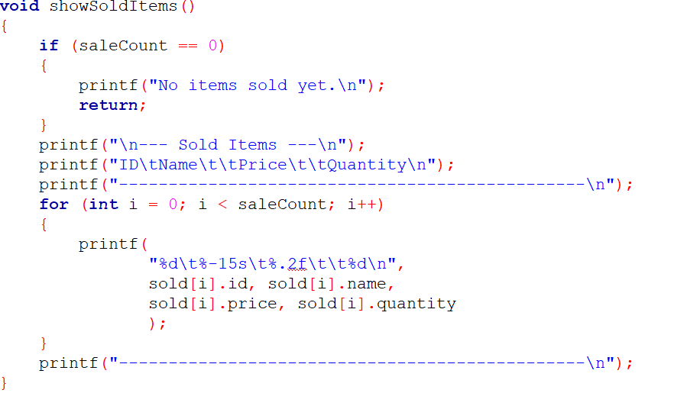

Page 11
- Sample Output
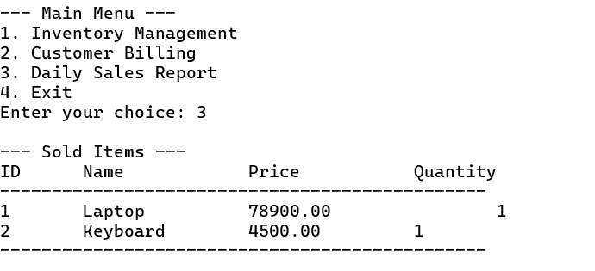

Testing and Results
  - Test Cases:

Test Input | Expected Output | Actual Output
Admin Login Credentials | Authenticate Credentials | User logged in / Wrong Pin
Add Item, price, stock | Item, stock, price added to inventory array | Item, Price, Stock added
Update stock, price | Manipulating array Elements | Info Updated
Display Items | Show items from inventory | Loop and print all the items of inventory array
  - Results and Screenshots
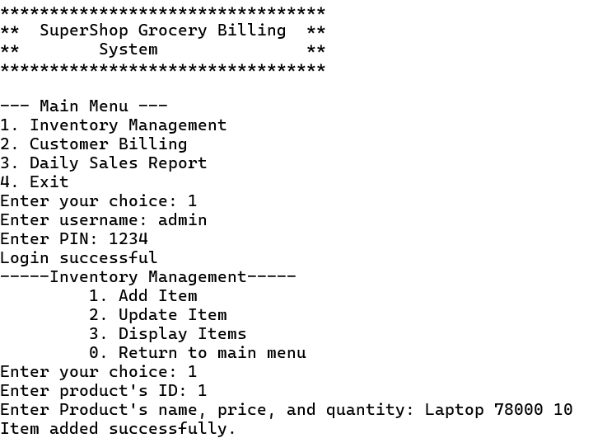

Page 12
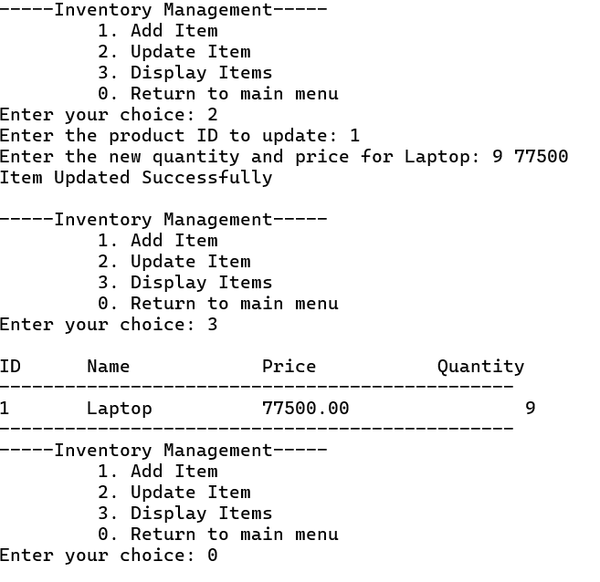

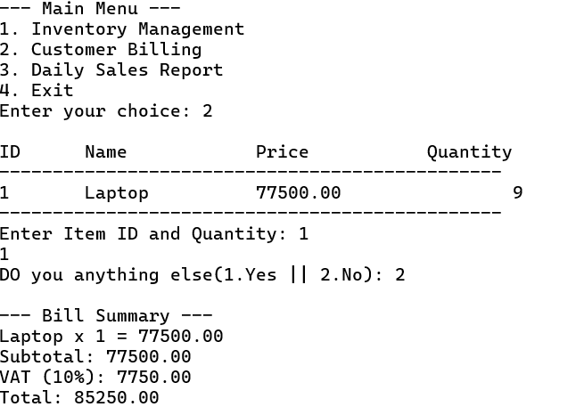

Page 13
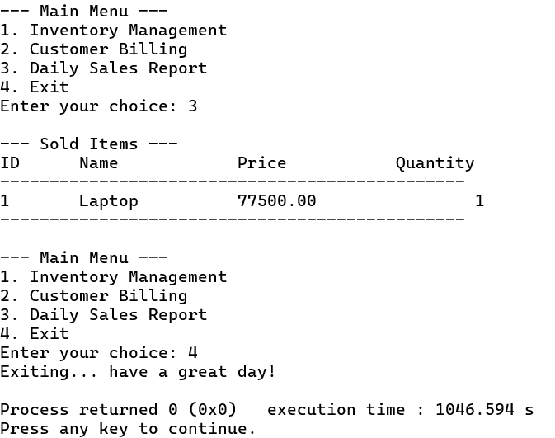

7.0 Conclusion

Project Summary and Results:

- The SuperShop Grocery Billing System fulfills key tasks such as inventory management, customer billing with VAT, and daily sales reporting. The program works as intended, demonstrating the use of structured programming principles in solving real-world problems.

Knowledge gained:

- Program reusability: Organizing code into reusable, modular functions.
- Data handling: Managing arrays and struct data types to store product and sales details.
- Improved Problem-solving skills.

Page 14

Group Collaboration Experience:

- We carefully planned the entire project, which allowed for equal task distribution and effective teamwork. As a result, we did not encounter any major issues throughout the process.

Challenges Faced:

- Login logic: Ensuring secure and functional authentication.
- Inventory updates: Preventing incorrect or duplicate data entries.
- Cart management: Correctly calculating totals and applying VAT per item.
- Testing: Repeated testing was needed to catch edge cases like invalid input or insufficient stock.

Opportunities for Improvement:

- No database:
- Currently, the program does not store data persistently. All inventory and sales data are lost when the program closes.
- Enhanced UI: Implementing colors or GUI libraries to improve the user interface.
- Product categorization: Grouping items into types (dairy, grocery, vegetable, meat etc.) for better management.

Remarks and Comments:

- Overall, this was a valuable learning experience. The project topic was practical and helped connect programming concepts with real-life applications.

References

- YouTube
- ChatGPT
- W3School

Page 15

