 | East West University  Department of Computer Science and Engineering  Course Outline  Summer 2025 Semester

Course: CSE106 Discrete Mathematics (Section – 8)

Credits and Teaching Scheme
 | Theory | Laboratory | Total
Credits | 3 | 0 | 3
Contact Hours | 2.5 Hours/Week for 15  Weeks + Final Exam in the  14 th Week |  | 4.5 Hours/Week for 15  Weeks + Final Exam in the  14 th Week

Prerequisite
CSE103 Structured Programming

Instructor Information
Instructor | : | Sadia Nur Amin  Lecturer, Department of Computer Science and Engineering  East West University, Bangladesh.
Email | : | sadian.amin@ewubd.edu
Office: : Room# 368
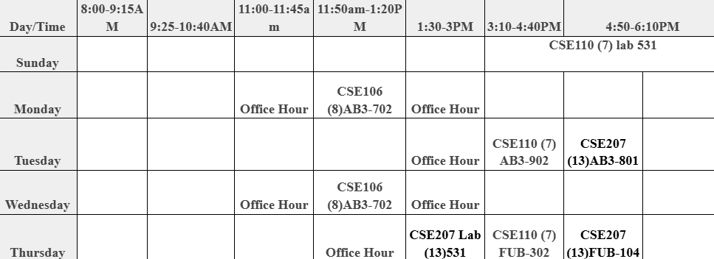

Course Objective
This course builds up the students’ ability to think and express logically and mathematically. The course will address mathematical reasoning, combinatorial analysis, algorithmic thinking, and discrete structures. Knowledge of this course will be needed as prerequisite knowledge for future courses such as CSE110 Object Oriented Programming, CSE207 Data Structures, CSE246 Algorithms, CSE302 Database Systems, CSE366 Artificial Intelligence, CSE405 Computer Networks, and CSE471 Compiler Design.

Knowledge Profile
K2: Conceptually-based mathematics, numerical analysis, statistics, and formal aspects of computer and information science
K3: Theory-based engineering fundamentals

Learning Domains
Cognitive - C2: Understanding, C3: Applying
Psychomotor - P3: Precision
Affective - A2: Responding

Program Outcomes (POs)
PO1: Engineering Knowledge

Complex Engineering Problem Solution
EP1: Depth of knowledge required
EP2: Range of conflicting requirements

Complex Engineering Activities
None

Course Outcomes (COs) with Mappings
After completion of this course students will be able to:
CO | CO Description | PO | Learning Domains | Knowledge Profile | Complex Engineering Problem Solving/ Engineering Activities
CO1 | Interpret and apply propositional logic, predicate logic, and theorem proving for mathematical reasoning. | PO1 | C2, C3 | K2 | -
CO2 | Interpret and apply counting principles for combinatorial analysis. | PO1 | C2, C3 | K2 | -
CO3 | Interpret and apply the growth of functions, complexity analysis of algorithms, and integer algorithms for algorithmic thinking; demonstrate this knowledge and write report for realistic problem solving. | PO1 | C2, C3  P3  A2 | K2, K3 | EP1, EP2
CO4 | Interpret and apply discrete structures such as sets, functions, relations, graphs, and trees for modeling discrete objects; demonstrate this knowledge and write report for realistic problem solving. | PO1 | C2, C3  P3  A2 | K2, K3 | EP1, EP2

Course Topics, Teaching-Learning Method, and Assessment Scheme
Course Topic | Teaching-Learning Method | CO | Class Tests |  |  | Mid Semester Exam |  | Presentation | Project | Final Exam
 |  |  | 1 | 2 | 3
 |  |  | C2 | C2 | C2 | C2 | C3 |  |  | C2 | C3
Propositional Logic, Propositional Equivalences, Predicates and Quantifiers, Nested Quantifiers | Lectures and discussions inside and outside the class | CO1 | 5 |  |  | 7  [3+4] | 8  [4+4]
Introduction to Proofs, Mathematical Induction | Do | CO1 |  |  |  |  | 5  [2+3]
Sets, Set Operations, Functions, Recursive Functions, Relations and Their Properties | Do | CO4 |  |  |  | 5  [2+3] | 5  [2+3]
The Basics of Counting, The Pigeonhole Principle | Do | CO2 |  | 5 |  |  |  |  |  | 10  [5+5] | 5  [5]
Algorithms, The Growth of Functions, Complexity of Algorithms, The Integers and Division, Primes, Greatest Common Divisor, Least Common Multiplier | Do | CO3 |  |  | 5 |  |  | 5 | 5 | 4  [4] | 8  [4+4]
Graphs, Graph Terminologies and Special Types of Graphs, Representing Graphs, Introduction to Trees | Do | CO4 |  |  |  |  |  |  | 5 | 6 [3+3] | 7 [3+4]
 |  |  | 15 |  |  | 30 |  | 5 | 10 | 40

Presentation
Presentation | Teaching-Learning Method | CO | Mark of Cognitive Learning Level | Mark of Psycho-motor Learning Level | Mark of Affective Learning Level | Presentation Mark
 |  |  | C3 | P3 | A2
Presentation on a selected topic | Self-study and five-minute individual powerpoint presentation | CO3 | 4 | 0.5 | 0.5 | 5
Date of presentation will be announced in the class

Mini Projects
Mini Project | Teaching-Learning Method | CO | EP/  EA | Mark of Cognitive Learning Level | Mark of Psycho-motor Learning Level | Mark of Affective Learning Level | CO Mark | Mini Project Mark
 |  |  |  | C3 | P3 | A2
Mini Project with reports and presentation | Group-based moderately complex programming projects with report writing and presentation | CO3  CO4 | EP1, EP2  EP1, EP2 | 4  4 | 0.5  0.5 | 0.5  0.5 | 5  5 | 10
 |  | Total |  | 8 | 1 | 1 | 10
Dates of report submission and presentation will be announced in the class

Overall Assessment Scheme
Assessment Area | CO |  |  |  | PO Marks
 | CO1 | CO2 | CO3 | CO4 | PO1
Class Test | 5 | 5 | 5 |  | 15
Mid Semester Exam | 20 |  |  | 10 | 30
Presentation |  |  | 5 |  | 05
Final Exam |  | 15 | 12 | 13 | 40
Mini Projects with report and presentation |  |  | 5 | 5 | 10
Total Mark | 25 | 20 | 27 | 28 | 100
Teaching Materials/Equipment
Textbook:
Kenneth H. Rosen, Discrete Mathematics and Its Applications with Combinatorics and Graph Theory, 7th Edition, Tata McGraw-Hill Publishing Company Limited, New Delhi, 2015.

Teaching-Learning Method:
Lectures, guest lectures, classroom discussions, assignments and examinations

Slide Links: Will be shared in google classroom

Mini Projects:
Mini Project description will be provided in the class.

Grading System

Marks (%) | Letter Grade | Grade Point | Marks (%) | Letter Grade | Grade Point
80-100 | A+ | 4.00 | 55-59 | B- | 2.75
75-79 | A | 3.75 | 50-54 | C+ | 2.50
70-74 | A- | 3.50 | 45-49 | C | 2.25
65-69 | B+ | 3.25 | 40-44 | D | 2.00
60-64 | B | 3.00 | Below 40 | F | 0.00

Exam Dates
Based on the academic calendar.

Academic Code of Conduct
Academic Integrity:
Any form of cheating, plagiarism, personification, falsification of a document as well as any other form of dishonest behavior related to obtaining academic gain or the avoidance of evaluative exercises committed by a student is an academic offence under the Academic Code of Conduct and may lead to severe penalties as decided by the Disciplinary Committee of the university.

Special Instructions:
- Students are expected to attend all classes and examinations. A student MUST have at least 80% class attendance to sit for the final exam.
- Students will not be allowed to enter into the classroom after 20 minutes of the starting time.
- For plagiarism, the grade will automatically become zero for that exam/assignment.
- Normally there will be NO make-up exam. However, in case of severe illness, death of any family member, any family emergency, or any humanitarian ground, if a student miss the mid-semester exam, the student MUST get approval of makeup exam by written application to the Chairperson through the Course Instructor within 48 hours of the exam time. Proper supporting documents in favor of the reason of missing the exam have to be presented with the application. It is the responsibility of the student to arrange a Makeup Exam in consultation with the Course Instructor.
- For final exam, there will be NO makeup exam. However, in case of severe illness, death of any family member, any family emergency, or any humanitarian ground, if a student miss the final exam, the student MUST get approval of Incomplete Grade by written application to the Chairperson through the Course Instructor within 48 hours of the final exam time. Proper supporting documents in favor of the reason of missing the final exam have to be presented with the application. It is the responsibility of the student to arrange an Incomplete Exam within the deadline mentioned in the Academic Calendar in consultation with the Course Instructor.
- All mobile phones MUST be turned to silent mode during class and exam period.
- There is zero tolerance for cheating in exam. Students caught with cheat sheets in their possession, whether used or not; writing on the palm of hand, back of calculators, chairs or nearby walls; copying from cheat sheets or other cheat sources; copying from other examinee, etc. would be treated as cheating in the exam hall. The only penalty for cheating is expulsion for several semesters as decided by the Disciplinary Committee of the university.

