
East West University
Department of Computer Science and Engineering
Course Outline of CSE110
Fall 2025

Course Outline
Course: CSE110 Object Oriented Programming (Section 4)
Credit and Teaching Scheme:
 | Theory | Laboratory | Total
Credits | 3.0 | 1.5 | 4.5
Contact  Hours | 3 Hours/Week for 13 Weeks | 3 Hours/Week for 13 Weeks | 6 Hours/Week for 13 Weeks

Prerequisite: CSE106 Discrete Mathematics
Instructor Information

Instructor: Dr. Md Hasanul Ferdaus
Assistant Professor, Department of Computer Science and Engineering
Office: Room # 443
Tel. No.: N/A
E-mail: hasanul.ferdaus@ewubd.edu
GTA: Mr Moniruzzaman Sarkar
Class and Office Hour:
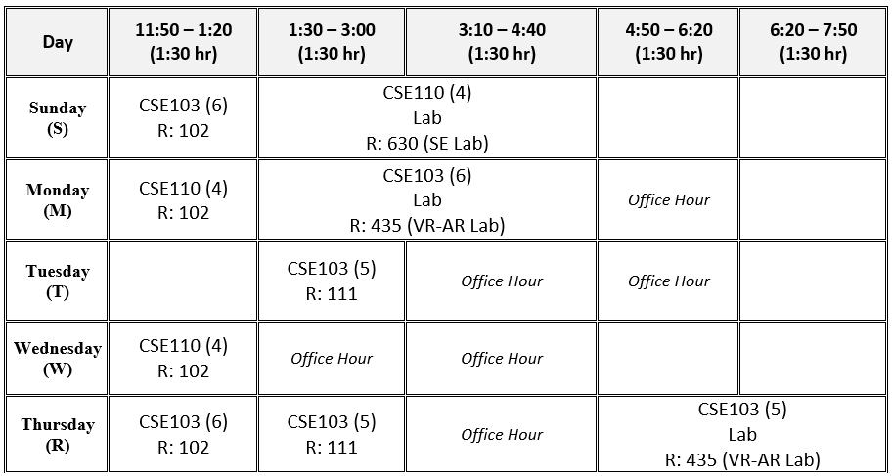
Course Objective
This course presents a conceptual and practical introduction to object-oriented programming (OOP). The course will cover general principles of programming in object-oriented frameworks to enhance transferable skills, such as programming, designing, and problem-solving. This course introduces object-oriented concepts and develops OOP programs that provide solutions to real-world object-oriented problems. Java is primarily chosen as the programming language in this course. Knowledge of this course will be needed as a prerequisite for CSE207 Data Structures.
Course Outcomes (COs)
After completion of this course, students will be able to:
CO1 | Understand and apply the fundamental principles of object-oriented programming in the target language to solve problems using an object-oriented approach.
CO2 | Use the principles of inheritance, polymorphism, abstraction, and interfaces to develop reusable and modular code.
CO3 | Apply exceptions, generics, inner classes, and perform file I/O operations to develop robust and data-driven applications.
CO4 | Choose appropriate tools, perform and demonstrate skills, and write a report to design, build, and test interactive applications that incorporate a graphical user interface (GUI) with the option of using multithreading and database connectivity in the target language to solve real-life complex problems.

Course Topics, Teaching-Learning Methods, and Assessment Scheme
Course Topic | Teaching  Learning  Method | CO | Mark of  Cognitive  Learning  Levels |  | Mark of  COs | Exam  (Mark)
 |  |  | C2 | C3
Principles of Object-Oriented Programming and Basics of Elementary Programming in Java (conditional branching, looping, methods, and arrays) | Lecture,  Class  Discussion, Discussion Outside  Class with  Instructor/  Teaching  Assistant | CO1 | 2.5 | 2.5 | 5 | Mid Term  Exam  (25)

Introduction to Classes and Objects (Classes, Objects, Instance variables and instance methods, Constructors)  [Class Test 01 will be conducted on topics under CO1] | Do |  | 5 | 5 | 10
Inheritance, Polymorphism in OOP (super class, sub class, multiple level inheritance, late binding) | Do | CO2 |  | 10 | 10
Abstract Class and Interfaces  [Class Test 02 will be conducted on topics under CO2] | Do | CO2 |  | 10 | 10 | Final Exam (30)
Exception Handling in OOP | Do | CO3 |  | 5 | 5
File handling using Text and Binary I/O | Do |  |  | 5 | 5
Implementation of Collections, Generics, and Inner Classes  [Class Test 03 will be conducted on topics under CO3] | Do |  |  | 10 | 10

Lab Exercises
Experiment | Teaching  Learning  Method | CO | Marks of  Cognit  ive  Level | Mark of  Psychomotor Level |  | Mark of  Affective Level | Mark  of  COs
 |  |  | C3 | P2 | P3 | A2
Java Basics of  Elementary  Programming,  Conditional  Statements | Lab Experiment and Result Analysis and Discussion with Instructor, Post  Lab Report | CO4
Looping, Nested Looping, Arrays  Java Methods and library functions | Do | CO4
Designing and Implementing  simple Classes and | Do | CO4
Objects, Arrays of Objects etc.
Implementing  associations of Classes, and Inner class | Do | CO4
Designing and Implementing  Inheritance and Polymorphism | Do | CO4
Designing and Implementing  Abstract Class and Interfaces | Do | CO4
Understanding and Implementing  Exceptions and File management,  Collections,  Generics | Do | CO4
GUI using JavaFX | Do | CO4
Lab Experiments |  | CO4 | 3 | 2.5 | 2.5 | 2 | 10
Lab Final (Exam) | Individual Exam | CO4 | 3 | 2.5 | 2.5 | 2 | 10
Total |  |  | 6 | 5 | 5 | 4 | 20

Mini Project
Mini Project | Teaching  Learning Method | CO | Mark of  Cognitive Levels |  | Mark of  Psychomotor Levels |  | Mark of  Affective Levels | Mark  of COs
 |  |  | C3 | C4 | P2 | P3 | A2
Mini Project  including Report and Presentation | Moderately  Complex project with report writing, and oral/poster presentation. | CO4 | 2 | 2 | 2 | 2 | 2 | 10

Overall Assessment Scheme
 | COs |  |  |  | Assessment Area Mark
Assessment Area | CO1 | CO2 | CO3 | CO4
Class Participation/Test/Quizzes | 5 | 5 | 5 |  | 15
Mid-Semester Assessment | 15 | 10 |  |  | 25
Final Exam |  | 10 | 20 |  | 30
Lab Performance |  |  |  | 10 | 10
Lab Final |  |  |  | 10 | 10
Mini Project Demonstration and Viva |  |  |  | 10 | 10
Total Mark | 20 | 25 | 25 | 30 | 100

Teaching Materials and Equipment
Textbook:
● Java: The Complete Reference, Herbert Schildt, 11th edition, McGraw-Hill Education (2023)
● Introduction to Java Programming by Daniel Liang
Reference Book:
● Paul Deitel, Harvey Deitel, Java™ How to Program Early Objects, 11th edition ● Walter Savitch, Absolute Java, Pearson (5th edition)
● Bert Bates and Kathy Sierra, Head First Java, O’Reilly Media (2nd edition)

Software/Tools:
● Java Development Kit (JDK 1.8)
https://www.oracle.com/technetwork/java/javase/downloads/jdk8-downloads 2133151.html
● Any Integrated Development Environment (IDE) supporting Java, preferably any of the following:
- Eclipse: https://www.eclipse.org/downloads/
- NetBeans: https://netbeans.apache.org/download/index.html
- IntelliJ IDEA: https://www.jetbrains.com/idea/download/
- Visual Studio Code (VS Code) with Java Extension Pack: https://code.visualstudio.com/docs/java/extensions
- Android Studio: https://developer.android.com/codelabs/basic-android-kotlin-compose-install-android-studio

Grading System
Marks  (%) | Letter  Grade | Grade  Point | Marks  (%) | Letter  Grade | Grade  Point
80-100 | A+ | 4.00 | 55-59 | B- | 2.75
75-79 | A | 3.75 | 50-54 | C+ | 2.5
70-74 | A- | 3.5 | 45-49 | C | 2.25
65-69 | B+ | 3.25 | 40-44 | C- | 2
60-64 | B | 3.00 | Below 40 | F | 0.00

Exam Dates
As per the schedule provided by the department and the university.
Section | Class Slot | Mid Semester | Final
4 | MW | TBA | 24th December, 2025
Academic Code of Conduct
Academic Integrity:
Any form of cheating, plagiarism, personification, falsification of a document, as well as any other form of dishonest behavior related to obtaining academic gain or the avoidance of evaluative exercises committed by a student, is an academic offence under the Academic Code of Conduct and may lead to severe penalties as decided by the Disciplinary Committee of the university.
For details on Student Ethics and Academic Discipline, please visit: https://www.ewubd.edu/student-rules-regulation
Special Instructions:
● Students are expected to attend all classes and examinations. A student MUST have at least 80% class attendance to sit for the final exam.
● Students will not be allowed to enter the classroom after 10 minutes of the starting time.
● For plagiarism, the grade will automatically become zero for that exam/assignment.
● Normally, there will be NO make-up exam. However, in case of severe illness, death of any
family member, any family emergency, or any humanitarian ground, if a student misses any exam, the student MUST get approval for a makeup exam by written application to the Chairperson through the Course Instructor within 48 hours of the exam time. Appropriate supporting documents in favor of the reason for missing the exam have to be presented with the application.
● For the final exam, there will be NO makeup exam. However, in case of severe illness, death of any family member, any family emergency, or any humanitarian ground, if a student misses the final exam, the student MUST get approval of an Incomplete (I) Grade by written application to the Chairperson through the Course Instructor within 48 hours of the final exam time. Proper supporting documents in favor of the reason for missing the final exam have to be presented with the application. It is the responsibility of the student to arrange an Incomplete Exam within the deadline mentioned in the Academic Calendar in consultation with the Course Instructor.
● All mobile phones MUST be turned to silent mode during class and exam period.
● There is zero tolerance for cheating in the exam. Students caught with cheat sheets in their possession, whether used or not; writing on the palm of their hand, back of calculators, chairs, or nearby walls; copying from cheat sheets or other cheat sources; copying from other examinees, etc., would be treated as cheating in the exam hall. The only penalty for cheating is expulsion for several semesters, as decided by the Disciplinary Committee of the university.

