GRAMSHEBA
Union Parishad Digital Service Portal
Consolidated Project Documentation | 16-Week Roadmap
Project Group: Group 7
Project Members: Shah Md Sadman Sakib, Sumaiya Akther Mim, Tusher Imran Shakib
Technology baseline: React frontend, FastAPI backend, PostgreSQL database
Document status: Consolidated working version. Implemented items are separated from planned roadmap scope. This document is not a claim that all 16 weeks of features are complete.

1. Project Overview
GramSheba is a proposed digital governance portal for Union Parishads in Bangladesh. It aims to make selected public services easier to request and track while supporting authorized staff in reviewing applications and keeping data separated by Union Parishad.

1.1 Objectives
- Provide a citizen-facing online entry point for service applications.
- Support secure login, role-based access, and Union Parishad-level data separation.
- Allow citizens to track their own applications and authorized staff to review relevant records.
- Deliver the wider roadmap in four phases over 16 weeks, with advanced capabilities introduced only as planned prototypes or future work.

1.2 Scope boundary
The document follows the supplied 16-week roadmap. It does not add features outside that roadmap. A requirement or diagram may describe future scope; it does not imply that the feature is implemented.

2. Current Implementation Status

2.1 Implemented or tested core
- React/Vite frontend is available in the development setup.
- FastAPI backend with PostgreSQL connection to gramsheba_db.
- Registration validates a Union Parishad code; duplicate email is handled.
- Login and JWT-based authentication; /api/me returns the authenticated user profile.
- Role-protected admin endpoint and union-scoped birth-application listing.
- Birth-application creation links the authenticated applicant and Union Parishad; own-application listing is scoped to the applicant.
- Core tests covered valid/invalid union code, duplicate email, login, current-user endpoint, unauthorized access, role-injection protection, and union-level filtering.

2.2 Planned / incomplete roadmap work
- Full citizen profile management and complete portal experience.
- Document upload and full service-form coverage.
- Complete staff review, return/reject/approve workflow and certificate generation.
- Officer assignment/routing, queues, reminders/SLA, QR verification, complaints, notifications, sandbox/mock payments, and backup/restore test.
- OCR prototype, Bangla FAQ assistant, offline draft/sync prototype, analytics/GIS/event-driven demo where feasible.
- Full integration, security, performance and usability testing, deployment, and final documentation/presentation.
Status note: database-design notes also identify remaining Phase 1 sign-off work: confirm the role model and database constraints, complete and retain integration-test evidence, consider a stronger database rule matching an application’s union to its applicant, and verify indexes/constraints directly in PostgreSQL.

3. Functional Requirements
Requirement IDs group work by the four phases in the supplied roadmap. “Planned” means within scope, not currently delivered.
ID / Phase | Requirement | Status
FR-01  Phase 1 | The system shall allow a user to register with required details and a valid Union Parishad code. | Core implemented/tested
FR-02  Phase 1 | The system shall authenticate registered users and issue a token for authenticated API access. | Core implemented/tested
FR-03  Phase 1 | The system shall enforce role-based access to protected endpoints. | Core checks implemented/tested; full permission matrix to finalize
FR-04  Phase 1 | The system shall associate each user with a Union Parishad and scope administrative records to that union. | Core implemented/tested
FR-05  Phase 1 | The system shall prevent ordinary registration input from assigning privileged roles. | Tested
FR-06  Phase 2 | The system shall let citizens view and manage permitted profile information. | Planned
FR-07  Phase 2 | The system shall provide online service application forms, including required fields and validation. | Birth-application API exists; full portal and broader forms planned
FR-08  Phase 2 | The system shall allow citizens to upload supporting documents for an application. | Planned
FR-09  Phase 2 | The system shall let citizens view the status of their own applications. | Basic own-application API exists; full tracking experience planned
FR-10  Phase 2 | The system shall let authorized staff review applications belonging to their Union Parishad. | Union-scoped listing exists; complete review workflow planned
FR-11  Phase 2 | The system shall support basic certificate generation for approved applications. | Planned
FR-12  Phase 2 | The system shall record relevant application and administrative actions for auditability. | Planned
FR-13  Phase 3 | The system shall support assigning or routing applications to responsible officers. | Planned
FR-14  Phase 3 | The system shall support queues, reminders, and service-level tracking where feasible. | Planned
FR-15  Phase 3 | The system shall support QR-based certificate verification. | Planned
FR-16  Phase 3 | The system shall allow citizens to submit complaints and follow their status. | Planned
FR-17  Phase 3 | The system shall provide status notifications and reminders. | Planned
FR-18  Phase 3 | The system shall demonstrate payment flow using a sandbox/mock workflow. | Planned; no live payment claim
FR-19  Phase 3 | The project shall include a backup and restore test. | Planned
FR-20  Phase 4 | The project shall prototype OCR-assisted document processing. | Planned prototype
FR-21  Phase 4 | The project shall prototype a Bangla FAQ assistant. | Planned prototype
FR-22  Phase 4 | The project shall prototype offline draft storage and synchronization. | Planned prototype
FR-23  Phase 4 | The project may demonstrate limited analytics/GIS/event-driven capability where feasible. | Optional planned demo
FR-24  Phase 4 | The project shall undergo integration, security, performance, and usability testing. | Planned
FR-25  Phase 4 | The project shall prepare deployment, documentation, and presentation deliverables. | Planned

4. Non-Functional Requirements

NFR-01 Security
Passwords shall be stored as hashes; plaintext passwords shall not be stored.

NFR-02 Authentication
Protected endpoints shall require valid authentication tokens.

NFR-03 Authorization
Access to protected actions shall be controlled by role and authorization rules.

NFR-04 Tenant isolation
Administrative queries shall be scoped to the authenticated staff member’s Union Parishad.

NFR-05 Privacy
Users shall only access personal application records permitted by their role.

NFR-06 Reliability
The application shall handle invalid inputs and expected API errors without exposing secrets.

NFR-07 Backup and recovery
A backup/restore procedure shall be documented and tested within the roadmap.

NFR-08 Usability
The interface shall be understandable for citizens and staff; UI/UX shall be refined during development.

NFR-09 Language and access
Bangla support and low-bandwidth considerations shall be addressed within the planned design.

NFR-10 Maintainability
Frontend, backend, and database responsibilities shall remain separated and documented.

NFR-11 Performance
The project shall test common API and user workflows for acceptable response time within the project environment.

NFR-12 Auditability and testability
Relevant actions, permissions, and key workflows shall have documented test evidence; audit logging is planned.

NFR-13 Testability
Registration, login, role restrictions, and cross-union isolation shall be covered by repeatable tests.

5. System Architecture
Current baseline: React/Vite frontend communicates with FastAPI endpoints; FastAPI authenticates users and applies role/Union Parishad checks; SQLAlchemy models persist records in PostgreSQL database gramsheba_db. Roadmap modules shown separately remain planned until implemented and tested.
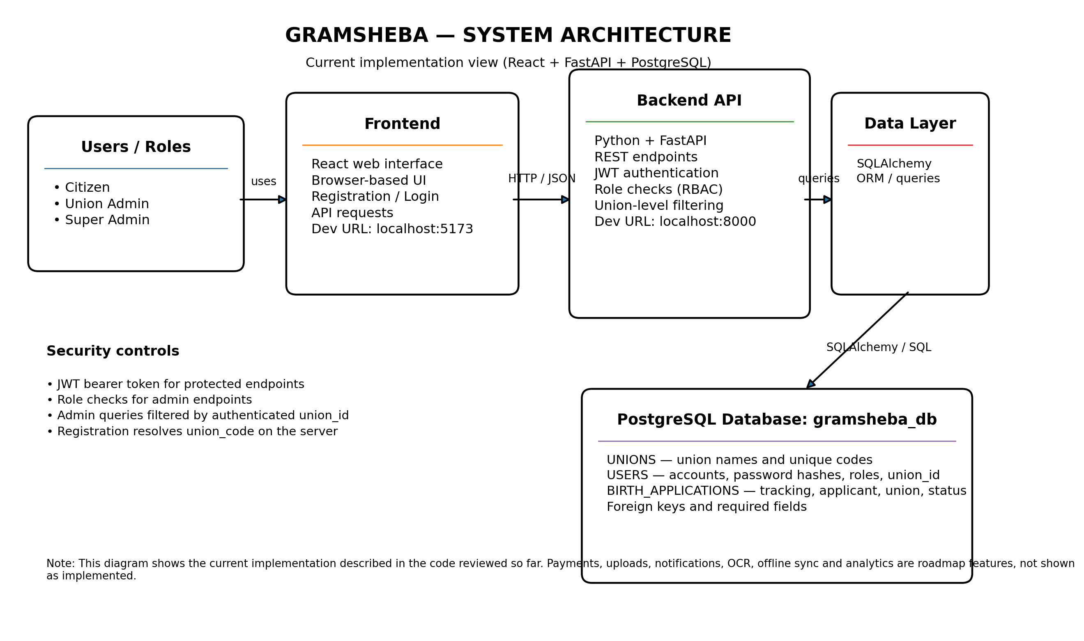
Figure 1. System architecture (implementation baseline and roadmap boundaries).

6. System Block Diagram
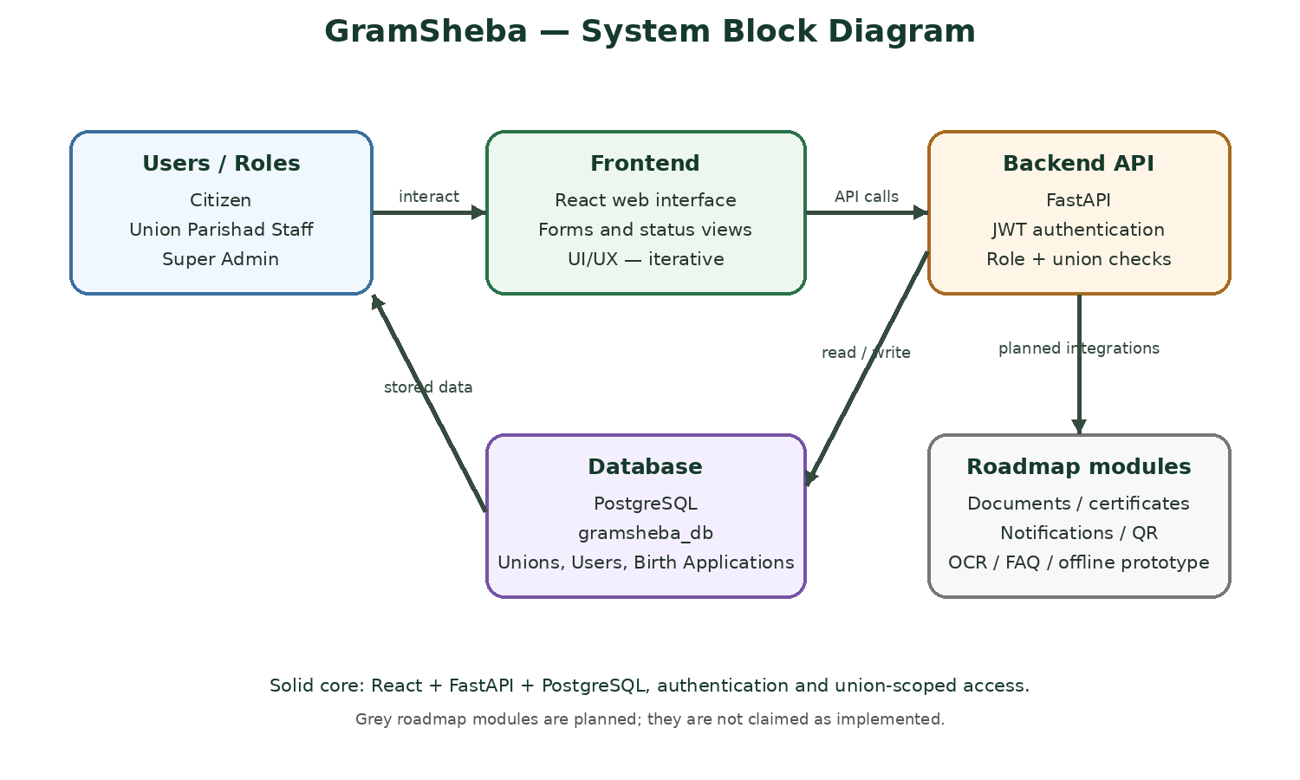
Figure 2. Block diagram. Grey roadmap modules are planned, not implemented.

7. Entity Relationship (ER) Diagram
The currently reviewed database model contains three core entities: UNIONS, USERS, and BIRTH_APPLICATIONS. A Union has many users and applications; a user can submit many birth applications. Each user and application references a Union Parishad.
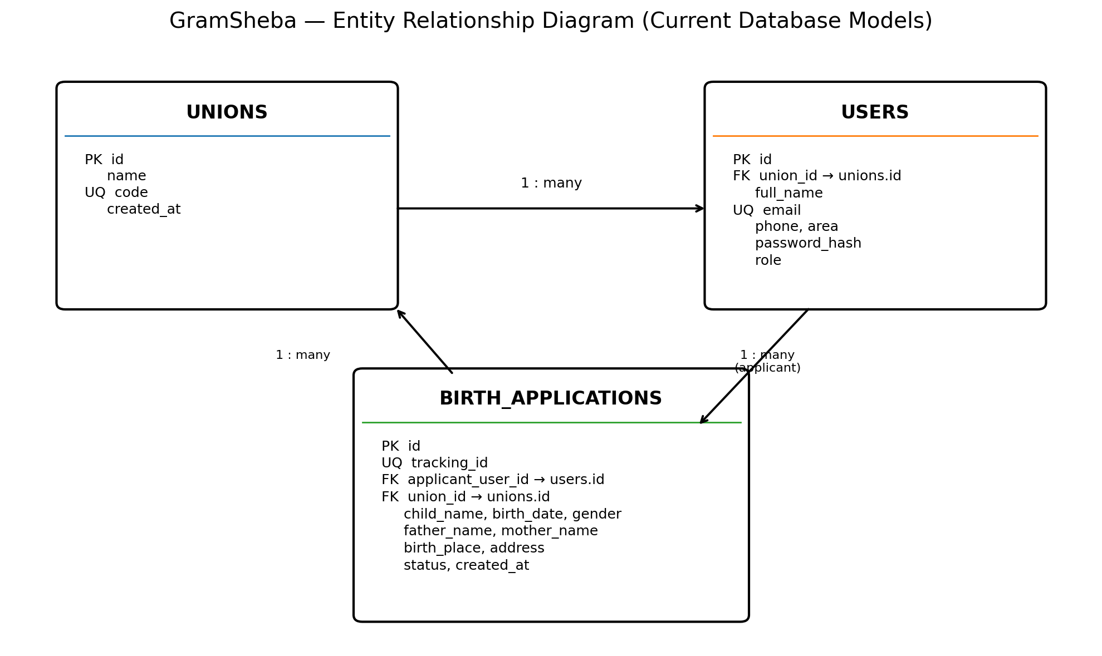
Figure 3. ER diagram for the current database models.

7.1 Entity summary
- UNIONS: Union Parishad identity and unique union code.
- USERS: account details, password hash, role, and required union_id.
- BIRTH_APPLICATIONS: tracking ID, applicant user, union, birth details, address, status, and creation timestamp.
Database note: foreign keys confirm that referenced records exist but do not, by themselves, guarantee that an application’s union_id matches the applicant user’s union_id. This is listed as a database-level integrity improvement to review.

8. Use Case Diagram and Actors
Main actors from the project use-case documentation: Citizen, Union Parishad Administrator/Staff, Union Officer, and Super Admin. Use cases span the roadmap; their appearance in this diagram describes intended scope, not delivery status.
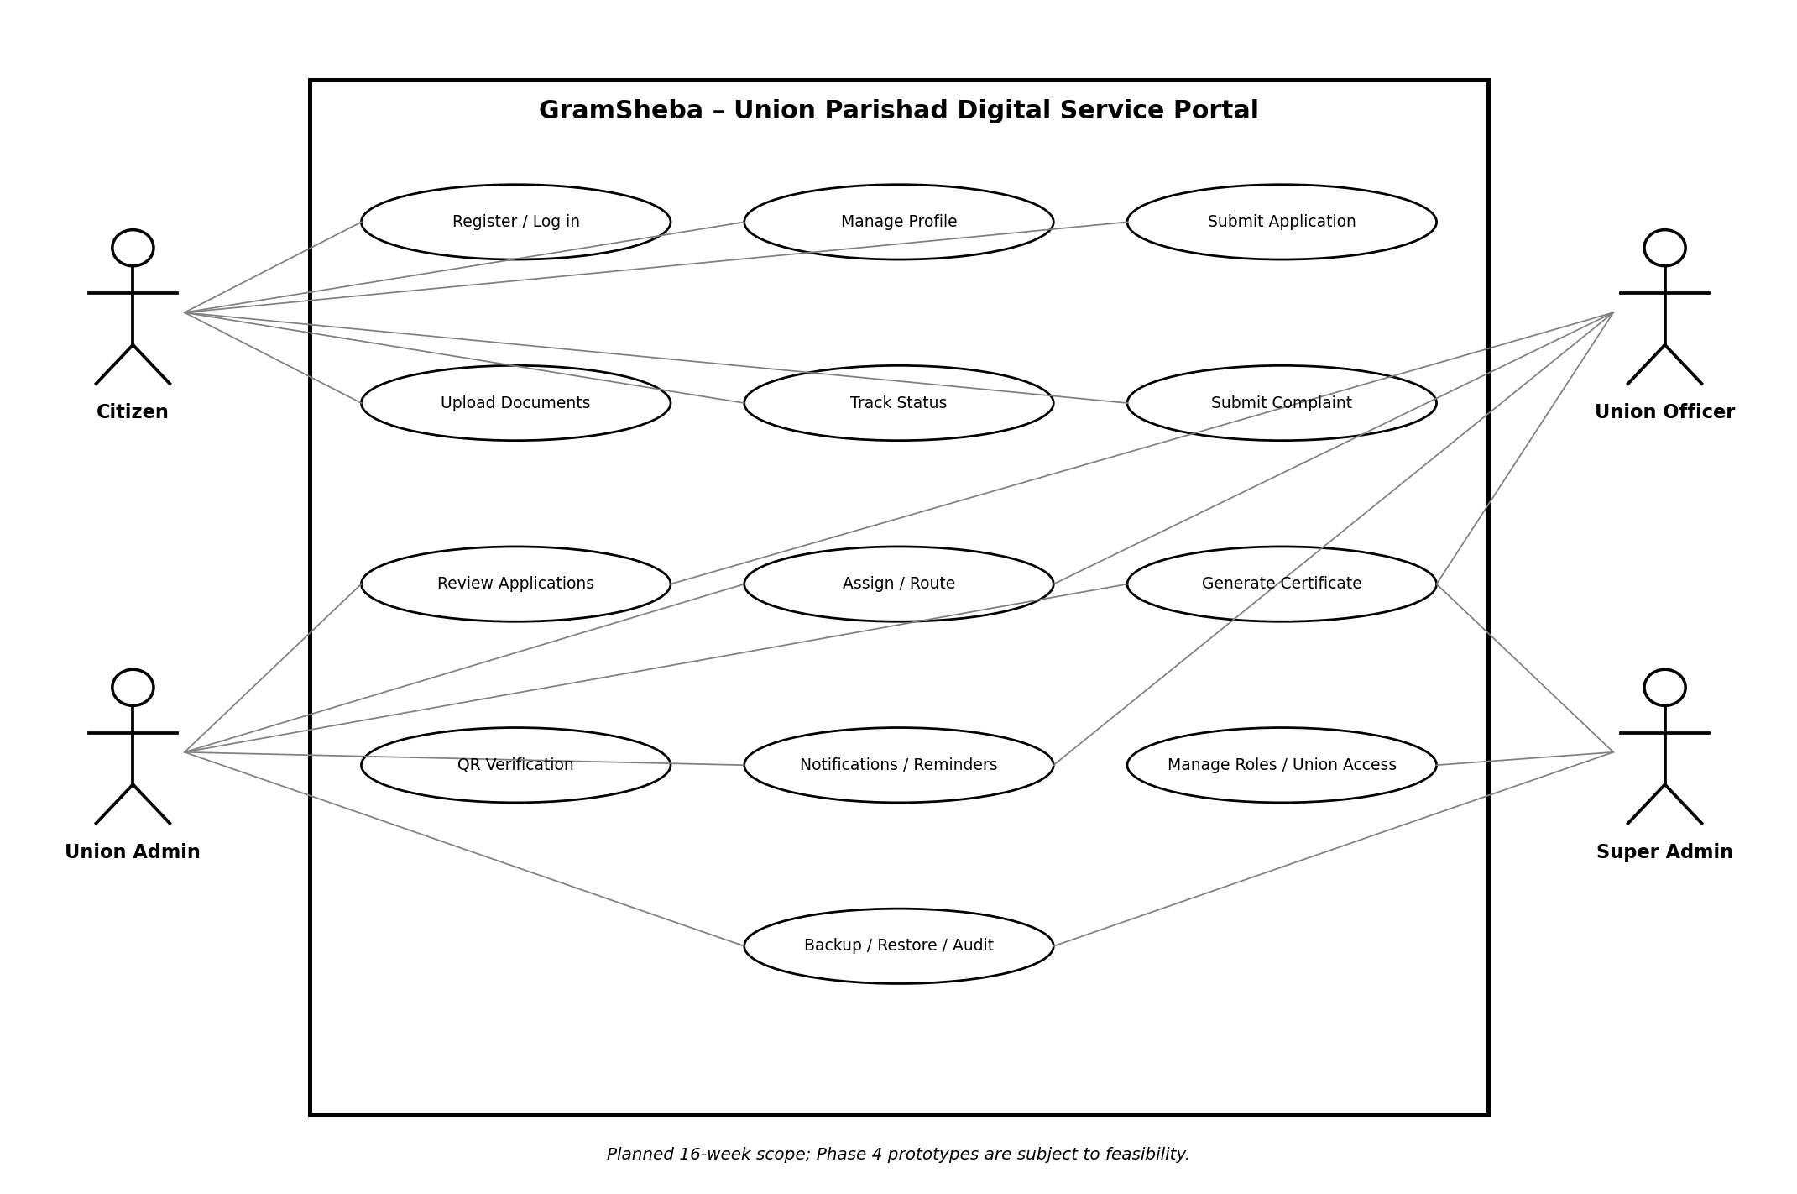
Figure 4. Use case diagram for the 16-week roadmap.

8.1 Use case status summary
- Register / log in — core implemented and tested.
- Submit service application — birth-application API exists; full portal and broader forms planned.
- Track own application — basic API exists; full tracking interface planned.
- Review applications — union-scoped listing tested; full review workflow planned.
- Profile management, document upload, certificate generation, officer routing, QR verification, complaints, notifications, mock payments, backup/restore, and advanced prototypes — planned.

9. System Workflow
The intended workflow starts with registration/login, proceeds through service selection and form submission, stores the application with applicant and Union Parishad linkage, then routes it to authorized staff for review. Rejection/return and approval branches are part of the planned complete workflow; certificate generation and notifications remain planned.
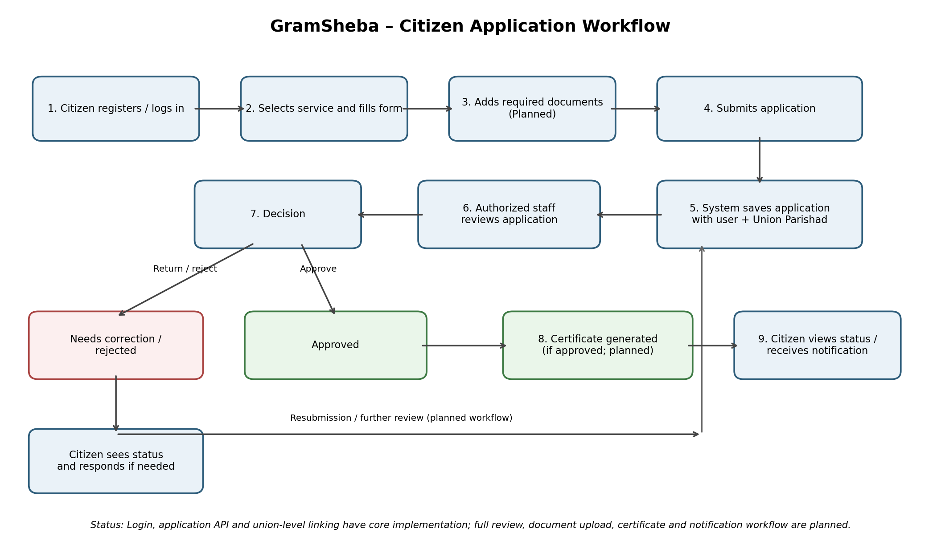
Figure 5. System workflow; implementation and planned steps are distinguished in the diagram.

10. 16-Week Roadmap Alignment

Phase 1 — Weeks 1–4
Requirements confirmation, architecture and database design, setup, tenant-aware schema, authentication, roles, and Union Parishad access control.

Phase 2 — Weeks 5–8
Citizen portal/profile, service forms, document upload, status tracking, staff review, basic certificate generation, and audit logging.

Phase 3 — Weeks 9–12
Officer assignment/routing, queues/reminders/SLA, QR verification, complaints, notifications, sandbox/mock payment workflow, and backup/restore test.

Phase 4 — Weeks 13–16
OCR prototype, Bangla FAQ assistant, offline draft/sync prototype, limited analytics/GIS/event demo where feasible, integration/security/performance/usability testing, deployment, documentation, and presentation.

11. Testing and Acceptance Notes
- Verify registration with valid and invalid Union Parishad codes.
- Verify duplicate-email handling and successful login.
- Verify token-protected /api/me and 401 behavior without a token.
- Verify a citizen cannot access admin-only endpoints (403).
- Verify registration cannot set privileged roles by injecting a role field.
- Verify admin application listing only returns records for that admin’s Union Parishad.
- Before Phase 1 sign-off, retain repeatable test output and confirm database indexes, unique constraints, and role constraints.
- For later phases, test each planned workflow and label prototype results accurately.

12. Risks, Constraints, and Open Items
- Role is currently represented as a string; confirm controlled role assignment and consider a database constraint.
- Review stronger database-level enforcement that an application’s union matches its applicant’s union.
- Confirm database indexes and unique constraints directly in PostgreSQL and preserve evidence.
- Do not represent document upload, certificates, notifications, payments, OCR, FAQ assistant, offline sync, analytics, or GIS as complete until implemented and tested.
- Deployment target and any external payment/notification provider are not specified in the supplied source; no provider is assumed in this document.

13. Source and Scope Note
Consolidated from the GramSheba 16-Week Roadmap, Phase 1 Database Design Documentation, Use Case Documentation, System Architecture Diagram, ER Diagram, and System Workflow Diagram available in the project workspace. When details differ, this document preserves the current implementation notes and the roadmap’s phased intent; uncertain or incomplete items are explicitly marked for confirmation.

GRAMSHEBA
COMPLETE PROJECT DOCUMENTATION
Union Parishad Digital Service Portal | 16-Week Roadmap

Submission information | Fill before submission
University / Institution | ________________________________________
Department | ________________________________________
Course Title & Code | ________________________________________
Course Instructor / Supervisor | ________________________________________
Project Group | Group 7
Project Members | Shah Md Sadman Sakib; Sumaiya Akther Mim; Tusher Imran Shakib
Submission Date | ________________________________________

Document control: Consolidated working version. This document describes the complete 16-week scope, but distinguishes implemented/tested core functions from planned or incomplete features. It does not claim that all roadmap phases are complete.

14. Detailed Database Dictionary
The following dictionary summarizes the database entities documented for the current baseline. Confirm exact column names and constraints against the current SQLAlchemy models and database migration before final submission.
Entity / table | Purpose | Known fields / relationships | Status note
Union | Represents a Union Parishad tenant. | Referenced by User.union_id and BirthApplication.union_id; union code is used during registration. | Core tenant relationship implemented; confirm exact table columns in schema.
User | Stores account and role information. | id, full_name, email, phone, area, password_hash, role, union_id. | Registration, login, JWT identity and role checks implemented/tested in the documented baseline.
BirthApplication | Stores a citizen’s birth application. | id, tracking_id, applicant_user_id, union_id, child_name, birth_date, gender, father_name, mother_name, birth_place, address, status, created_at. | Create and own-application listing exist; complete staff review/certificate workflow remains planned/incomplete.

Integrity note: foreign keys ensure referenced records exist, but additional application-level or database constraints may be needed to guarantee that an application’s union_id always matches its applicant’s union_id. Keep this as an open item until verified with tests or constraints.

15. Expanded Test and Acceptance Matrix
The “Observed status” column reflects the implementation notes available for this documentation. Do not mark a test as passed unless the team retains actual output, screenshot, or test-run evidence.
Test ID | Test scenario | Expected result | Observed status / evidence
T-01 | Register using a valid Union Parishad code. | Account is created and linked to the selected Union Parishad. | Reported tested; attach current test output before submission.
T-02 | Register using an invalid Union Parishad code. | Request is rejected; no account is created. | Reported tested; attach current test output before submission.
T-03 | Register with an email already in use. | Duplicate account is rejected with a clear response. | Reported tested; attach current test output before submission.
T-04 | Log in with valid credentials. | A valid authentication token is returned. | Reported tested; attach current test output before submission.
T-05 | Request the current-user endpoint with a valid token. | Authenticated user profile is returned. | Reported tested; attach current test output before submission.
T-06 | Access a protected endpoint without a token. | Request is rejected with an authentication error (e.g. 401). | Reported tested; attach current test output before submission.
T-07 | Citizen attempts a Union Admin-only endpoint. | Request is rejected (e.g. 403). | Reported tested; attach current test output before submission.
T-08 | Try to submit a privileged role during public registration. | Public registration cannot assign an unauthorized role. | Reported tested; attach current test output before submission.
T-09 | Admin lists birth applications for their own union. | Only records scoped to the admin’s Union Parishad are returned. | Reported tested; attach current test output before submission.
T-10 | Check cross-union access isolation. | Records from another Union Parishad are not exposed. | Reported tested; attach current test output before submission.
T-11 | Upload required supporting documents. | Files are validated, stored securely, and linked to the application. | Planned; not yet verified as implemented.
T-12 | Staff approves/rejects/returns an application. | Status and audit history are updated; citizen can see the result. | Full workflow planned/incomplete.
T-13 | Generate and verify a certificate/QR code. | Certificate is generated only after approval and verification returns valid status. | Planned; not yet verified as implemented.
T-14 | Backup and restore database. | Backup can be restored and key data verified. | Roadmap item; attach restore-test evidence when completed.
T-15 | Run end-to-end usability/security/performance tests. | Critical issues are documented and resolved or disclosed. | Planned for later roadmap phase.

16. UI Evidence and Screenshot Checklist
Screenshots must be captured from the actual running GramSheba application. No screenshot has been invented for a feature that is not yet implemented. Insert screenshots under the matching captions before final submission.
- Figure UI-01 — Homepage: capture the current homepage in the browser.
- Figure UI-02 — Registration form: show the real registration UI; hide or blur personal test data.
- Figure UI-03 — Login form: show the real login UI; never show passwords or JWT tokens.
- Figure UI-04 — Successful login / current-user view: include only non-sensitive test account details.
- Figure UI-05 — API/database evidence: capture a safe health or database-check response; hide credentials and secrets.
- Future UI screenshots (document upload, admin review, certificates, notifications, analytics) should be added only after those features are implemented and tested.

17. Phase Deliverables and Exit Criteria
Phase / weeks | Planned deliverables within the roadmap | Exit evidence to collect
Phase 1 / Weeks 1–4 | Requirements, architecture, database/ER design, project setup, tenant-aware schema, authentication, roles and Union Parishad-level access control. | Approved requirements; architecture/ER diagrams; migration/schema evidence; registration/login/API tests; role and cross-union isolation test output.
Phase 2 / Weeks 5–8 | Citizen portal/profile, service forms, document upload, status tracking, admin review, basic certificate generation, audit logging. | Working screens and APIs; upload validation tests; review-state tests; certificate sample generated from test data; audit log evidence.
Phase 3 / Weeks 9–12 | Officer assignment/routing, queues, reminders/SLA, QR certificate verification, complaints, notifications, sandbox/mock payment workflow, backup/restore test. | Workflow tests; QR verification tests; mock-payment disclaimer/evidence; backup and restore results.
Phase 4 / Weeks 13–16 | OCR prototype, Bangla FAQ assistant, offline draft/sync prototype, limited analytics/GIS/event-driven demo where feasible, integration/security/performance/usability tests, deployment and final presentation. | Prototype demo evidence; documented test results and known limitations; deployment steps; final user/developer documentation and presentation.

18. Constraints, Assumptions, and Open Items
- The project follows the supplied 16-week roadmap; no extra feature has been added to the committed scope.
- The current technical baseline is React/Vite, FastAPI, SQLAlchemy and PostgreSQL. Confirm package versions and deployment configuration in the repository before submission.
- Only the core functions listed in the implementation-status section should be described as implemented/tested. All other functions remain planned unless supported by fresh evidence.
- Confirm role names, Union Parishad registration-code management, unique constraints, delete/update behavior, and database-level tenant isolation before Phase 1 sign-off.
- Keep secrets, .env values, passwords, password hashes, tokens, and personal citizen data out of screenshots and the submitted documentation.
- The project’s legal/administrative certificate requirements and real payment processing are not assumed to be approved or implemented; the roadmap calls for a sandbox/mock payment workflow.
- The screenshot checklist is pending until genuine screenshots are inserted from the running application.

19. Conclusion
GramSheba is designed as a Union Parishad Digital Service Portal with a phased 16-week implementation plan. The documented baseline includes a React/Vite frontend, FastAPI backend, PostgreSQL database, registration with Union Parishad-code validation, JWT-based login, role checks, and union-scoped birth-application handling as reported in the project notes. The remaining portal, service workflow, certificate, notification, prototype, testing and deployment features must be completed and verified according to the roadmap. The project should be presented honestly with test evidence and clear separation between completed work and future work.

20. Glossary
Term | Meaning
API | Application Programming Interface; endpoints used by the frontend to communicate with the backend.
JWT | JSON Web Token; a token used to identify an authenticated session/request.
RBAC | Role-Based Access Control; permissions are granted based on a user role.
Tenant isolation | Ensuring users/staff access only the data belonging to their permitted Union Parishad.
ER Diagram | Entity Relationship Diagram showing database entities and their relationships.
OCR | Optical Character Recognition; planned prototype for extracting text from documents.
SLA | Service-Level Agreement/target; planned time expectations for service handling.
PWA | Progressive Web App; web application approach included in the roadmap direction.
Mock / sandbox payment | A test-only payment flow, not a claim of real payment processing.

21. Final Submission Checklist
- ☐ Fill university, department, course, instructor/supervisor and submission date on the cover page.
- ☐ Confirm team-member names and project group details with the official project submission requirements.
- ☐ Review all diagrams at readable zoom and ensure diagram captions match the current architecture and database.
- ☐ Insert genuine screenshots from the running application and remove sensitive test data.
- ☐ Attach actual test output for tests described as passed; do not rely only on the status notes in this document.
- ☐ Check page numbering, table readability, spelling, and required citation/reference style set by the university.
- ☐ Re-run the tests after any code/schema change and update the implementation-status section before submission.

