**FoodCall**

# Project Supervisor

Ridwan Kabir, Lecturer, CSE

# Members

1. Mosabbir Sadman Adib, 180042106
2. Mohammed Afzal Siddique, 180042112
3. Moshiur Rafi, 180042114

# Date of Submission

20 September 2020

# Course Title

Software Project Lab I, SWE 4304

# Problem Statement

To create an app that will make the process of ordering and paying bills in a restaurant convenient and effortless for both customers and the restaurant staff.

# Motivation

I shall share my experience when I went for a hangout with some of my friends in a restaurant for dinner. We were sitting beside a table for around fifteen-twenty minutes before the waiter showed up. He looked busy and exhausted. We told him what we wanted to eat. As we are eight people, the order was fairly complicated. Listening to what we said, the waiter left without taking any notes. We were hoping that he would remember what we ordered.

Another fifteen-twenty minute later, the waiter came up with the food. But the food that came is not the food we ordered. So we complained to the waiter that the wrong food showed up on our table. He looked confused and left our table with that food. We were pretty much sure that this food was meant to be delivered to another table. A few moments later, our food came in. This time it was almost ok. But the only mistake that the waiter made was he replaced my 'naga sauce' with 'regular sauce.' Given that he has to remember all the different items we ordered, it is well understood that this kind of mistake will be commonplace. After all, we were highly dissatisfied with the process.

Having that experience, I was thinking to myself there should be a better way of managing restaurants. After having some discussions with my teammates, we came up with the idea of an app to solve these problems.

# Objectives

The goal of this app is to solve the following problems-

1. The waiter in a typical restaurant has to move to different tables to take the orders physically. During peak hours, this way of taking orders is very slow. Sometimes the customer has to wait up to twenty minutes even before he can place an order.

2. If the waiter is busy, he does not have enough time to write down what the customer has ordered. So he has to remember everything the customer has said, which often results in mistakes in food processing.

3. Again, the waiter has to remember from which table the order came.

Given these three problems, this app should be a faster and easier way to process orders for the manager and place orders for the customer.

# Features

1. Provides Sign up/ Sign in options as a customer or as a manager

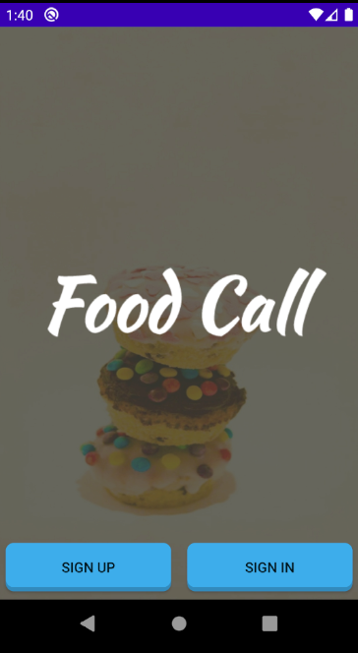

1. When signed in as a customer, a customer can place an order in the restaurant.

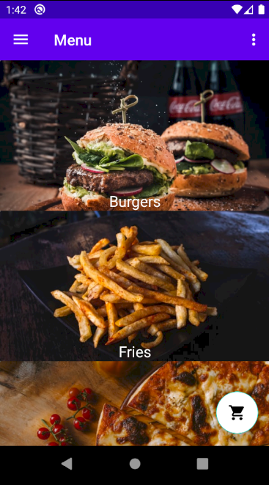 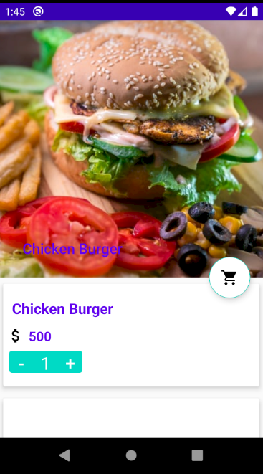

1. Items selected by the customer will appear in the cart and the bill will be shown here

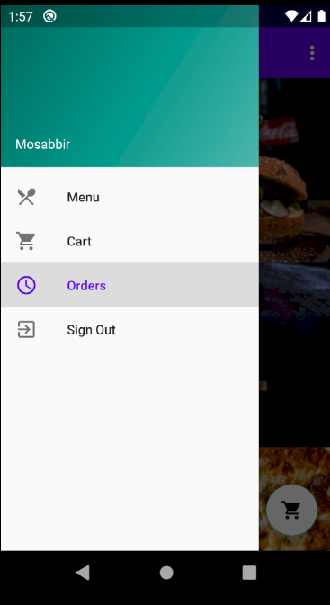 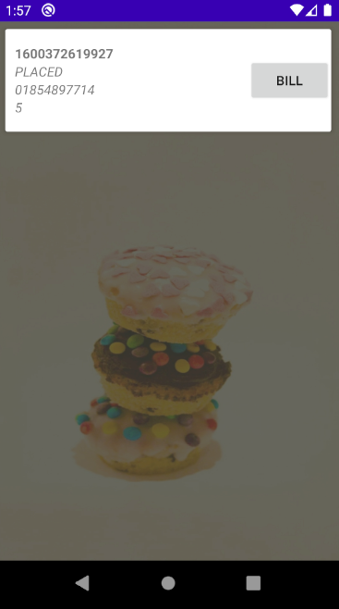

# Requirement Analysis

For the app to be in a functional state, the app must contain the following-

1. Sign up/ Sign in: The app should require to sign up as a customer. Otherwise, if we let anyone to place order without signing up as a customer, then anyone will be able to spam the app by placing multitudes of anonymous orders. For signing up, a customer has to fill up some basic information. This information will be stored in the database (in our case, it is firebase). Next time when a customer signs in, it will cross-check with the information stored in the database.
2. Restaurant Food Menu: After signing in as a customer, the customer should be able to see the restaurant's food menu. The menu should be same for all the customers. This food menu should contain the price for each item. The menu and the pricing should be easily customizable by the manager of the restaurant.
3. Add to Cart: After selecting a food item, this food item should appear in the respective customer cart. The cart should only appear when signed in as a customer and no customer should be able to see what is in someone else’s cart.
4. Place an order: After food items being added to the cart, a customer will be able to place order. At this stage, a pop-up menu will appear asking which table they are ordering from. After finishing with that, the order will be stored in the database and this will also show up to the manager.

# Use Case Diagram

Manager

Customer

# Project Timeline

Project start date: 1 February 2020 (approx.)

Project deadline: 20 September 2020

Note: The project was suspended from the second week of March 2020 until the end of June

# Platform and Technologies

Language: The project is fully written in Java

IDE: Android Studio was the primary IDE for the project

Database: Firebase

# Future Works

Currently, only one app has been developed for the customer-end which means only the customer can place orders. But there are no features for the manager of a restaurant to check which orders have been placed other than directly looking up in the database. We plan to develop another app for the manager-end where the manager will be able to do the following-

    1. check which order has been placed

    2. add new items to the food list

3. change the pricing for an item

    4. sales analysis based on previous

The app will enhance the overall experience of the manager of a restaurant.

# GitHub repository link

<https://github.com/SadmanAdib/FoodCall/>