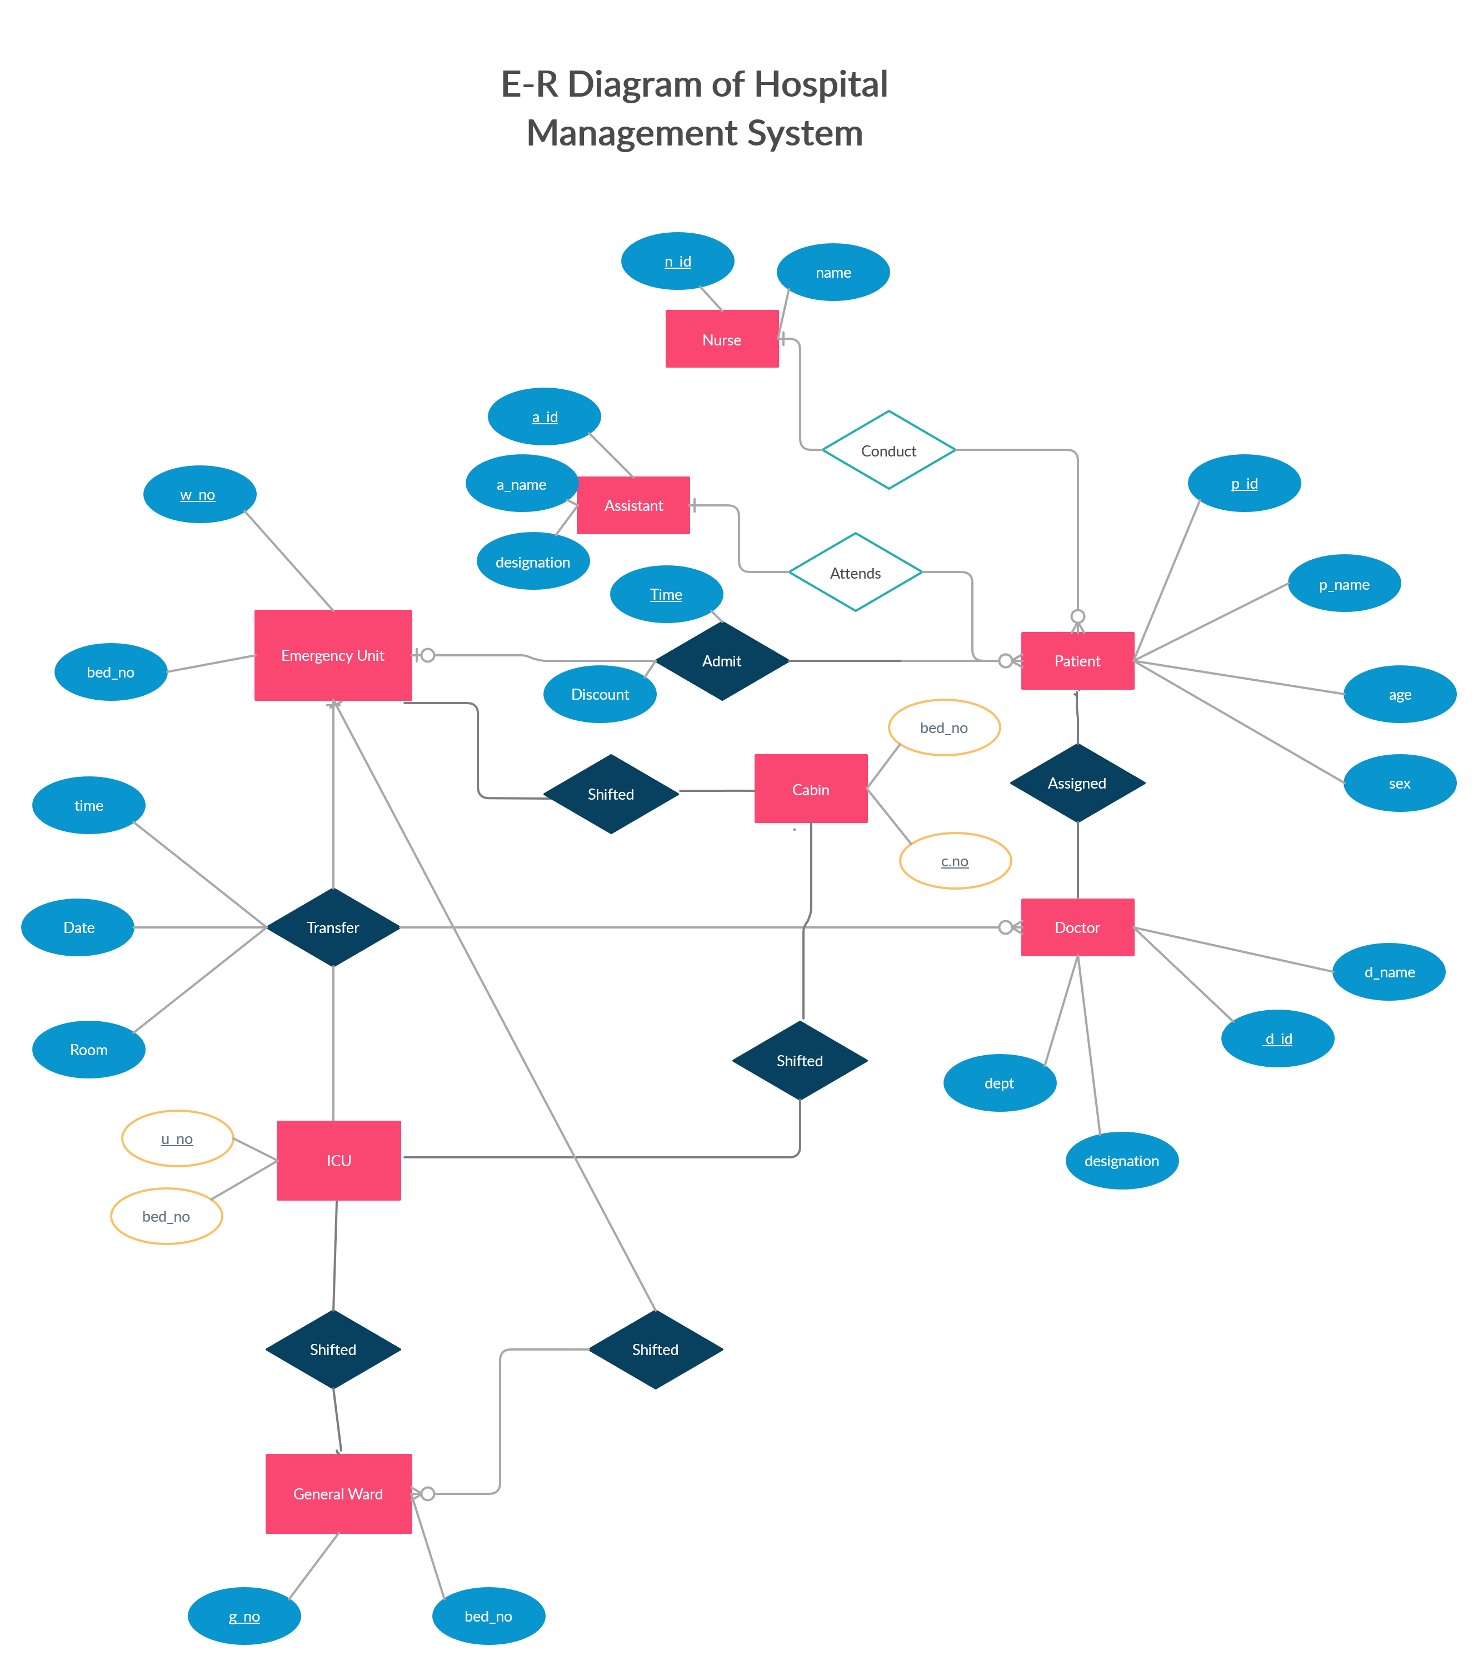

Possible Entity:  
-Patients  
-Doctors  
-Nurses  
-Assistants  
-Emergency Ward  
-ICU Unit  
-General Ward  
-Cabin  
  
Possible Relationship:  
-Admit  
-Transfer  
-Assign  
-Attend  
-Conduct  
-Shift  
  
Attributes  
=Patients – p_id(Primary Key), p_name, age, sex, phone, BG  
=Doctors – d_id(Primary Key,), d_name, designation, dept.  
=Nurses- n_id(Primary Key),, n_name, dept.  
=Assistants- a_id(Primary Key),, a_name, designation, dept.  
=Emergency Ward – w_no(Primary Key),, bed_no  
=ICU Unit – u_no(Primary Key),, bed_no  
=General Ward- g_no(Primary Key),, bed_no  
=Cabin –c_no(Primary Key),, bed_no  
=Admit- date , time(Foreign Key)  
=Transfer- date, time(Foreign Key)  
=Assign- records  
=Attend-records, labs, tests  
=Conduct – medicine, time  
=Shift – date, condition