**AHSANULLAH UNIVERSITY OF SCIENCE**

**&**

**TECHNOLOGY**

DHAKA-1208, BANGLADESH.



Department of Computer Science and Engineering

Spring 2019

Program: Bachelor of Science in Computer Science and Engineering

Course No Course Title

CSE 2200

Software Development III

Project Proposal

Project Name: **Voice of Bangladesh**

Submitted To

Mr. Md. Aminur Rahman

Lecturer, Department of CSE, AUST.

Mr. Shihab Shahriar

Adjunct Faculty, Department of CSE, AUST.

Submitted By

Name Student ID

: Md. Moniruzzaman Joy

: 17.02.04.067

Name Student ID

: Sadman Jahin

: 17.02.04.115

Lab Group

: B1

**Project Name:** *Voice of Bangladesh*

**Introduction**

Our software project is named "Voice of Bangladesh" which basically represents the people of

of Bangladesh where they can raise their voice and fulfill the basic civics right of them through

our app. By using this app a citizen can uphold the problems of their area, complain,

report crime and corruption.

**Motivation:**

This app will help people in great way such as the app works to outreach people's daily

problems. People finds easier way to share their problems related to their area

(crime, fraud, harassment) through this app which is completely anonymous make sure every

person's identity are safe. People finding Govt. websites in easier way and also can call

Police, Ambulance, Fire Service quickly through the app which saves user's time and life both.

We measure user's and our safety through their national identity card. So, users will find

comfort to use this app.

**List of Features:**

1. **User friendly and Attractive UI with Animations**: We designed a user friendly and Attractive UI that user might not be get bored or face difficulty to use the app.
2. **Two Steps Verification**: We kept Two Steps Verification process to ensure Maximum Security. An OTP code will be send to user's registered mobile number after registration and login to check the user.
3. **All Within One App**: We tried to serve all types of needs of a user. It is easy to find all the necessary things at hand by using our app including emergency services Govt. info, Necessary Websites and Report which is the fundamental feature we provide.
4. **Report** : It is the key feature we are providing. A user can report any kind of problems regarding his area or country based problem including corruptions, terrorism, crime etc. He can also include crime scene/footage in his report. He can also give advice and feedback to improve the condition of his area. The special features we are providing that submissions of report of an user will be kept anonymous and send to admin for processing.

**5. Settings**: User can limitedly change their information's like address and passwords.

**Description of activities:**

This is the loading page of app where we showed animated map intro activity.

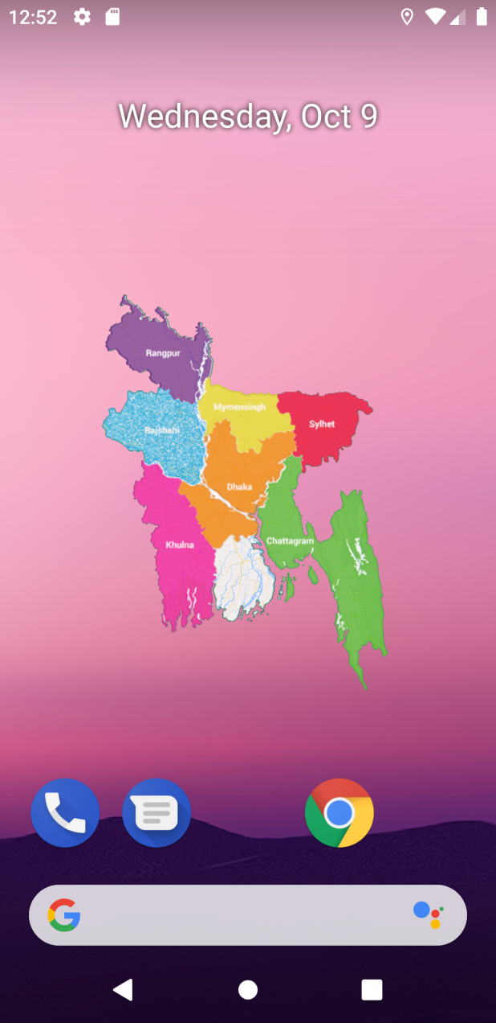

This is the Login-Registration fragment under Login-Registration Activity

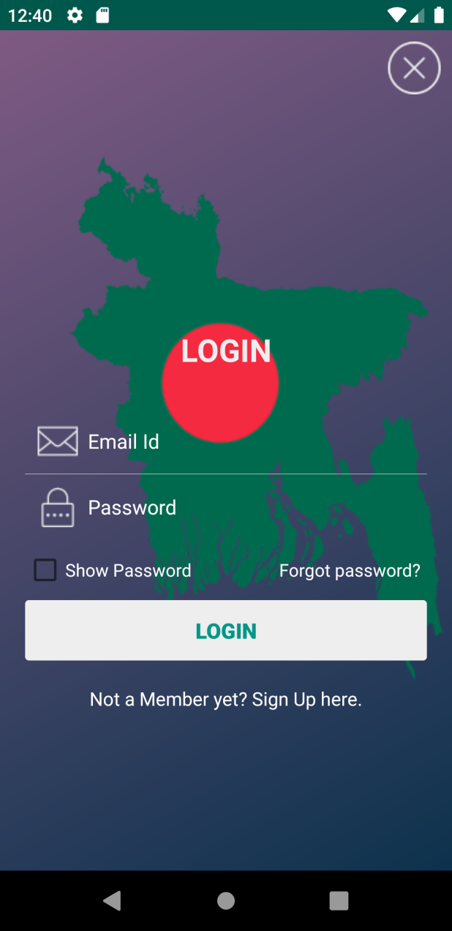 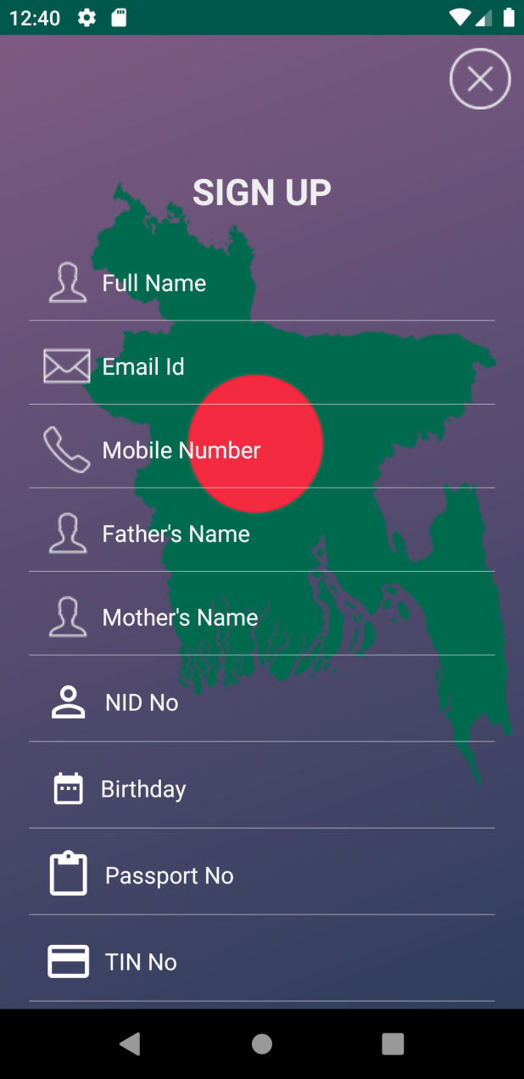

App fetching data from Database while we showing Animation of Logging In/Signing from Animation Activity.

 

Main Menu after Successful Login .Menu options where user can change settings, share this app and also can rate this app under Main Activity.

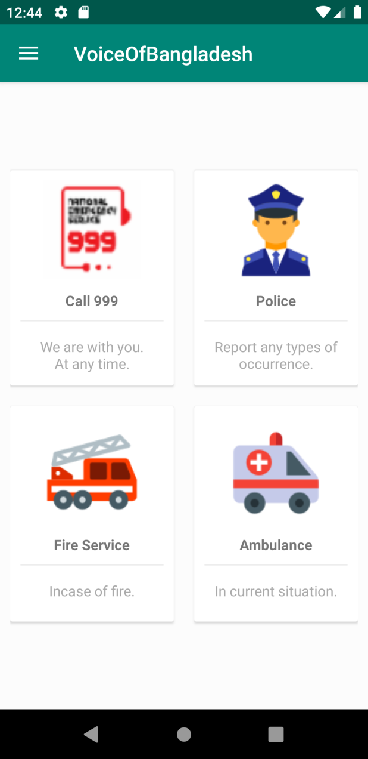 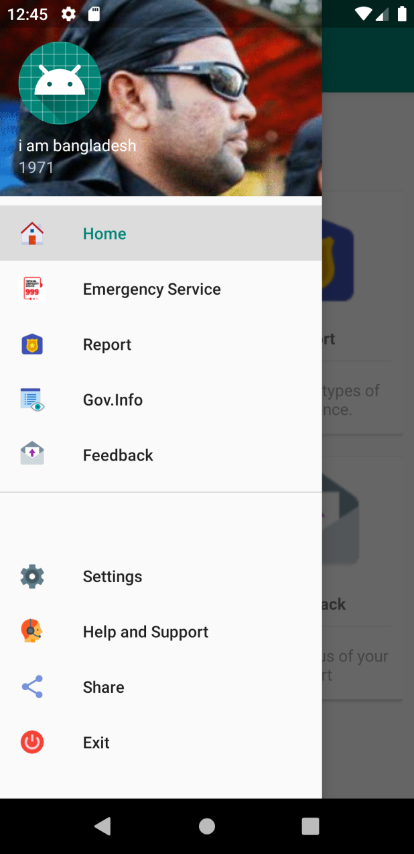

Settings Page

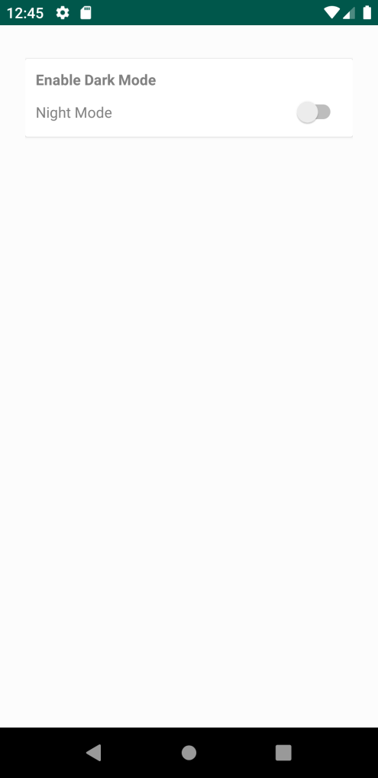

**Future works:**

1. Creating Admin Panel for Admin Access.
2. Sending OTP codes from Govt. Server to user Devices by the  
   help of Tele Networking companies.
3. Adding Location services with reports for more accurate and verified result.