hw1_code

pacman::p_load(ggplot2, tidyverse, dplyr, plotly, processx, nycflights13)  
setwd("C:/Users/dnskd/Desktop/20Spring/graphics/week1/hw")

airlines_df <- airlines  
airports_df <- airports  
flights_df <- flights  
planes_df <- planes  
weather_df <- weather

## cancelled 표시  
flights_df2 <- flights_df %>% mutate(cancelled = ifelse(is.na(dep_time) == TRUE, 1, 0))  
flights_df3 <- flights_df2 %>% left_join(airlines_df, by = "carrier")  
  
## 결항율  
## palette 써서 color에 customization을 주고 싶다.  
library(wesanderson)

## Warning: package 'wesanderson' was built under R version 3.6.3

pal <- wes_palette("Zissou1", 16, type = c("continuous"))  
  
flights_df3 %>% group_by(carrier) %>% summarise(cancelled_rate = mean(cancelled)) %>%  
 ggplot(aes(x = reorder(carrier, cancelled_rate), y = cancelled_rate, fill = carrier)) + geom_bar(stat = "identity") + theme_bw() + theme_minimal()+  
 labs(title = "Cancellation Rate by Airlines in 2013", x = "Airlines", y = "Cancellation Rate") + theme(plot.title = element_text(hjust = 0.5, size = 20), legend.position = "bottom") +  
 coord_flip() + scale_fill_manual(name = "Airlines", values = pal)

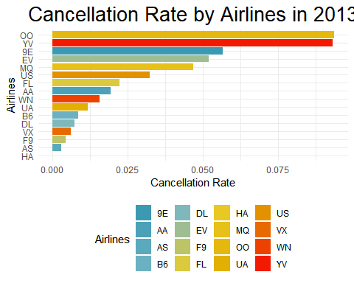

pal2 <- wes_palette("FantasticFox1", 16, type = c("continuous"))  
flights_df4 <- flights_df3 %>% mutate(on.time= ifelse(arr_delay < 16, 1, 0))  
  
flights_df4 %>% group_by(carrier) %>% summarise(on_time_rate = mean(on.time, na.rm = T)) %>%  
 ggplot(aes(x = reorder(carrier, on_time_rate), y = on_time_rate, fill = carrier)) + geom_bar(stat = "identity") + theme_bw() + theme_minimal()+  
 labs(title = "On Time Arrival Rate by Airlines in 2013", x = "Airlines", y = "On Time Arrival Rate") +  
 theme(plot.title = element_text(hjust = 0.5, size = 15), legend.position = "bottom") + coord_flip()+  
 scale_fill_manual(name = "Airlines", values = pal2)

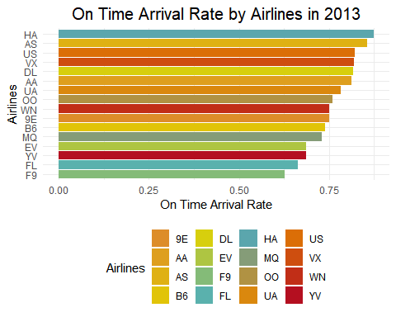

pal3 <- wes_palette("Moonrise3", 16, type = c("continuous"))  
count_flights <- flights_df %>% group_by(carrier) %>% summarise(total = n()) %>% arrange(-total)  
top8 <- count_flights[1:8, ]  
worst <- count_flights[9:16, ] %>% summarise(total = sum(total))  
worst$carrier <- 'ECT.'  
worst <- worst %>% select(carrier, total)  
count <- rbind(top8, worst)  
pie(count$total, count$carrier, col = pal3, clockwise = TRUE, main = "Number of flights by Airlines in 2013")  
legend("bottomright", legend = count$carrier, bty = "n", fill = pal3)

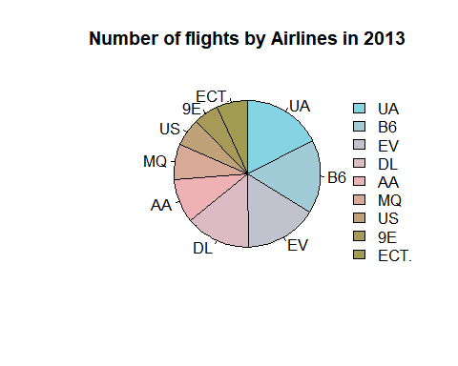

flights_df %>% group_by(carrier, origin) %>% summarise(total = n()) %>%  
 ggplot(aes(x = reorder(carrier, total) , y = total, fill = origin)) + geom_bar(position = "stack", stat = "identity") + theme_bw() + theme_minimal()+  
 labs(title = "Departures by Airline in 2013", x = "Airline", y = " ") + theme(plot.title = element_text(hjust = 0.5, size = 15), legend.position = "bottom") + coord_flip()

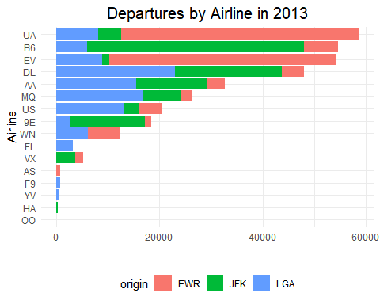

flights_df %>% group_by(carrier, dest) %>% summarise(total = n()) %>%  
 ggplot(aes(carrier, total, fill = dest)) + geom_bar(position = "stack", stat = "identity") + theme_bw() + theme_minimal()+  
 labs(title = "Airway by Airline in 2013", x = "Airline", y = " ") + theme(legend.position = "none", plot.title = element_text(hjust = 0.5, size = 15))

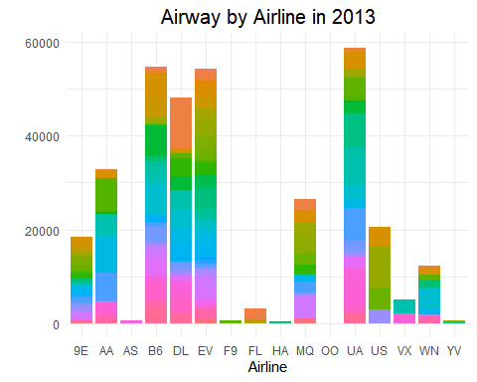

airports_df %>% filter(is.na(tzone))

## # A tibble: 3 x 8  
## faa name lat lon alt tz dst tzone  
## <chr> <chr> <dbl> <dbl> <dbl> <dbl> <chr> <chr>  
## 1 EEN Dillant Hopkins Airport 72.3 42.9 149 -5 A <NA>   
## 2 LRO Mount Pleasant Regional-Faiso~ 32.5 -79.5 12 -5 A <NA>   
## 3 YAK Yakutat 59.3 -139. 33 -9 A <NA>

airports_df[airports_df$faa %in% c("EEN", "LRO"), "tzone"] <- "America/New_York"  
airports_df[airports_df$faa == "YAK", "tzone"] <- "America/Yakutat"  
airports_df %>% filter(faa %in% c("EEN", "LRO", "YAK"))

## # A tibble: 3 x 8  
## faa name lat lon alt tz dst tzone   
## <chr> <chr> <dbl> <dbl> <dbl> <dbl> <chr> <chr>   
## 1 EEN Dillant Hopkins Airport 72.3 42.9 149 -5 A America/Ne~  
## 2 LRO Mount Pleasant Regional~ 32.5 -79.5 12 -5 A America/Ne~  
## 3 YAK Yakutat 59.3 -139. 33 -9 A America/Ya~

flights_airport <- flights_df %>% left_join(airports_df, by = c("dest" = "faa"))  
flights_airport[is.na(flights_airport$tzone), "tzone"] <- "ETC"  
  
df1 <- flights_airport %>% group_by(carrier, tzone) %>% summarise(total = n())   
df2 <- flights_airport %>% group_by(carrier) %>% summarise(ttotal = n())  
df1 %>% left_join(df2 , by = "carrier") %>% ggplot(aes(x = reorder(carrier, ttotal), y = total, fill = tzone)) + geom_bar(position = "stack", stat = "identity") + theme_bw() + theme_minimal()+  
 labs(title = "Arrival Region by Airline in 2013", x = "Airline", y = " ") + theme(plot.title = element_text(hjust = 0.5, size = 15), legend.position = "bottom", legend.title = element_text(size = 8), legend.text = element_text(size = 6 ) ) + coord_flip()

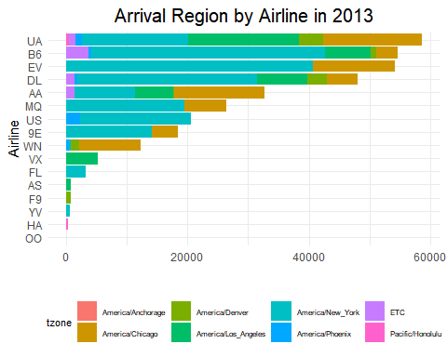

flights_weather <- flights_df %>% left_join(weather_df, by = c("year", "month", "day", "hour","origin", "time_hour"))  
flights_weather <- flights_weather %>% mutate(cancelled = ifelse(is.na(dep_time) == TRUE, 1, 0))  
flights_weather %>% ggplot(aes(as.factor(cancelled), temp)) + geom_boxplot(aes(group= as.factor(cancelled), fill = as.factor(cancelled))) + theme_bw() + theme_minimal() + labs(title = "Temperature", x = "cancelled", y = " ") + theme(plot.title = element_text(hjust = 0.5, size = 20), legend.position = "none") + scale_fill_manual(values = c("gray", "royalblue"))

## Warning: Removed 1573 rows containing non-finite values (stat_boxplot).

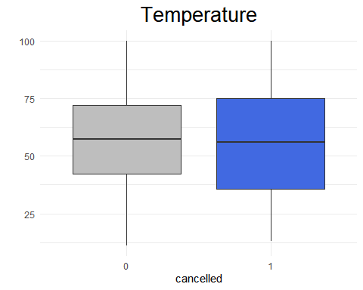

flights_weather %>% ggplot(aes(as.factor(cancelled), dewp)) + geom_boxplot(aes(group= as.factor(cancelled), fill = as.factor(cancelled))) + theme_bw() + theme_minimal() + labs(title = "Dewpoint", x = "cancelled", y = " ") + theme(plot.title = element_text(hjust = 0.5, size = 20), legend.position = "none") + scale_fill_manual(values = c("gray", "royalblue")) # 결항때 dewp가 좀더 높다.

## Warning: Removed 1573 rows containing non-finite values (stat_boxplot).

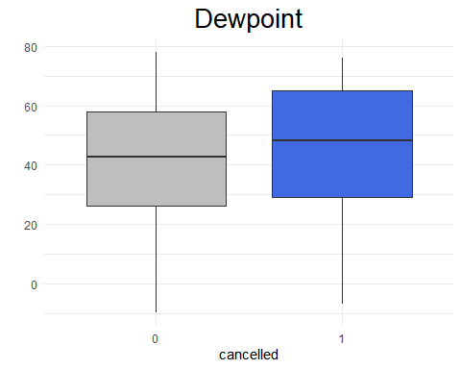

flights_weather %>% ggplot(aes(as.factor(cancelled), wind_dir)) + geom_boxplot(aes(group= as.factor(cancelled), fill = as.factor(cancelled))) + theme_bw() + theme_minimal() + labs(title = "Wind Direction", x = "cancelled", y = " ") + theme(plot.title = element_text(hjust = 0.5, size = 20), legend.position = "none") + scale_fill_manual(values = c("gray", "royalblue"))

## Warning: Removed 9796 rows containing non-finite values (stat_boxplot).

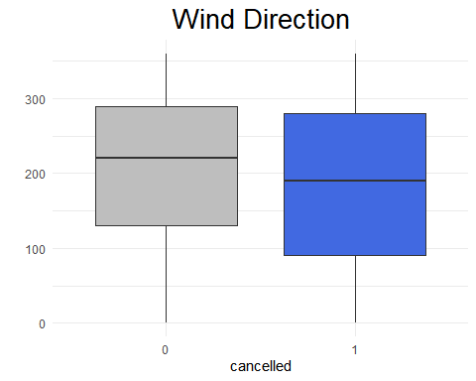

flights_weather %>% ggplot(aes(as.factor(cancelled), wind_speed)) + geom_boxplot(aes(group= as.factor(cancelled), fill = as.factor(cancelled))) + theme_bw() + theme_minimal() + labs(title = "Wind Speed", x = "cancelled", y = " ") + theme(plot.title = element_text(hjust = 0.5, size = 20), legend.position = "none") + scale_fill_manual(values = c("gray", "royalblue"))

## Warning: Removed 1634 rows containing non-finite values (stat_boxplot).

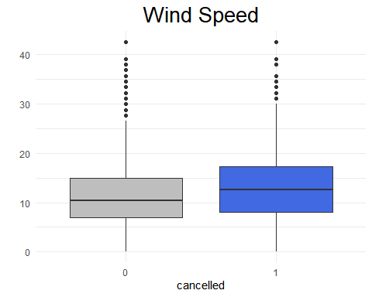

flights_weather %>% ggplot(aes(as.factor(cancelled), wind_gust)) + geom_boxplot(aes(group= as.factor(cancelled), fill = as.factor(cancelled))) + theme_bw() + theme_minimal() + labs(title = "Wind Gust", x = "cancelled", y = " ") + theme(plot.title = element_text(hjust = 0.5, size = 20), legend.position = "none") + scale_fill_manual(values = c("gray", "royalblue"))

## Warning: Removed 256391 rows containing non-finite values (stat_boxplot).

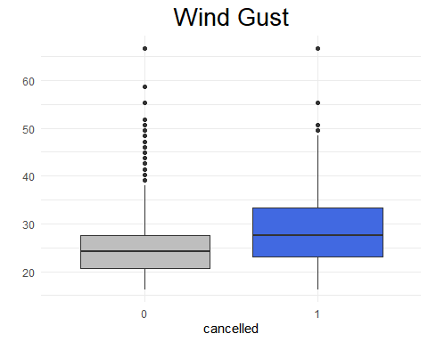

flights_weather %>% ggplot(aes(as.factor(cancelled), precip)) + geom_boxplot(aes(group= as.factor(cancelled), fill = as.factor(cancelled))) + theme_bw() + theme_minimal() + labs(title = "Precipitation", x = "cancelled", y = " ") + theme(plot.title = element_text(hjust = 0.5, size = 20), legend.position = "none")

## Warning: Removed 1556 rows containing non-finite values (stat_boxplot).

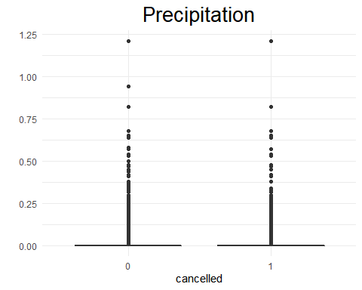

flights_weather %>% ggplot(aes(as.factor(cancelled), pressure)) + geom_boxplot(aes(group= as.factor(cancelled), fill = as.factor(cancelled))) + theme_bw() + theme_minimal() + labs(title = "Pressure", x = "cancelled", y = " ") + theme(plot.title = element_text(hjust = 0.5, size = 20), legend.position = "none") + scale_fill_manual(values = c("gray", "royalblue"))

## Warning: Removed 38788 rows containing non-finite values (stat_boxplot).

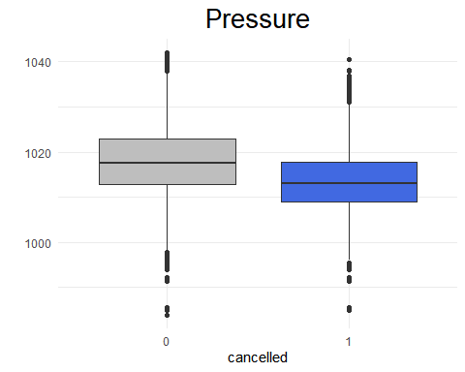

flights_weather %>% ggplot(aes(as.factor(cancelled), visib)) + geom_boxplot(aes(group= as.factor(cancelled), fill = as.factor(cancelled))) + theme_bw() + theme_minimal() + labs(title = "Visibility", x = "cancelled", y = " ") + theme(plot.title = element_text(hjust = 0.5, size = 20)) + labs(title = "Visibility", x = "cancelled", y = " ") + theme(plot.title = element_text(hjust = 0.5, size = 20), legend.position = "none") + scale_fill_manual(values = c("gray", "royalblue"))

## Warning: Removed 1556 rows containing non-finite values (stat_boxplot).

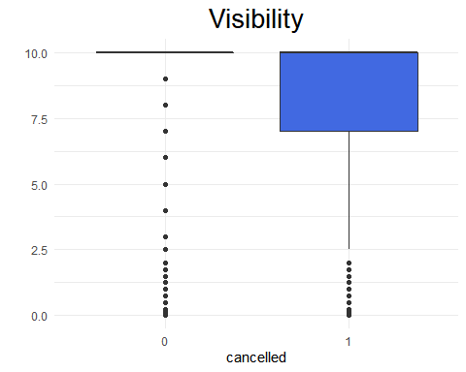

flights_planes <- flights_df %>% left_join(planes_df, by = "tailnum") %>% rename(model_year = year.y) %>%  
 mutate(on.time = ifelse(arr_delay < 16, 1, 0))   
flights_planes %>% filter(!is.na(on.time)) %>% group_by(tailnum, on.time) %>% summarise(n = n()) %>%  
 ggplot(aes(tailnum, n)) + geom_bar(stat = "identity", aes(fill = as.factor(on.time)), position = "fill") +  
 scale_fill_manual("on_time", values = c("gray", "royalblue")) + labs(title = "Tailnum of plane arrives on time") + theme(plot.title = element_text(hjust = 0.5, size = 15))

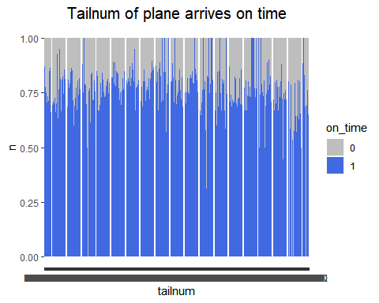

## year  
flights_planes %>% filter(!is.na(on.time)) %>% group_by(model_year, on.time) %>% summarise(total = n()) %>%  
 ggplot(aes(model_year, total)) + geom_bar(stat = "identity", aes(fill = as.factor(on.time))) +  
 scale_fill_manual("on_time", values = c("gray", "royalblue")) + labs(title = "Relationship between model_year and on-time arrival", x = "model_year", y = "n")+ theme(plot.title = element_text(hjust = 0.5, size = 15), axis.text.x = element_text(angle = 45, hjust = 1)) + theme_minimal()+  
 facet_wrap(~on.time, scale = "free_y")

## Warning: Removed 2 rows containing missing values (position_stack).

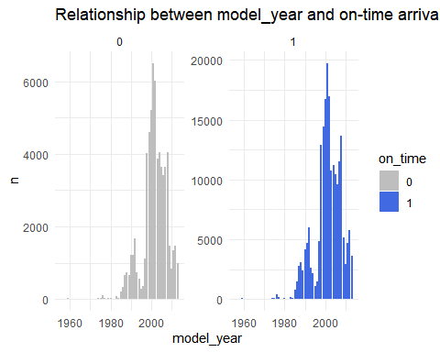

## type  
flights_planes %>% filter(!is.na(on.time)) %>% group_by(type, on.time) %>% summarise(total = n()) %>%  
 ggplot(aes(type, total)) + geom_bar(stat = "identity", aes(fill = as.factor(on.time))) +  
 scale_fill_manual("on_time", values = c("gray", "royalblue")) + labs(title = "Relationship between type and on-time arrival", x = "type", y = "n")+ theme(plot.title = element_text(hjust = 0.5, size = 15), axis.text.x = element_text(angle = 45, hjust = 1)) + theme_minimal()+  
 facet_wrap(~on.time, scale = "free_y")

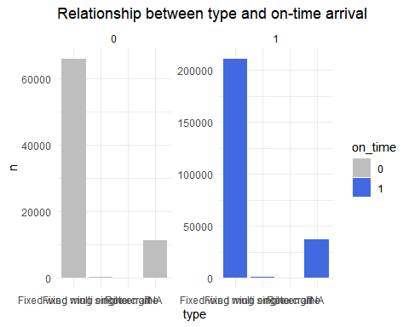

## manufacturer  
flights_planes %>% filter(!is.na(on.time)) %>% group_by(manufacturer, on.time) %>% summarise(total = n()) %>%  
 ggplot(aes(manufacturer, total)) + geom_bar(stat = "identity", aes(fill = as.factor(on.time))) +  
 scale_fill_manual("on_time", values = c("gray", "royalblue")) + labs(title = "Relationship between manufacturer and on-time arrival", x = "type", y = "n")+ theme(plot.title = element_text(hjust = 0.5, size = 15), axis.text.x = element_text(angle = 45, hjust = 1)) + theme_minimal()+  
 facet_wrap(~on.time, scale = "free_y")

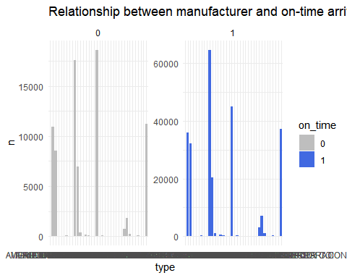

## model  
flights_planes %>% filter(!is.na(on.time)) %>% group_by(model, on.time) %>% summarise(total = n()) %>%  
 ggplot(aes(model, total)) + geom_bar(stat = "identity", aes(fill = as.factor(on.time))) + facet_wrap(~on.time, scale = "free_y")+  
 scale_fill_manual("on-time", values = c("gray", "royalblue")) + labs(title = "Relationship between plane model and on-time arrival", x = "model", y = "n")+  
 theme(plot.title = element_text(hjust = 0.5, size = 15)) + theme_minimal()

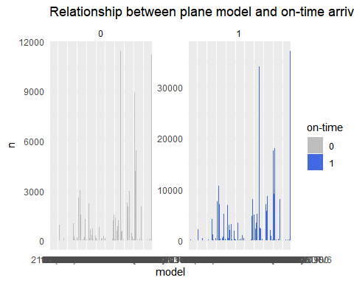

## engines  
flights_planes %>% filter(!is.na(on.time)) %>% group_by(engines, on.time) %>% summarise(total = n()) %>%  
 ggplot(aes(engines, total))+geom_bar(stat = "identity", aes(fill = as.factor(on.time))) + facet_wrap(~on.time, scale = "free_y")+  
 scale_fill_manual("on-time", values = c("gray", "royalblue")) + labs(title = "Relationship between the number of engines and on-time arrival", x = "engines", y = "n")+  
 theme(plot.title = element_text(hjust = 0.5, size = 10)) + theme_minimal()

## Warning: Removed 2 rows containing missing values (position_stack).

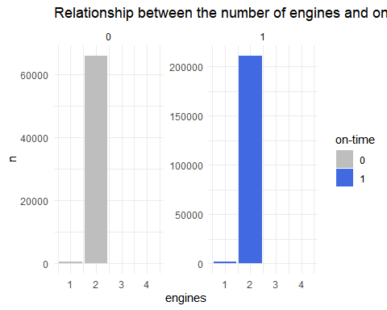

## seats  
flights_planes %>% filter(!is.na(on.time)) %>% group_by(seats, on.time) %>% summarise(total = n()) %>%  
 ggplot(aes(seats, total)) + geom_density(aes(y = ..density.., fill = as.factor(on.time)), alpha = 0.2)+  
 scale_fill_manual("on-time", values = c("gray", "royalblue")) + labs(title = "Relationship between the number of seats and on-time arrival", x = "seats", y = "n")+  
 theme(plot.title = element_text(hjust = 0.5, size = 10)) + theme_minimal()

## Warning: Removed 2 rows containing non-finite values (stat_density).

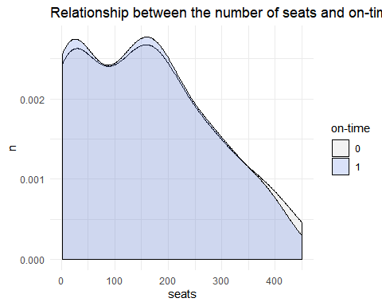

## engines  
flights_planes %>% filter(!is.na(on.time)) %>% group_by(engine, on.time) %>% summarise(total = n()) %>%  
 ggplot(aes(engine, total))+geom_bar(stat = "identity", aes(fill = as.factor(on.time))) + facet_wrap(~on.time, scale = "free_y")+  
 scale_fill_manual("on-time", values = c("gray", "royalblue")) + labs(title = "Relationship between type of engine and on-time arrival", x = "engines", y = "n")+  
 theme(plot.title = element_text(hjust = 0.5, size = 10)) + theme_minimal()

