**MEDICAL INVENTORY OPTIMIZATION**

**(By Sadnya kolhe)**

BUSINESS INSIGHTS

We worked on the Medical Inventory optimization where we are provided with the data set .The Business insights for the specific data and to know the probabilistic thoughts are following:

1. According to the SQL Query for null values there are 12525 null values which should be deleted . That can make the result complicated

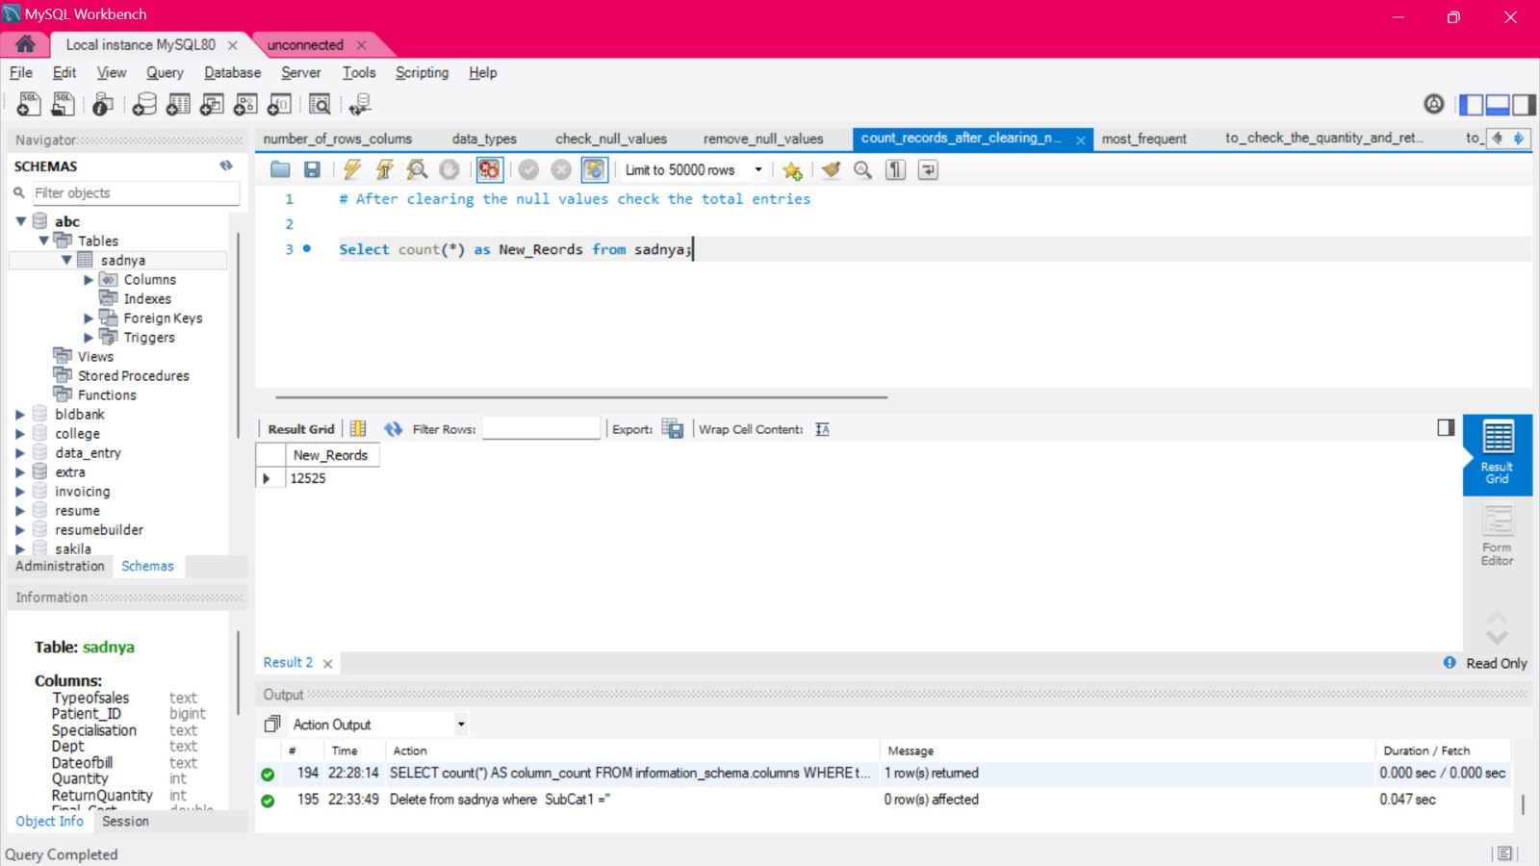

2)The min and max of the final cost show that there is possibility to increase the profit by 25%

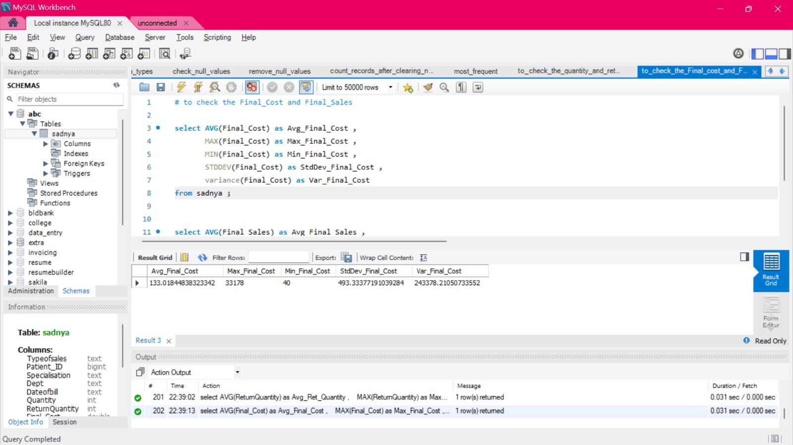

3) the below pairplot can give a account idea on the final sales n final cost .That is the maximum profit can be Figure out

