**🌟SQL Query Documentation🌟**

This document contains a collection of SQL queries along with their explanations. Each query is designed to extract meaningful insights from the dataset. Spaces have been left for adding relevant screenshots.

## 1. Retrieving the Top 10 Most Popular Songs

Explanation: This query retrieves the top 10 most popular songs categorized as 'High' in popularity.

SQL Query:

SELECT song_title, artist, popularity_category  
FROM new_spotify_app  
WHERE popularity_category = 'High'  
ORDER BY popularity_category DESC  
LIMIT 10;

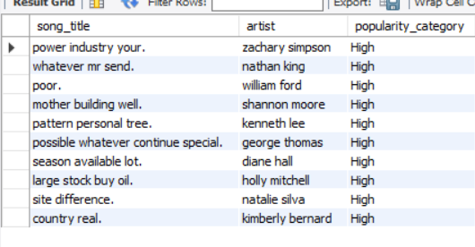

## 2. Average Song Duration by Genre

Explanation: This query calculates the average duration of songs for each genre and orders them from longest to shortest.

SQL Query:

SELECT genre, AVG(duration_min) AS avg_duration  
FROM new_spotify_app  
GROUP BY genre  
ORDER BY avg_duration DESC;

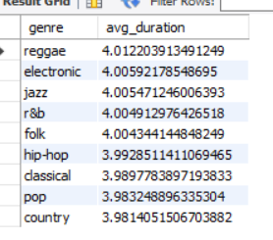

## 3. Total Number of Songs by Popularity Category

Explanation: This query counts the number of songs for each popularity category and sorts them in descending order.

SQL Query:

SELECT popularity_category, COUNT(*) AS total_songs  
FROM new_spotify_app  
GROUP BY popularity_category  
ORDER BY total_songs DESC;

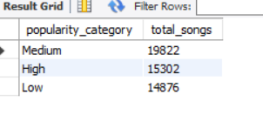

## 4. Top 5 Artists with the Most Songs

Explanation: This query retrieves the top 5 artists who have the highest number of songs in the dataset.

SQL Query:

SELECT artist, COUNT(*) AS song_count  
FROM new_spotify_app  
GROUP BY artist  
ORDER BY song_count DESC  
LIMIT 5;

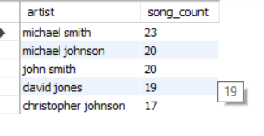

## 5. Top 10 Most Streamed Songs

Explanation: This query selects the top 10 songs with the highest stream count, ordered in descending order.

SQL Query:

SELECT song_title, artist, stream  
FROM new_spotify_app  
ORDER BY stream DESC  
LIMIT 10;

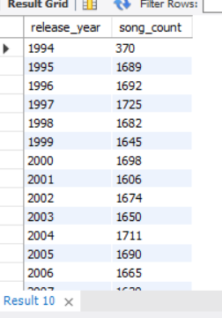

## 6. Yearly Song Releases Trend

Explanation: This query shows the number of songs released each year, ordered by release year.

SQL Query:

SELECT release_year, COUNT(*) AS song_count  
FROM new_spotify_app  
GROUP BY release_year  
ORDER BY release_year;

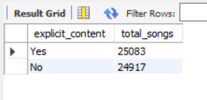

## 7. Explicit vs. Non-Explicit Songs Count

Explanation: This query categorizes songs into explicit and non-explicit and counts the number of songs in each category.

SQL Query:

SELECT explicit_content, COUNT(*) AS total_songs  
FROM new_spotify_app  
GROUP BY explicit_content;



## 8. Most Common Song Duration Category

Explanation: This query categorizes songs based on duration and counts how many songs fall into each category.

SQL Query:

SELECT CASE   
 WHEN duration_min < 3 THEN 'Short (<3 min)'  
 WHEN duration_min BETWEEN 3 AND 5 THEN 'Medium (3-5 min)'  
 ELSE 'Long (>5 min)'  
 END AS duration_category, COUNT(*) AS total_songs  
FROM new_spotify_app  
GROUP BY duration_category  
ORDER BY total_songs DESC;

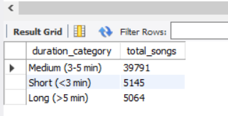

## 9. Top 5 Most Popular Music Genres

Explanation: This query retrieves the top 5 most popular music genres based on the number of songs.

SQL Query:

SELECT genre, COUNT(*) AS total_songs  
FROM new_spotify_app  
GROUP BY genre  
ORDER BY total_songs DESC  
LIMIT 5;

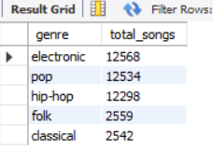

## 10. Most Streamed Songs Released Before 2000

Explanation: This query retrieves the top 10 most streamed songs that were released before the year 2000.

SQL Query:

SELECT song_title, artist, composer, release_year, log_streams  
FROM new_spotify_app  
WHERE release_year < 2000  
ORDER BY log_streams DESC  
LIMIT 10;

