REQUIREMENTS:

Create a Website Using XHTML + CSS

TITLE : DISASTERS

ANALYSIS:

* FRONT-END : XHTML and CSS
* EDITOR : NOTEPAD++
* BROWSER : GOOGLE CHROME Version 64
* PICTURES : GOOGLE
* INFORMATION : WIKIPEDIA

DESIGN:

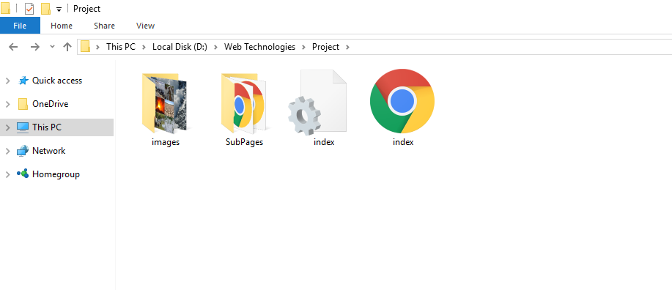

* Total Number of Pages : 7
* Page Names : index.html

avalanche.html

earthquake.html

tornado.html

tsunami.html

volcano.html

feedback.html

SOURCE CODE:

1. index.html:

<? xml version="1.0" encoding="utf-8"?>

<! DOCTYPE html PUBLIC "-//W3C//DTD XHTML 1.0 Transitional//EN" "http://www.w3.org/TR/xhtml1/DTD/xhtml1-transitional.dtd">

<html xmlns = "http://www.w3.org/1999/xhtml">

<head>

<title>Disasters</title>

<link rel="stylesheet" type="text/css" href="index.css"></link>

<link rel="icon" type="image/png" href="images/dis-icon.png"></link>

<link href="https://fonts.googleapis.com/css?family=Roboto" rel="stylesheet"></link>

<meta name="viewport" content="width=device-width" />

</head>

<body>

<ul id="nav">

<li><a href="index.html"><img src="images/icon.png" alt="home-icon" width="70" height="50" /> </a></li>

<li id="title"><a href="index.html">Disasters</a></li>

<li><a href="SubPages/avalanche.html">Avalanches</a></li>

<li><a href="SubPages/earthquake.html">Earthquakes</a></li>

<li><a href="SubPages/tornado.html">Tornados</a></li>

<li><a href="SubPages/tsunami.html">Tsunamis</a></li>

<li><a href="SubPages/volcano.html">Volcanoes</a></li>

<li>

<select>

<option>menu</option>

<option>Avalanche</option>

<option>Earthquake</option>

<option>Tornado</option>

<option>Tsunami</option>

<option>Volcano</option>

</select>

</li>

<li><input id="search" type="text"/></li>

</ul>

<div class="body">

<div class="container">

<h1 id="h1Animation">Disasters of the World</h1>

<div class="sideBySide">

<img src="images/catastrofes.jpg" width="400" height="400" alt="Disaster pic" />

</div>

<div class="back_see">

<p>A natural disaster is a major adverse event resulting from natural processes of the Earth; examples include floods, hurricanes, tornadoes, volcanic eruptions, earthquakes, tsunamis, and other geologic processes. </p><p>An adverse event will not rise to the level of a disaster if it occurs in an area without vulnerable population. In a vulnerable area, however, such as Nepal during the 2015 earthquake, an earthquake can have disastrous consequences and leave lasting damage, which can require years to repair. </p><p>International law, for example Geneva Conventions defines International Red Cross and Red Crescent Movement the Convention on the Rights of Persons with Disabilities, requires that "States shall take, in accordance with their obligations under international law, including international humanitarian law and international human rights law, all necessary measures to ensure the protection and safety of persons with disabilities in situations of risk, including the occurrence of natural disaster." </p><p>Natural disasters can also affect political relations with countries and vice versa. Violent conflicts within states can exacerbate the impact of natural disasters by weakening the ability of states, communities and individuals to provide disaster relief. </p>

</div><br />

<div class="back_see">

<div>

<div class="sideBySide">

<h1>Avalanches</h1>

<a href="SubPages/avalanche.html" target="_blank"> <img class="image" src="images/avalanche.jpg" alt="All Pics" /></a>

</div>

<div class="sideBySide">

<h1>Earthquakes</h1>

<a href="SubPages/earthquake.html" target="_blank"><img class="image" src="images/earthquake.jpg" alt="All Pics" /></a>

</div>

<div class="sideBySide">

<h1>Tornadoes</h1>

<a href="SubPages/tornado.html" target="_blank"><img class="image" src="images/tornado.jpg" alt="All Pics" /></a>

</div>

<div class="sideBySide">

<h1>Tsunamis</h1>

<a href="SubPages/tsunami.html" target="_blank"><img class="image" src="images/tsunami.jpg" alt="All Pics" /></a>

</div>

<div align="center" style="padding-bottom: 30px;">

<h1>Volcanoes</h1>

<a href="SubPages/volcano.html" target="_blank"><img class="image" src="images/Volcano.jpg" alt="All Pics" /></a></div></div></div><br />

<div class="back_see" style="text-align: center;">

<h4>Pictures and Contents of all the pages in this domain are extracted from Wikipedia and Google</h4>

<h4>This site works best with Desktop - Google Chrome</h4>

</div>

</div>

</div>

<div class="footer">

<h3>A Project Made by: </h3>

<dl>

<dt>Sai Kiran Chandolu</dt>

<dd>1601-16-733-166</dd>

<dt>Anurag Muppala</dt>

<dd>1601-16-733-152</dd>

</dl>

<h3><a href="SubPages/feedback.html">Feeling Gracious? </a></h3>

</div></body></html>

1. index.css:

ul {

list-style-type: none;

margin: 0;

padding: 0;

overflow: auto;

}

li {

display: inline;

padding-right: 38px;

float: left;

}

textarea {

border: 2px solid #ccc;

border-radius: 4px;

font-size: 16px;

padding: 12px 20px 12px 20px;

}

a {

text-decoration: none! important;

color: white;

}

a: visited {

color: white;

}

select {

width: 130px;

border: 2px solid #ccc;

border-radius: 4px;

font-size: 16px;

padding: 12px 10px 12px 10px;

}

*{

font-family: 'Roboto', sans-serif;

}

p {

font-size: 20px;

}

input[type=text] {

width: 200px;

border: 2px solid #ccc;

border-radius: 4px;

font-size: 16px;

padding: 12px 20px 12px 20px;

}

button {

background-color: #4CAF50;

border: none;

color: white;

padding: 15px 32px;

text-align: center;

text-decoration: none;

display: inline-block;

font-size: 16px;

}

. feedback_text {

width: 200px;

}

#search[type=text] {

width: 50px;

border: 2px solid #ccc;

border-radius: 4px;

font-size: 16px;

padding: 12px 20px 12px 20px;

transition: width 0.4s ease-in-out;

}

#search[type=text]: focus {

width: 75%;

}

#feedback {

padding: 100px, 300px, 100px, 300px;

}

#nav {

position: relative;

background-color: black;

padding: 12px 10px 12px 5px;

}

#title {

font-weight: 50px;

font-size: 2.5em;

}

#h1Animation {

color: white;

font: bold Roboto;

width: 18ch;

white-space: nowrap;

overflow: hidden;

-webkit-animation: typing 3s;

}

.container {

margin: 0px 150px 0px 150px;

}

. body {

background-image: ul(images/explosion.jpg);

background-repeat: no-repeat;

background-attachment: fixed;

}

.sideBySide {

float: left;

padding: 30px;

}

.back_see {

background-color: white;

padding: 5px;

}

. image {

width: 400px;

height: 200px;

}

. footer {

text-align: center;

background-color: black;

color: white;

}

1. avalanche.html:

<? xml version="1.0" encoding="utf-8"?>

<! DOCTYPE html PUBLIC "-//W3C//DTD XHTML 1.0 Transitional//EN" "http://www.w3.org/TR/xhtml1/DTD/xhtml1-transitional.dtd">

<html xmlns = "http://www.w3.org/1999/xhtml">

<head>

<title>Avalanche</title>

<link rel="stylesheet" type="text/css" href="../index.css"></link>

<link rel="icon" type="image/png" href="../images/dis-icon.png"></link>

<link href="https://fonts.googleapis.com/css?family=Roboto" rel="stylesheet"></link>

<meta name="viewport" content="width=device-width" />

</head>

<body>

<ul id="nav">

<li><a href="../index.html"><img src="../images/icon.png" alt="home-icon" width="70" height="50" /></a></li>

<li id="title"><a href="../index.html">Disasters</a></li>

<li><a href="avalanche.html">Avalanches</a></li>

<li><a href="earthquake.html">Earthquakes</a></li>

<li><a href="tornado.html">Tornados</a></li>

<li><a href="tsunami.html">Tsunamis</a></li>

<li><a href="volcano.html">Volcanoes</a></li>

<li>

<select>

<option>menu</option>

<option>Avalanche</option>

<option>Earthquake</option>

<option>Tornado</option>

<option>Tsunami</option>

<option>Volcano</option>

</select>

</li>

<li><input id="search" type="text"/></li>

</ul>

<div class="container">

<h1>Avalanche</h1>

<div class="sideBySide">

<img src="../images/Avalanche/avalanche.jpg" width="400" height="400" alt="Disaster pic" />

</div>

<div class="back_see">

<p>An avalanche (also called a snow slide) is a rapid flow of snow down a sloping surface. Avalanches are typically triggered in a starting zone from a mechanical failure in the snowpack (slab avalanche) when the forces on the snow exceed its strength but sometimes only with gradually widening (loose snow avalanche). After initiation, avalanches usually accelerate rapidly and grow in mass and volume as they entrain more snow. If the avalanche moves fast enough some of the snow may mix with the air forming a powder snow avalanche, which is a type of gravity current. </p><p>Slides of rocks or debris, behaving in a similar way to snow, are also referred to as avalanches. The remainder of this article refers to snow avalanches. </p></p>The load on the snowpack may be only due to gravity, in which case failure may result either from weakening in the snowpack or increased load due to precipitation. Avalanches initiated by this process are known as spontaneous avalanches. Avalanches can also be triggered by other loading conditions such as human or biologically related activities. Seismic activity may also trigger the failure in the snowpack and avalanches. </p><p>Although primarily composed of flowing snow and air, large avalanches have the capability to entrain ice, rocks, trees, and other surficial material. However, they are distinct from mudslides which have greater fluidity, rock slides which are often ice free, and serac collapses during an icefall. Avalanches are not rare or random events and are endemic to any mountain range that accumulates a standing snowpack. Avalanches are most common during winter or spring but glacier movements may cause ice and snow avalanches at any time of year. In mountainous terrain, avalanches are among the most serious objective natural hazards to life and property, with their destructive capability resulting from their potential to carry enormous masses of snow at high speeds. </p><p>There is no universally accepted classification system for different forms of avalanches. Avalanches can be described by their size, their destructive potential, their initiation mechanism, their composition and their dynamics</p>

</div>

<h1>Formation</h1>

<div class="back_see">

<p>Most avalanches occur spontaneously during storms under increased load due to snowfall. The second largest cause of natural avalanches is metamorphic changes in the snowpack such as melting due to solar radiation. Other natural causes include rain, earthquakes, rock fall and icefall. Artificial triggers of avalanches include skiers, snowmobiles, and controlled explosive work. Contrary to popular belief, avalanches are not triggered by loud sound; the pressure from sound is orders of magnitude too small to trigger an avalanche. </p><p>Avalanche initiation can start at a point with only a small amount of snow moving initially; this is typical of wet snow avalanches or avalanches in dry unconsolidated snow. However, if the snow has sintered into a stiff slab overlying a weak layer then fractures can propagate very rapidly, so that a large volume of snow, that may be thousands of cubic meters, can start moving almost simultaneously. </p><p>A snowpack will fail when the load exceeds the strength. The load is straightforward; it is the weight of the snow. However, the strength of the snowpack is much more difficult to determine and is extremely heterogeneous. It varies in detail with properties of the snow grains, size, density, morphology, temperature, water content; and the properties of the bonds between the grains. These properties may all metamorphose in time according to the local humidity, water vapour flux, temperature and heat flux. The top of the snowpack is also extensively influenced by incoming radiation and the local air flow. One of the aims of avalanche research is to develop and validate computer models that can describe the evolution of the seasonal snowpack over time.</p>

</div>

<h3>Some interesting pictures of Avalanches in action:</h3>

<div class="back_see">

<div>

<div class="sideBySide">

<img class="image" src="../images/Avalanche/101.jpg" alt="All Pics" />

</div>

<div class="sideBySide">

<img class="image" src="../images/Avalanche/102.jpg" alt="All Pics" />

</div>

<div class="sideBySide">

<img class="image" src="../images/Avalanche/103.jpg" alt="All Pics" />

</div>

<div class="sideBySide">

<img class="image" src="../images/Avalanche/104.jpg" alt="All Pics" />

</div>

</div>

</div>

</div>

</body>

</html>

1. earthquake.html:

<? xml version="1.0" encoding="utf-8"?>

<! DOCTYPE html PUBLIC "-//W3C//DTD XHTML 1.0 Transitional//EN" "http://www.w3.org/TR/xhtml1/DTD/xhtml1-transitional.dtd">

<html xmlns = "http://www.w3.org/1999/xhtml">

<head>

<title>Earthquake</title>

<link rel="stylesheet" type="text/css" href="../index.css"></link>

<link rel="icon" type="image/png" href="../images/dis-icon.png"></link>

<link href="https://fonts.googleapis.com/css?family=Roboto" rel="stylesheet"></link>

<meta name="viewport" content="width=device-width" />

</head>

<body>

<ul id="nav">

<li><a href="../index.html"><img src="../images/icon.png" alt="home-icon" width="70" height="50" /></a></li>

<li id="title"><a href="../index.html">Disasters</a></li>

<li><a href="avalanche.html">Avalanches</a></li>

<li><a href="earthquake.html">Earthquakes</a></li>

<li><a href="tornado.html">Tornados</a></li>

<li><a href="tsunami.html">Tsunamis</a></li>

<li><a href="volcano.html">Volcanoes</a></li>

<li>

<select>

<option>menu</option>

<option>Avalanche</option>

<option>Earthquake</option>

<option>Tornado</option>

<option>Tsunami</option>

<option>Volcano</option>

</select>

</li>

<li><input id="search" type="text"/></li>

</ul>

<div class="container">

<h1>Earthquake</h1>

<div class="sideBySide">

<img src="../images/Earthquake/earthquake.jpg" width="400" height="400" alt="Disaster pic" />

</div>

<div class="back_see">

<p>An earthquake (also known as a quake, tremor or temblor) is the shaking of the surface of the Earth, resulting from the sudden release of energy in the Earth's lithosphere that creates seismic waves. Earthquakes can range in size from those that are so weak that they cannot be felt to those violent enough to toss people around and destroy whole cities. The seismicity or seismic activity of an area refers to the frequency, type and size of earthquakes experienced over a period of time. </p><p>At the Earth's surface, earthquakes manifest themselves by shaking and sometimes displacement of the ground. When the epicentre of a large earthquake is located offshore, the seabed may be displaced sufficiently to cause a tsunami. Earthquakes can also trigger landslides, and occasionally volcanic activity. </p><p>In its most general sense, the word earthquake is used to describe any seismic event — whether natural or caused by humans — that generates seismic waves. Earthquakes are caused mostly by rupture of geological faults, but also by other events such as volcanic activity, landslides, mine blasts, and nuclear tests. An earthquake's point of initial rupture is called its focus or hypocentre. The epicentre is the point at ground level directly above the hypocentre. </p>

</div>

<h1>Major Earthquakes:</h1>

<div class="back_see">

<ol>

<li>

<h4>23 January 1556 in Shaanxi province, China</h4>

<img class="image" src="../images/Earthquake/1.jpg" alt="23 January 1556 in Shaanxi province, China" />

<p>One of the most devastating earthquakes in recorded history was the 1556 Shaanxi earthquake, which occurred on 23 January 1556 in Shaanxi province, China. More than 830,000 people died. Most houses in the area were yaodongs—dwellings carved out of loess hillsides—and many victims were killed when these structures collapsed. The 1976 Tangshan earthquake, which killed between 240,000 and 655,000 people, was the deadliest of the 20th century. </p>

</li>

<li>

<h4>1960 Chilean earthquake</h4>

<img class="image" src="../images/Earthquake/2.jpg" alt="1960 Chilean earthquakes" />

<p>The 1960 Chilean earthquake is the largest earthquake that has been measured on a seismograph, reaching 9.5 magnitude on 22 May 1960. Its epicentre was near Cañete, Chile. The energy released was approximately twice that of the next most powerful earthquake, the Good Friday earthquake (March 27, 1964) which was centered in Prince William Sound, Alaska. The ten largest recorded earthquakes have all been megathrust earthquakes; however, of these ten, only the 2004 Indian Ocean earthquake is simultaneously one of the deadliest earthquakes in history. </p>

</li>

</ol>

</div>

<p>Earthquakes that caused the greatest loss of life, while powerful, were deadly because of their proximity to either heavily populated areas or the ocean, where earthquakes often create tsunamis that can devastate communities thousands of kilometres away. Regions most at risk for great loss of life include those where earthquakes are relatively rare but powerful, and poor regions with lax, unenforced, or non-existent seismic building codes. </p>

<h3>Some interesting pictures of Earthquakes in action:</h3>

<div class="back_see">

<div>

<div class="sideBySide">

<img class="image" src="../images/Earthquake/101.png" alt="All Pics" />

</div>

<div class="sideBySide">

<img class="image" src="../images/Earthquake/102.jpg" alt="All Pics" />

</div>

<div class="sideBySide">

<img class="image" src="../images/Earthquake/103.jpg" alt="All Pics" />

</div>

<div class="sideBySide">

<img class="image" src="../images/Earthquake/104.jpg" alt="All Pics" />

</div>

</div>

</div>

</div>

</body>

</html>

1. tornado.html:

<? xml version="1.0" encoding="utf-8"?>

<! DOCTYPE html PUBLIC "-//W3C//DTD XHTML 1.0 Transitional//EN" "http://www.w3.org/TR/xhtml1/DTD/xhtml1-transitional.dtd">

<html xmlns = "http://www.w3.org/1999/xhtml">

<head>

<title>Tornadoes</title>

<link rel="stylesheet" type="text/css" href="../index.css"></link>

<link rel="icon" type="image/png" href="../images/dis-icon.png"></link>

<link href="https://fonts.googleapis.com/css?family=Roboto" rel="stylesheet"></link>

<meta name="viewport" content="width=device-width" />

</head>

<body>

<ul id="nav">

<li><a href="../index.html"><img src="../images/icon.png" alt="home-icon" width="70" height="50" /></a></li>

<li id="title"><a href="../index.html">Disasters</a></li>

<li><a href="avalanche.html">Avalanches</a></li>

<li><a href="earthquake.html">Earthquakes</a></li>

<li><a href="tornado.html">Tornados</a></li>

<li><a href="tsunami.html">Tsunamis</a></li>

<li><a href="volcano.html">Volcanoes</a></li>

<li>

<select>

<option>menu</option>

<option>Avalanche</option>

<option>Earthquake</option>

<option>Tornado</option>

<option>Tsunami</option>

<option>Volcano</option>

</select>

</li>

<li><input id="search" type="text"/></li>

</ul>

<div class="container">

<h1>Tornadoes</h1>

<div class="sideBySide">

<img src="../images/Tornado/tornado.jpg" width="400" height="400" alt="Disaster pic" />

</div>

<div class="back_see">

<p>A tornado is a rapidly rotating column of air that is in contact with both the surface of the Earth and a cumulonimbus cloud or, in rare cases, the base of a cumulus cloud. They are often referred to as twisters, whirlwinds or cyclones, although the word cyclone is used in meteorology to name a weather system with a low-pressure area in the center around which winds blow counter clockwise in the Northern Hemisphere and clockwise in the Southern. </p>p>Various types of tornadoes include the multiple vortex tornado, land spout and waterspout. Waterspouts are characterized by a spiralling funnel-shaped wind current, connecting to a large cumulus or cumulonimbus cloud. They are generally classified as non-super cellular tornadoes that develop over bodies of water, but there is disagreement over whether to classify them as true tornadoes. </p><p>Tornadoes occur in North America, particularly in the area of the United States known as tornado alley, as well as in northern and east-central South America, Southern Africa, north-western and southeast Europe, western and south-eastern Australia, and New Zealand. Tornadoes can be detected before or as they occur through the use of Pulse-Doppler radar by recognizing patterns in velocity and reflectivity data, such as hook echoes or debris balls, as well as through the efforts of storm spotters. </p><p>There are several scales for rating the strength of tornadoes. The Fujita scale rates tornadoes by damage caused and has been replaced in some countries by the updated Enhanced Fujita Scale. An F0 or EF0 tornado, the weakest category, damages trees, but not substantial structures. An F5 or EF5 tornado, the strongest category, rips buildings off their foundations and can deform large skyscrapers. </p>

</div>

<h1>Types of Tornadoes:</h1>

<div class="back_see">

<ol>

<li>

<h4>Multiple vortex</h4>

<img class="image" src="../images/Tornado/1.jpg" alt="A multiple-vortex tornado outside Dallas, Texas on April 2, 1957." />

<p>A multiple-vortex tornado outside Dallas, Texas on April 2, 1957. </p>

<p>A multiple-vortex tornado is a type of tornado in which two or more columns of spinning air rotate about their own axis and at the same time around a common center. A multi-vortex structure can occur in almost any circulation, but is very often observed in intense tornadoes. These vortices often create small areas of heavier damage along the main tornado path. This is a phenomenon that is distinct from a satellite tornado, which is a smaller tornado which forms very near a large, strong tornado contained within the same mesocyclone. The satellite tornado may appear to "orbit" the larger tornado (hence the name), giving the appearance of one, large multi-vortex tornado. However, a satellite tornado is a distinct circulation, and is much smaller than the main funnel. </p>

</li>

<li>

<h4>Waterspout</h4>

<img class="image" src="../images/Tornado/2.jpg" alt="A waterspout near Florida Keys in 1969." />

<p>A waterspout near the Florida Keys in 1969. </p>

<p>The 1960 Chilean earthquake is the largest earthquake that has been measured on a seismograph, reaching 9.5 magnitude on 22 May 1960. Its epicentre was near Cañete, Chile. The energy released was approximately twice that of the next most powerful earthquake, the Good Friday earthquake (March 27, 1964) which was centered in Prince William Sound, Alaska. </p>

</li>

<li>

<h4>Landspout</h4>

<img class="image" src="../images/Tornado/3.jpg" alt="Land spout" />

<p>A land spout, or dust-tube tornado, is a tornado not associated with a mesocyclone. The name stems from their characterization as a "fair weather waterspout on land". Waterspouts and land spouts share many defining characteristics, including relative weakness, short lifespan, and a small, smooth condensation funnel which often does not reach the surface. </p>

</li>

<li>

<h4>Gustnado</h4>

<img class="image" src="../images/Tornado/4.jpg" alt="Gustnado" />

<p>A dust devil in Arizona</p>

<p>A gustnado, or gust front tornado, is a small, vertical swirl associated with a gust front or downburst. Because they are not connected with a cloud base, there is some debate as to whether or not gustnado are tornadoes. They are formed when fast moving cold, dry outflow air from a thunderstorm is blown through a mass of stationary, warm, moist air near the outflow boundary, resulting in a "rolling" effect (often exemplified through a roll cloud). If low level wind shear is strong enough, the rotation can be turned vertically or diagonally and make contact with the ground. The result is a gustnado. They usually cause small areas of heavier rotational wind damage among areas of straight-line wind damage. </p>

</li>

<li>

<h4>Dust devil</h4>

<img class="image" src="../images/Tornado/5.jpg" alt="Dust devil" />

<p>A dust devil (also known as a whirlwind) resembles a tornado in that it is a vertical swirling column of air. However, they form under clear skies and are no stronger than the weakest tornadoes. They form when a strong convective updraft is formed near the ground on a hot day. If there is enough low level wind shear, the column of hot, rising air can develop a small cyclonic motion that can be seen near the ground. </p>

</li>

<li>

<h4>Fire whirls</h4>

<img class="image" src="../images/Tornado/6.jpg" alt="Fire whirls" />

<p>Small-scale, tornado-like circulations can occur near any intense surface heat source. Those that occur near intense wildfires are called fire whirls. They are not considered tornadoes, except in the rare case where they connect to a pyro cumulus or other cumuliform cloud above. Fire whirls usually are not as strong as tornadoes associated with thunderstorms. They can, however, produce significant damage. </p>

</li>

<li>

<h4>Steam devils</h4>

<img class="image" src="../images/Tornado/7.jpg" alt="Steam devils" />

<p>A steam devil is a rotating updraft between 50 and 200 meters wide that involves steam or smoke. These formations do not involve high wind speeds, only completing a few rotations per minute. Steam devils are very rare. They most often form from smoke issuing from a power plant's smokestack. Hot springs and deserts may also be suitable locations for a tighter, faster-rotating steam devil to form. The phenomenon can occur over water, when cold arctic air passes over relatively warm water. </p>

</li>

</ol>

</div>

<h3>Some interesting pictures of Tornado in action:</h3>

<div class="back_see">

<div>

<div class="sideBySide">

<img class="image" src="../images/Tornado/101.jpg" alt="All Pics" />

</div>

<div class="sideBySide">

<img class="image" src="../images/Tornado/102.jpg" alt="All Pics" />

</div>

<div class="sideBySide">

<img class="image" src="../images/Tornado/103.jpg" alt="All Pics" />

</div>

<div class="sideBySide">

<img class="image" src="../images/Tornado/104.gif" alt="All Pics" />

</div>

<div class="sideBySide">

<img class="image" src="../images/Tornado/105.jpg" alt="All Pics" />

</div>

<div class="sideBySide">

<img class="image" src="../images/Tornado/106.jpg" alt="All Pics" />

</div>

</div>

</div>

</div>

</body>

</html>

1. tsunami.html:

<? xml version="1.0" encoding="utf-8"?>

<! DOCTYPE html PUBLIC "-//W3C//DTD XHTML 1.0 Transitional//EN" "http://www.w3.org/TR/xhtml1/DTD/xhtml1-transitional.dtd">

<html xmlns = "http://www.w3.org/1999/xhtml">

<head>

<title>Tsunami</title>

<link rel="stylesheet" type="text/css" href="../index.css"></link>

<link rel="icon" type="image/png" href="../images/dis-icon.png"></link>

<link href="https://fonts.googleapis.com/css?family=Roboto" rel="stylesheet"></link>

<meta name="viewport" content="width=device-width" />

</head>

<body>

<ul id="nav">

<li><a href="../index.html"><img src="../images/icon.png" alt="home-icon" width="70" height="50" /></a></li>

<li id="title"><a href="../index.html">Disasters</a></li>

<li><a href="avalanche.html">Avalanches</a></li>

<li><a href="earthquake.html">Earthquakes</a></li>

<li><a href="tornado.html">Tornados</a></li>

<li><a href="tsunami.html">Tsunamis</a></li>

<li><a href="volcano.html">Volcanoes</a></li>

<li>

<select>

<option>menu</option>

<option>Avalanche</option>

<option>Earthquake</option>

<option>Tornado</option>

<option>Tsunami</option>

<option>Volcano</option>

</select>

</li>

<li><input id="search" type="text"/></li>

</ul>

<div class="container">

<h1>Tsunami</h1>

<div class="sideBySide">

<img src="../images/Tsunami/tsunami.jpg" width="400" height="400" alt="Disaster pic" />

</div>

<div class="back_see">

<p>A tsunami or tidal wave, also known as a seismic sea wave, is a series of waves in a water body caused by the displacement of a large volume of water, generally in an ocean or a large lake. Earthquakes, volcanic eruptions and other underwater explosions (including detonations of underwater nuclear devices), landslides, glacier calving’s, meteorite impacts and other disturbances above or below water all have the potential to generate a tsunami. </p><p>Tsunami waves do not resemble normal undersea currents or sea waves, because their wavelength is far longer. Rather than appearing as a breaking wave, a tsunami may instead initially resemble a rapidly rising tide, and for this reason they are often referred to as tidal waves, although this usage is not favoured by the scientific community because tsunamis are not tidal in nature. Tsunamis generally consist of a series of waves, with periods ranging from minutes to hours, arriving in a so-called "internal wave train".</p><p>Greek historian Thucydides suggested in his late-5th century BC History of the Peloponnesian War, that tsunamis were related to submarine earthquakes, but the understanding tsunami's nature remained slim until the 20th century and much remains unknown. </p>

</div>

<h1>History of Tsunami:</h1>

<div class="back_see">

<p>While Japan may have the longest recorded history of tsunamis, the sheer destruction caused by the 2004 Indian Ocean earthquake and tsunami event mark it as the most devastating of its kind in modern times, killing around 230,000 people. The Sumatran region is not unused to tsunamis either, with earthquakes of varying magnitudes regularly occurring off the coast of the island. </p><p>Tsunamis are an often underestimated hazard in the Mediterranean Sea and parts of Europe. Of historical and current (with regard to risk assumptions) importance are the 1755 Lisbon earthquake and tsunami (which was caused by the Azores–Gibraltar Transform Fault), the 1783 Calabrian earthquakes, each causing several tens of thousands of deaths and the 1908 Messina earthquake and tsunami. </p><p>As early as 426 BC the Greek historian Thucydides inquired in his book History of the Peloponnesian War about the causes of tsunami, and was the first to argue that ocean earthquakes must be the cause. </p><p>Tsunami can be generated when the sea floor abruptly deforms and vertically displaces the overlying water. Tectonic earthquakes are a particular kind of earthquake that are associated with the Earth's crustal deformation; when these earthquakes occur beneath the sea, the water above the deformed area is displaced from its equilibrium position. p><p>Tsunamis have a small amplitude (wave height) offshore, and a very long wavelength (often hundreds of kilometres long, whereas normal ocean waves have a wavelength of only 30 or 40 metres) </p><p>On April 1, 1946, the 8.6 Mw Aleutian Islands earthquake occurred with a maximum Mercalli intensity of VI (Strong). It generated a tsunami which inundated Hilo on the island of Hawaii with a 14-metre high (46 ft.) surge. p><p>Examples of tsunami originating at locations away from convergent boundaries include Storegga about 8,000 years ago, Grand Banks 1929, Papua New Guinea 1998 (Tappin, 2001). </p><p>The cause of the Storegga sediment failure is unknown. Possibilities include an overloading of the sediments, an earthquake or release of gas hydrates (methane etc.). </p>

</div>

<ul>

<li>The 1960 Valdivia earthquake (Mw 9.5)</li>

<li>1964 Alaska earthquake (Mw 9.2)</li>

<li>2004 Indian Ocean earthquake (Mw 9.2)</li>

<li>2011 Tohoku earthquake (Mw9.0)</li>

</ul>

<p>are recent examples of powerful megathrust earthquakes that generated tsunamis (known as tele tsunamis) that can cross entire oceans. Smaller (Mw 4.2) earthquakes in Japan can trigger tsunamis (called local and regional tsunamis) that can only devastate nearby coasts, but can do so in only a few minutes. </p>

<h3>Some interesting pictures of Tsunami in action:</h3>

<div class="back_see">

<div>

<div class="sideBySide">

<img class="image" src="../images/Tsunami/101.jpg" alt="All Pics" />

</div>

<div class="sideBySide">

<img class="image" src="../images/Tsunami/102.jpg" alt="All Pics" />

</div>

<div class="sideBySide">

<img class="image" src="../images/Tsunami/103.gif" alt="All Pics" />

</div>

<div class="sideBySide">

<img class="image" src="../images/Tsunami/104.jpg" alt="All Pics" />

</div>

</div>

</div>

</div>

</body>

</html>

1. volcano.html:

<?xml version="1.0" encoding="utf-8"?>

<!DOCTYPE html PUBLIC "-//W3C//DTD XHTML 1.0 Transitional//EN" "http://www.w3.org/TR/xhtml1/DTD/xhtml1-transitional.dtd">

<html xmlns = "http://www.w3.org/1999/xhtml">

<head>

<title>Volcano</title>

<link rel="stylesheet" type="text/css" href="../index.css"></link>

<link rel="icon" type="image/png" href="../images/dis-icon.png"></link>

<link href="https://fonts.googleapis.com/css?family=Roboto" rel="stylesheet"></link>

<meta name="viewport" content="width=device-width" />

</head>

<body>

<ul id="nav">

<li><a href="../index.html"><img src="../images/icon.png" alt="home-icon" width="70" height="50" /> </a> </li>

<li id="title"><a href="../index.html">Disasters</a></li>

<li><a href="avalanche.html">Avalanches</a></li>

<li><a href="earthquake.html">Earthquakes</a></li>

<li><a href="tornado.html">Tornados</a></li>

<li><a href="tsunami.html">Tsunamis</a></li>

<li><a href="volcano.html">Volcanoes</a></li>

<li>

<select>

<option>menu</option>

<option>Avalanche</option>

<option>Earthquake</option>

<option>Tornado</option>

<option>Tsunami</option>

<option>Volcano</option>

</select>

</li>

<li><input id="search" type="text" /></li>

</ul>

<div class="container">

<h1>Volcano</h1>

<div class="sideBySide">

<img src="../images/Volcano/volcano.jpg" width="400" height="400" alt="Disaster pic" />

</div>

<div class="back_see">

<p>A volcano is a rupture in the crust of a planetary-mass object, such as Earth, that allows hot lava, volcanic ash, and gases to escape from a magma chamber below the surface. </p><p>Earth's volcanoes occur because its crust is broken into 17 major, rigid tectonic plates that float on a hotter, softer layer in its mantle. Therefore, on Earth, volcanoes are generally found where tectonic plates are diverging or converging, and most are found underwater. </p><p>Erupting volcanoes can pose many hazards, not only in the immediate vicinity of the eruption. One such hazard is that volcanic ash can be a threat to aircraft, in particular those with jet engines where ash particles can be melted by the high operating temperature; the melted particles then adhere to the turbine blades and alter their shape, disrupting the operation of the turbine. Large eruptions can affect temperature as ash and droplets of sulphuric acid obscure the sun and cool the Earth's lower atmosphere (or troposphere); however, they also absorb heat radiated from the Earth, thereby warming the upper atmosphere (or stratosphere). Historically, volcanic winters have caused catastrophic famines. </p>

</div>

<h1>Volcanic Features:</h1>

<div class="back_see">

<p>The most common perception of a volcano is of a conical mountain, spewing lava and poisonous gases from a crater at its summit; however, this describes just one of the many types of volcano. The features of volcanoes are much more complicated and their structure and behaviour depends on a number of factors. Some volcanoes have rugged peaks formed by lava domes rather than a summit crater while others have landscape features such as massive plateaus. Vents that issue volcanic material (including lava and ash) and gases (mainly steam and magmatic gases) can develop anywhere on the landform and may give rise to smaller cones such as Pu?u ?O?o on a flank of Hawaii's Kilauea. Other types of volcano include cry volcanoes (or ice volcanoes), particularly on some moons of Jupiter, Saturn, and Neptune; and mud volcanoes, which are formations often not associated with known magmatic activity. Active mud volcanoes tend to involve temperatures much lower than those of igneous volcanoes except when the mud volcano is actually a vent of an igneous volcano. </p>

<ol>

<li>

<h4>Fissure vents</h4>

<p>Volcanic fissure vents are flat, linear fractures through which lava emerges. </p>

</li>

<li>

<h4>Shield volcanoes</h4>

<p>Shield volcanoes, so named for their broad, shield-like profiles, are formed by the eruption of low-viscosity lava that can flow a great distance from a vent. They generally do not explode catastrophically. Since low-viscosity magma is typically low in silica, shield volcanoes are more common in oceanic than continental settings. The Hawaiian volcanic chain is a series of shield cones, and they are common in Iceland, as well. </p>

</li>

<li>

<h4>Lava domes</h4>

<p>Lava domes are built by slow eruptions of highly viscous lava. They are sometimes formed within the crater of a previous volcanic eruption, as in the case of Mount Saint Helens, but can also form independently, as in the case of Lassen Peak. Like stratovolcanoes, they can produce violent, explosive eruptions, but their lava generally does not flow far from the originating vent. </p>

</li>

<li>

<h4>Crypto domes</h4>

<p>Crypto domes are formed when viscous lava is forced upward causing the surface to bulge. The 1980 eruption of Mount St. Helens was an example; lava beneath the surface of the mountain created an upward bulge which slid down the north side of the mountain. </p>

</li>

</ol>

</div>

<br />

<h3>Some interesting pictures of volcanoes in action:</h3>

<div class="back_see">

<div>

<div class="sideBySide">

<img class="image" src="../images/Volcano/101.jpg" alt="All Pics" />

</div>

<div class="sideBySide">

<img class="image" src="../images/Volcano/102.jpg" alt="All Pics" />

</div>

<div class="sideBySide">

<img class="image" src="../images/Volcano/103.jpg" alt="All Pics" />

</div>

<div class="sideBySide">

<img class="image" src="../images/Volcano/104.jpg" alt="All Pics" />

</div>

</div>

</div>

</div>

</body>

</html>

1. feedback.html:

<? xml version="1.0" encoding="utf-8"?>

<! DOCTYPE html PUBLIC "-//W3C//DTD XHTML 1.0 Transitional//EN" "http://www.w3.org/TR/xhtml1/DTD/xhtml1-transitional.dtd">

<html xmlns = "http://www.w3.org/1999/xhtml">

<head>

<title>Disasters</title>

<link rel="stylesheet" type="text/css" href="../index.css"></link>

<link rel="icon" type="image/png" href="../images/dis-icon.png"></link>

<link href="https://fonts.googleapis.com/css?family=Roboto" rel="stylesheet"></link>

<meta name="viewport" content="width=device-width" />

</head>

<body>

<ul id="nav">

<li><a href="../index.html"><img src="../images/icon.png" alt="home-icon" width="70" height="50" /></a></li>

<li id="title"><a href="../index.html">Disasters</a></li>

<li><a href="">Avalanches</a></li>

<li><a href="">Earthquakes</a></li>

<li><a href="">Tornados</a></li>

<li><a href="">Tsunamis</a></li>

<li><a href="">Volcanoes</a></li>

<li>

<select>

<option>menu</option>

<option>Avalanche</option>

<option>Earthquake</option>

<option>Tornado</option>

<option>Tsunami</option>

<option>Volcano</option>

</select>

</li>

<li><input id="search" type="text"/></li>

</ul>

<br />

<div class="container">

<div id="feedback">

<div>

Name:

<input class="feedback_text" type="text" />

</div>

<br />

<div>

Email:

<input class="feedback_text" type="text" />

</div>

<br />

<div>

Rating (out of 5):

<input class="feedback_text" type="text" />

</div>

<br />

<div>

Feedback Comments:

<textarea rows="5" cols="100"></textarea>

</div>

<br />

<div>

<button>Submit</button >

</div>

</div>

</div>

</body>

</html>

VALIDATION:















OUTPUT:

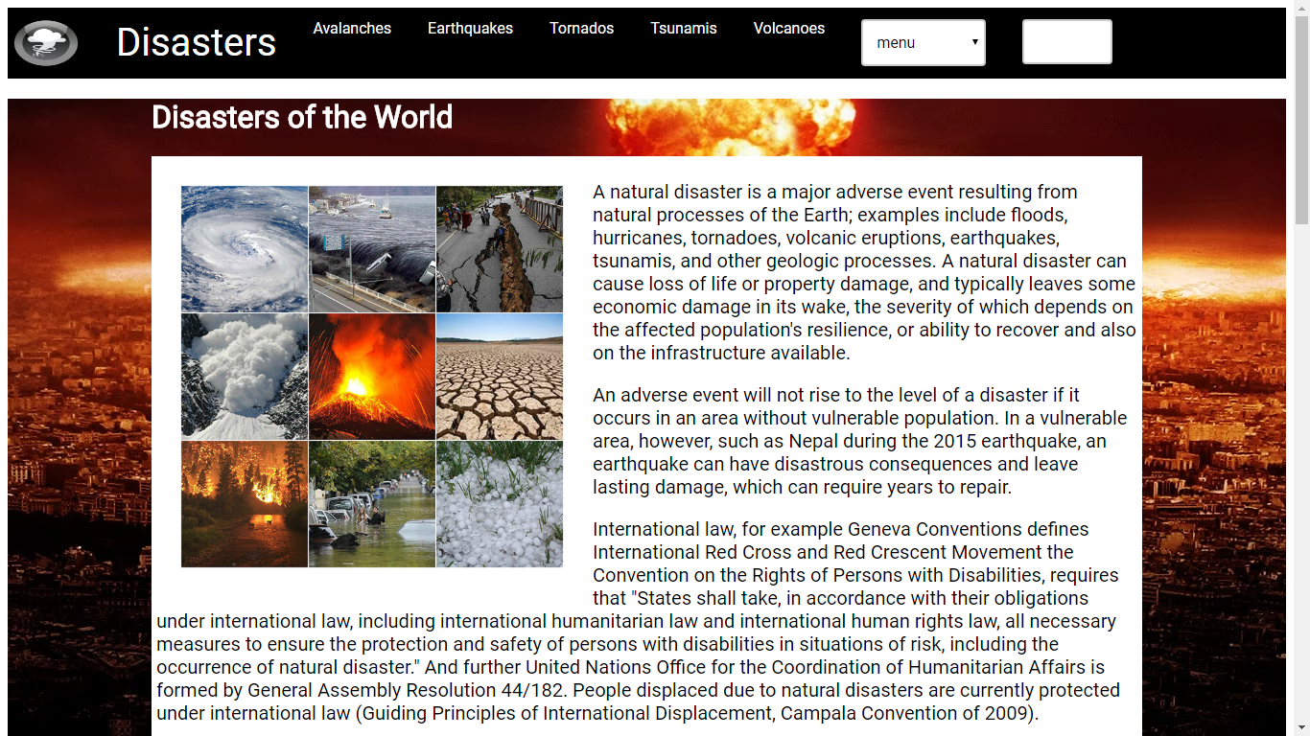

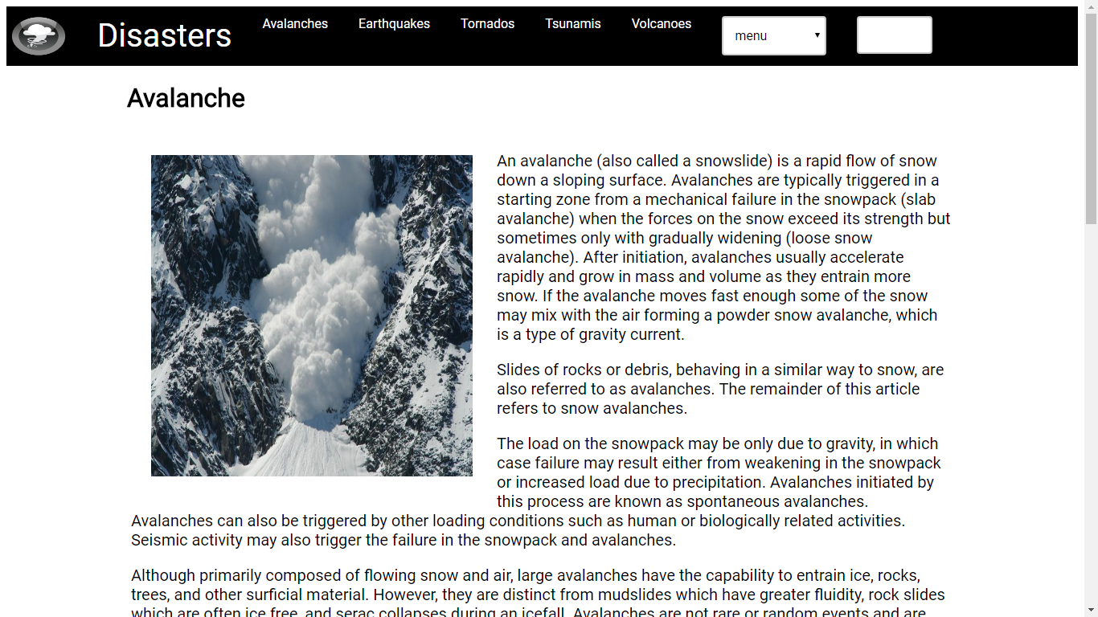

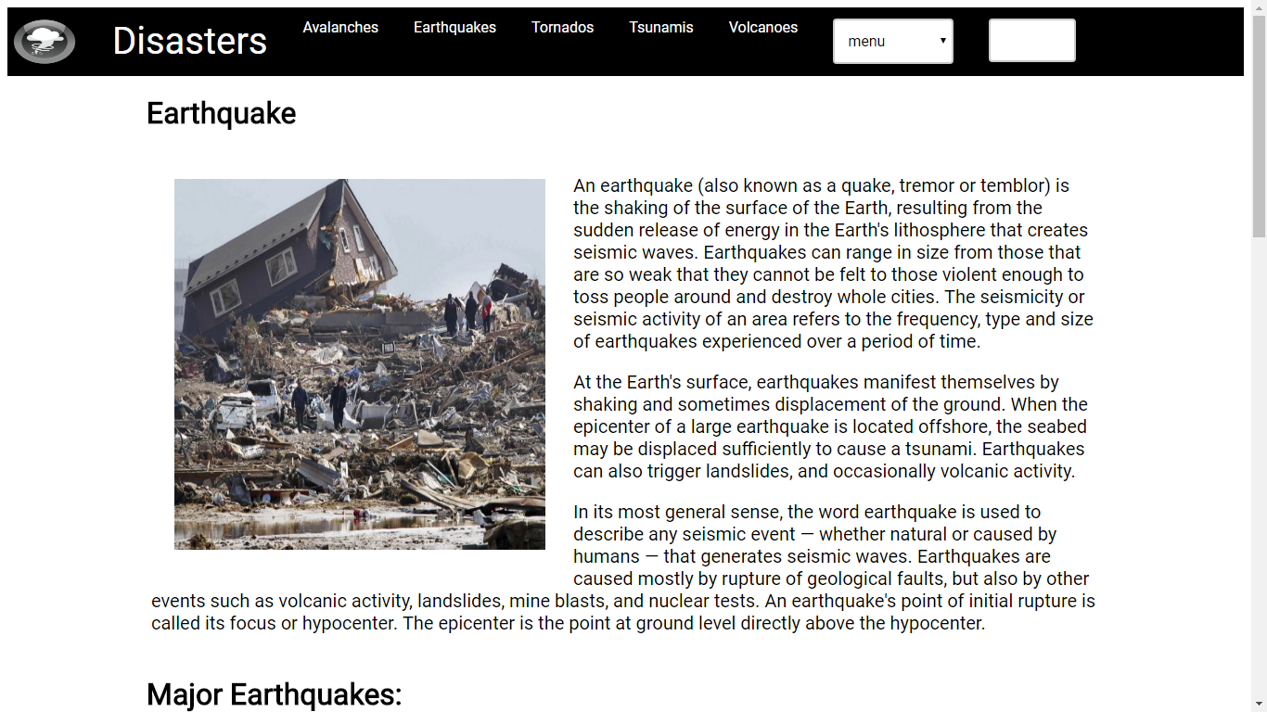

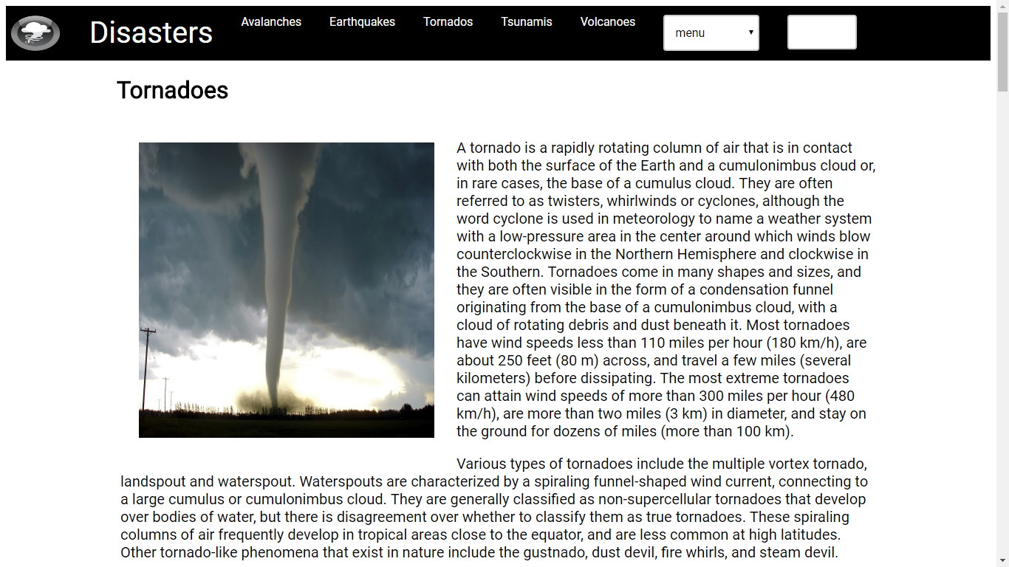

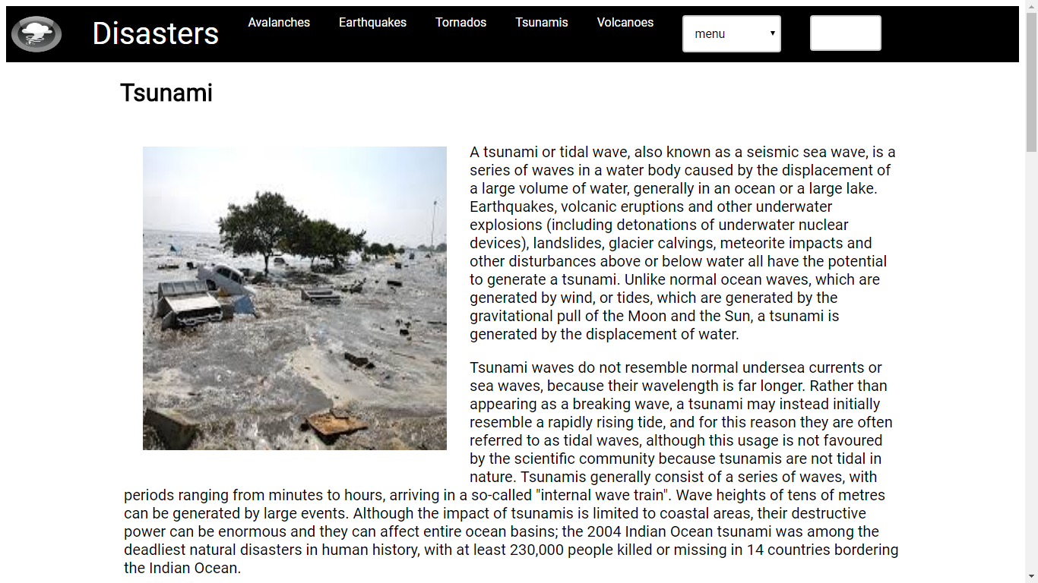 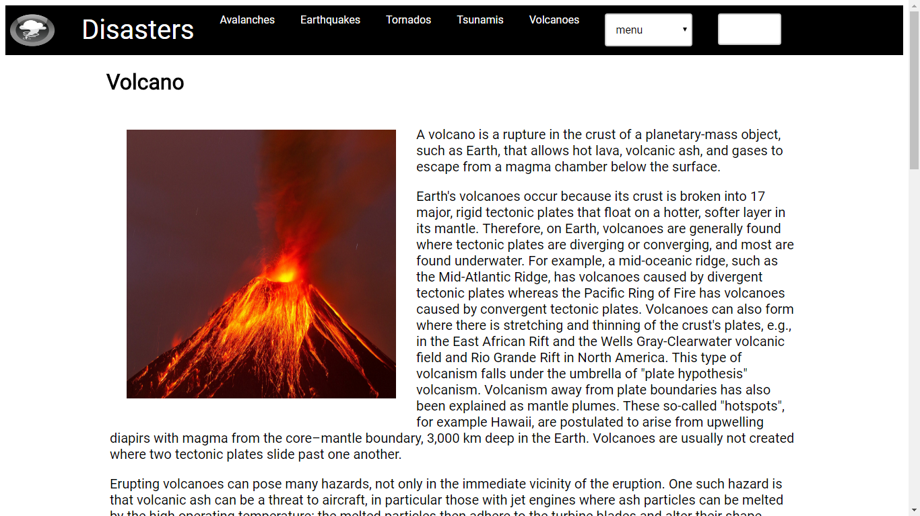

CONCLUSION:

The Static Website “Disaster” has been developed as per the requirement specification. It has been developed using XHTML & CSS compact, the complete system is thoroughly tested with the GUI Test Case which is prepared manually.