Sadra Madayeni Avval
810102564
CA3
FLIP-Flops
At first we want a Async D Latch
here is how we can implement it in Verilog
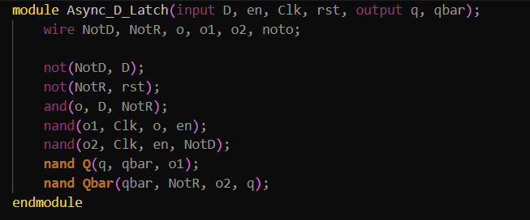

And We Have To Make A Master Slave Flip Flop With Giving The Clock = ~Clock To Master and
Just instance Two Times
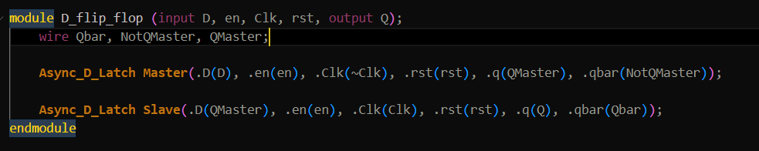

------------------------------------------------------------------------------------------------------------------------------------------
This Is How My D Latch Works
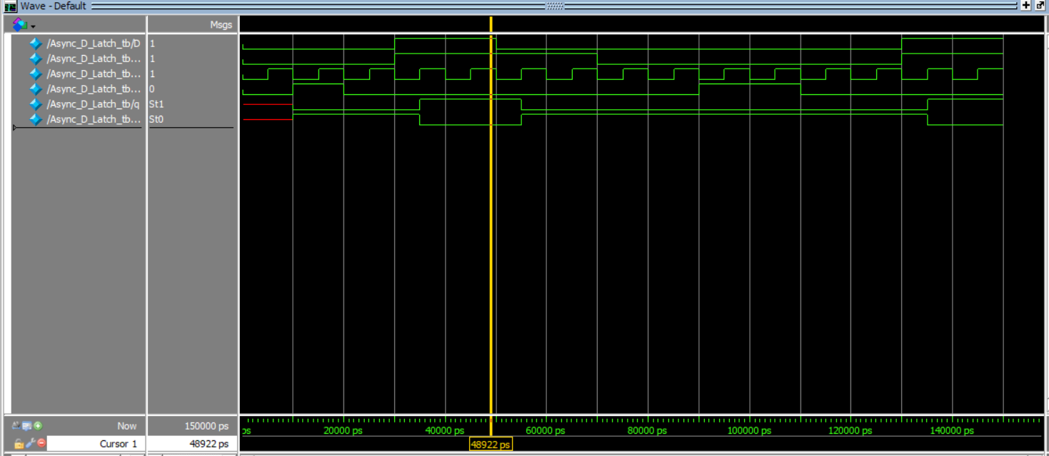
when clock and enable and D Is Active We Should Get Q = 1 and ~Q = 0
That Works Well
Here Is How A Flip Flop Works
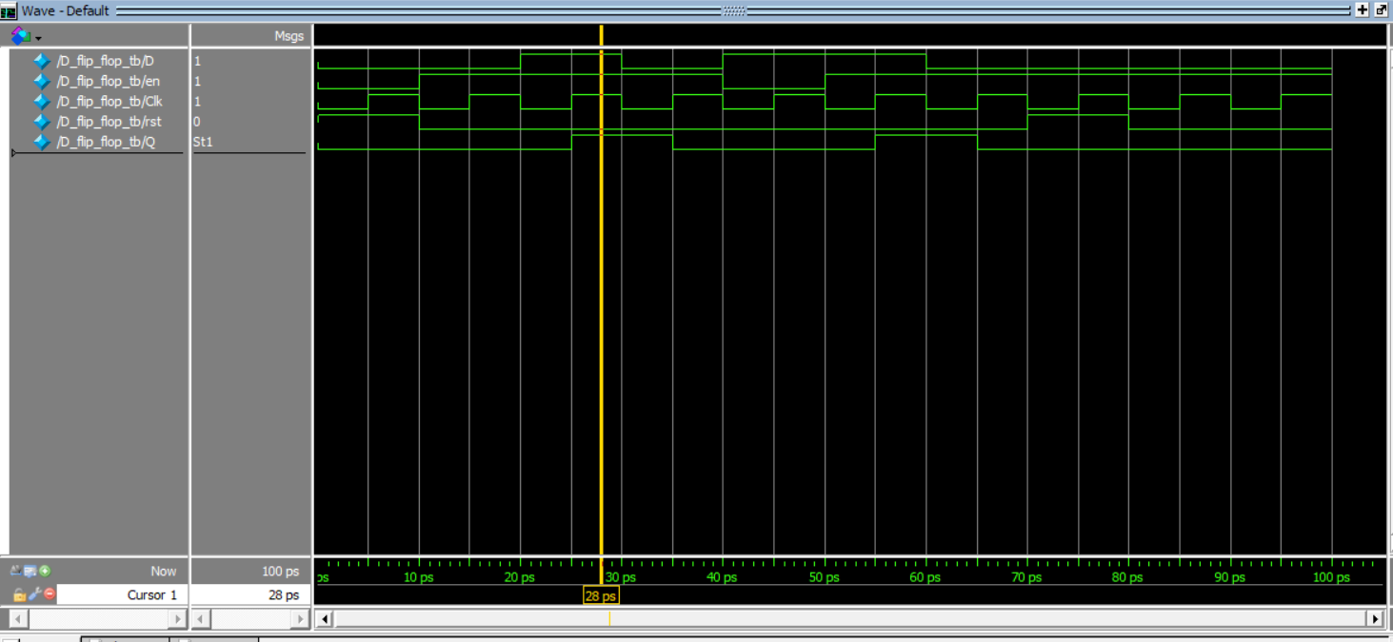
At First Our Reset Is 1 So is Q = 0
when D and En and Clk is 1 we Get Memory And That Works Aswell!

Next We Have To Implement Our Shift Register
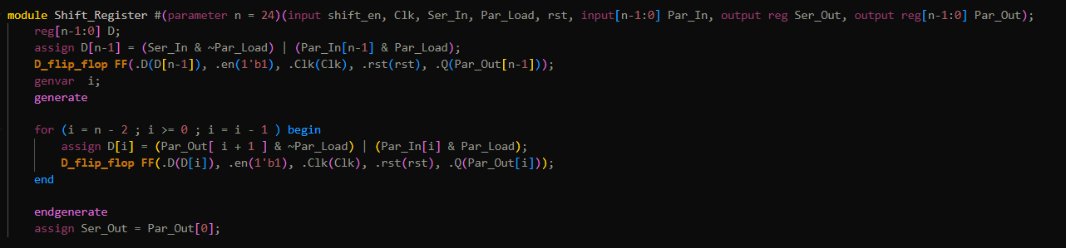
Here Is How It Works
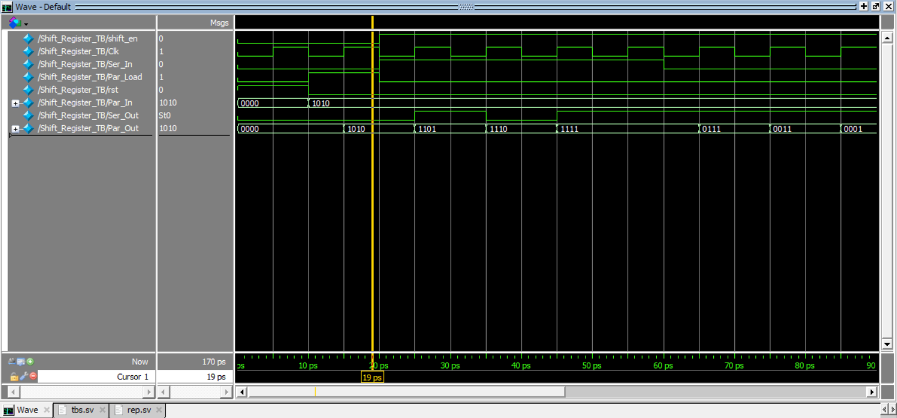
When I Load 1010 And I Active Clock It Appear and When Shifting It Shifts
------------------------------------------------------------------------------------------------------------------------------------------

For The LSFR

Here is my LFSR wave form with the seed as 123456789aaaaaaaaaaa
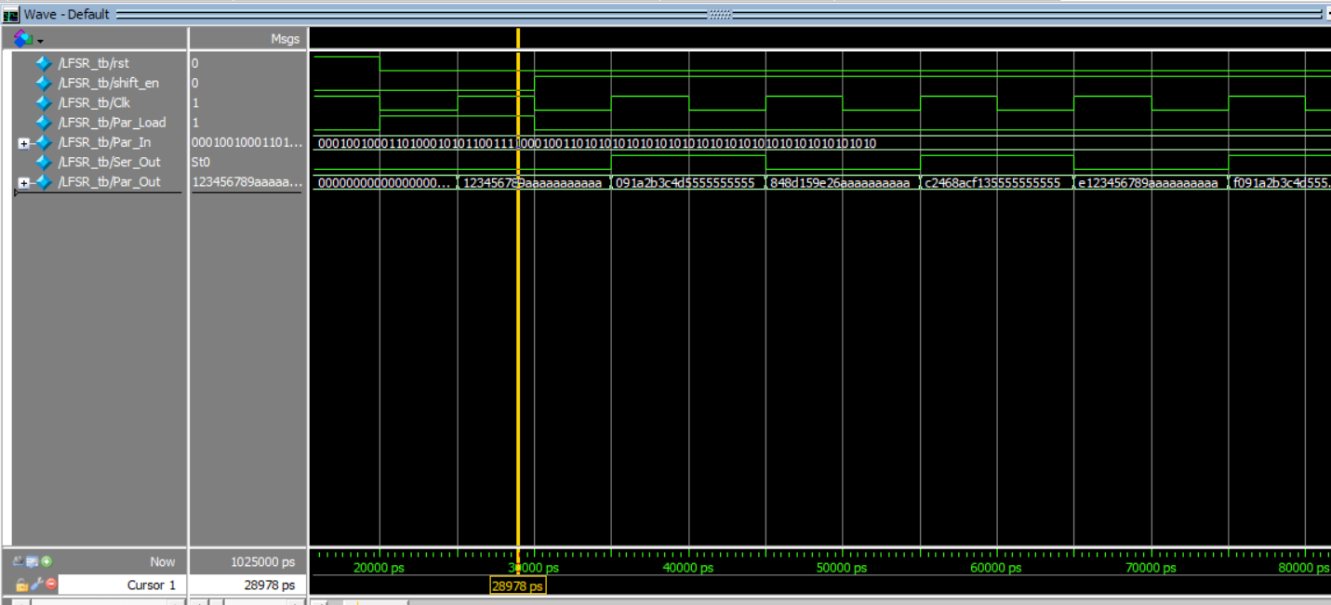

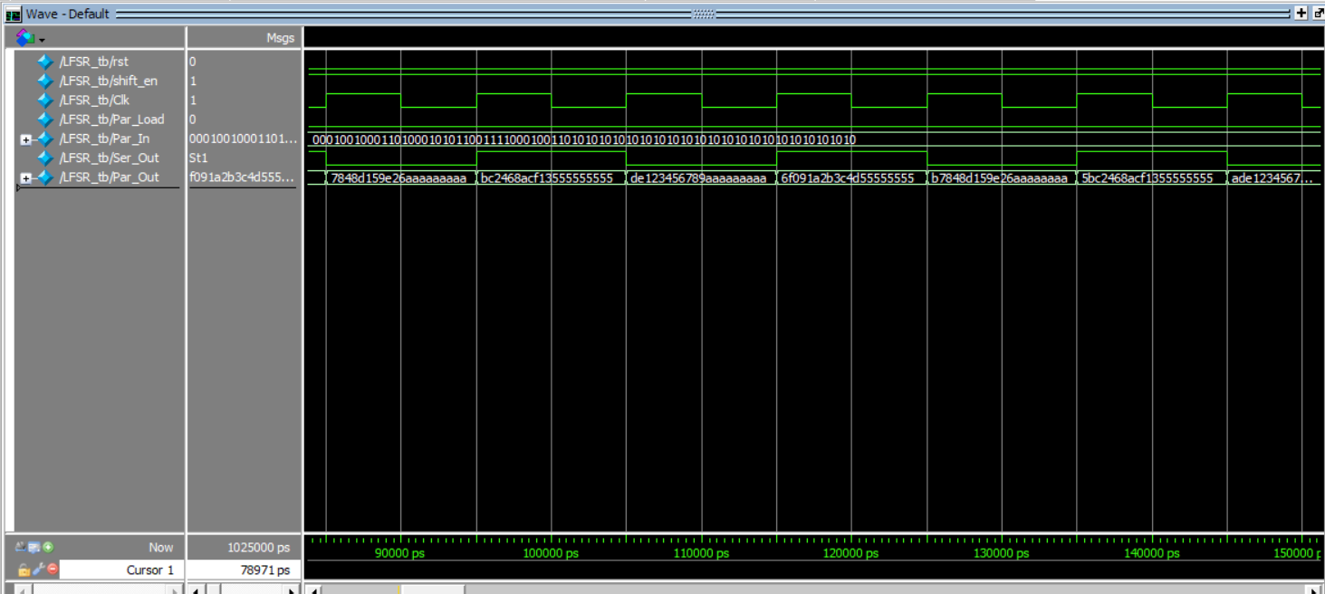

And here is my second test with the seed of 1234567890810102564a
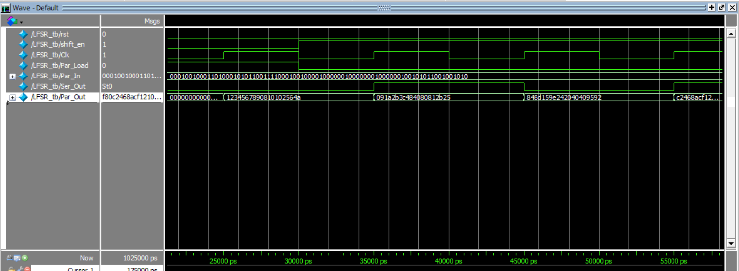

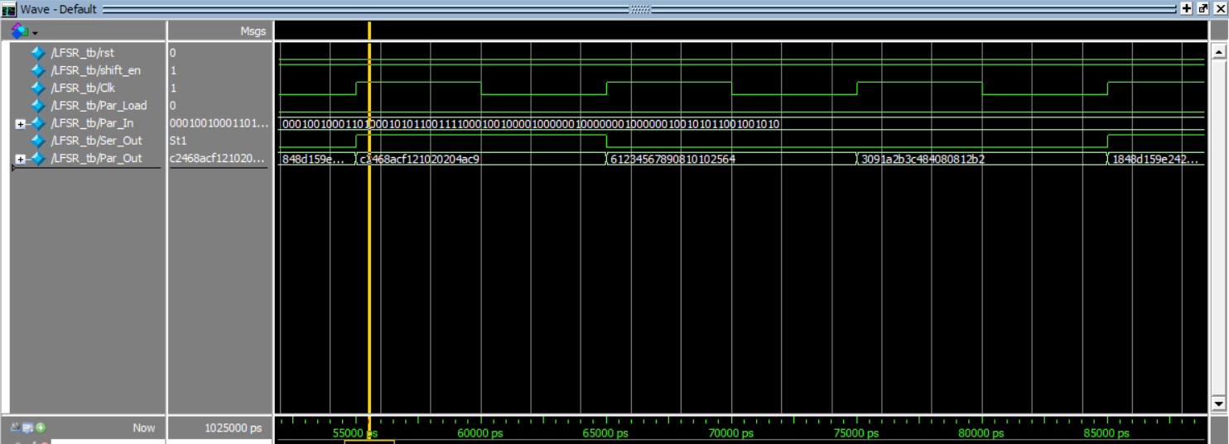

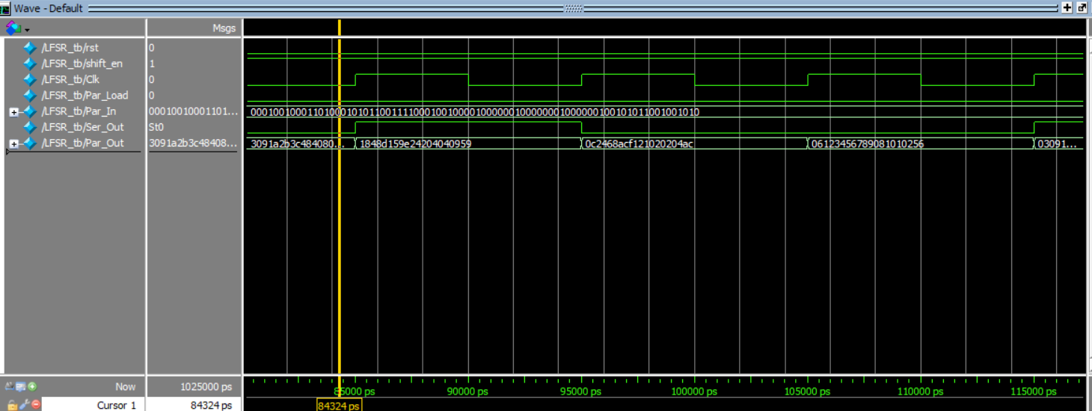

And here is my NFSR that the seed of it is 123abc
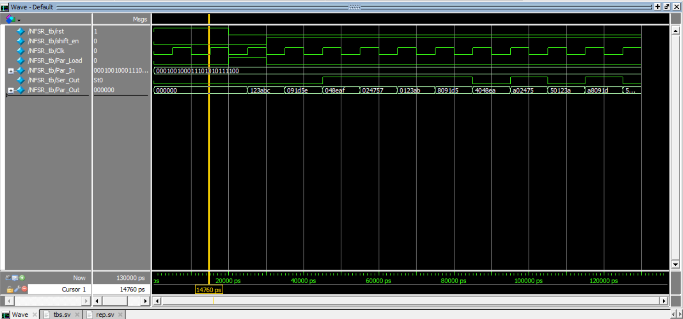

That with MAHAK Its correct!
And Here is the second seed for my NFSR that is 124abc
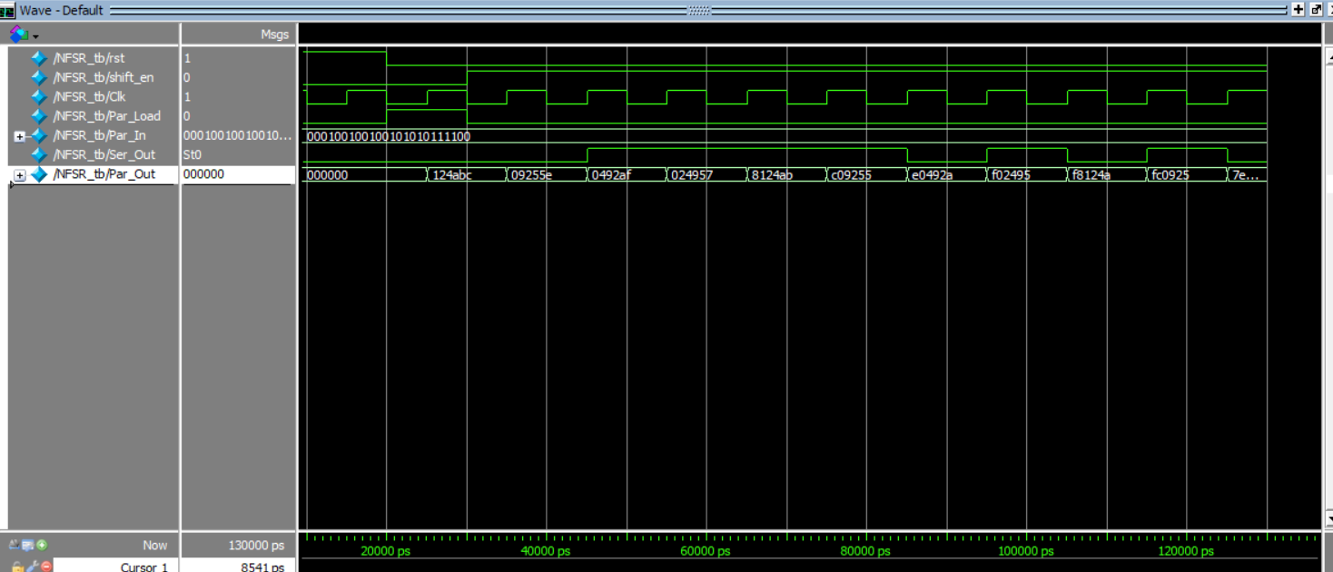
That works aswell

For Grain We need To Get Instance from our shift register and NFSR and also LFSR
We Give 80 Bits To LFSR and Then We Give Our NFSR the rest of the bits
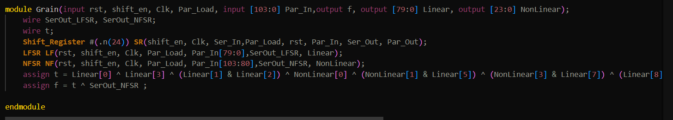

Here is How It Works With This Seed Of 123456aaaaaaaaaaaaaaaaaaaaa

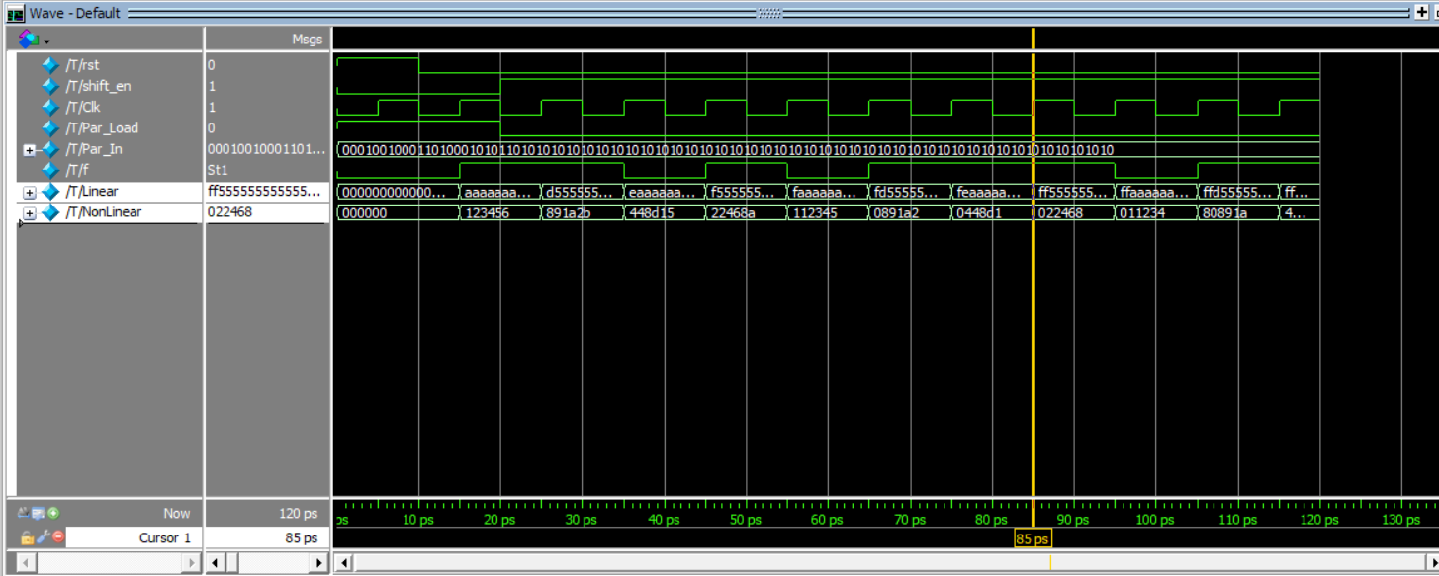
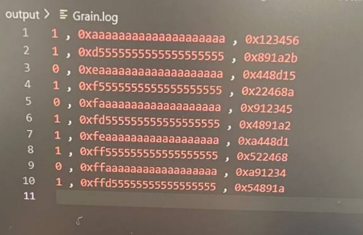
That According To Test Case Its Correct!

Here Is the gate level of My D Latch Async
