1/17/2020

Sadrul Akther Tipu

Student ID: 17124093

Modules Name:[**IS2S567_2019_v1: It Service Management And Ppe (2019/20)**](https://unilearn.southwales.ac.uk/webapps/blackboard/execute/launcher?type=Course&id=_152042_1&url=)

Lecturer: Paul Jarvis

BSc (Hons) Information Communication Technology

University of South Wales

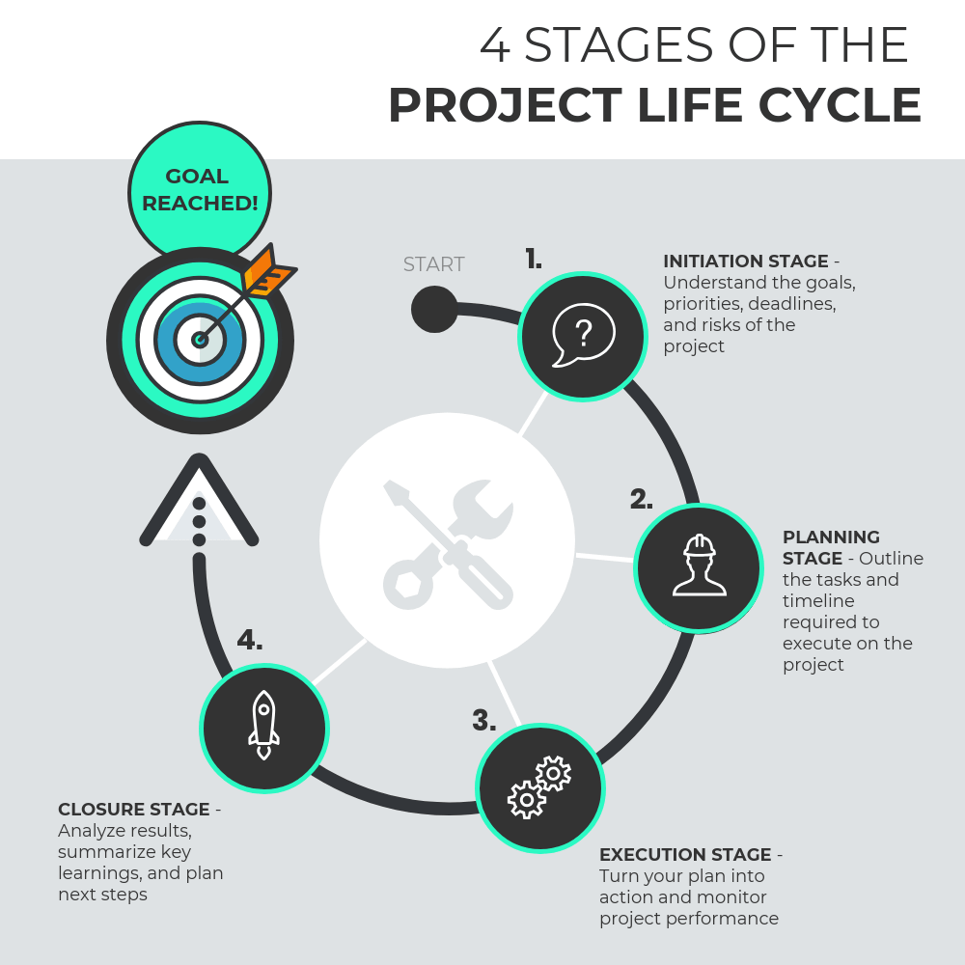

Table of Contents

What is the purpose of the Design lifecycle phase? 2

Do you think that we can get away with having the same person perform the role of Business Relationship Manager and Service Level Manager? They do the same thing, don’t they? 4

I know that it isn’t feasible for our Event Management team to track every event, but how are they meant to decide which events are important enough to track? 5

What is the difference between Release & Deployment Management and Service Validation & Testing, and would we need both the processes? 7

Bibliography 9

*Dear Ms Tracker,*

*Thank you for your email. You are correct that ITIL can bring benefits to an IT department, but also needs careful consideration when choosing how to apply it. To answer your four questions in turn:*

# What is the purpose of the Design lifecycle phase?

In a general view, the intention to perform anything for any greater interest is known as the project. A project can be anything like business project, science project, social welfare project, etc. From the beginning to the end on a particular project endure lots of situations to overcome, evaluate and develop and so on. If one thing isn’t good than other possible ways must be considered. After completing these challenges, the project result comes into the light. All these situations, in a nutshell, are known as the project life cycle.

The main purpose of a design phase is to have a complete plan of what is the main requirement of the project, how to do it, what are limitations that’s need to be face, hoe to overcome it, etc. To go for the development of the project, the project design should be such that it gets approved for the development and letting it become available to a customer. There are multiple number of processes to carry on a design phase which are identified below.

* Design coordination-

Service design ensures the detailing work as well as the complex part too. The only Better service provider can ensure proper service design coordination. The service design process has lots of purposes. Design coordination is responsible to ensure the objectives and goals so far also maintain the whole activities from a single point of service life (ITIL Service Design 2011 Edition (Best management practice), 2020).

Some objectives of design coordination are:

* Design Consistency for congenial services, technology, information processing, etc.
* Resources and capabilities are needed to be planned & coordinated to design or new service
* Service design, strategy, and transition are must be balanced with quality
* Improvement of service design efficiency
* Service catalogue management-

It is the process where promising care is required to achieve optimal benefit through the most efficient way. The purpose of catalogue management is to maintain information from a single source for all operational activities and ensures the availability of the authorized body.

Some objectives are:

* Entrusting information’s of service catalogue with accuracy, proper detailing, other defined policies, etc
* It should be accessible for the approved body for further effective application
* The catalogue should support all other management services
* Service level management-

This vital process of IT service provider is responsible for documentation of targets and responsibilities for SLA & SLRs. A proper decorated target will align the business requirement and achieve consumer satisfaction. If it is not then the problem will arise. It is more likely a warranty of service quality.

Some Objectives are:

* Checking the level of IT service
* Improving relation, satisfaction, expectation, quality among customer and business
* Ensuring proactive and cost-effective improvement
* Availability management

Availability is the term that directly puts the value of the business. Little doubt on promised availability will make the service not accessible.

Some Purposes are:

* Maintaining proper and new availability plan for reflecting current and future situation
* Appropriate guidance and advice need to provide in all related issues in both business and IT.
* Availability related problems must be diagnosed
* Change of availability plan for all services must be accessible.
* Capacity management

This phase extends the life cycle of the service. It is important as availability management. The service and performance must reach the promised capacity level, otherwise, the business will lose proper value.

Some objectives are:

* Producing and maintaining a proper and new capacity plan for current and future situation
* Appropriate guidance and advice need to provide in all related issues in both business and IT.
* Service performance achievement should meet the required targets
* Capacity related problems must be diagnosed
* Change of capacity plan for all services must be accessible.
* IT service continuity management (ITSCM)

It is part of the Warranty service. If service continuity isn’t restored or managed, the business will be experienced as valueless. The utility of the service won’t be accessible either.

Objectives are:

* Risk reduction
* Proper IT service continuity plans and preparations should be maintained
* Conduct risk management and BIA exercise for advanced impact
* Appropriate guidance and advice need to provide in all related issues in both business and IT.
* Information security management

This phase of IT Industry corporate governance framework and provides strategic direction for security activities and achieved objects. It is a critical part of the warranty service.

Objectives are:

* Authorized authority can access the confidential information
* Information should be recovered from failures and resisted from irrelevant attacks.
* Information should at trusted hands only
* Supplier management

This phase manages to ensure the desired business target. The aim is to raise business awareness and extract the maximum profit for the organization. Supplier management direction and plan are involved in every phase of the service life cycle. Partners and suppliers are parallelly responsible for IT service quality.

Objectives are:

* Ensuring Contracts, Suppliers, SLR & SLAs are aligned to business needs and supports
* Managing suppliers relation & performance through the life cycle
* Supporting Supplier and contract management information System

# Do you think that we can get away with having the same person perform the role of Business Relationship Manager and Service Level Manager? They do the same thing, don’t they?

**Business Relationship Manager**- *Business Relationship Manager* connects the IT department with all the other parts of the company. BRM provides all the technical advice that the company needs. It eliminates the gap between the business and the IT. BRM helps to increase the production by improving both the business and IT policy. BRM works and deal with the technological issues between all the departments of the business and develop new traits of technological progress that might be needed in future. BRM functions with the project leader to issue information about the company, tasks that are going on and its technological progress to the shareholders. On the general meeting that is held at every year the BRM helps with the financial leadership. In a company the BRM helps to expand the by working on the business policies (Techopedia.com, 2020).

**Service Level Manager-** service level manager controls and operates the complete Service level Management by working with the manager of other department and deals with the customers. A Service Level Manager has a lot of responsibilities. The Service Level Manager continuously maintain the Service Level Management system starting from Service Level Agreement structure, Operation Level Agreement structure with the suppliers of the service to the assisting of any remaining schemes. The Service Level Agreement is discussed, accepted and continued by the clients and monitored by the Service Level Manager. An Operation Level Agreement is done with the Service Distributor which again discussed and monitored by the Service Level Manager. Service Level Manager deals with the customers and service distributor about the Service Level Requirements of the newly generated service. The Service Level Manager Inspects and assess the Service Performance compared to the SLAs and OLAs (Visioline.ee, 2020). The service level manager analyse the unsettled assessment from the past, Service Levels and goals, supporting agreements and OLAs where required, go through the present actions, admits suitable procedures for continuous improvement of Service Levels, starts any actions that is needed for continuous improvement Service Levels with the IT consumer and the service distributor. The SRM confirms that the required changes are monitored to see the effect on the service level and carries out the responsibilities of Process Manager for the Service Level Management Process.

**Justification:**

From the above context it can clearly be stated that both the responsibilities cannot be served by same person. The main job of the **Business Relationship Manager** is to give IT support to the company and relates the IT department with all the other departments of the company whereas the **Service Level Manager** deals with the customers and the service distributors. The job of the **Business Relationship Manager** is more within the business, but the Service Level Manager works with people outside the company. The **BRM** deals with all the technological issues whereas the **SLM** deals more with the management related issues. Hence, it is not possible for the same person to play the role as a **BRM** and **SLM**.

# I know that it isn’t feasible for our Event Management team to track every event, but how are they meant to decide which events are important enough to track?

Event management is an organization who is responsible for organizing any sort of occasion. Occasions like a personal party, business conference, trade conference, etc. It is a booming industry and wroth of millions. This industry parallel enriches other small artistes like photography, dance/music artists, magic show, etc. every year many event management teams are joining in the industry. some are very big, some are midlevel and some in small scale.

An event can be best described as the alteration of the IT or CI service that has an important impact on the management. These events can be identified by the IT service, CI or monitoring tool alerts. An effective service operation depends on knowing about the framework and identifying the variation from the standard and desired operations which can be observed based on two types of tools.

* Active monitoring tools- polls keys Cis need to be activated to monitor and their status and availability. If any exemptions that must be communicated to the correct tool or action team shall be produced and alerted.
* Passive monitoring tools- this are tools that identifies and corresponds with operational alerts or communication produced by CI.

Events management is designed to plan events over their entire lives. The event management method co-ordinates this lifecycle of events for the detection, the awareness and the recognition of necessary monitoring actions. Event management is the function of event operating, monitoring and controlling. If operational information as well as warnings and exceptions are programmed to be communicated, events may serve as a basis to automate several routine operational management activities. For instance running scripts on a remote device or submitting work for processing or even balancing service demand dynamically across multiple devices to enhance performance. There are different types of events and the procedures are discussed below-

1. **Informational Event-**

* The Programmed assignment is finished.
* A user logs in to run a program
* An email is delivered to its designated receiver.

1. **Warning Event**

* Warning event dose not occurs usually but it does not mean that it never will take place.
* That’s why it needs a regular monitoring
* Where some incident will be resolve automatically by the aid of repeated programming.
* For instance, the programme will be resolve the current event then resorts by it self.
* These system can make operator wait for the interval period.

1. **Exception Events**

* When an incorrect password is given to log in by an user.
* If any circumstances occurs where and investigation is need to be done like during any unknown transaction.
* A device’s CPU is above the acceptable utilization rate ****
* Any illegal installation of software that is probed by the PC.

# What is the difference between Release & Deployment Management and Service Validation & Testing, and would we need both the processes?

**Release & Deployment Management** works with the development, processing and trying out new operating systems practically in the industry. It makes sure that the alterations that are made are implemented instantly with best price and limited chances of failure. It concerns about on time distribution of the produced service to the customers. Release and Deployment Management confirms that the service that the company is supposed to provide the customers serves the purpose in an updated manner after any alteration in the service. Release & Deployment Management verifies that the consumers are well known about the service provided by the company that will be an advantage to the company. It makes sure that the consumers and the employees are pleased with services provided by fulfilling the requirements and understanding what they need (Tutorialspoint.com, 2020).

**Service Validation & Testing** is trying out service that undergoes any kind of alteration or improvements to make sure that the change serves the purposes that it is made for, is efficient and supports IT operation. It also identifies the risk factor, the problems that occurs dues to the upgrading. These tests are monitored by Validation and Test Management to make sure they work best for what they were made for. Planning is done at the beginning of the production of the service. This planning includes everything starting for every single detail about the service, how to provide, where to provide, whom to provide, etc. Test plans are outlined and carried out which leads to reduced possibilities of failure of the service. A guideline and made for carrying out the test plan. The test plane is carried out in every possible way and the results are recorded. A comparison is done between the real-life results and the experimented one and improvements are done where it is needed (Itilnews.com, 2020).

**Justification**

According to the above explanation it can be concluded that **Release and Deployment Management** works with the service after the service is developed and produce whereas the **Service Validation and Testing** works with the testing of the service before the service is produced on a large scale, i.e., it is the trial version of the actual service to completely know about the service, how it works, the pros and cons of the service. Both the **Release & Deployment Management** and **Service Validation & Testing** is needed in a company because it is very important to have a trial version of the actual service, know about how it works, the advantages and disadvantages, whether the service meets the expectation of the customers and after the approval of the trial version to monitor the availability, demand of the service and price.

*I hope that you find these answers helpful and look forward to offering my support to your business over the coming months.*

*Kind regards,*

*Tipu.*

# Bibliography

* Itilnews.com. (2020). *An ITIL perspective - What is Service Validation and Testing : ITILNews.com*. [online] Available at: <https://www.itilnews.com/index.php?pagename=Service_Validation_and_Testing> [Accessed 17 Jan. 2020].
* Techopedia.com. (2020). *What is a Business Relationship Manager (BRM)? - Definition from Techopedia*. [online] Available at: <https://www.techopedia.com/definition/28017/business-relationship-manager-brm> [Accessed 17 Jan. 2020].
* Visioline.ee. (2020). *Role: Service Level Manager*. [online] Available at: <https://www.visioline.ee/itup/itup/roles/service_level_manager_C28D56BE.html> [Accessed 17 Jan. 2020].
* Tutorialspoint.com. (2020). *ITIL - Release & Deployment Management - Tutorialspoint*. [online] Available at: https://www.tutorialspoint.com/itil/release_and_deployment_management.htm [Accessed 17 Jan. 2020].
* ITIL Service Design 2011 Edition (Best management practice). (2020). 11th ed. The official publisher.