**MEASURING DIMENSIONS OF**

**A ROOM USING ESP32**

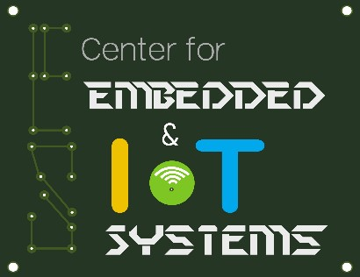

A project report submitted in partial fulfilment of requirement for the course

On

# Fundamentals of IoT

By

|  |  |
| --- | --- |
| **S. GOPI KRISHNA** | **(2003A52015)** |
| **S. SIDDHARTHA** | **(2003A52016)** |
| **V. SAIRAM** | **(2003A52020)** |
|  |  |
| **S. VIVEK** | **(2003A52076)** |
|  |  |

Under the guidance of

# Mr. Rajeshwarrao Arabelli

Asst. Prof. & Director, Centre for Embedded Systems and IoT

Department of Electronics and Communication Engineering



**MEASURING DIMENSIONS OF**

**A ROOM WITH ESP32**



A project report submitted in partial fulfilment of requirement for the course

On

# Internet of Things

By

|  |  |
| --- | --- |
| **S. GOPI KRISHNA** | **(2003A52015)** |
| **S. SIDDHARTHA** | **(2003A52016)** |
| **V. SAIRAM** | **(2003A52020)** |
| **S. VIVEK** | **(2003A52076)** |
|  |  |
|  |  |

Under the guidance of

# Dr. Sumit Gupta

Asst. Prof.(Department of ECE)

Department of Electronics and Communication Engineering



**Center for Embedded Systems and Internet of things**

**SR UNIVERSITY**

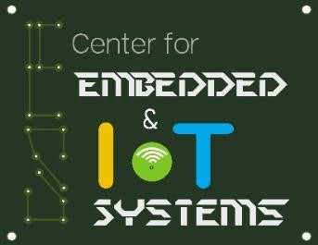

**CERTIFICATE**

This is to certify that the course project entitled **“**MEASURING DIMENSIONS OF A ROOM WITH ESP32**”** is the bonafied work carried out by GOPI KRISHNA (2003A52015), SIDDHARATHA (2003A52016), SAIRAM (2003A52020), VIVEK (2003A52076) in the partial fulfilment of the requirement for the award of course Internet of Things during the academic year 2022-2023 under our guidance and Supervision.

## Dr. Sumit Gupta

Asst. Prof.

Department of ECE

# ABSTRACT

we will connect two servo motors to the ultrasonic sensor and it will rotate in all directions and calculates the dimensions of the room.

Then esp32 connect to the wifi and wifi is connected to thingspeak then thingspeak will display dimensions.

# CONTENTS

**Chapter No. Title Page No.**

**1 Introduction 1**

**2 System Description 2**

**2.1 Block Diagram 3**

1. **Hardware & Software Tools 3-5**
2. **Implementation 4-6**
3. **Results 6- 7**
4. **Conclusion 7**
5. **References 8**

# 1. INTRODUCTION

In this we are going to measure the dimensions of a room with esp32 and we are going to display the output in thingspeak. The ultrasonic sensor which is connected to esp32 will calculate distances in all directions. We are using two servomotors to rotate the ultrasonic sensor in all directions.

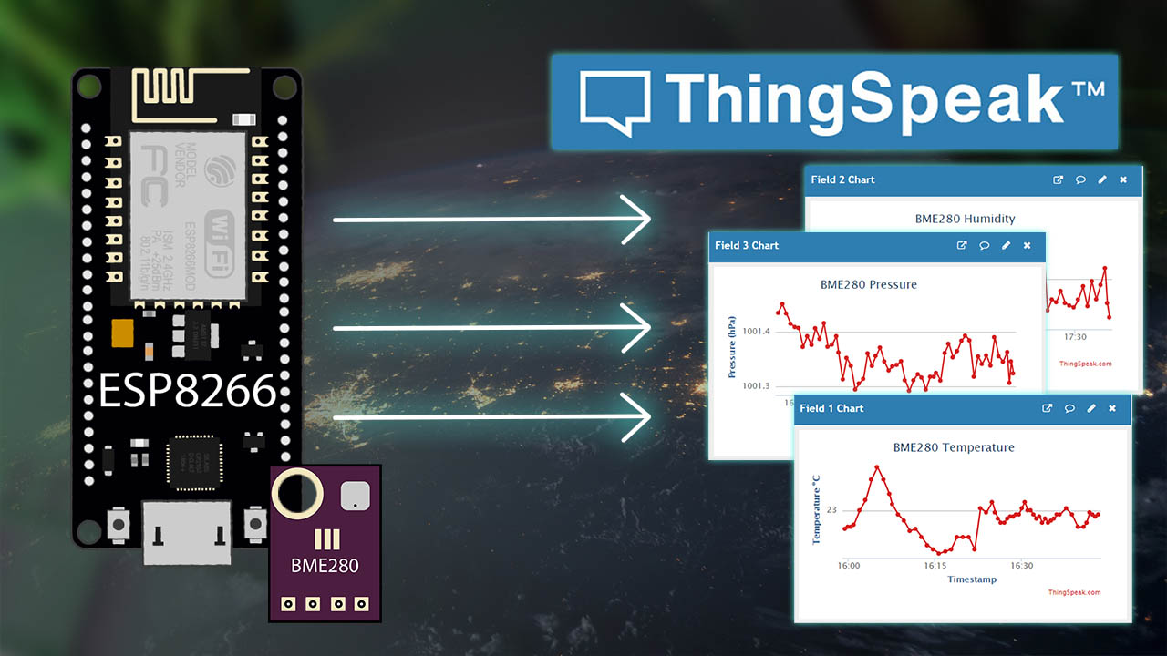

# 1. SYSTEM DESCRIPTION

**AURDINO COMPILER:**

The Arduino IDE is an open-source software, which is used to write and upload code to the Arduino boards. The IDE application is suitable for different operating systems such as **Windows, Mac OS X, and Linux**. It supports the programming languages C and C++. Arduino IDE is crossplatform, and it can run on operating systems from Microsoft, Linux, and Windows. It consists of a feature-rich code editor, compiler, programmer, serial console, serial plotter, and many other features. It is simple and easy to use.

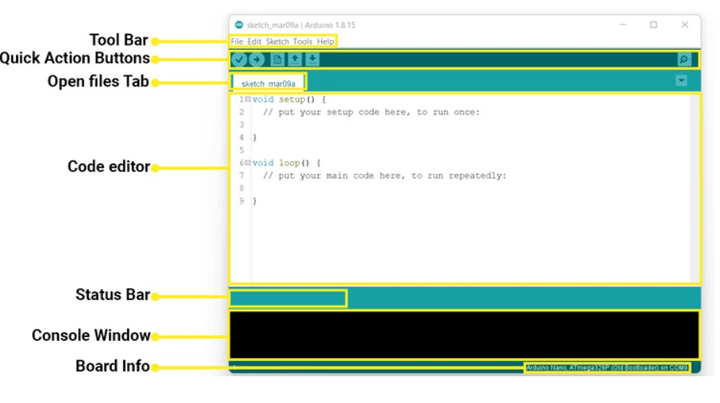

# BLOCK DIAGRAM :

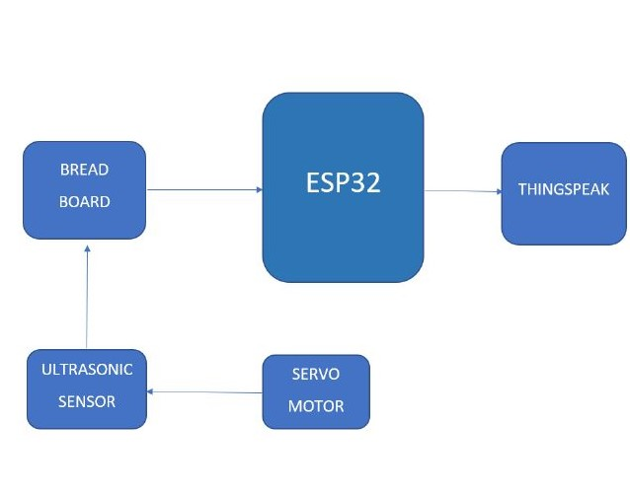

## 3. HARDWARE AND SOFTWARE TOOLS

**ESP32:**

* The ESP32 hosts a web server that shows the latest temperature readings from a DS18B20 temperature sensor.
* There is an input field to set up a threshold. When the temperature goes above or below the threshold value, you will receive an email.
* You can also set up the recipient’s email address on the web page.

**BREADBOARD:**

A breadboard is a solderless device for temporary prototype with electronics and test circuit designs. Most electronic components in electronic circuits can be interconnected by inserting their leads or terminals into the holes and then making connections through wires where appropriate.

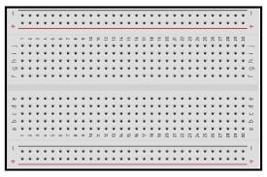

**ULTRASONIC SENSOR:**

An ultrasonic sensor is an electronic device that measures the distance of a target object by emitting ultrasonic sound waves, and converts the reflected sound into an electrical signal.

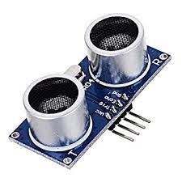

**SERVO MOTOR:**

A **servo motor** is a type of motor that can rotate with great precision. Normally this type of motor consists of a control circuit that provides feedback on the current position of the motor shaft, this feedback allows the servo motors to rotate with great precision.

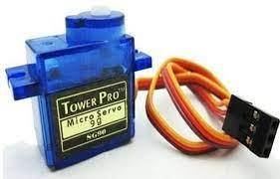

## IMPLEMENTATION

### 1) Installing the required libraries and programming part

We will use the ESP32 Mail Client library to Send the Emails, and ESP Async Web Server, Async TCP libraries to build an asynchronous web server. We will program the ESP32 using Arduino IDE.

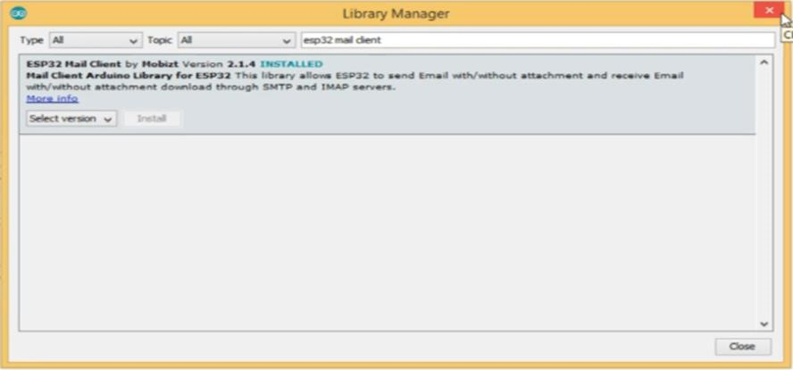

### 2) Circuit diagram and connections on breadboard

Connect the circuit, as shown below. connected 5, GND, and VIN of ESP32 with VCC, GND, and Data pins of the sensor, respectively. Connect the micro USB cable with ESP32 and Connect another end of the cable to your PC.

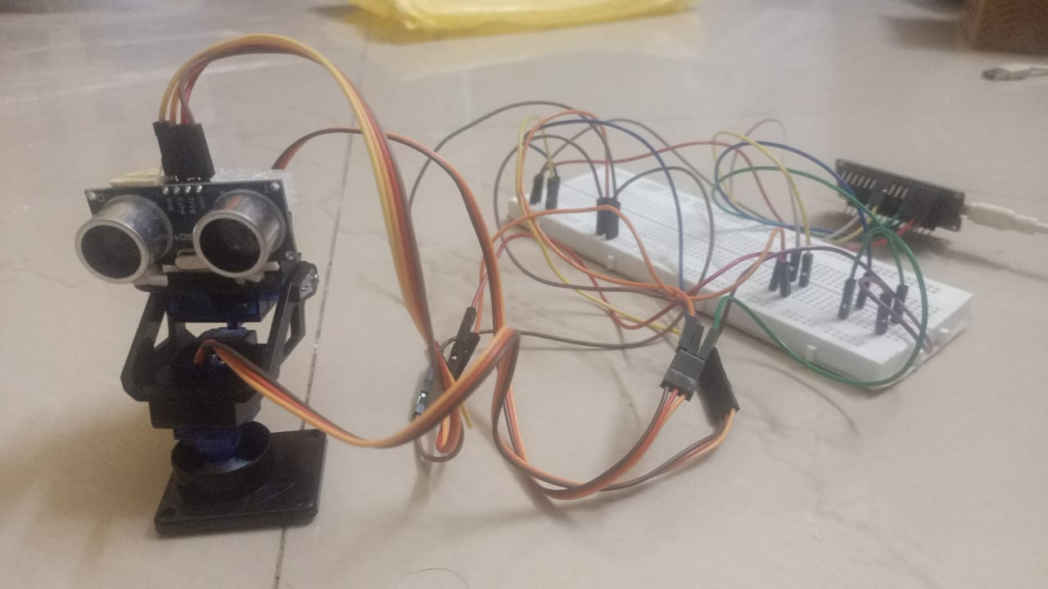

### 3) Testing and debugging

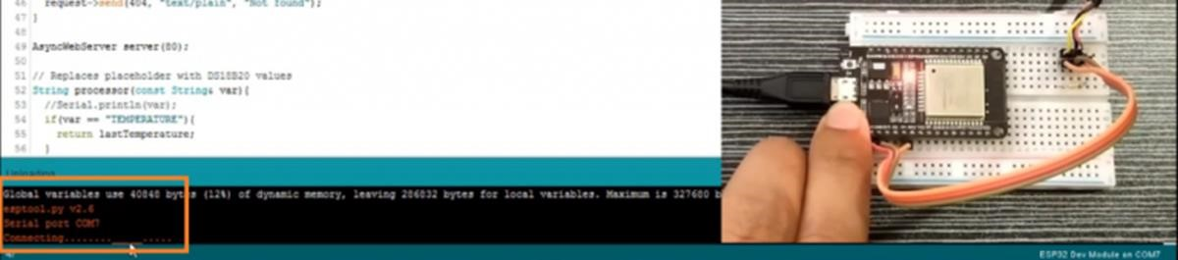

once the uploading is done, open the serial monitor. make sure baud rate of the serial monitor 115200 and click the reset button.

Here you can find the ESP Ip address to access the webserver we receive length, width, height of a room using Ultrasonic sensor. And we can calcualate area of a room.

4).Creating thingspeak account

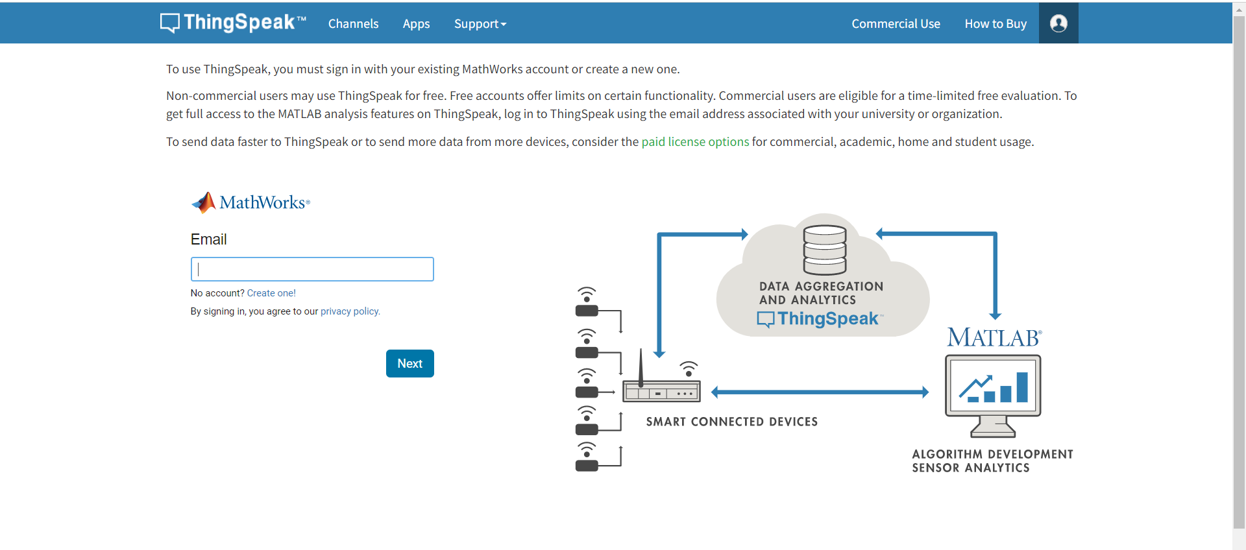

Once ultrasonic sensor measure distance ,now we can calculate area of room.

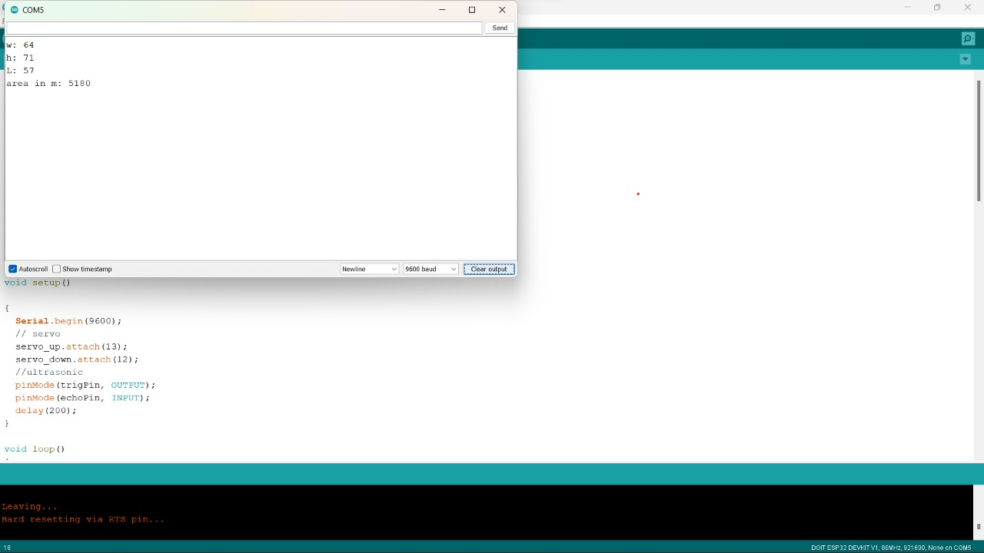

## RESULT

By using servomotor we can rotate ultrasonic sensor in all directions

To measure height, breadth, length of a room. So that by applying area formula we get area of a room.

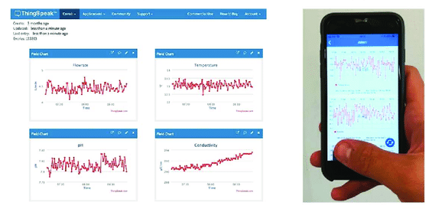

## CONCLUSION

Likewise, we can receive dimensions of a room without using any physical work. We receive information wirelessly.

Moreover we can’t go to every place so by placing this device in a drone it will measure the dimensions and send information to us by using wifi.

## REFERENCES

1. <https://youtu.be/Kn8_JAvAJsY>
2. <https://youtu.be/bN3JPxvIMsk>
3. <https://youtu.be/_WqfNyE_pt8>
4. <https://youtu.be/6bvkTyNRSjI>
5. <https://youtu.be/cgFVEk7z46U>