**How to run application**  
Prerequisite:

Docker should be in running.  
Please end the process for below ports if below ports are busy before start the application.  
**used ports**

user-service: 8090

Journal-service: 8091

SQL: 3037

Zookeeper: 2181

Kafka: 9092

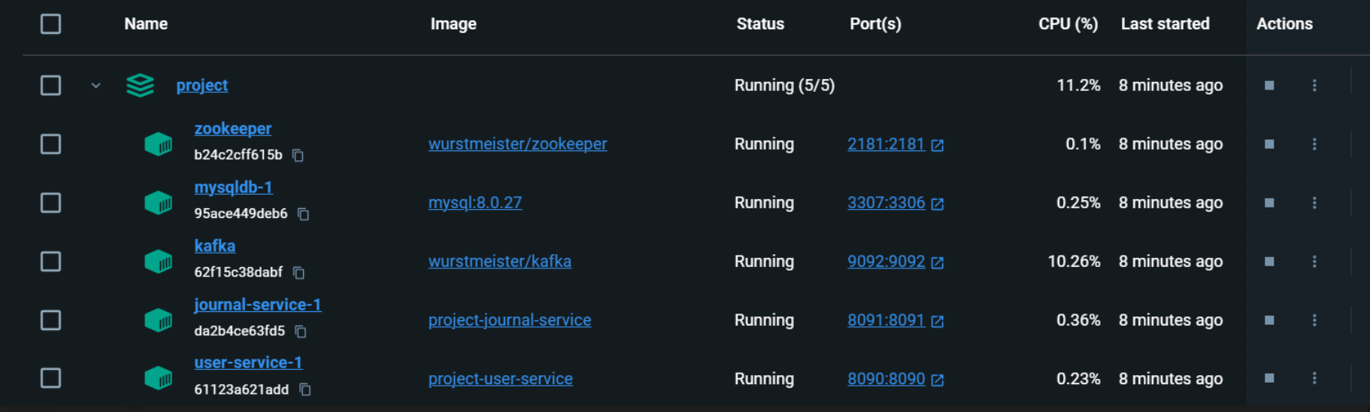

Steps to run application.

Step1) Clone the following git repo

GitHub link :- <https://github.com/Sadvik-gowda-BD/java-assignment-apica>

Step2) After clone we can see below folder.

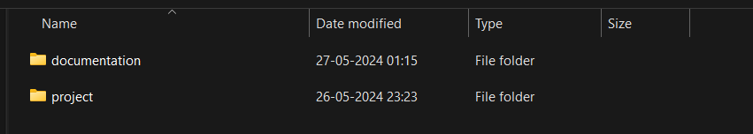

Documentation: contains postman collection, API details and others.

Project: contains docker files and executable jar files to run the application.

Step3) Open project folder, it contains all project files.

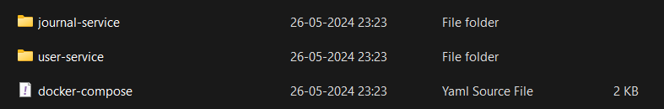

Step4) open cmd/terminal from above path.  
~\java-assignment-apica\project>

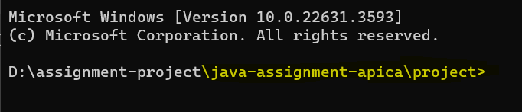

Step5) Run **docker-compose up** command like below.

\java-assignment-apica\project>docker-compose up



Step6) All services will be up and running, and API can be test via postman.

Please import postman collection which is available on

\java-assignment-apica\documentation\sadvik-java-assignment.postman_collection path.

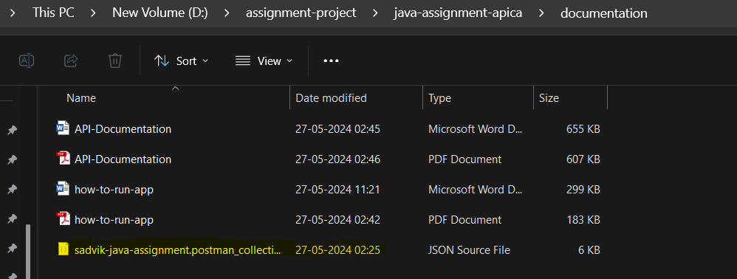

Contact number:

Please call to following mobile number for any doubts: +91 9741471445

Email-id: sadvikgowda3333@gmail.com