INDEX.HTML

What Is Black Pink?

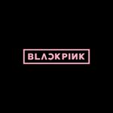

**Black Pink** ([Hangul](https://en.wikipedia.org/wiki/Hangul): 블랙핑크), stylized as **BLACKPINK** or **BLΛƆKPIИK**, is a South Korean [girl group](https://en.wikipedia.org/wiki/Girl_group" \o "Girl group) formed by [YG Entertainment](https://en.wikipedia.org/wiki/YG_Entertainment" \o "YG Entertainment), consisting of members Jisoo, Jennie, Rosé, and Lisa.

The group officially debuted on August 8, 2016, with their single *Square One*, which spawned their first number-one hit, "[Whistle](https://en.wikipedia.org/wiki/Whistle_(Black_Pink_song)" \o "Whistle (Black Pink song))." The single also included "[Boombayah](https://en.wikipedia.org/wiki/Boombayah" \o "Boombayah)," their first number-one hit on *[Billboard](https://en.wikipedia.org/wiki/Billboard_(magazine)" \o "Billboard (magazine))* [World Digital Songs](https://en.wikipedia.org/wiki/World_Digital_Songs) chart, which set the record as the most-viewed debut music video by a Korean act. With the group's commercial success in their first five months, they were hailed as the New Artist of the Year at the 31st [Golden Disc Awards](https://en.wikipedia.org/wiki/Golden_Disc_Awards" \o "Golden Disc Awards) and the 26th [Seoul Music Awards](https://en.wikipedia.org/wiki/Seoul_Music_Awards" \o "Seoul Music Awards).

Black Pink is the highest-charting female K-pop act on *Billboard* [Social 50](https://en.wikipedia.org/wiki/Social_50), peaking at no. 15. They are also the first K-pop act to be on [YouTube](https://en.wikipedia.org/wiki/YouTube" \o "YouTube)'s Global Top 25 Summer Songs, with their 2017 hit "[As If It's Your Last](https://en.wikipedia.org/wiki/As_If_It%27s_Your_Last" \o "As If It's Your Last)." They are also the first female K-pop act to have three number-one hits on *Billboard'*s World Digital Song Sales chart.



|  |  |
| --- | --- |
| **Background information** | |
| **Origin** | [Seoul](https://en.wikipedia.org/wiki/Seoul), [South Korea](https://en.wikipedia.org/wiki/South_Korea) |
| **Genres** | [K-pop](https://en.wikipedia.org/wiki/K-pop) |
| **Years active** | 2016–present |
| **Labels** | * [YG Entertainment](https://en.wikipedia.org/wiki/YG_Entertainment) * [Avex](https://en.wikipedia.org/wiki/Avex_Trax) |
| **Associated acts** | [YG Family](https://en.wikipedia.org/wiki/YG_Family) |
| **Website** | [blackpinkofficial](http://blackpinkofficial.com/) |

"[Whistle](https://en.wikipedia.org/wiki/Whistle_(Black_Pink_song))."

[video: black_pink/whistle_video.mp4 ]

Can you fill this form,please ).

|  |  |
| --- | --- |
| Email | Url Field |
| Lisa is the coolest? | Checkbox |
| Site rating | Radio Button (1-5) |
| Comment | Textarea |
|  | Submit, Reset Button |

LISA.HTML

Lisa

**Lisa**(리사) is a Thai singer. She is a member of the girl group [BLACKPINK](http://kpop.wikia.com/wiki/BLACKPINK" \o "BLACKPINK). She is the main dancer, sub-vocalist, maknae and lead rapper of the group.

**Pre-debut**

Since she began dancing at a young age, Lisa was part of a Thai dance crew called "We Zaa Cool" which included [BamBam](http://kpop.wikia.com/wiki/BamBam" \o "BamBam) of [GOT7](http://kpop.wikia.com/wiki/GOT7). She was introduced as a trainee under YG Entertainment with the release of a dance practice video on their official Youtube channel in 2012. She also made an appearance in the music video for "Ringa Linga" by [Taeyang](http://kpop.wikia.com/wiki/Taeyang" \o "Taeyang) in 2013, though unidentifiable.

**Facts:**

* Lisa is referred to as the "Thailand Princess" in her birthplace.
* Lisa is YG's first non-Korean artist.
* Her Zodiac Sign is Aries.
* Her Chinese Zodiac Sign is Ox.
* Lisa was the only person accepted into YG during the YG audition in Thailand in 2010.
* She was the 2nd member to be revealed.
* She appeared with YG Entertainment stars in the ad for the fashion brand NONAGON.
* She is expected to be a role worldwide because she speaks Korean and English.
* She has practiced at YG for about 5 years in YG, she has a talent for dancing.
* Lisa is fluent in Thai, Korean, Japanese and English.
* Nicknames: Lalice, Laliz, Pokpak, Flying Lisa, RyeoLisa, Kkogi (elephant) Lisa.
* Her favorite food is Gamjatang (spicy pork spine soup) and French Fries.
* She's childhood friends with Got7's BamBam.

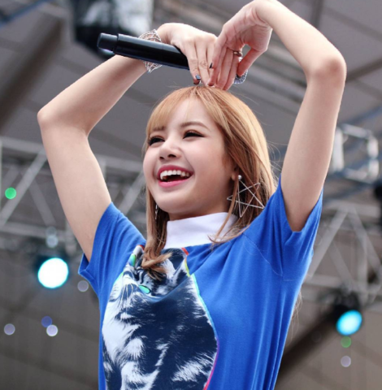

[video: black_pink/lisa_video.mp4 ]

ROSE.HTML

**Rosé**

**Rosé**(로제) is a Korean-Australian singer and dancer. She is a member of the girl group [BLACKPINK](http://kpop.wikia.com/wiki/BLACKPINK" \o "BLACKPINK).

### Early life

Rosé revealed that she was born in Auckland, New Zealand, but was raised in Melbourne and Box Hill, Australia. Her father believed in her talent and flew her to another area just to audition for YG. She ended up winning first place.

**Facts:**

* Rosé placed first at [YG](http://kpop.wikia.com/wiki/YG_Entertainment" \o "YG Entertainment) auditions in Australia and joined the agency in 2012.
* She graduated from Canterbury Girls Secondary College in Melbourne, Australia.
* Her Zodiac Sign is Aquarius.
* Her Chinese Zodiac Sign is Ox.
* She can speak Korean, English and Japanese.
* Her favorite food is Kimchi Jjigae (stew).
* She doesn't like jokbal.
* Her hobbies are drawing, riding a bicycle and playing the guitar.
* Nicknames: Rose, Rosie, Pasta.
* She is left-handed and can rotate her arm 360 degrees.
* Her ideal type, as she herself quoted, is 'a handsome guy with a good voice who can play the guitar'.
* She covered many English songs, such as "Livin' La Vida Loca" , "Shape of You" , "Cry", and "Versace on the Floor".
* She has an older sister, named Alice.
* She was the last member to be revealed.

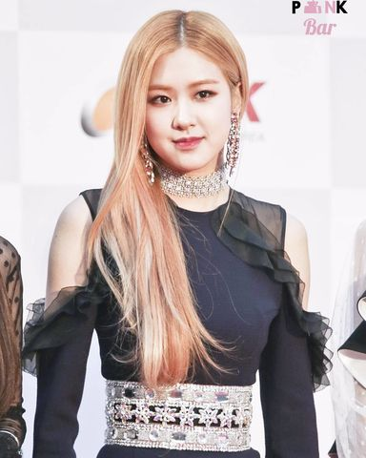

[video: black_pink/rose_video.mp4 ]

JENNIE.HTML

**Jennie**

**Jennie**(제니) is a South Korean singer. She is a member of the girl group [BLACKPINK](http://kpop.wikia.com/wiki/BLACKPINK" \o "BLACKPINK), and is known as the unofficial 'leader', Main Rapper, and the YG Princess or YG's Ace/Lucky Charm.

She was born in the Netherlands in 1996. Jennie grew up in Auckland, New Zealand until returning in high school.

**Facts:**

* Jennie learned Spanish in New Zealand, but is not very fluent in it.
* Her Zodiac Sign is Capricorn.
* Her Chinese Zodiac Sign is Pig.
* She's the first member to be revealed publicly.
* Her favorite food is milk flavored ice cream.
* Nicknames: Jendeuk, Jendeukie, Jen, Nini, JenJen, Human Gucci, Jerry.
* She went to the college "ACG Parnell College".
* She is known as the YG Princess of the group.
* She is described as being jolly and cheerful.
* She is fluent in Korean, Japanese, and English.
* She has two dogs called Kai and Kuma, which are featured in [BLACKPINK's](http://kpop.wikia.com/wiki/BLACKPINK" \o "BLACKPINK) V-Live broadcasts.
* During variety and game shows, she appears to be shy and modest.
* Jennie is called "The Lucky Member", because she always wins games.
* She prefers a sexy man over a cute one.
* Her favorite colors are black, white and pink.
* Jennie has mentioned that her mom wants her to be a lawyer or a teacher.

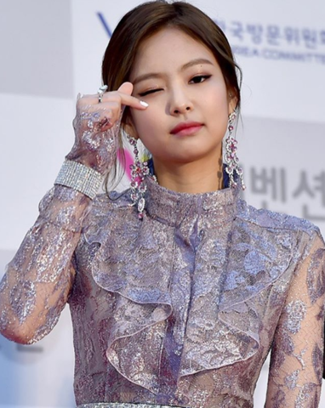

[video: black_pink/jennie_video.mp4 ]

JISOO.HTML

**Jisoo**

**Jisoo**(지수) is a South Korean singer. She is a member of the girl group [BLACKPINK](http://kpop.wikia.com/wiki/BLACKPINK). She is also the visual of the group.

**Facts:**

* She joined YG Entertainment as a trainee in July 2011.
* Nickames: Chichyu, Jichu
* Her Zodiac Sign is Capricorn.
* Her Chinese Zodiac Sign is Dog.
* She has a 4D personality.
* Her favorite color is purple.
* Her favorite food is rice.
* Foods such as pork skin, bones, and intestines do not appeal to her.
* She has an older brother and older sister.
* She has a bubbly personality.
* She lives in the fourth dimension.
* She has a dog named Dalgom.
* She plays with water bottles when she's bored; especially at concerts and ceremonies.
* She is fluent in Korean, and is conversational in Japanese and English.
* She is an MC on the music show SBS Inkigayo.
* She was the 3rd member to be revealed.
* She really likes Pikachu.
* She has a white belt in Taekwondo.



[video: black_pink/jisoo_video.mp4 ]