Project Sprint #1

The Solitaire game is described in CS449HomeworkOverview. You should read the description very carefully.

In this assignment, you aim to specify the requirements (i.e., user stories and acceptance criteria) of the target software that allows a human player to play a Solitaire game. These requirements will be fully implemented by the end of sprint 3. The minimum features include choosing the board size and type, starting a new game, making a move, determining if a game is over. The following is a sample GUI layout.

Board size
7
Board Type  - English  - Hexagon  - Diamond | 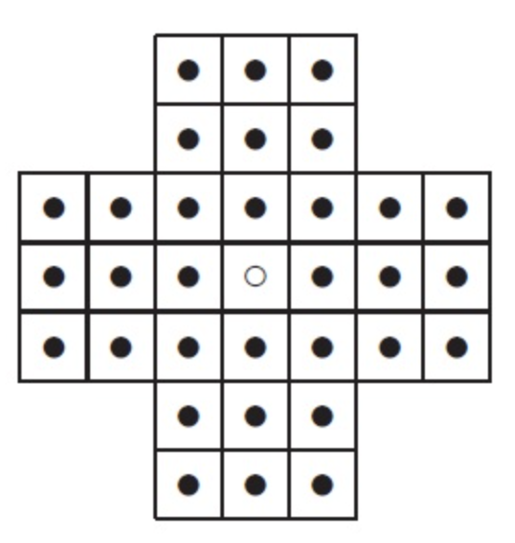 | New Game
Figure 1. Sample GUI layout of the first working program by the end of Sprint 3

Use the following tables to document your user stories and acceptance criteria.

You are required to use the free ChatGPT or another LLM to complete two user stories and two of their respective acceptance criteria. You must ensure that the generated user stories are correct and fix them if not. At the end of the submission, provide screenshots of your LLM prompts and answers, along with the description of errors the LLM made that you had to correct. Points will be deducted if no screenshots/description are provided.

For the other user stories and acceptance criteria, you are not required to use LLM.

- User Stories (3 points)

- User Story Template: As a <role>, I want <goal> [so that <benefit>]

ID | User Story Name | User Story Description | Priority | Estimated effort (hours)
1 | Choose a board size | As a player, I want to choose my own board size so I can play on my preferred board size. | High | 2
2 | Choose the board type | As a player, I want to choose an English board, Hexagon board, French board, or a triangular board so that I can play my preferred layout. | Medium | 2
3 | Start a new game of the chosen board size and type | As a player, I want to start a new game with the type of board I prefer, so that I can play on my preferred layout and size. | High | 3
4 | Make a move in a game | As a player, I want to move a peg by jumping over an adjacent peg into an empty hole so that I can remove the jumped peg and work toward leaving only one peg on the board. Well written; I don't see anything wrong with this user story. 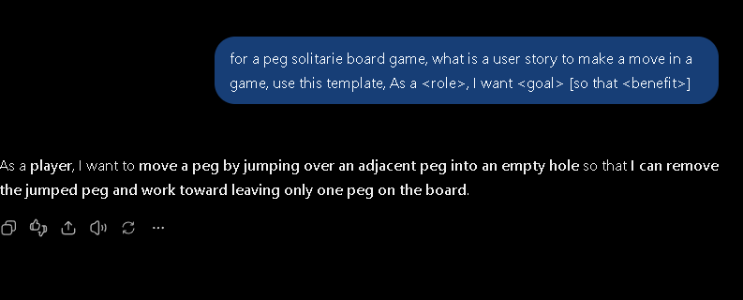 | High | 3
5 | A game is over | As a player, I want to be notified when there are no more valid moves and whether I won or lost, so that I know the game has ended and see how I did. I just changed up a bit of the wording since you can win or lose, but seeing how you did can show more than just the result of the game. 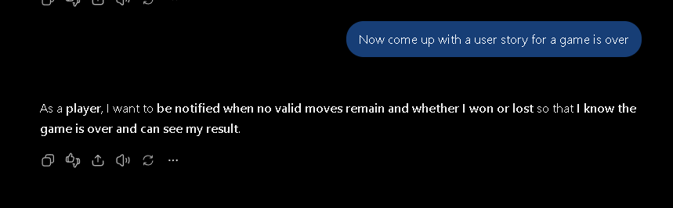 | High | 3

- Acceptance Criteria (AC) (12 points): Add/delete rows as needed.

User Story ID and Name | AC  ID | Description of Acceptance Criterion | Status (completed, toDo, inPprogress)
1. Choose a board size | 1.1 | AC 1.1 A player chooses a board size before starting a game  Given I can see the board sizes  When I select the size I prefer and begin the game  Then the game begins with the selected board size | ToDo
1. Choose a board size | 1.2 | AC 1.2 Change the selected board size before starting the game  Given I have selected a supported board size but have not started the game  When I select a different board size and click New Game  Then the game displays a board using the most recently selected size  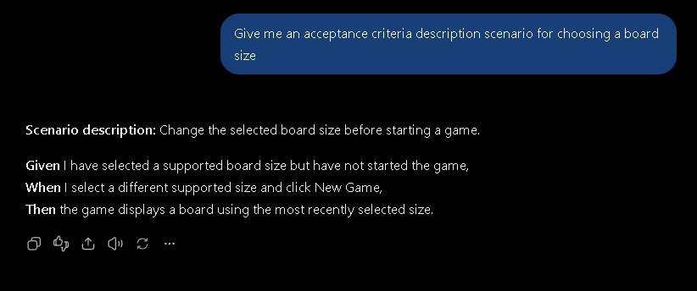  Seems well written, no errors | ToDo
1. Choose a board size | …
2. Choose the board type | 2.1 | AC 2.1 A player chooses the board type before starting the game  Given I have already selected the size and am now selecting the board type  When I choose my board type and click to begin a game  Then the game will display my selected size and preferred board type | ToDo
2. Choose the board type | …
3. Start a new game of the chosen board size and type | 3.1 | Given I have selected a supported board size and type  When I click New Game  Then the selected board appears with the center hole empty and all other playable holes occupied. | ToDo
4. Make a move in a game |  | Given a peg can jump over an adjacent peg into an empty playable hole two positions away in an allowed direction  When I select the starting peg and its destination  Then the peg moves to the destination, the jumped peg is removed, and the peg count decreases by one. | ToDo
4. Make a move in a game |  | Given a proposed move does not follow the game rules  When I attempt that move  Then the board remains unchanged and an invalid-move message appears. | ToDo
5. A game is over |  | Given no valid moves remain  When the game checks the board  Then it displays game over and the remaining peg count, showing a win if exactly one peg remains and a loss otherwise. | ToDo

