SYEDA FAKIHA ZAIDI

MSc Final Year

Assignment# 1

The Special and General theory of Relativity

SIR JAVEED QAMAR

CONTENT:

Part 1

1. The theory of special relativity:
2. Physics Before 1905
3. Motivations
4. A New Point of View
5. Time Dilation
6. Lorentz transformation:
7. The Doppler Shift
8. Consequences of the Theory of Relativity
9. Einstein's Approach

Part 2

1. Einstein's General Theory of Relativity.
2. The happiest thought of my life.
3. Newton vs. Einstein
4. Gravitation vs acceleration
5. Light Concept
6. The Einstein Cross:
7. Black holes
8. Radiation’s emission:
9. Gravitation and energy
10. Space and time:
11. Curvature
12. Waves
13. Gravitational red-shift
14. The double pulsar

**The Theory of Special Relativity:**

The theory of special relativity explains how space and time are linked for objects that are moving at a consistent speed in a straight line. One of its most famous aspects concerns objects moving at the speed of light.

A defining feature of special relativity is the replacement of the [Galilean transformations](https://en.wikipedia.org/wiki/Galilean_transformation) of Newtonian mechanics with the [Lorentz transformations](https://en.wikipedia.org/wiki/Lorentz_transformation). Time and space cannot be defined separately from each other. Rather, space and time are interwoven into [a single continuum known as space-time](https://en.wikipedia.org/wiki/Space-time_continuum).

*Physics Before 1905*

For centuries, physics was dominated by Newton's ideas about space, time and mechanics. These ideas led to a very successful description of the solar system. In the 1800s the theory of electromagnetism came into being with the work of Faraday, Maxwell and others. From the resulting tension between Newtonian physics and electromagnetic theory was born the 'Special Theory of Relativity'.

*Motivations:*

* Explaining the results of the Michelson-Morley experiment without invoking a “force” exerted on bodies moving through the aether.
* Make the equations that describe electromagnetism (called Maxwell’s equations) simple and symmetrical in all reference frames, independent of whether the frames are moving or not.

*A New Point Of View*

Einstein formulated the special theory of relativity during his tenure at the Swiss Patent Office at Berne. In his famous 1905 paper 'On the Electrodynamics of Moving Bodies' Einstein wrote, " ... no properties of observed correspond to a concept of absolute rest ... for all coordinate systems for which the mechanical equations hold, the equivalent electro dynamical and optical equations hold also ... In the following we make these assumptions (which we shall subsequently call the Principle of Relativity) and introduce the further assumption.

*Time Dilation*

A light pulse goes from the floor to the ceiling and back. Since c=const but the distance is longer in case B (moving frame): Time intervals seen in moving reference frames appear longer than the same interval seen at rest

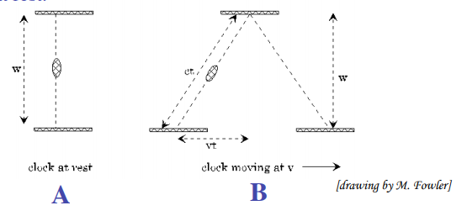

*Lorentz Transformation:*

Lorentz made a large number of ad hoc hypotheses to arrive at his transformation equations. Einstein arrived at the same transformation equations from a much more elegant point of view. He made the following two postulates:

1. The ***Principle of Relativity***: The laws of physics are the same in all inertial frames. No preferred inertial frame exists.

2. The ***Principle of the Constancy of the Speed of Light***: The speed of light in free space has the same value c in all inertial frames.

*The Doppler Shift*

Doppler relations in the space-time coordinate equations, we get

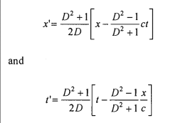

*Consequences of the Theory of Relativity*

There are several consequences that follow from Einstein's two basic postulates. Some of these are:

* From the Lorentz transformations he was led to Fitzgerald Lorentz contraction of lengths and the dilation of time: rl = lo and t = r ‘to’ where ‘lo’ and to are, respectively, a length and duration of time in the rest frame. r = 1/ 1- v 2 / c 2 ,where v is the speed of the moving frame relative to the rest frame and c is the speed of light in vacuum.
* The relativistic expression for the angle a of aberration of starlight coming from the zenith: tan a= r v/c where v is the speed of earth relative to the star.
* The relativistic invariance of the classical form of the momentum conservation law. Thus, m, the measured mass and mo ' the rest mass of a body, are related via m = mov.
* Energy transformation law of his June 1905 paper played a crucial role in his derivation of the celebrated mass-energy equivalence relation E = me2• This relation appeared in his September 1905 paper.

*Einstein's Approach*

Einstein's approach was bold, simple and general. Einstein's general theory of relativity with its modified notion of space and time, led directly to Minkowski's mathematical framework for relativistic kinematics in terms of four-dimensional space-time. This paved the way for Einstein's general theory of relativity. Einstein initially dismissed Minkowski's mathematical work as 'superfluous learnedness'. '. However, he later realised how Minkowski's approach greatly facilitated the transition from special to general relativity.

Einstein's General Theory of Relativity

The General Theory of Relativity is, as the name indicates, a generalization of the Special Theory of Relativity. It is certainly one of the most remarkable achievements of science to date; it was developed by Einstein with little or no experimental motivation

*The Happiest Thought of My Life*

In 1907, only two years after the publication of his Special Theory of Relativity, Einstein wrote a paper attempting to modify Newton’s theory of gravitation to fit special relativity. Newton’s expression for the gravitational force between two objects depends on the masses and on the distance separating the bodies, but makes no mention of time at all. In this view of the world if one mass is moved, the other perceives the change (as a decrease or increase of the gravitational force) instantaneously. If exactly true this would be a physical effect which travels faster than light (in fact, at infinite speed), and would be inconsistent with the Special Theory of Relativity. The only way out of this problem is by concluding that Newton’s gravitational equations are not strictly correct. In 1920 Einstein commented that a thought came into his mind when writing the above-mentioned paper he called it “***the happiest thought of my life***”.

*Statement:*

The gravitational field has only a relative existence... Because for an observer freely falling from the roof of a house – at least in his immediate surroundings – there exists no gravitational field.

*Newton vs. Einstein*

I have stated that Newton’s mechanics and his theory of gravitation are but approximations to reality and whose limitations are now known 4. So it might be questionable to use F = ma and Fgrav = mMG/r2 as basis to any argument as was done above. Einstein was careful to use these expressions only in situations where they are extremely accurate (small speeds compared to c and small gravitational forces). In these cases the inertial and gravitational masses are identical, as shown by experiment.

*Gravitation vs. Acceleration*

All objects are falling together and are assumed to be rather close to each other (the box is not immense) hence the paths they will follow will be essentially the same for each of them. The principle of equivalence is of interest neither because its simplicity, nor because it leads to philosophically satisfying conclusions. Its importance is based on the enormous experimental evidence which confirms it; as with the Special Theory, the General Theory of Relativity is falsifiable. In a small region the effects produced by a gravitational force are indistinguishable from those present in an accelerated reference frame

*Light Concept*

The bending of light was one of the most dramatic predictions of the General Theory of Relativity. The bending of light from a star by a massive compact object, if both the bright objects and the massive object are prefect sphere, there will be an apparent image for every point on the “***Einstein ring***”.

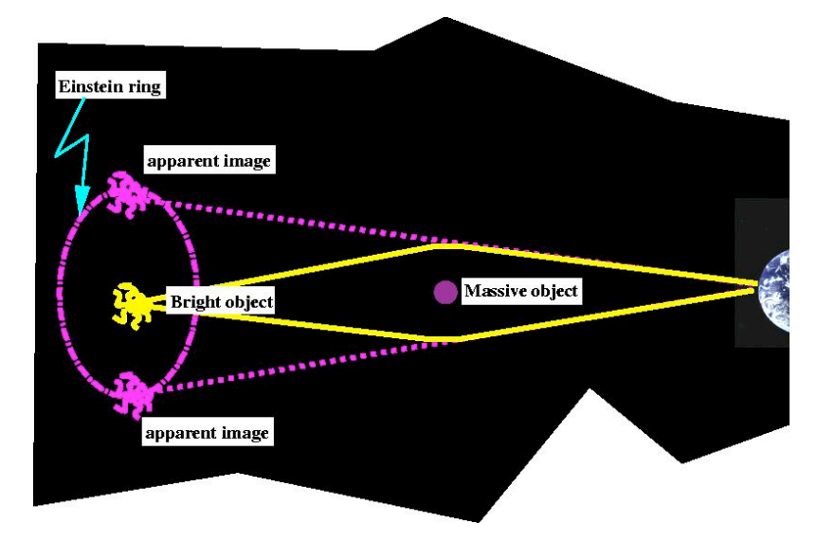

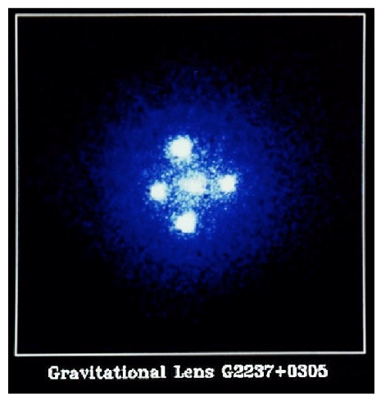*The Einstein Cross:*

Four images of a quasar GR2237+0305 (a very distant – 8 billion light-years–, very bright object) appear around the central glow. The splitting of the central image is due to the gravitational lensing effect produced by a nearby galaxy. The central image is visible because the galaxy does not lie on a straight line from the quasar to Earth. The Einstein Cross is only visible from the southern hemisphere.

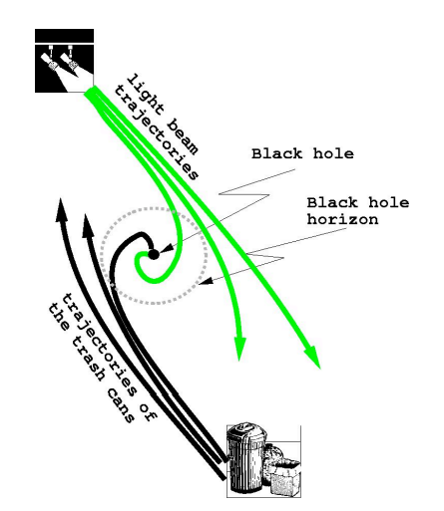*Black Holes*

Since no light can leave this object it will appear perfectly black, this is a black hole. An object which comes sufficiently close to a black hole will also disappear into it. The effect of a black hole, like all gravitational effects, decreases with distance. This means that there will be a “boundary” surrounding the black hole such that anything crossing it will be unable to leave the region near the black hole; this boundary is called the black-hole horizon.

The horizon surrounding the black hole.The black holes is represented by the small heavy dot, the light rays or particle trajectories which cross the dotted line cannot cross it again.

*Gravitation and Energy*

The force of gravity affects both light and all material bodies; since both carry energy, but only the bodies’ carry mass, it follows that gravity will affect anything carrying energy. This conclusion lies at the root of the carrying energy construction of Einstein’s equations which describe gravity

*Radiation’s Emission:*

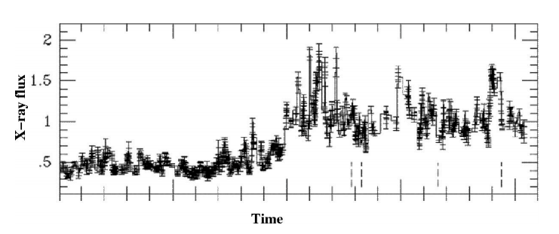

General Theory of Relativity, even in this one of its most extreme predictions is falsifiable. The saving circumstance is provided by the matter surrounding the black hole. All such stuff is continuously being dragged into the hole and devoured, but in the process it gets extremely hot and radiates light, ultraviolet radiation and X rays. Moreover, this cosmic Maelstrom is so chaotic that the radiation changes very rapidly, sometimes very intense, sometimes much weaker, and these changes come very rapidly..

*Space and Time:*

The Special Theory of Relativity concluded the bending of space produced by a massive object.

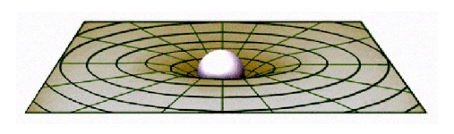

The gravity alters the properties of space, we also saw that the rates of clocks are altered under the influence of a gravitational force, it follows that gravity alters the properties of space and time. Space Gravity alters the properties of space and time and time is in fact very far from the unchanging arena envisaged by Newton, they are dynamical objects whose properties are affected by matter and energy. These changes or deformations of space and time in turn determine the subsequent motion of the bodies in space time: matter tells space-time how to curve and space-time tells matter how to move.

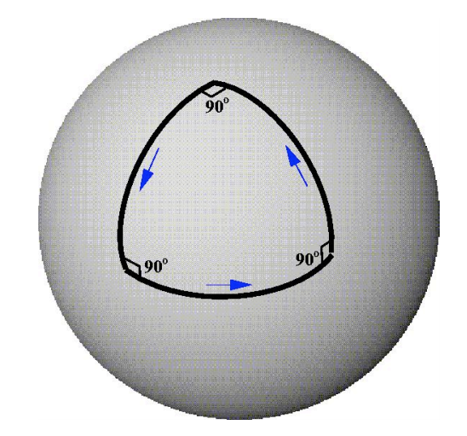*Curvature*

The curvature of space is real and is generated by the mass of the bodies in it. Correspondingly the curvature of space determines the trajectories of all bodies moving in it. The Einstein equations are the mathematical embodiment of this idea. Their solutions predict, given the initial positions and velocities of all bodies, their future relative positions and velocities.

A path followed by a determined being living on the surface of a sphere; each turn is at right angles to the previous direction, the sum of the angles in this triangle is then 270o indicating that the surface in which the bug lives is not flat.

*Waves*

Several systems which according to the General Theory of Relativity ought to lose energy by giving off gravitational waves have been observed. The observations show that these systems lose energy, and the rate at which this happens coincides precisely with the predictions from the theory.

The corresponding deformation of space travels forth from this site site as a gravitational wave. High intensity gravitational waves are also produced during the collision of two black holes or any sufficiently massive compact objects.

*Gravitational Red-Shift*

The gravitational red-shift predicted by the General Theory of Relativity. A heavy object is denoted by a deformation of space represented by the funnel. As light leaves the vicinity of this object it is shifted towards the red: for a sufficiently compact and massive object a blue laser on the surface will be seen as red in outer space.

The gravitational red-shift was also tested by looking at the light from a type of stars which are very well-studied. The observations showed that the light received on Earth was slightly redder than expected and that the reddening is also in agreement with the predictions from the General Theory of Relativity.

*The Double Pulsar*

There are certain kind of stars which are called pulsars, the pulsar pulses occur at very regular intervals. Moreover there are several physical effects which can be used to determine the shape of the orbits of the pulsar and the compact object. It was found that these objects are slowly spiraling into each other, indicating that the system is losing energy in some way.

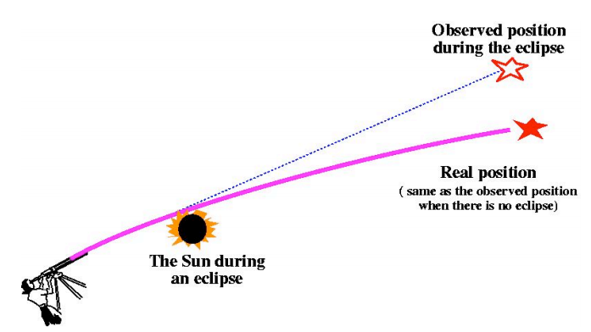

This system can also be studied using the General Theory of Relativity which predicts that the system should radiate gravitational waves carrying energy with them and producing the observed changes. These predictions are in perfect agreement with the observations. This is the first test of General Theory of Relativity using objects outside our solar system.

-----------------------X------------------X------------------------X-------------------------X----------------------------

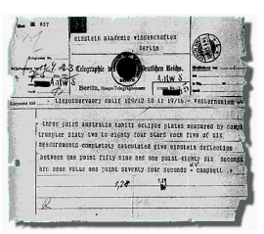

***Einstein announcing the observation of the benign of light by a gravitational force as predicted by the General Theory of Relativity***