Name-: 1) Saee Chandrakant Bhanuskar
11) Divya Sandip Gawand

Health Insurance Fraud Detection Using AI and Blockchain

Problem statement
Fraud in healthcare insurance claims has become a major concern, leading to massive financial losses and misuse of public and private health resources. Traditional systems rely heavily on manual audits and rule-based validation, which are time-consuming and prone to human error. Additionally, the centralized nature of current claim systems lacks transparency, making it difficult to trace and prevent fraudulent activities effectively.
This project addresses the urgent need for a robust, intelligent, and secure healthcare fraud detection mechanism by integrating machine learning with blockchain technology. It enhances the accuracy of fraud detection and ensures tamper-proof logging of sensitive transaction data.

Objectives
Develop an AI-assisted system that accurately detects fraudulent healthcare insurance claims using machine learning models trained on past data.
Integrate blockchain technology to ensure tamper-proof storage and transparent logging of all claim-related transactions.
Provide a user-friendly web interface for administrators and analysts to review, manage, and investigate flagged claims.
Enhance data security by implementing strong encryption mechanisms for storing sensitive health information.

Design methodology
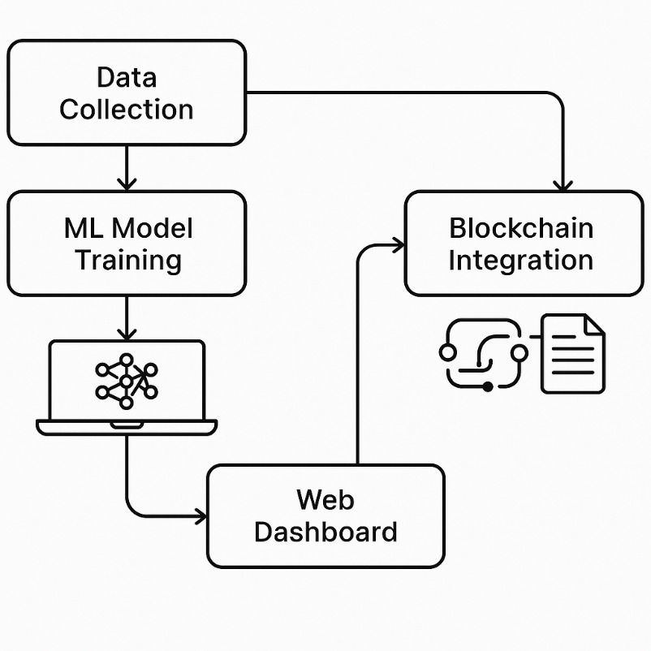

Data Collection: Sample healthcare claim datasets are collected and labeled (fraudulent or legitimate).
ML Model Training: Use supervised learning techniques (Random Forest, Logistic Regression, or XGBoost) to build a prediction model.
Blockchain Integration: Every verified claim is logged into a private blockchain ledger to ensure data immutability and traceability.
Web Dashboard: Flask-based interface for uploading claims, reviewing predictions, and tracking blockchain-logged records.

Hardware and Software Details
Hardware requirement
- Any computing device (Laptop/Desktop)
- Local or cloud server for blockchain and ML model hosting
Software Requirements
- OS: Windows 10 or Ubuntu
- Python (scikit-learn, pandas, Flask, joblib)
- Ganache (for local blockchain)
- Solidity (for smart contracts)
- Web3.py (Python–Ethereum communication)
- HTML/CSS/JavaScript (for UI)
- MetaMask (for signing transactions)

References
- https://www.ibm.com/blogs/blockchain/healthcare-blockchain-usecases/
- https://ieeexplore.ieee.org/document/9334407 — “A Blockchain-Based Framework for Healthcare Claim Fraud Detection Using AI” – IEEE, 2021
- https://towardsdatascience.com/how-to-detect-insurance-fraud-using-machine-learning-ff75f403fb7e

