UNIVERSITY OF ENGINEERING AND TECHNOLOGY, PESHAWAR PAKISTAN

*Main Campus*



**OOP Final Lab Exam**

**Submitted By**

|  |  |
| --- | --- |
| **Name:** | **Syed Muhammad Saeed** |
| **Registration No:** | **24pwbcs1174** |
| **Semester:** | **2nd Semester, BS Computer Science** |
| **Section:** | **D** |
| **Submission Date:** | **01/07/2025** |

**Submitted To**

**Sir Muhammad**

DEPARTMENT OF COMPUTER SCIENCE

UNIVERSITY OF ENGINEERING AND TECHNOLOGY, PESHAWAR, PAKISTAN

**Course:**

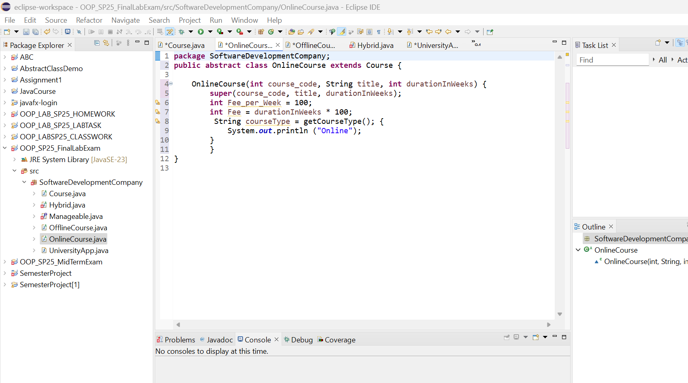

**Manageable:**

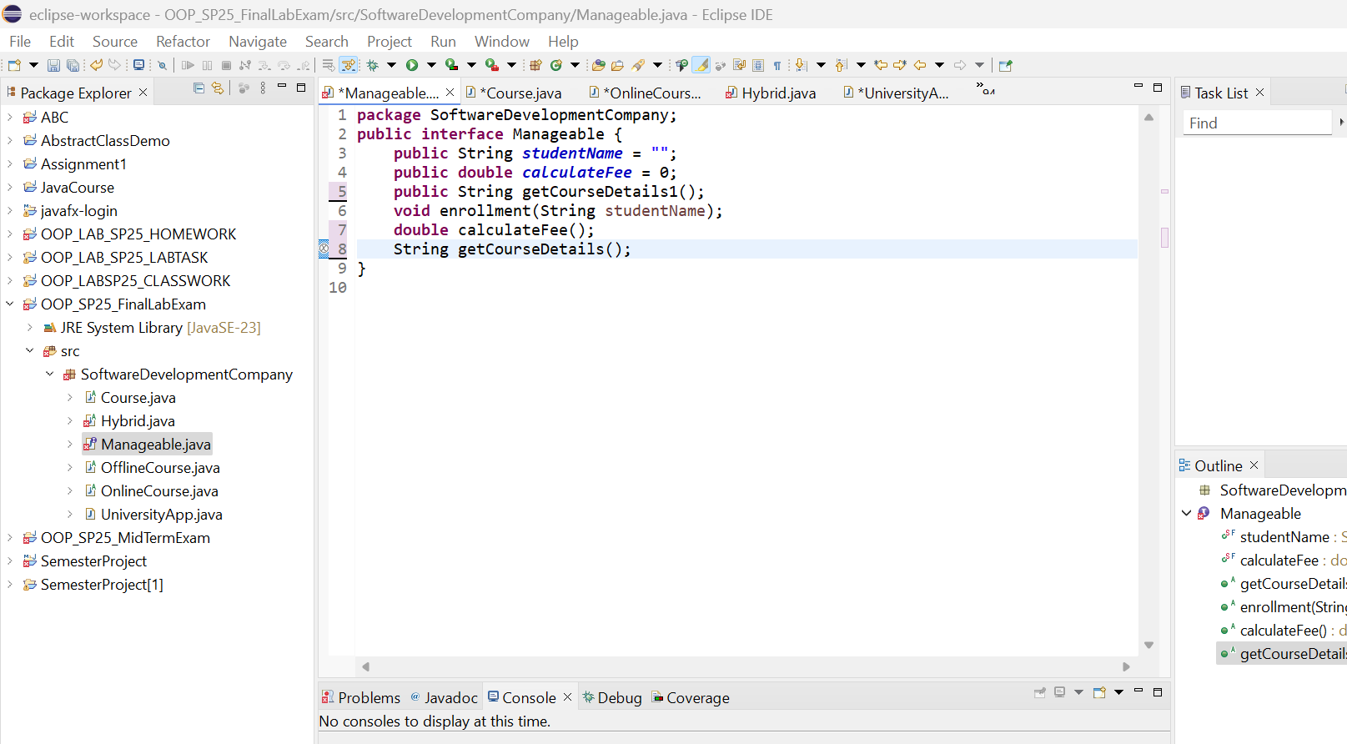

**Offline Course:**

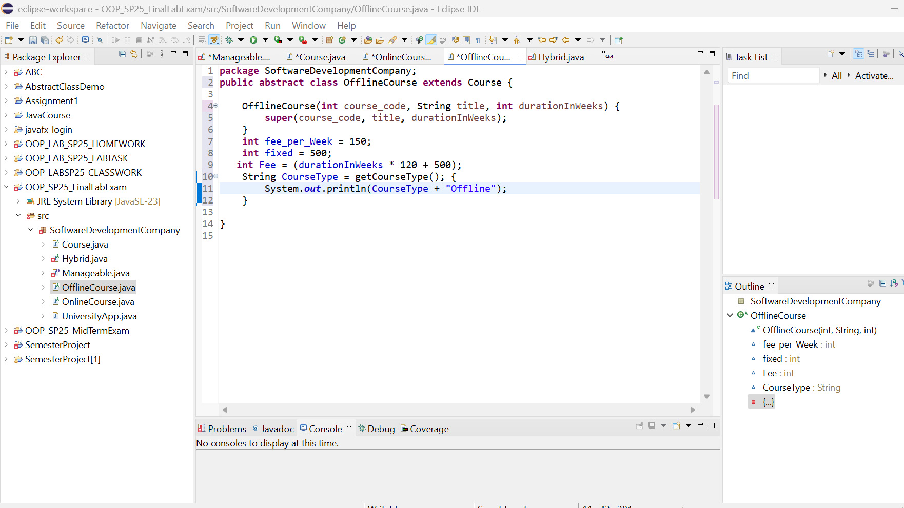

**Online Course:**

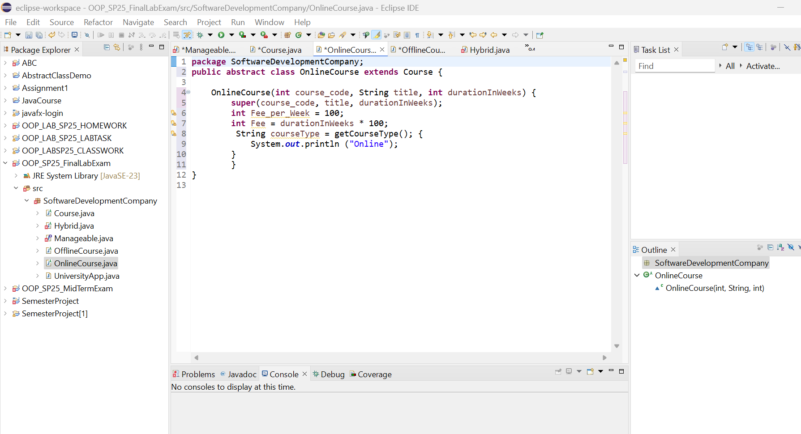

**Hybrid Course:**

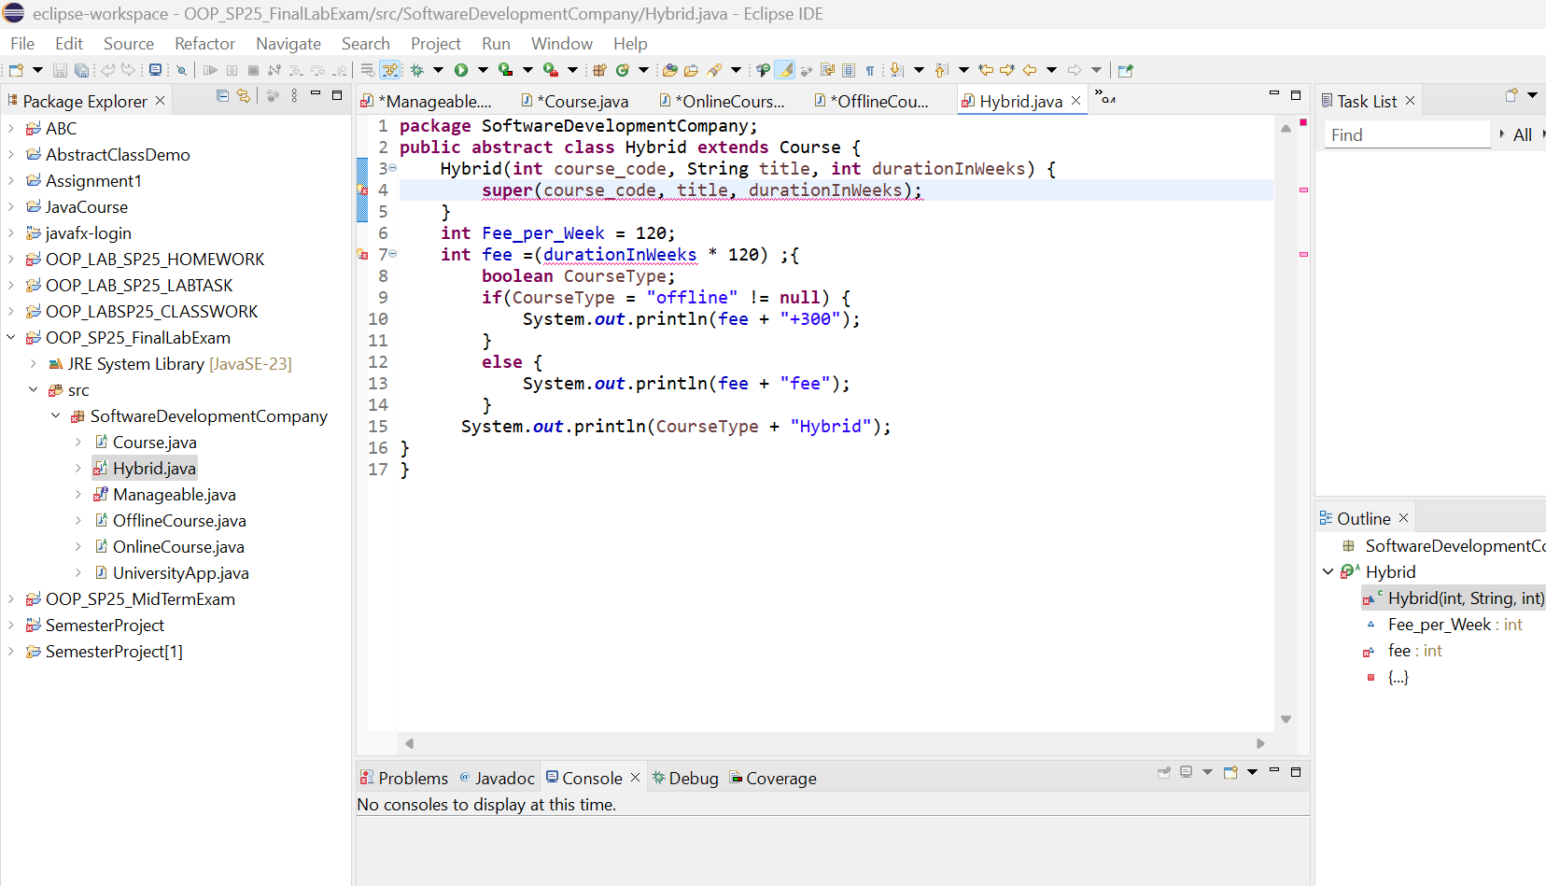

**University App:**

