Secure-Two-Tier-Cloud Network

Example:
Vpc name : Prod-VPC
VPC ID : vpc-05df659cf2f212303

Phase -1 The Network Foundation.

Create the VPC:
- Search for VPC in the AWS console.
- Click Create VPC.
- Select VPC only.
- Name: Mumbai-Prod-VPC
- IPv4 CIDR: 10.0.0.0/16
- Click Create VPC.

Internet Gateway
Name: Mumbai-IGW
IG ID: igw-00c46acb84772eb70

Attach the IGW:
  - Select your new Mumbai-IGW.
  - Click Actions > Attach to VPC.
  - Select Mumbai-Prod-VPC and click Attach.

Subnetting: 4 subnets(3blocks - Availability zone)

output: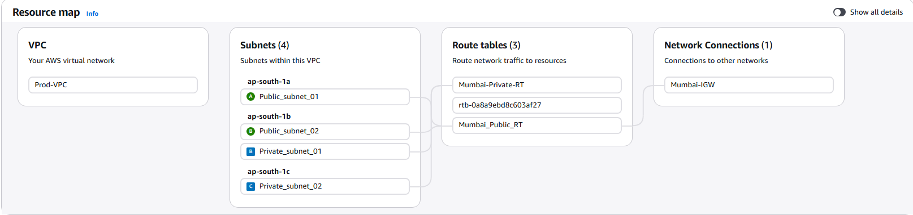

“The Restaurant Analogy”

Block-1
public_subnet_01: The Seating Area, it’s open to the street so customers can walk in. It’s "Public" because anyone can see it and enter it.
- Your web server would be here (waiter) to take orders.

Block -2
Public_subnet_02:This is a Second Seating Area. If a pipe bursts in the First seating Area, customers just go to this block instead.
Private Subnet 01: This is the Main Kitchen. It is "Private"customers aren't allowed here. There is no door to the street. The only way in is through the staff door from the seating area.
- our Primary Database (the "Chef" who has all the secret recipes)

Block-3
Private Subnet 02: This is a Backup Kitchen/Pantry. It’s in a completely different building for safety.
Your Standby Database. If the Main Kitchen in Block 2 catches fire, your Chef instantly moves to this kitchen to keep cooking.

I used 3 Availability Zones to ensure that even if one whole data center in goes offline, my website (Web Tier) and my data (Database Tier) are still available in the other two locations

Why? /16 for vpc
1.Industry Standard.
2.zero cost - private ips are free
3.Simple Math
4.No_IP Exhaustion: Small ranges (like /24) run out fast because AWS reserves 5 IPs per subnet automatically.
5.Future Proof: You can add hundreds of extra subnets later (for things like Lambda, EKS, or separate Dev/Test environments) without needing a new VPC.

Phase -2 The Routing Logic

1. Configure the Public Route Table
- Go to VPC Dashboard > Route Tables.
- Click Create route table.
example:
- Name: Mumbai-Public-RT
- VPC: Mumbai-Prod-VPC
3. Once created, select it and go to the Routes tab > Edit routes.
- Click Add route.
- Destination: 0.0.0.0/0 (This means "everywhere on the internet").
- Target: Select Internet Gateway and pick your Mumbai-IGW.
- Click Save changes.
4.Go to the Subnet Associations tab > Edit subnet associations.
- Select Public-Subnet-01 and Public-Subnet-02.
- Click Save.

2. Configure the Private Route Table
- Click Create route table again.
  - Name: Mumbai-Private-RT
  - VPC: Mumbai-Prod-VPC
- Do NOT add a route to 0.0.0.0/0. We want this to stay private.
- Go to Subnet Associations > Edit subnet associations.
  - Select Private-Subnet-01 and Private-Subnet-02.
  - Click Save.

Phase 3: Security Groups (The Bouncers)

We need to set the rules for who can enter the servers we are about to launch.
- Create Web-SG (For the Public Servers):The Front Door
  - Go to EC2 Dashboard > Security Groups > Create security group.
  - Name: Web-SG | VPC: Mumbai-Prod-VPC.
  - Inbound Rules:
    - Add HTTP (80) from 0.0.0.0/0 (So everyone can see your website).
    - Add SSH (22) from My IP (So only you can log in).
note:In source dropdown you can find the My Ip option (it usually says "Custom").
Note:
Outbound: 0.0.0.0/0 (Allows the database/app to download security patches).

Why we do this
If you leave it as 0.0.0.0/0 for SSH, bots from all over the world will immediately start trying to "brute force" (guess) your password. By using your IP, you are basically making your server invisible to everyone except you.

- Create App-SG (For the Private Servers):The Staff Door
  - Click Create security group.
  - Name: App-SG | VPC: Mumbai-Prod-VPC.
  - Inbound Rules:
    - Add SSH (22). For the Source, don't type an IP. Start typing sg- and select your Web-SG.
    - This is the professional way: Your private server only trusts your public server.
Note:
Inbound: SSH (Allowed only if coming from Web-SG).
Outbound: 0.0.0.0/0 (Allows the database/app to download security patches).

Phase 4: Launching the Instances.

Step 1: Launch the "Public" Web Server
This is the one that will face the internet.
- In the AWS Console, search for EC2 and click Launch instance.
- Name: Mumbai-Web-Server
- Application and OS (AMI): Select Amazon Linux 2023 (it should say "Free tier eligible").
- Instance type: t2.micro (Free tier).
- Key pair: Click Create new key pair.
  - Name: Mumbai-Key
  - Format: .pem (for Mac/Linux/Windows 10+) or .ppk (for older Putty).
  - Download it! You cannot download this again later.
- Network settings (Click "Edit"):
  - VPC: Select your Mumbai-Prod-VPC.
  - Subnet: Public-Subnet-01.
  - Auto-assign public IP: Enable (If you forget this, you can't reach it from your house!).
  - Firewall (Security Groups): Select "Select existing security group" and choose your Web-SG.

Step 2: Launch the "Private" App Server
This is the "Hidden" server that only your Web Server can talk to.
- Click Launch instances again.
- Name: Mumbai-App-Server
- OS/Instance Type: Same as above (Amazon Linux / t2.micro).
- Key pair: Select the same Mumbai-Key you just created.
- Network settings (Click "Edit"):
  - VPC: Select your Mumbai-Prod-VPC.
  - Subnet: Private-Subnet-01.
  - Auto-assign public IP: Disable (We want this one hidden!).
  - Firewall (Security Groups): Select "Select existing security group" and choose your App-SG.
- Click Launch Instance.
This is the moment of truth! If your networking is set up correctly, you should be able to "jump" into your Web Server from your computer.

Note: wait for 2 -3 minutes until the status check is shown passed

output:

Since the App Server is in a private subnet, you can't talk to it directly from your house. To reach it, you have to go through the Web Server (this is called using a Bastion Host or Jump Box).
- Open the terminal and navigate to location, where the pem file is stotred
- Change the file permission to chmod 400 Mumbai-key.pem

Step 2: Log into the Web Server (The "Lobby")
- Go to the AWS Console and copy the Public IP of your Mumbai-Web-Server.
- Run this command: ssh -i "Mumbai-Key.pem" ec2-user@YOUR-PUBLIC-IP
- Type yes if it asks about the authenticity of the host.
If you see the "Amazon Linux 2023" logo, YOU ARE IN! 🚀
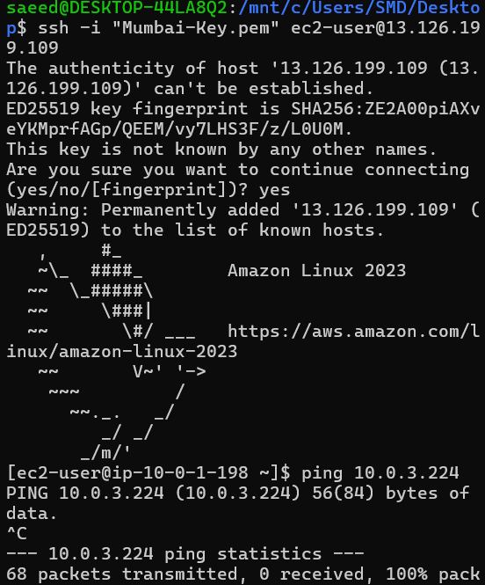
- Type : curl -I google.com , if it shows, HTTP/1.1 301 Moved Permanently……..
Internet Gateway is working: Your VPC successfully sent a request out to the world.
Public Route Table is correct: Your Web Server knew to use the 0.0.0.0/0 route via the IGW.
DNS is working: Your VPC was able to resolve "google.com" into an IP address.

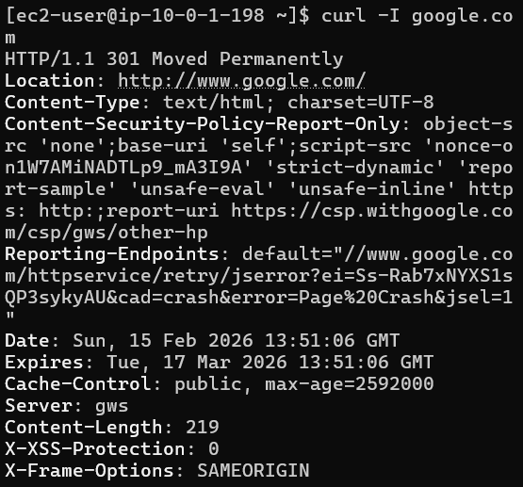

Step 3: The "Magic" Test (Can the Web Server see the App Server?)
Now that you are inside the Web Server, let's see if it can "talk" to the hidden App Server in the private subnet.
- Go to the AWS Console and copy the Private IP of your Mumbai-App-Server (it should look like 10.0.3.x).
- Inside your terminal (where you are logged into the Web Server), type: ping YOUR-PRIVATE-IP
Note: If the ping doesn't respond, don't worry! It’s because we didn't add "ICMP" (ping) to the Security Group—we only added SSH.
Note: you need to install ncat to use it.
Install : sudo yum install nmap-ncat -y
From your terminal (while still logged into the Web Server), run:
nc -zv <PRIVATE_IP_OF_APP_SERVER> 22
(Replace <PRIVATE_IP_OF_APP_SERVER> with the 10.0.3.x address of your App Server).

Output:
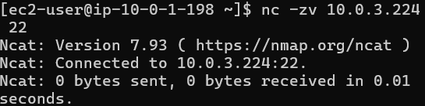

Option 2: The "SSH" Test (No install needed)
If you don't want to install anything, you can try to SSH from the Web Server to the App Server. It will fail because the Web Server doesn't have your .pem key yet, but the error message will tell us if the connection is open.
Run this: ssh ec2-user@10.0.3.224
- If it says Permission denied (publickey): SUCCESS! This means the Web Server reached the App Server, the App Server answered, but it just rejected you because you didn't show it the Mumbai-Key.
- If it hangs (Connection timed out): This means the App-SG is blocking the Web Server, or the Route Table is missing.

VPC Resource Map

