Movie Recommendation & Rating Management System

Course Title | Database Systems
Lab Instructor | Ms. Ambreen Akmal
Program | BSCS
Submission | Spring 2026

Group Members
Name | Registration No. | GitHub Profile
Saeed Ahmad | 70154454 | https://github.com/Saeed-Ahmad0/70154454_db-lab
Muhammad Ali | 70145657 | https://github.com/muhammadalishah64021-glitch/Movie-Recommendation-Database
Muhammad Ismail Rafique | 70153472 | https://github.com/minhasismail788-a11y/MovieRecomemdatio

1. Project Scenario Description
The Movie Recommendation and Rating Management System is a relational database application designed to store, manage, and analyze comprehensive movie-related information. The system provides a centralized platform where users can discover movies, rate them, write reviews, manage personal watchlists, and receive genre-based recommendations.

Core Entities
- Users — registered members who interact with the platform
- Movies — the central entity with metadata like title, year, language, and duration
- Directors & Actors — people associated with movies
- Genres — classification of movies into categories
- Ratings — numerical scores (1–10) given by users to movies
- Reviews — written feedback submitted by users
- Watchlist — personalized list of movies a user wants to watch
- Awards — official recognitions and nominations received by movies

Real-World Applications
- Movie streaming platforms (e.g., Netflix, Amazon Prime)
- Online movie review websites (e.g., IMDb, Rotten Tomatoes)
- Recommendation engines for entertainment
- Film festival and awards tracking databases

2. Database Design Overview
The database follows a normalized relational design (3NF) to minimize redundancy and ensure data integrity. The schema consists of 11 tables connected through clearly defined primary keys, foreign keys, and junction tables for many-to-many relationships.

2.1 Design Principles Applied
- Normalization up to Third Normal Form (3NF) to eliminate redundancy
- Primary keys on every table for unique identification
- Foreign keys with CASCADE rules to maintain referential integrity
- CHECK constraints to enforce business rules (e.g., rating must be 1–10)
- UNIQUE constraints to prevent duplicate entries (e.g., one rating per user per movie)
- Junction tables for many-to-many relationships (MOVIE_GENRE, MOVIE_CAST)

2.2 Relationship Summary

Relationship | Type | Tables Involved
Movie ↔ Director | 1 to Many | MOVIES, DIRECTORS
Movie ↔ Genre | Many to Many | MOVIES, GENRES (via MOVIE_GENRE)
Movie ↔ Actor | Many to Many | MOVIES, ACTORS (via MOVIE_CAST)
User ↔ Rating | 1 to Many | USERS, RATINGS
User ↔ Review | 1 to Many | USERS, REVIEWS
User ↔ Watchlist | 1 to Many | USERS, WATCHLIST
Movie ↔ Award | 1 to Many | MOVIES, AWARDS

3. Tables and Relationships

Table Name | Columns & Key Constraints
USERS | user_id (PK) | username | email (UNIQUE) | password | country | join_date
DIRECTORS | director_id (PK) | director_name | nationality | birth_date
ACTORS | actor_id (PK) | actor_name | gender | birth_date | nationality
GENRES | genre_id (PK) | genre_name (UNIQUE)
MOVIES | movie_id (PK) | title | release_year | duration | language | description | director_id (FK→DIRECTORS)
MOVIE_GENRE | movie_id (FK→MOVIES) | genre_id (FK→GENRES) | Composite PK
MOVIE_CAST | movie_id (FK→MOVIES) | actor_id (FK→ACTORS) | role_name | Composite PK
RATINGS | rating_id (PK) | user_id (FK) | movie_id (FK) | rating (1–10) | rating_date
REVIEWS | review_id (PK) | user_id (FK) | movie_id (FK) | review_text | review_date
WATCHLIST | watchlist_id (PK) | user_id (FK) | movie_id (FK) | added_date | status (ENUM)
AWARDS | award_id (PK) | movie_id (FK) | award_name | category | award_year | result (ENUM)

4. ER Diagram
The Entity-Relationship diagram describes the logical structure of the database. A visual ER diagram generated using MySQL Workbench is included in the GitHub repository. The textual description below captures all entities, attributes, and relationships.

Entity | Primary Key | Related To | Cardinality
USERS | user_id | RATINGS, REVIEWS, WATCHLIST | 1 to Many
MOVIES | movie_id | DIRECTORS, GENRES, ACTORS, RATINGS, REVIEWS, AWARDS, WATCHLIST | Central Hub
DIRECTORS | director_id | MOVIES | 1 to Many
ACTORS | actor_id | MOVIES (via MOVIE_CAST) | Many to Many
GENRES | genre_id | MOVIES (via MOVIE_GENRE) | Many to Many
RATINGS | rating_id | USERS, MOVIES | Many to 1 (both)
REVIEWS | review_id | USERS, MOVIES | Many to 1 (both)
WATCHLIST | watchlist_id | USERS, MOVIES | Many to 1 (both)
AWARDS | award_id | MOVIES | Many to 1
5. Description of the 10 Features

Feature 1: View Movie Details
Retrieves complete information about a movie including its director name and a comma-separated list of genres. Uses LEFT JOIN across MOVIES, DIRECTORS, MOVIE_GENRE, and GENRES tables with GROUP_CONCAT to aggregate genre names.
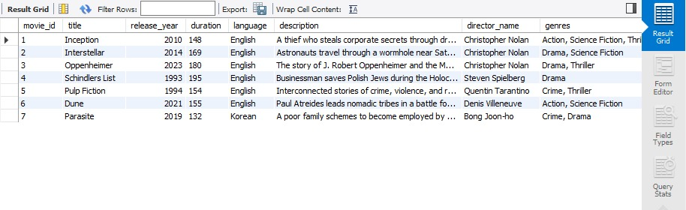

Feature 2: Rate a Movie
Allows a user to submit a numerical rating (1–10) for a movie, or update an existing one. A CHECK constraint enforces the valid range. The INSERT adds a new rating and the UPDATE modifies an existing entry.

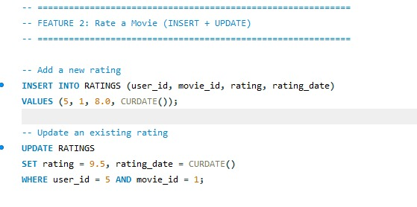

Feature 3: Write / Update / Delete a Review
Enables users to write written feedback for a movie (INSERT), edit their review text (UPDATE), or remove their review (DELETE). This feature demonstrates full CRUD operations on the REVIEWS table.



Feature 4: Search Movies by Genre or Director
Provides filtering capability so users can find movies by a specific genre category or by director name. Uses LIKE for partial director name matching and an exact match for genre name.
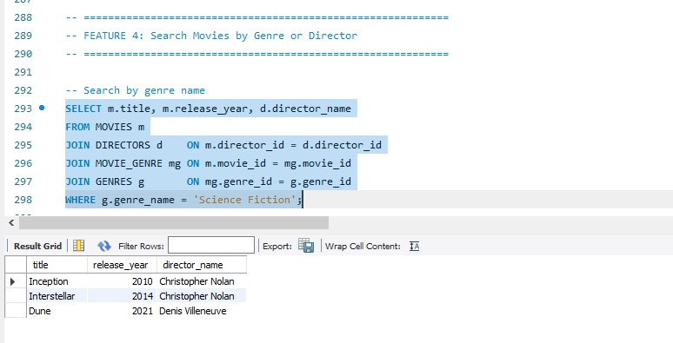

Feature 5: View Actor Filmography
Displays the complete list of movies an actor has appeared in, along with the character role they played, ordered by release year. Joins ACTORS, MOVIE_CAST, and MOVIES.
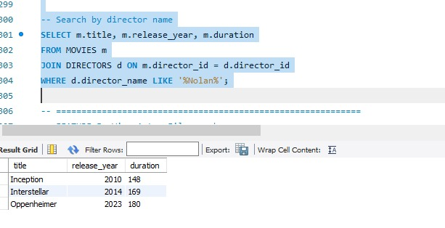

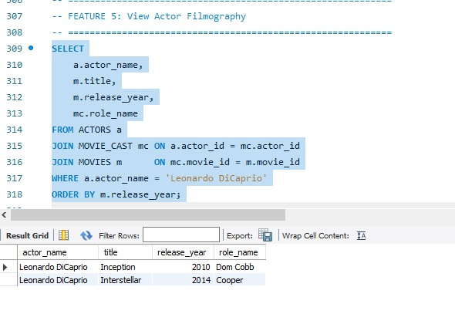

Feature 6: Identify Top-Rated Movies
Calculates the average rating and total rating count for each movie, then returns the top 5 movies ordered by average rating descending. Uses AVG() and COUNT() aggregate functions with GROUP BY and HAVING.


Feature 7: Analyze Popular Genres
Aggregates data across genres to show how many movies belong to each genre and the average user rating per genre. This provides insight into audience preferences and content distribution.
z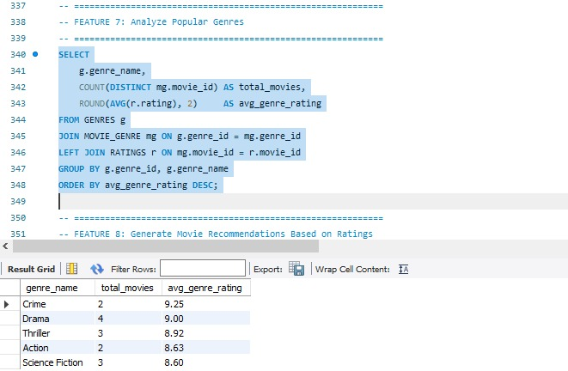

Feature 8: Generate Movie Recommendations
Recommends unseen movies to a user based on genres they have previously rated highly (>= 8). A correlated subquery first identifies the user's preferred genres, then surfaces movies in those genres the user has not yet rated.




Feature 9: Watchlist Management
Allows users to maintain a personal watchlist by adding movies they want to watch, updating their watch status (Want to Watch / Watching / Watched), and removing entries. A UNIQUE constraint prevents duplicate entries per user-movie pair.
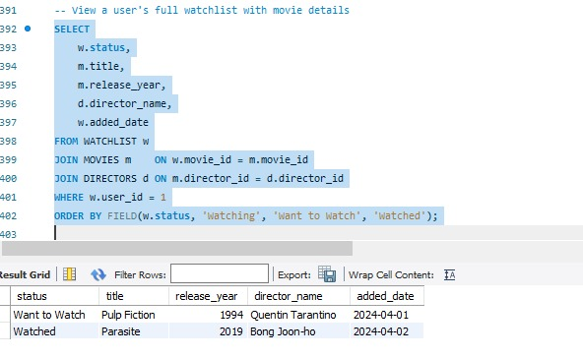

Feature 10: Track Movie Awards & Nominations
Stores official award wins and nominations for movies. Users can view all awards for a specific movie, find the most-awarded movies using aggregate queries, add new award records, and delete incorrect entries. The RESULT column uses an ENUM to enforce valid values.
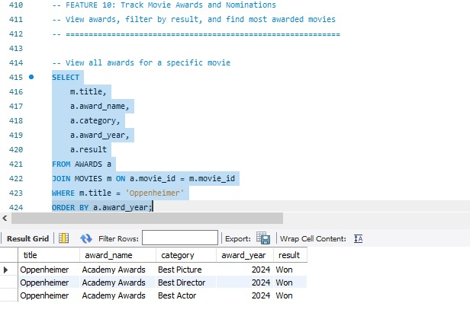
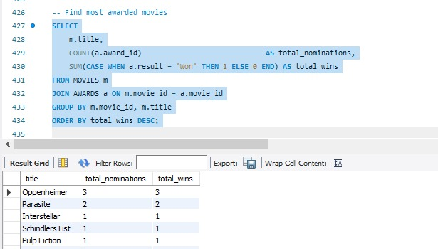
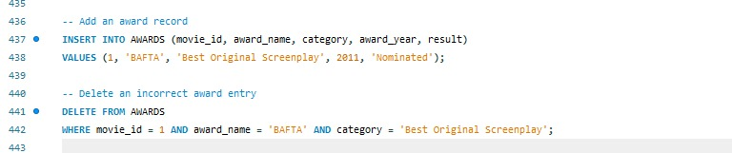

6. SQL Command Categories Used

6.1 DDL — Data Definition Language
DDL commands define the structure of the database. The following CREATE TABLE statements were used:
CREATE TABLE USERS ( user_id INT AUTO_INCREMENT PRIMARY KEY, ... );
CREATE TABLE DIRECTORS ( director_id INT AUTO_INCREMENT PRIMARY KEY, ... );
CREATE TABLE ACTORS ( actor_id INT AUTO_INCREMENT PRIMARY KEY, ... );
CREATE TABLE GENRES ( genre_id INT AUTO_INCREMENT PRIMARY KEY, ... );
CREATE TABLE MOVIES ( movie_id INT AUTO_INCREMENT PRIMARY KEY, ..., FOREIGN KEY (director_id) ... );
CREATE TABLE MOVIE_GENRE ( movie_id INT, genre_id INT, PRIMARY KEY (movie_id, genre_id), ... );
CREATE TABLE MOVIE_CAST ( movie_id INT, actor_id INT, role_name VARCHAR(100), PRIMARY KEY (...) );
CREATE TABLE RATINGS ( rating_id INT AUTO_INCREMENT PRIMARY KEY, ..., CHECK (rating>=1 AND rating<=10) );
CREATE TABLE REVIEWS ( review_id INT AUTO_INCREMENT PRIMARY KEY, ... );
CREATE TABLE WATCHLIST ( watchlist_id INT AUTO_INCREMENT PRIMARY KEY, ..., UNIQUE KEY (...) );
CREATE TABLE AWARDS ( award_id INT AUTO_INCREMENT PRIMARY KEY, ..., result ENUM('Won','Nominated') );

6.2 DML — Data Manipulation Language
DML commands manage the data within the tables:

Command | Usage in Project
INSERT | Add users, movies, directors, actors, genres, cast, ratings, reviews, watchlist entries, awards
SELECT | View movie details, search by genre/director, top-rated movies, actor filmography, recommendations
UPDATE | Modify ratings, review text, watchlist status
DELETE | Remove reviews, watchlist entries, incorrect award records
JOIN | INNER and LEFT JOINs used across all multi-table queries
GROUP BY / HAVING | Used in genre analysis and top-rated movie queries
Subquery | Used in recommendation feature to find unseen movies in preferred genres

6.3 DCL — Data Control Language
DCL commands control access permissions on the database:
-- Read-only analyst account
CREATE USER 'movie_analyst'@'localhost' IDENTIFIED BY 'analyst_pass';
GRANT SELECT ON MovieRecommendationSystem.* TO 'movie_analyst'@'localhost';

-- Application user with full DML access
CREATE USER 'movie_app'@'localhost' IDENTIFIED BY 'app_pass';
GRANT SELECT, INSERT, UPDATE, DELETE ON MovieRecommendationSystem.* TO 'movie_app'@'localhost';
FLUSH PRIVILEGES;

7. GitHub Repository

Member | GitHub Profile | Role
Saeed Ahmad | https://github.com/Saeed-Ahmad0/70154454_db-lab | SQL Design & Features
Muhammad Ali | https://github.com/muhammadalishah64021-glitch/Movie-Recommendation-Database | Documentation & Testing
Muhammad Ismail Rafique | https://github.com/minhasismail788-a11y/MovieRecomemdatio | Schema & DCL Implementation

8. Feature Summary Table

# | Feature Name | SQL Operations | Tables Involved
1 | View Movie Details | SELECT, JOIN, GROUP_CONCAT | MOVIES, DIRECTORS, MOVIE_GENRE, GENRES
2 | Rate a Movie | INSERT, UPDATE | RATINGS
3 | Write/Update/Delete Review | INSERT, UPDATE, DELETE | REVIEWS
4 | Search by Genre/Director | SELECT, JOIN, WHERE, LIKE | MOVIES, DIRECTORS, GENRES, MOVIE_GENRE
5 | View Actor Filmography | SELECT, JOIN, ORDER BY | ACTORS, MOVIE_CAST, MOVIES
6 | Top-Rated Movies | SELECT, AVG, COUNT, HAVING | MOVIES, RATINGS, DIRECTORS
7 | Analyze Popular Genres | SELECT, COUNT, AVG, GROUP BY | GENRES, MOVIE_GENRE, RATINGS
8 | Movie Recommendations | SELECT, Subquery, NOT IN | MOVIES, RATINGS, MOVIE_GENRE, GENRES
9 | Watchlist Management | INSERT, UPDATE, SELECT, DELETE | WATCHLIST, MOVIES, DIRECTORS
10 | Track Awards & Nominations | INSERT, SELECT, COUNT, SUM, CASE | AWARDS, MOVIES

