HRMS Sprint #14 Report
Dated: May 18th, 2023 – June 1st, 2023
Sprint Highlights

Stories | Completed | Comments
https://kavtech.atlassian.net/browse/HS-659 | Yes | Everything went accordingly
https://kavtech.atlassian.net/browse/HS-631 | Yes | Everything went accordingly
https://kavtech.atlassian.net/browse/HS-618 | Yes | Everything went accordingly
https://kavtech.atlassian.net/browse/HS-616 | Yes | Everything went accordingly
https://kavtech.atlassian.net/browse/HS-653 | Yes | Everything went accordingly
https://kavtech.atlassian.net/browse/HS-620 | Yes | Everything went accordingly
https://kavtech.atlassian.net/browse/HS-650 | Yes | Everything went accordingly
https://kavtech.atlassian.net/browse/HS-689 | Yes | Everything went accordingly
https://kavtech.atlassian.net/browse/HS-662 | Yes | Everything went accordingly
https://kavtech.atlassian.net/browse/HS-669 | Yes | Everything went accordingly
https://kavtech.atlassian.net/browse/HS-682 | Yes | Everything went accordingly
https://kavtech.atlassian.net/browse/HS-693 | Yes | Everything went accordingly
https://kavtech.atlassian.net/browse/HS-694 | Yes | Everything went accordingly
https://kavtech.atlassian.net/browse/HS-696 | Yes | Everything went accordingly
https://kavtech.atlassian.net/browse/HS-698 | Yes | Everything went accordingly
https://kavtech.atlassian.net/browse/HS-720 | Yes | Everything went accordingly
https://kavtech.atlassian.net/browse/HS-649 | Yes | Everything went accordingly
https://kavtech.atlassian.net/browse/HS-695 | Yes | Everything went accordingly
https://kavtech.atlassian.net/browse/HS-697 | Yes | Everything went accordingly
https://kavtech.atlassian.net/browse/HS-559 | Yes | Everything went accordingly
https://kavtech.atlassian.net/browse/HS-646 | Yes | Everything went accordingly
https://kavtech.atlassian.net/browse/HS-668 | Yes | Everything went accordingly
https://kavtech.atlassian.net/browse/HS-699 | Yes | Everything went accordingly
https://kavtech.atlassian.net/browse/HS-721 | Yes | Everything went accordingly
https://kavtech.atlassian.net/browse/HS-679 | Yes | Everything went accordingly
https://kavtech.atlassian.net/browse/HS-678 | Yes | Everything went accordingly

Story Points | Planned | 19
Story Points | Completed | 19

Sprint Burn up Report.
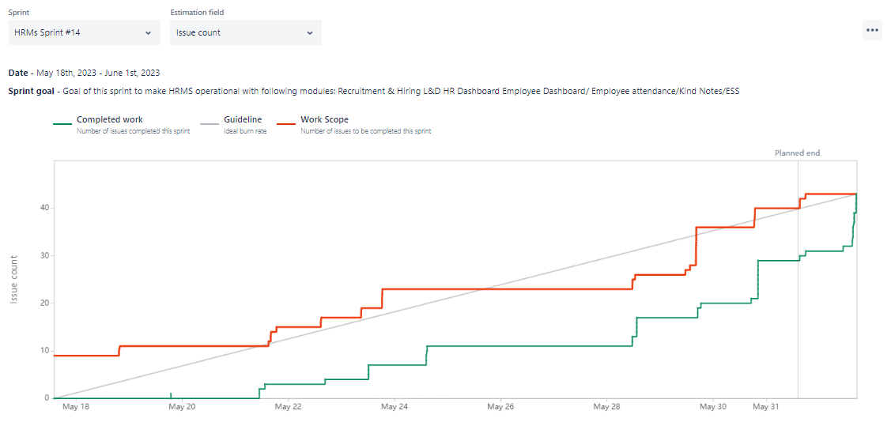
Burn down Report
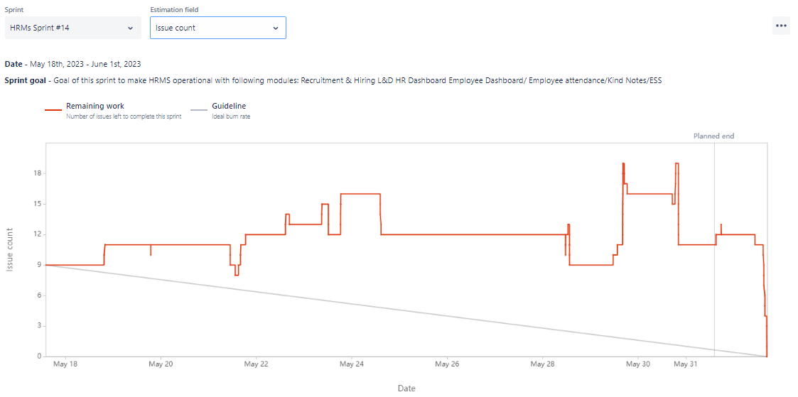

Change Requests in Sprint
Change Requests | Description

Issue Faced

Bugs Report
Bugs | Status
https://kavtech.atlassian.net/browse/HS-651 | Bug Removed
https://kavtech.atlassian.net/browse/HS-652 | Bug Removed
https://kavtech.atlassian.net/browse/HS-672 | Bug Removed
https://kavtech.atlassian.net/browse/HS-673 | Bug Removed
https://kavtech.atlassian.net/browse/HS-680 | Bug Removed
https://kavtech.atlassian.net/browse/HS-686 | Bug Removed
https://kavtech.atlassian.net/browse/HS-687 | Bug Removed
https://kavtech.atlassian.net/browse/HS-688 | Bug Removed
https://kavtech.atlassian.net/browse/HS-715 | Bug Removed
https://kavtech.atlassian.net/browse/HS-716 | Bug Removed
https://kavtech.atlassian.net/browse/HS-717 | Bug Removed
https://kavtech.atlassian.net/browse/HS-718 | Bug Removed
https://kavtech.atlassian.net/browse/HS-600 | Bug Removed

Improvements
Bugs | Status
https://kavtech.atlassian.net/browse/HS-670 | Done

Retrospective Points
- Everything thing gone well in this sprint according to the target
- Bugs reported by QA
- Few major tasks are to be added in the next sprint like QA, code optimization, user manual. Before making ESS live these tasks should be done.
- Time logs are properly done on daily basis

Jira Reports
Overall Progress

