19 October 2017

**Results and Analysis**

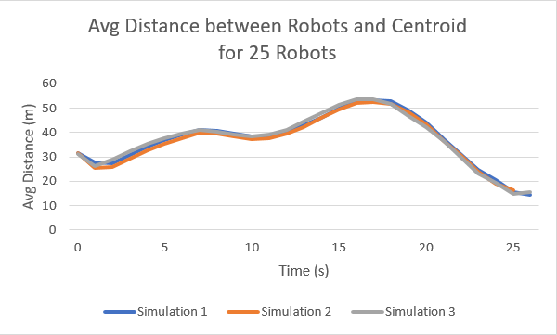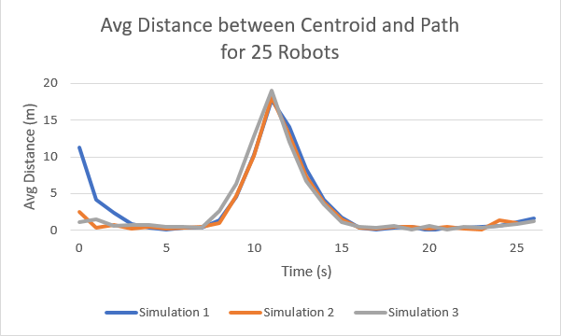

Figure 1: Avg Distance between Robots and Centroid Figure 2: Avg Distance between Centroid and Path

As seen on the graphs above, the flocking implementation used (a combination of homing and dispersion) presented very consistent results. The group of robots naturally organize themselves into a line that follows the path towards the goal. Notice from Figure 1 that the robots initially disperse into a space they are comfortable with and remain constantly spaced apart until the turn when they start to drift off the centroid but quickly return to their natural spacing before homing closer together towards the goal. Figure 2 shows the turning point and how the average drift away from the path leading to the increase in distance between robots and centroid as seen in Figure 1.

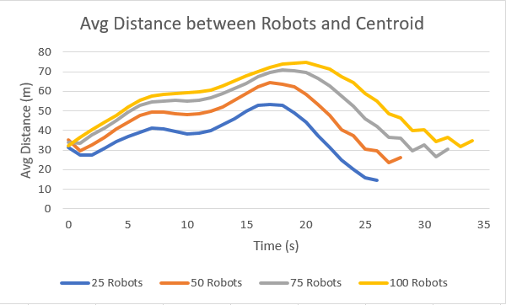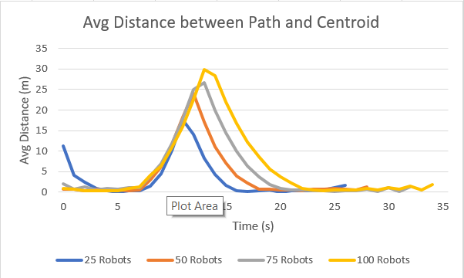

Figure 3: Avg Distance between Robots and Centroid Figure 4: Avg Distance between Centroid and Path

Similarly, increasing the number of robots to 50, 75, and 100 displayed the same behavior we saw above for 25 robots. As the number of robots increase, The robots are forced to disperse even farther away leading to an offset increase of average distance between the robots and the centroid as well as the distance between the centroid and the path as seen in Figures 3 and 4. As the number of robots increase, the robots take slightly longer to reach goal because they are slower due to dispersion and they have to wait for more robots. Nevertheless, the robots never failed to reach home and there were no signs of collisions!