19 November 2017

**Results and Analysis**

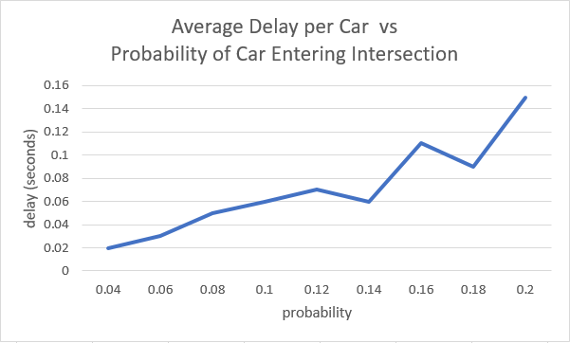 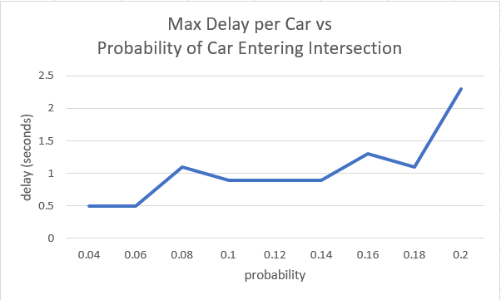

Figure 1: Average delay per car in seconds Figure 2: Max delay per car in seconds

As can be seen from the plots above, the traffic control does a great job avoid traffic jams at the intersection. Even with 0.2 probability of a new car entering the intersection, the average delay per car was less than 0.2 seconds and no car waited longer than 2.5 seconds. These simulations ran for 5 simulated minutes allowing time for hundreds of cars to pass the intersection. In the run with probability = 0.2, around 300 cars used the intersection. As expected, as more cars enter the intersection, the delay increases. More cars on the intersection causes the traffic control to halt and delay cars to avoid collision at the intersection. Nevertheless, due to the efficiency and perfection of autonomous robots, each robot minimizes their own delay by getting as close as possible and maintaining fastest speed at all times. As we increase the probability and have more cars on the intersection, the average delay will increase but no car will wait longer than the traffic control period.

**Design**

Traffic control implementation was used to accomplish the goal of this assignment. In the block diagram below, you can see a high-level diagram to the functions in the code submitted. The focus of the implementation design is in the function controlMovement.m. All other code (blocks) are either setting up the environment or updating it.

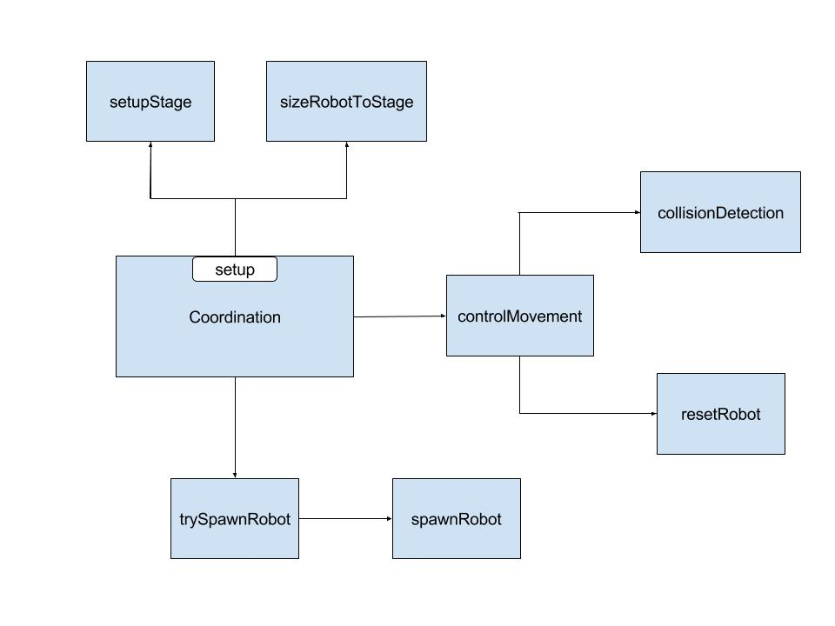

Figure: High-level diagram of traffic control Matlab implementation

In the implementation, each robot controls its own speed based on its position, traffic control, and collision detection.

1. Each robot (I) predicts collision with robot (J) directly in front of it
   1. Robot (I) inquires velocity of robot (J)
   2. Robot (I) predicts future position of both robots
      1. Slow down/stop if collision is predicted (future distance between centers is less than radius*2)
      2. Drive at full speed if no collision is predicted
2. Each robot on the region looks at the traffic light
   1. Drive at full speed if green/pass
   2. Slow down/stop id red/not pass
3. Each robot minimizes its own delay by moving as close as possible without collision and breaking traffic control law
4. Each robot counts its own delay

The traffic control is simple and allows the closest car to the intersection to pass

* The implementation inherently guarantees no car waits forever
* Traffic control prevents collision in intersection while allowing closest car to pass

Assumptions:

* Robots have infinite acceleration
* Robots always drive in a straight light
  + North and South can pass the intersection together
  + East and West can pass the intersection together